# Financial Model Implementations based on real-world market data

by

## Yishu Yang

A thesis

presented to Pro. Liu Zhi from University of Macau in fulfillment of the

thesis requirement for the Summer Research Program at June, 2024 for the major of Statistics and Data Science in Mathematics

### Taipa, Macau SAR, China, 2024

© Yishu Yang 2024

## Author’s Declaration

I am here to declare that this thesis is solely written by myself and the only reference is the book: <Analyzing Financial Data and Implementing Financial Models Using R> by Clifford S. Ang, which is the requirement for the summer research program for me as required by Pro. Liu Zhi.

I also declare that the only program software is R language as required by Pro. Liu Zhi to complete this thesis, where the package of codes and outputs are attached to this thesis and code is provided in the Appendix.

## Abstract

This thesis mainly does research on the relevant financial modeling techniques studied by Clifford S. Ang in his book: < Analyzing Financial Data and Implementing Financial Models Using R>, which implemented several common financial quantities in term of real-world data and provides me with basic financial knowledge for preparation of possible further project on study of price staleness’s effect realize covariance.

Hence the majority of this thesis is my understanding of relevant chapters of book attached by programming outcomes and ideology summarization after successful programming of financial models.

This thesis won’t follow every step of programming algorithm in the book, but all outcome screenshots will be provided and important step-by-step programming will be provided in terms of vital programming examples of real-world data.

This thesis contains analysis of basic terminologies like prices, individual security returns, portfolio returns and risks, where after the introduction of basic terminologies it also provides detailed analysis of specific financial models like Factor Models, Risk-Adjusted Portfolio Performance Measures, Markowitz Mean-Variance Optimization, Fixed Income and various Options.

We will refer to the book: < Analyzing Financial Data and Implementing Financial Models Using R> as “This Book” in the later chapters.

## Acknowledgements

I would firstly thank all my mathematics professors who give me solid and comprehensive mathematical knowledge which helps me to review this financial mathematics book to improve my application of my mathematics knowledge in financial areas.

Secondly, I would thank Clifford S. Ang, who is the author of this book: <Analyzing Financial Data and Implementing Financial Models Using R> to provide resources and materials with my summer research program about specific R programming in financial areas.

Finaly, I would thank Pro. Liu Zhi to give this opportunity to review a financial classic book to help me improve my mathematical ability in programming and doing research on realistic mathematics problems.

I would also thank my family to support my study as always by financial assistance to my study in University of Macau.

## Dedication

This is dedicated to my grandma, who has raised me up since I was born and will be my love forever until my death.

Financial Model Implementations based on real-world market data 1

Yishu Yang 1

Taipa, Macau SAR, China, 2024 1

Author’s Declaration 2

Abstract 3

Acknowledgements 4

Dedication 5

Chapter 1 Prices 8

1.1 Import Data 8

1.2 Import Price Data from Yahoo Finance 8

1.3 Checking the data 12

1.4 Basic Data Manipulation Techniques 14

1.5 Comparing Capital Gains of Multiple Securities Over Time 21

1.6 Technical Analysis Examples 28

1.7 Further Reading 33

Chapter 2 Individual Security Returns 35

2.1 Price Returns 35

2.2 Total Returns 36

2.3 Logarithmic Total Returns 38

2.4 Cumulating Multi-Day Returns 39

2.5 Weekly Returns 43

2.6 Monthly Returns 44

2.7 Comparing Performance of Multiple Securities: Total Returns 45

Chapter 3 Portfolio Returns 48

3.1 Constructing Portfolio Returns (Long Way) 48

3.2 Constructing Portfolio Returns (Matrix Algebra) 51

3.3 Constructing Benchmark Portfolio Returns 52

3.4 Further Reading 76

Chapter 4 Risk 77

4.1 Risk-Return Trade-Off 78

4.2 Individual Security Risk 82

4.3 Portfolio Risk 87

4.4 Value-at-Risk 94

4.5 Expected Shortfall 105

4.6 Alternative Risk Measures 109

4.7 Further Reading 119

Chapter 5 Factor Models 120

5.1 CAPM 120

5.2 Market Model 131

5.3 Rolling Window Regressions 132

5.4 Fama-French Three Factor Model 135

5.5 Event Studies 139

5.6 Further Reading 148

Chapter 6 Risk-Adjusted Portfolio Performance Measures 149

6.1 Portfolio and Benchmark Data 149

6.2 Sharpe Ratio 152

6.3 Roy’s Safety-First Ratio 153

6.4 Treynor Ratio 154

6.5 Sortino Ratio 156

6.6 Information Ratio 158

6.7 Combining Results 160

6.8 Further Reading 161

Chapter 7 Markowitz Mean-Variance Optimization 162

7.1 Two Assets the “Long Way” 162

7.2 Two-Assets Using Quadratic Programming 167

7.3 Multiple Assets Using Quadratic Programming 171

7.4 Effect of Allowing Short Selling 177

7.5 Further Reading 181

Chapter 8 Fixed Income 183

8.1 Economic Analysis 183

8.2 US Treasuries 191

8.3 Further Reading 198

Reference 199

Attachment of zips of R codes 200

## Chapter 1 Prices

In Chapter I Price the author of This Book mainly discusses the distinctive difference of price and value of certain securities, whose distinction majorly serves as the inner driven characteristic of market trades of buying and selling of certain securities. And the author firstly introduces how to import business data in Yahoo Finance to manipulate and analyses later on, which is mostly stock data and exchange traded funds (ETF).

### Import Data

The way of importing data from Yahoo Finance here is very direct, just downloading data into a CSV file and upload CSV file into R software. However, we still need to perform some data manipulation to transform the raw data.

### 1.2 Import Price Data from Yahoo Finance

#### Step 1: Import CSV File from Yahoo Finance

I will download data from Amazon.com with ticker symbol AMZN in Yahoo Finance, which means I retrieve a CSV file of the historical data for AMZN from December 31, 2010 to December 31, 2013.

The below screenshots are from the file ‘AMZN Yahooo.csv’ opened in visual studio code for view.

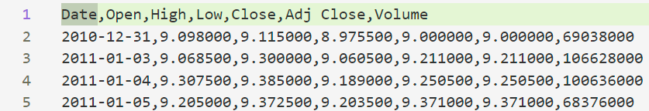

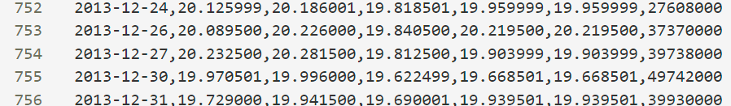

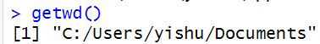

Use this command to get path of the directory of R files and data files.

#### Step 2: Import Data into R

Read the data by “read.csv()” and sort it from the latest to the oldest:

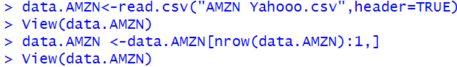



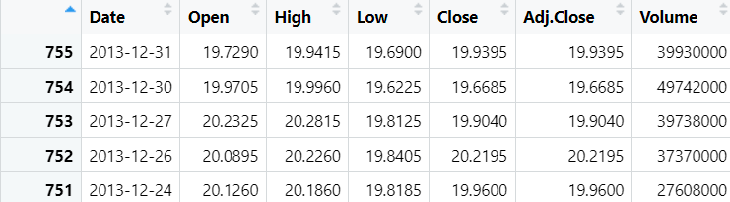

By using “head()” and “tail()” in R language:

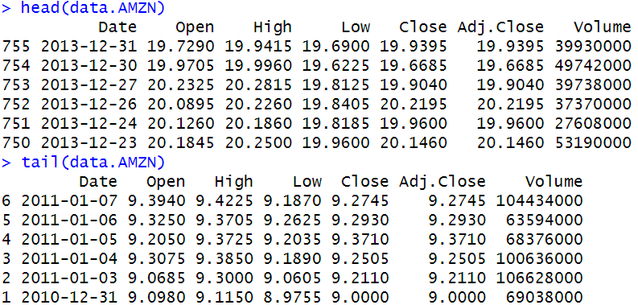

#### Step 3: Convert the date Variable from a Factor to a Date

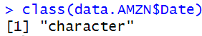

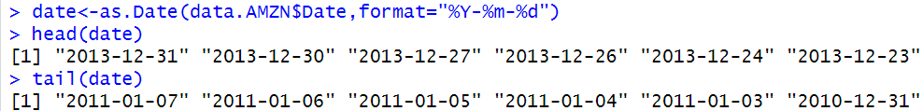

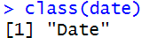

#### Step 4: Combining *date* and *data.AMZN*

Combine the “Date” class “date” with all columns of data.AMZN except the first column of “character” class “Date”: 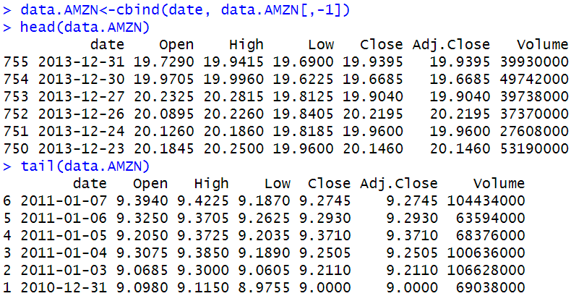

#### Step 5: Sort Data in Chronological Order

Now I sort the rows by the order of date time again to make the top row with date of 2010-12-31.

Also from the order it could see that the oldest date has smallest number: “1”, which means it has the correct order as time goes on, which is better than the output in the book:

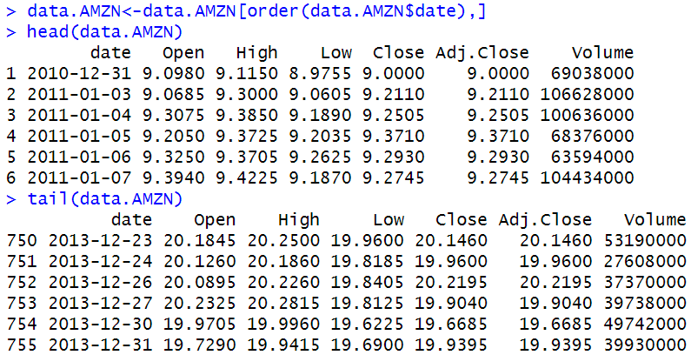

#### Step 6: Convert from data.frame Object to xts Object data.AMZN is structured as a data.frame class.

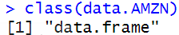

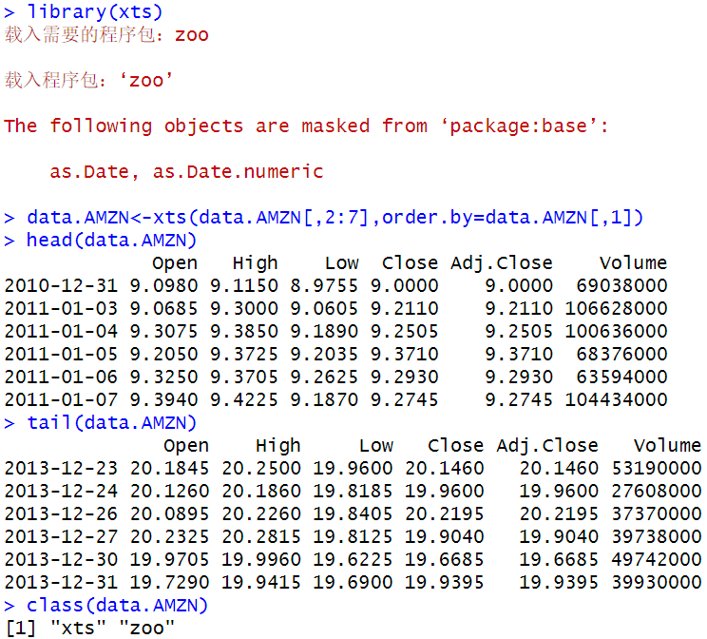

#### Step 7: Rename Variables

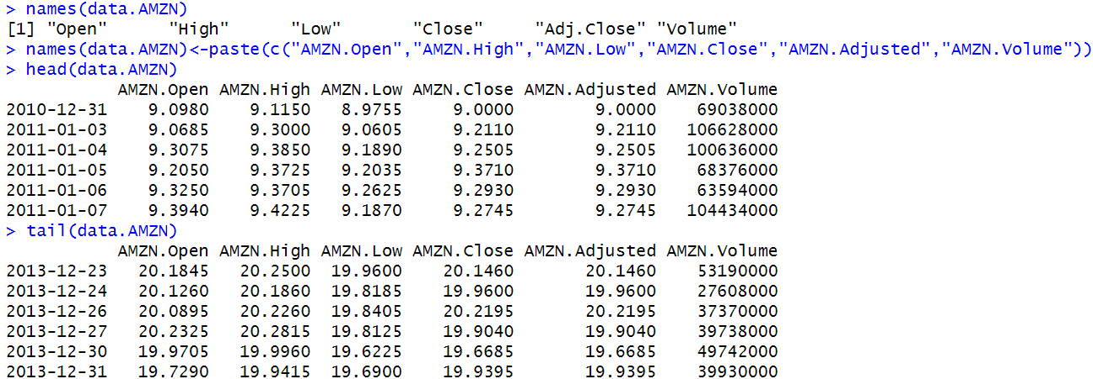

Now I could just use “AMZN**.** …” to refer to these quantities which match the names in **getSymbols** command.

### 1.3 Checking the data

#### 1.3.1 Plotting the data

I plot the Amazon.com closing price (AMZN.Close) against the time:

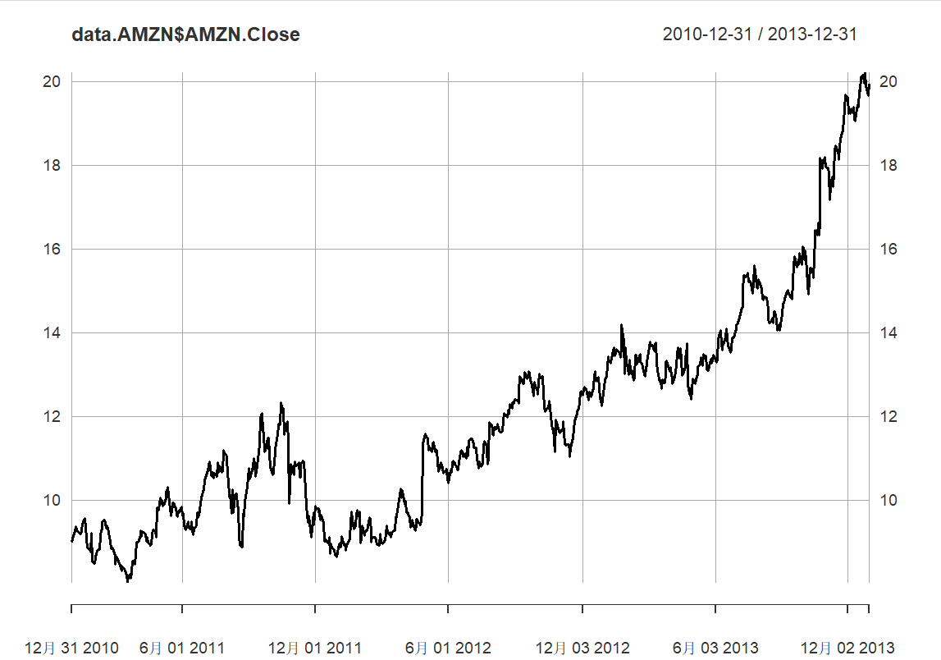

Now I manipulate the data to make an effect that there are some data losses in some dates and compare these to the above original one to see the missing data effect:

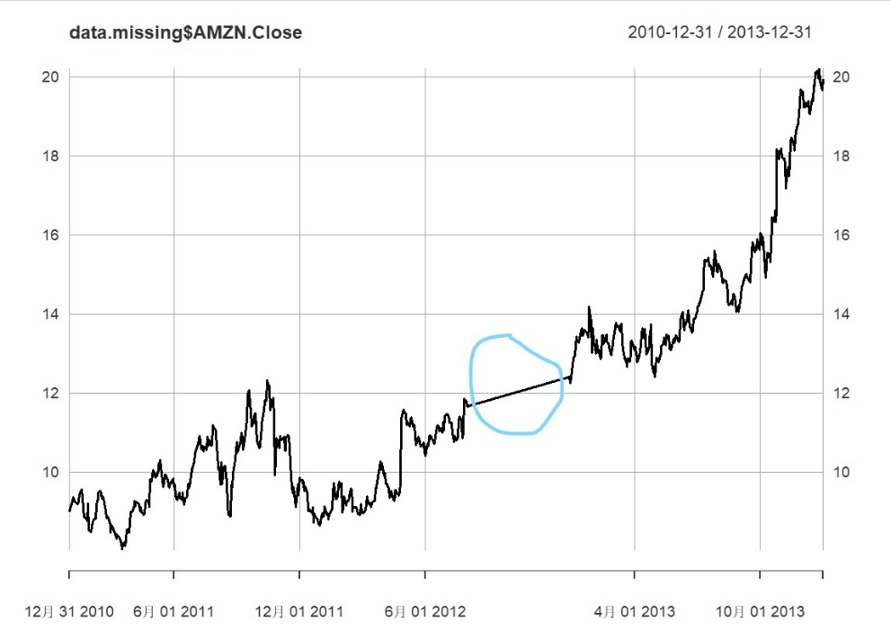

Clearly from the light blue circle part we see that there is a flat group of spots in the missing data plot, which is just due to the missing of important data from no.400 to no.500.

#### 1.3.2 Checking the Dimension

I use a simple code here to output the dimension of the Amazon.com data:

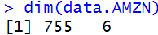

#### 1.3.3 Outputting Summary Statistics

I also use a simple line of code here to output the summary table of statistics of the Amazon.com data:

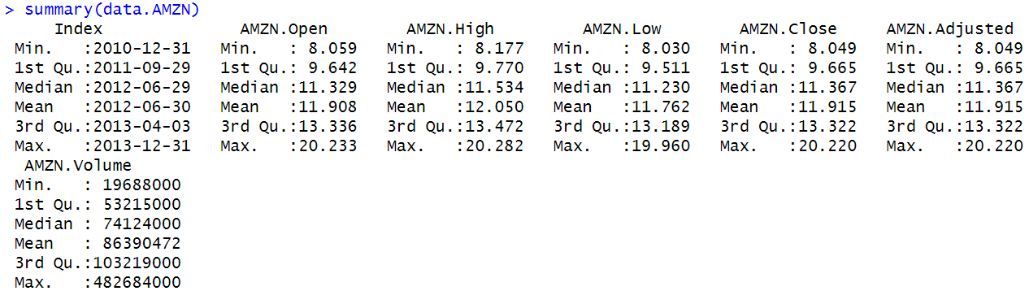

#### 1.3.4 Checking the Ticker Symbol

We double check the ticker symbol here for the Amazon.com again:

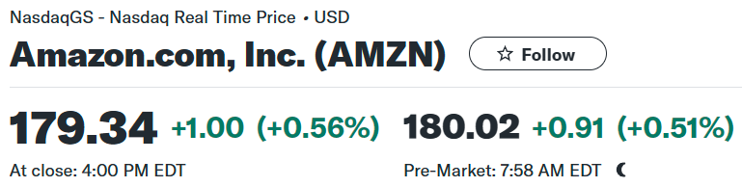

This screenshot from Yahoo Finance clearly shows that the ticker symbol for Amazon.com, Inc. is “AMZN” which is on market of Nasdaq Real Time Price by using US Dollars.

The reason that Ticker Symbol should be double checked is that it changes occasionally and may be the same with other companies having similar initial alphabet letters.

### 1.4 Basic Data Manipulation Techniques

#### 1.4.1 Keeping and Deleting One Row

1: Only keep the first row of data at 2010-12-31:

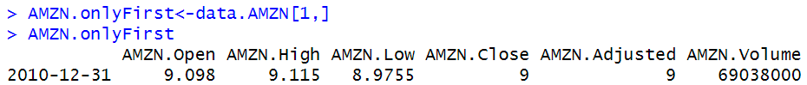

2: Only leave the first row of data and keep all the remaining data:

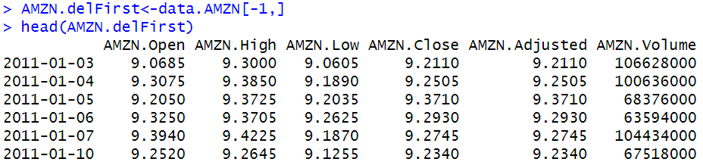

We could see that only the first row of data (2010-12-31) here is deleted and all the remaining is kept.

#### 1.4.2 Keeping First and Last Rows

Here we compare the first row data (2010-12-31) and the last row data (2013-12-31) to see the overall change in this range of time:

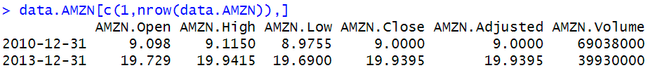

#### 1.4.3 Keeping Contiguous Rows

Suppose we need to output the row data of the first week of year 2011, then we need to output row data within a sequence of row numbers.

Here is the solution of manipulating row index in R language:

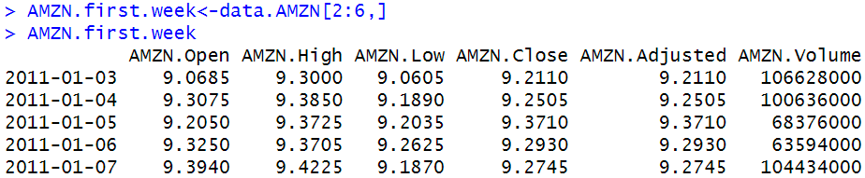

Similarly, we could use this technique to output the last 30 row data of the total observation:

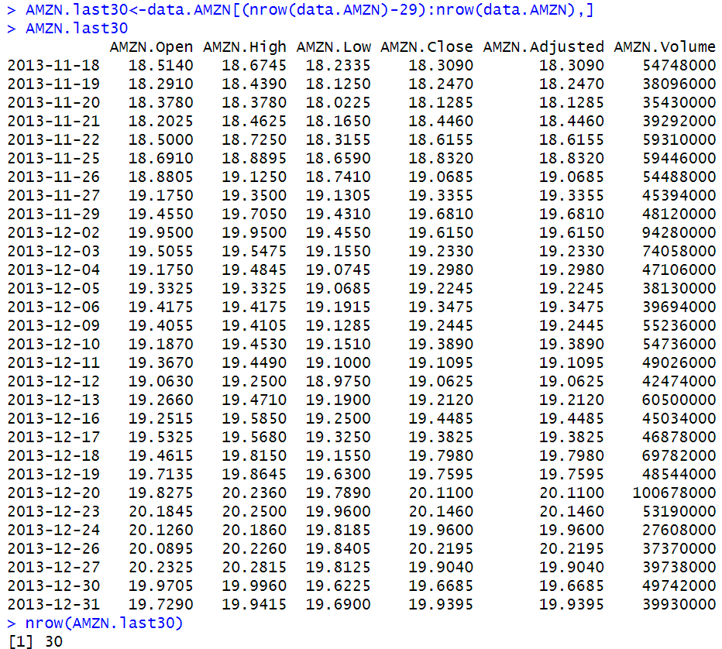

#### 1.4.4 Keeping First Three Rows and Last Row

I use colon or “:” and comma or “,” together in c() to make the selection of keeping both continuous and discrete rows:

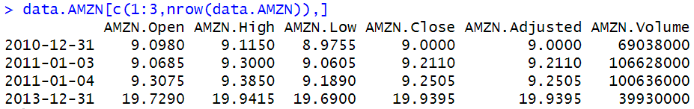

#### 1.4.5 Keeping and Deleting One Column

I will provide two different ways of extracting one specific column in AMZN data.

I output the names of columns first:



The first way is to use index after comma to represent the number of column and use group of indices before comma to select row data in terms of the number of rows:

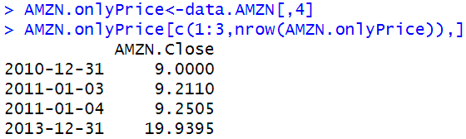

The second way is to just nominate the column name we want to keep, like “AMZN.Close”:

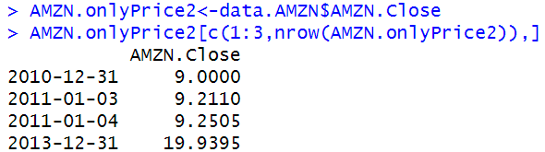

Since we need to delete the column “AMZN.Adjusted” here in the model of OHLC financially, hence we only need to type [ , -5] to eliminate Adjusted:

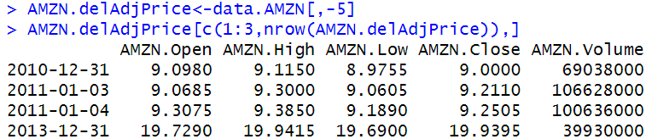

#### 1.4.6 Keeping Non-Contiguous Columns

Here we use “c()” in R language to combine non-contiguous columns to analyze different features data:

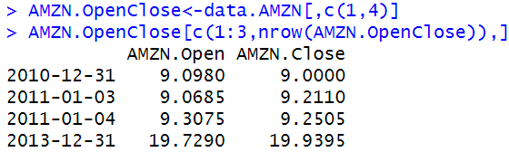

#### 1.4.7 Keeping Contiguous Columns

Here we use “c()” in R language to combine contiguous columns to analyze different features data in a sequence:

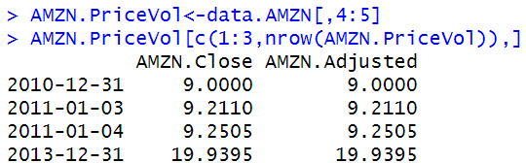

#### 1.4.8 Keeping Contiguous and Non-Contiguous Columns

Here we use “:” and “,” in “c()” to combine both continuous and discrete features together to do analysis on AMZN data:

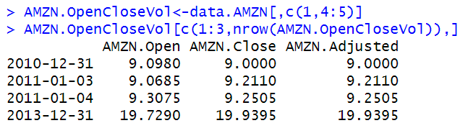

Also, we could do this by using “-” in “c()” to delete intermediate columns:

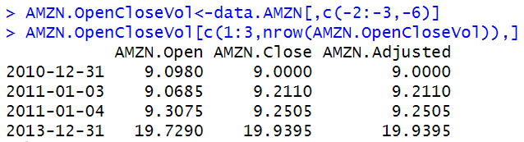

#### 1.4.9 Subsetting Rows and Columns

We combine row information before comma and column information after comma together to use the subset of both rows and columns, here we only output the first three rows and last rows: 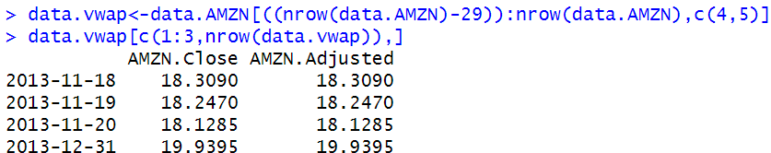

This is the information of AMZN data of the last 30 days with 4th and 5th columns.

#### 1.4.10 Sub-setting Using Dates

Since dates are more obvious and tangible in time series analysis, so using dates in R language is more used apparently. Here It should be noted that the “Date” here is an “xts” object.

Here we define all information of the year 2012 and output the first three row information and the last day information, which is accompanied by the output of the class of “data.AMZN” to show the trivial “xts” class:

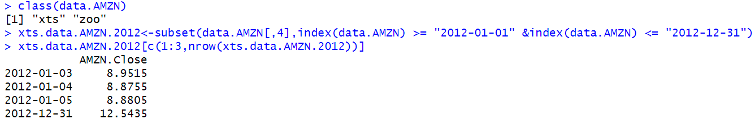

As in some cases we need to transform the data class to be “data.frame” object to perform some data analysis, hence we also transfer the data class from “xts” here to be “data.frame”:

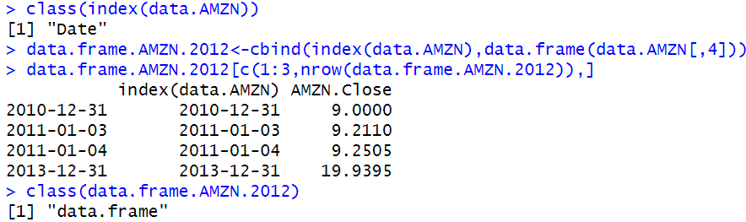

There are two main problems here in the above table. The first problem is that the name of the first column is “index(data.AMZN)”, which is not a meaningful name. The second problem is that the index is also in the form of date, which is redundant compared to first column, so we need to change the name of first column and change the form of the index:

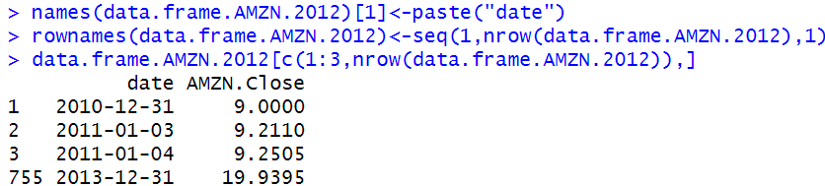

Now we apply the above subnet technique in this data.frame form again to make the year 2012 data demonstration:

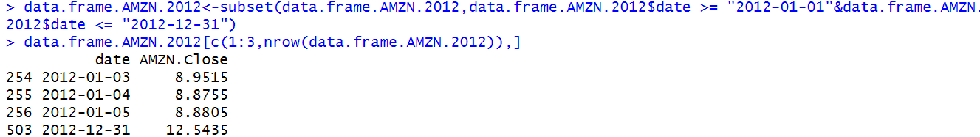

#### 1.4.11 Converting Daily Prices to Weekly and Monthly Prices

We need to convert daily data into weekly or monthly data to get summarized data analysis, so here we transfer the AMZN data into weekly and monthly form, with the help from “xts” class object:

1. Weekly Price:

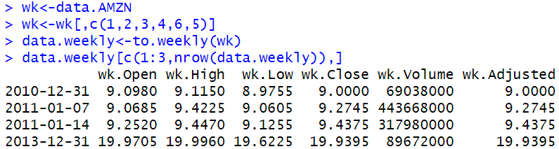

Also, we use the original data to verify the results weekly, whose data is ranged from 2011-01-03 to 2011-01-07:

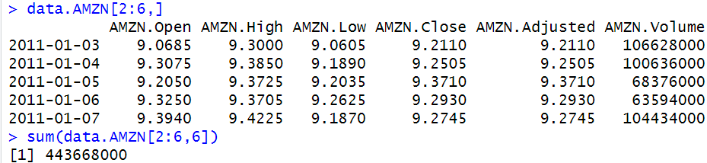

We could see that the weekly Volume is matched with the Volume of week 2011-01-07, with the number of 443668000.

1. Monthly Price:

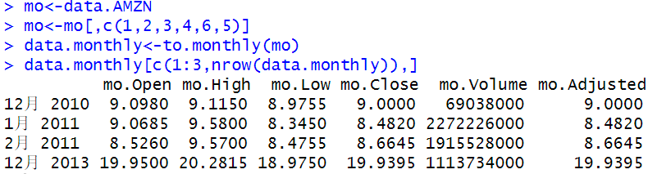

We could see the data is correct especially for December 2010 since only one day from that month is counted when summarizing volume.

1. Plotting a Candlestick Chart Using Monthly Data

We would need to first convert the data into an open-high-low-close (OHLC) object, which means we will present a OHLC table of monthly data:

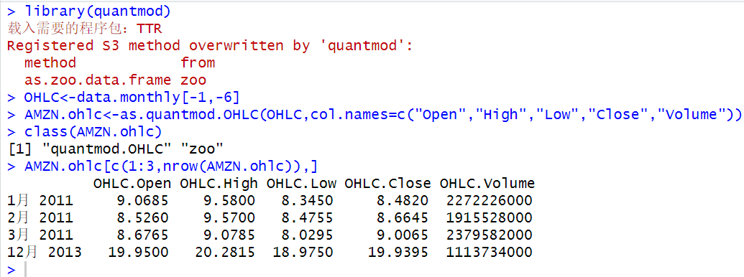

Now we plot the OHLC Chart with above line bars and below bar charts:

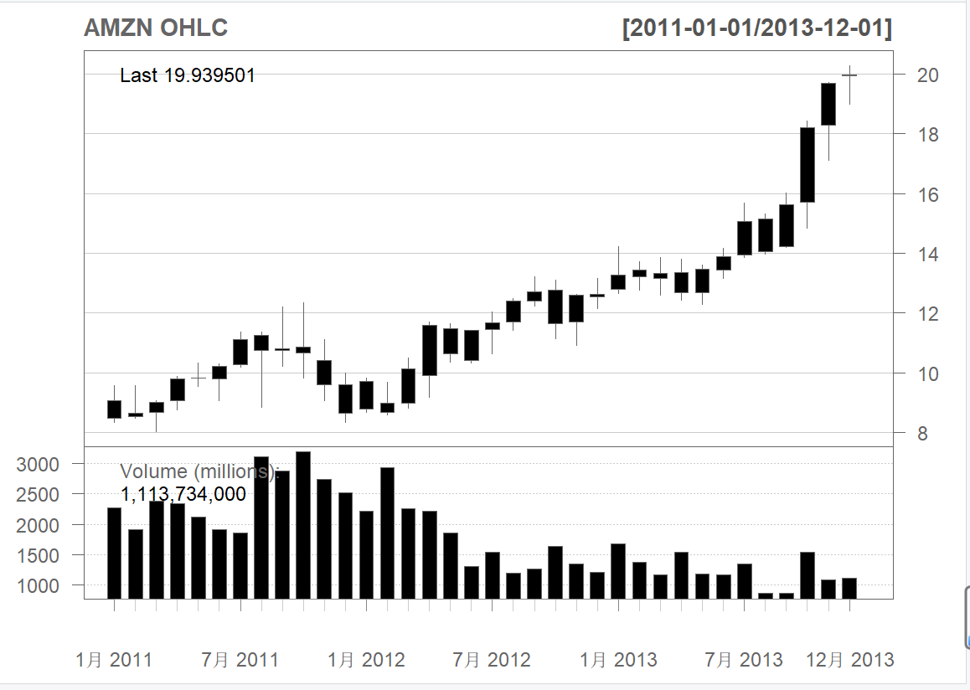

Here the only one day data December 2010 is dropped and Adjusted column is also dropped for redundant.

### 1.5 Comparing Capital Gains of Multiple Securities Over Time

At first, we clear out all the old data objects and show again to verify that all old objects have been cleared out:

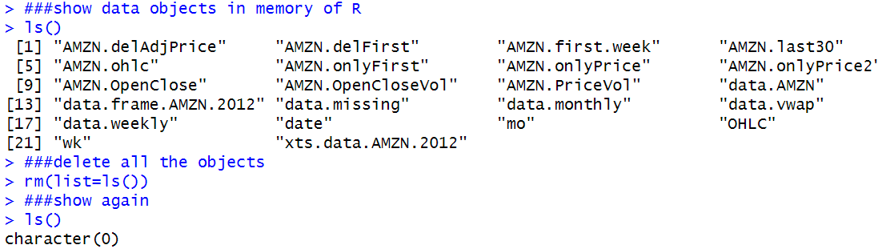

Here we combine 4 securities with the assistance of data from Yahoo Finance within the time range from December 31, 2010 to December 31, 2013 to find out which one is the best security for investment.

The four chosen security is AMZN, IBM, YHOO and ^GSPC.

We download these four csv data files and begin to plot the combined graph.

I am really sorry that Yahoo has officially exited the stock market many years ago, so I have to change YHOO to AAPL.

Hope Apple will not fail and exit the market in the future (lol).

Also ^GSPC cannot be downloaded from Yahoo Finance since it is a market index, we change it into NVIDIA (NVDA).

Now we import the data from the csv files.

Step 1: Import Data for Each of the Four Securities:

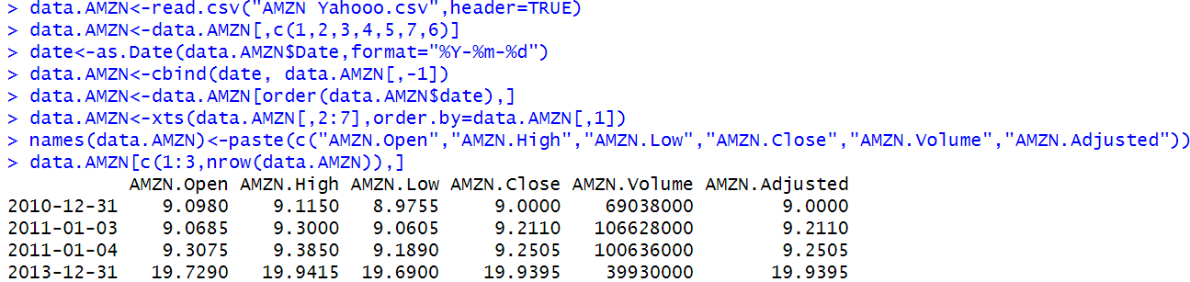

This is the example from AMZN, other securities follow this style similarly.

This is AAPL:

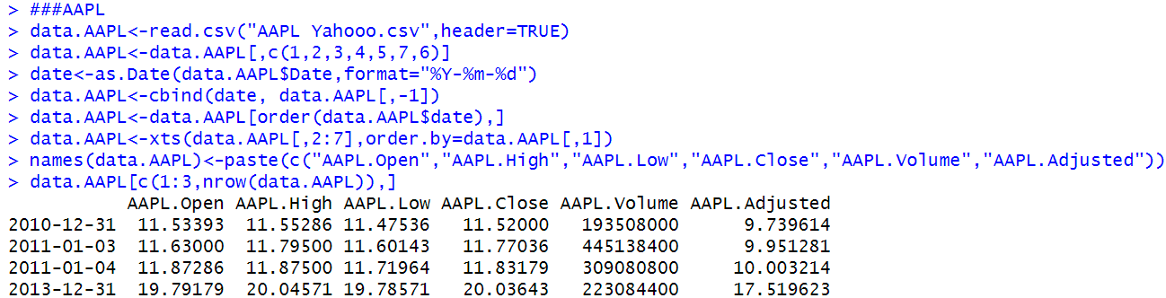

This is IBM:

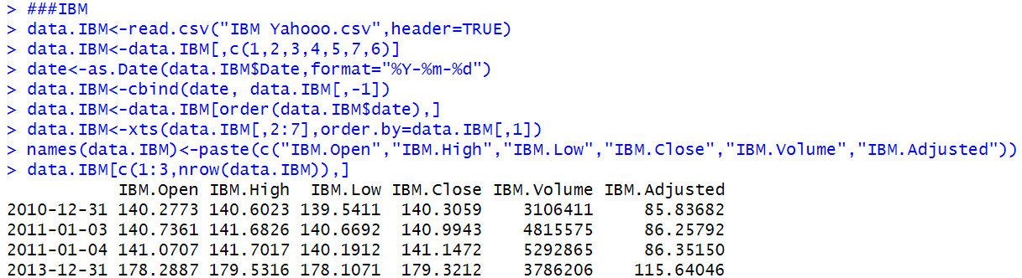

This is NVDA:

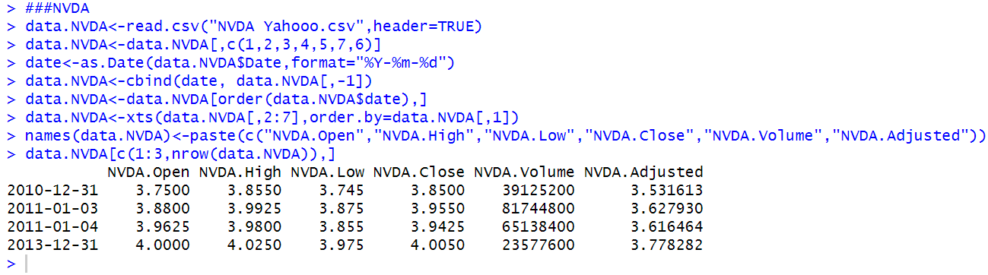

And here are my comments for the entire codes for NVDA, which is the same for other securities.

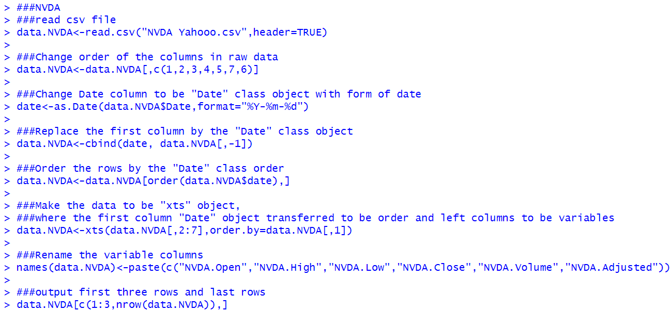

Step 2: Combine Data into One Data Object:

Here we only need the “Close” data columns of the four securities. Hence, we use the only column required to be combined together to build a new “Close.Prices” data.

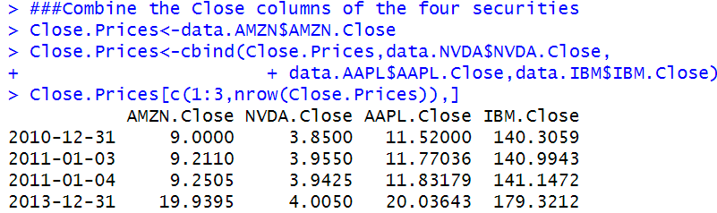

Step 3: Convert Data into a “data.frame” object.

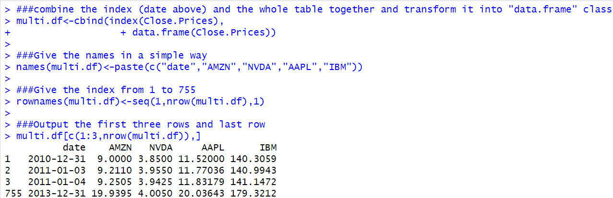

Step 4: Calculate Normalized Values for Each Security.

Here normalized means we divide every close price by the price of December 31, 2010 for each security in the data, which will not affect the increasing rate for each security. The advantage is that the numeric value of close prices will not outclass too much to compose too many outliers.

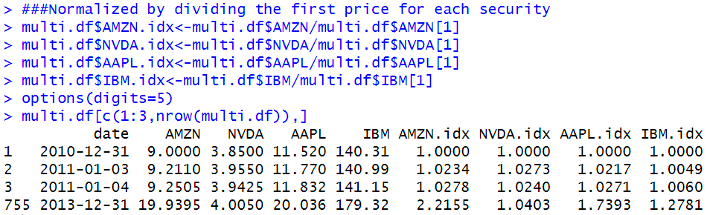

Step 5: Plot the Capital Appreciation of Each Security

To plot the comparison of four securities, we need to select the first basic security to chart the data, which should be the smallest data in relevant, namely NVDA. This is the first section:

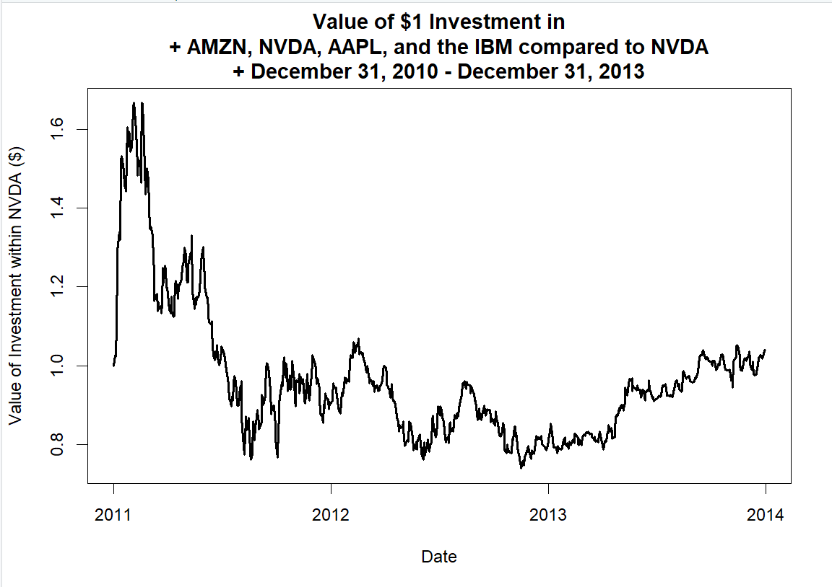

The next step is including all other three securities by plotting the lines with similar arguments. This is the second section:

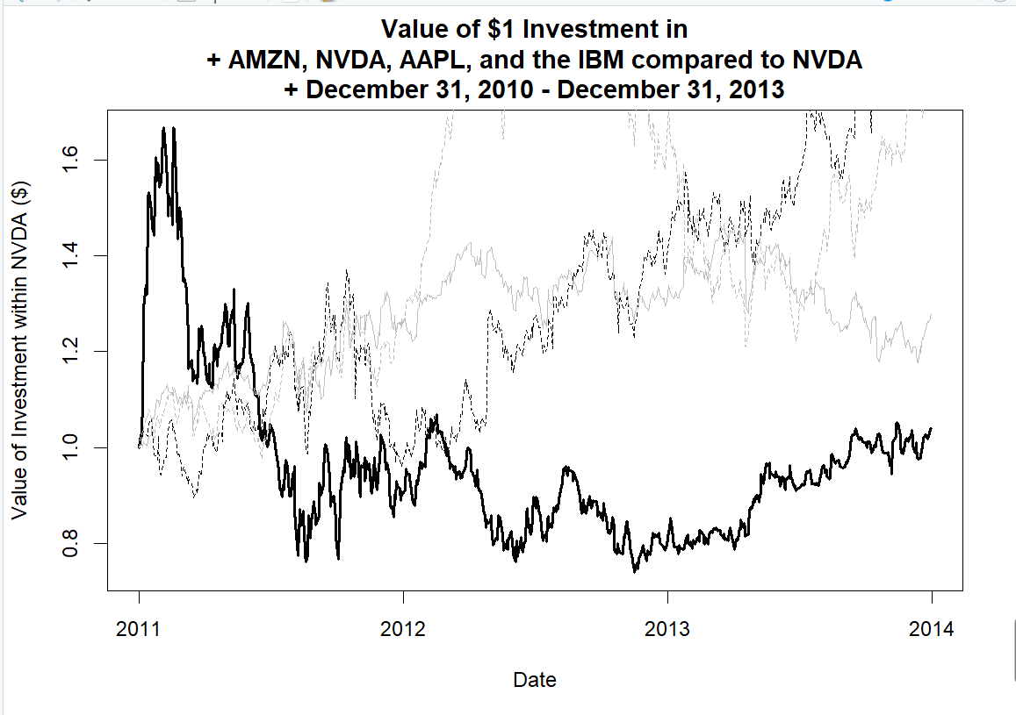

Now we can see that some lines are out of range, hence we need to add “ylim” parameter in plot and change the range.

I also add a horizonal line with value 1 to mark the beginning line. This is the third section.

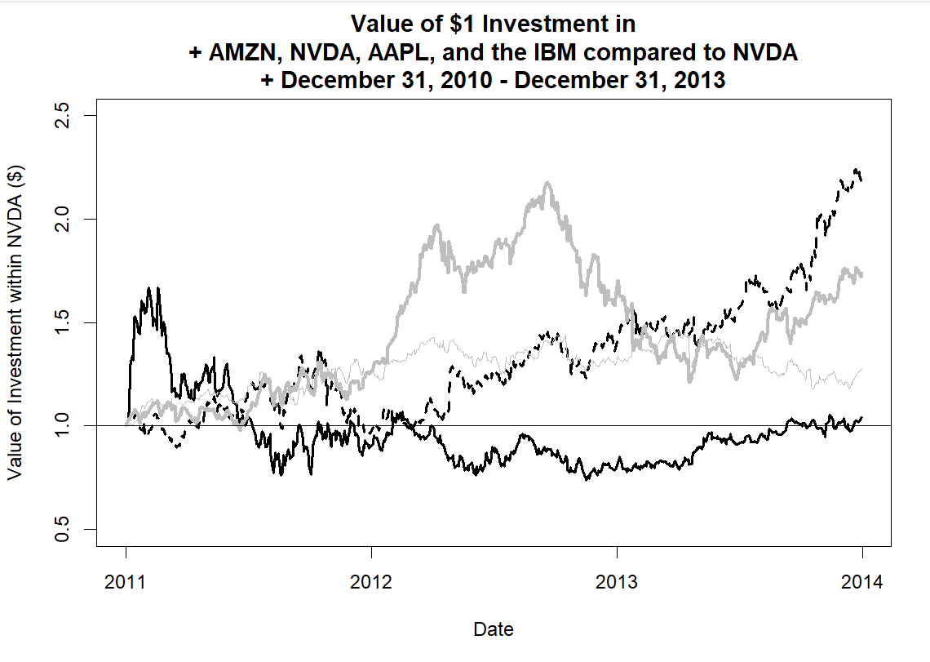

Now we add the legend for each line of each security to distinguish each other. This is the final section.

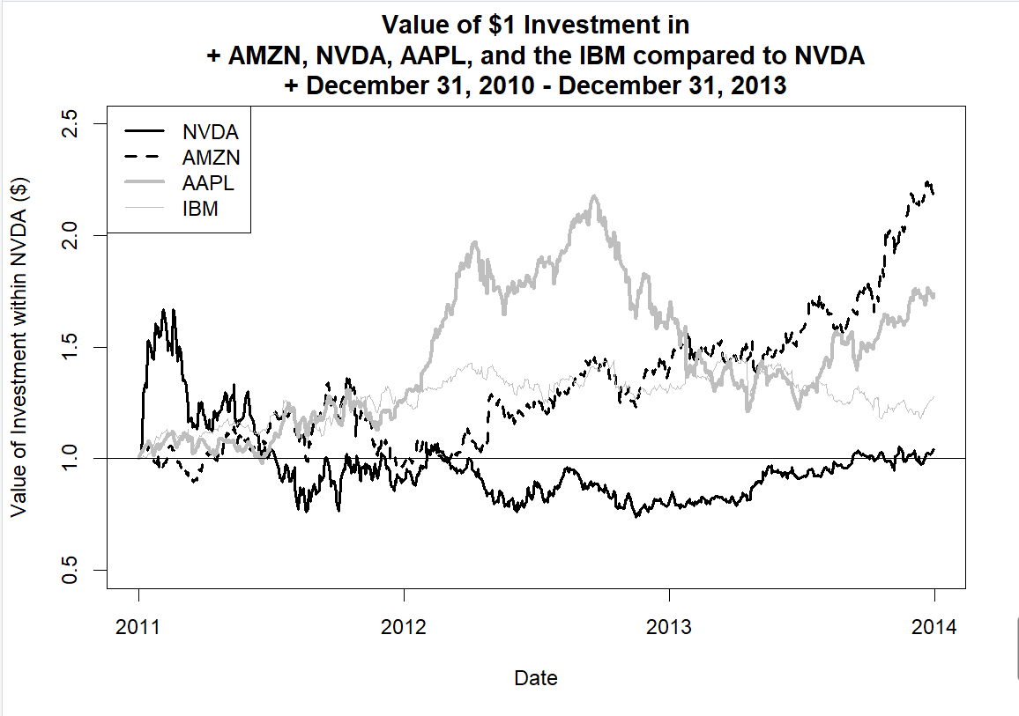

Step 6: Fix the y-axis to Encompass Range of Normalized Values for All Securities:

Here we calculate the y range for all 4 securities to calculate the minimum and maximum to fit the graph in the suitable range, and insert this range in the “ylim” parameter in the first plot arguments.

And this is the final plot:

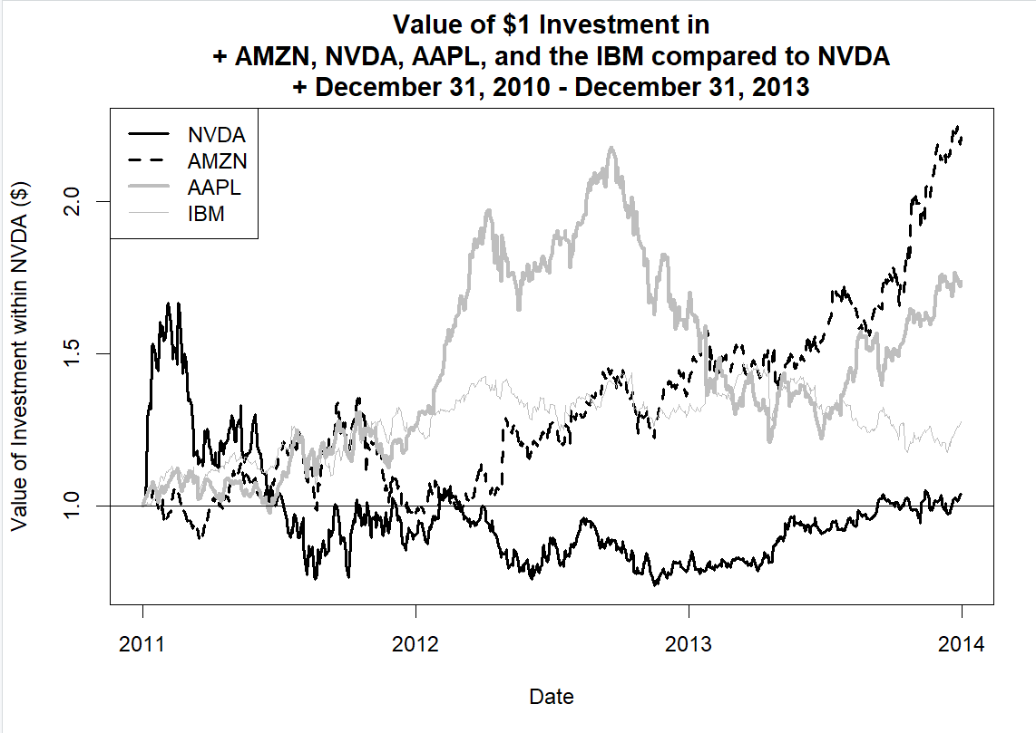

#### 1.5.1 Alternative Presentation of Normalized Price Chart

Another approach is that we plot four similar mini-graphs, where each security is highlighted by a dark bond line with all other three grey and thin lines, which could also be an effective plot.

Step 1: Setup Chart Layout in R

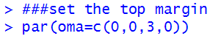

Step 2: Let R Know We Will Be Plotting 4 Charts with 2 Charts in Each Column and 2 Charts in Each Row

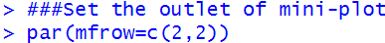

Step 3: Create the 4 Plots

Now we plot the four individual mini-graphs.

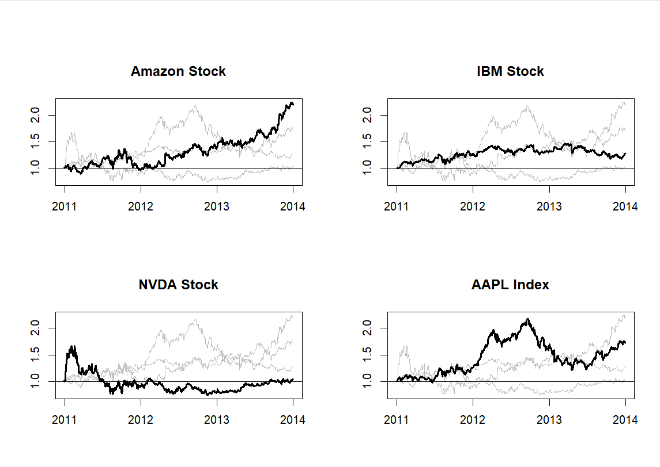

Step 4: Create a Global Title for the Charts

Use “outer = T” here to set a global title in the upper margin settled before.

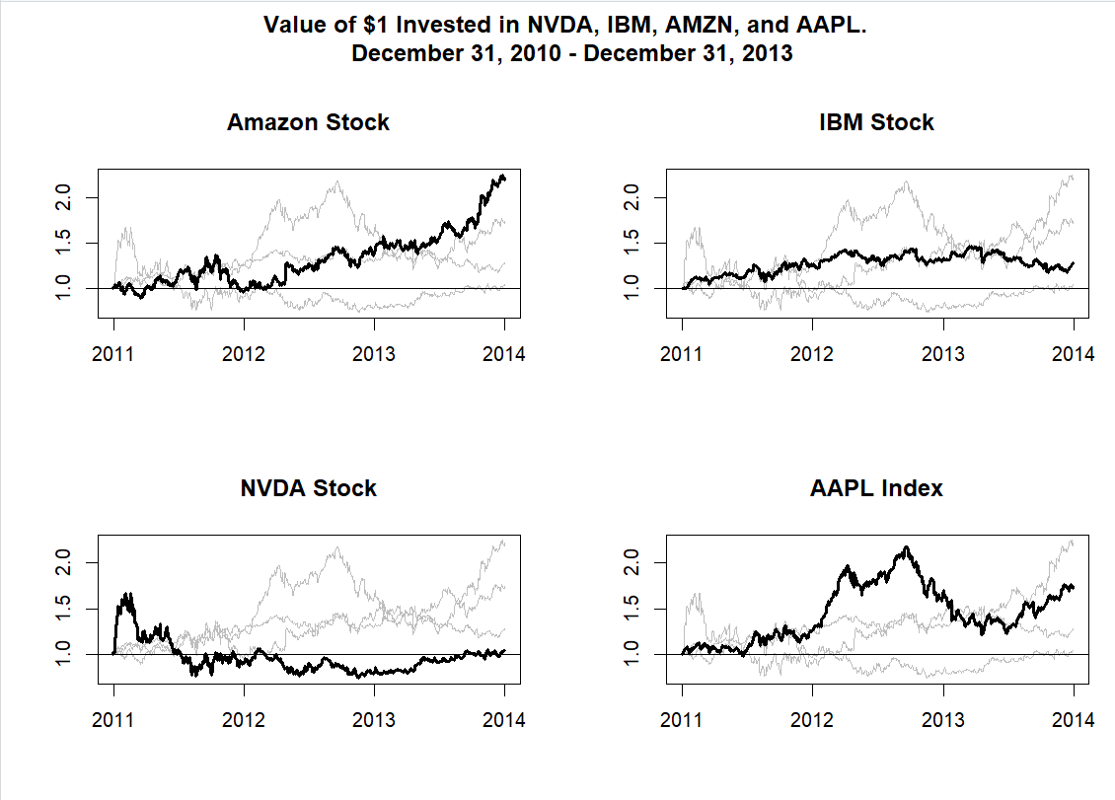

### 1.6 Technical Analysis Examples

The major understanding of stock prices up and down should be related to demand and supply. More obviously, if demand surpasses the supply then the price is going to increase, if not then the price is likely to go down. The effectiveness of technical analysis is just to predict and follow these possible trends at early stage.

Here are three major types of technical indicators, trend indicator, volatility indicator and momentum indicator. Normally the analysis is made in composition of various indicators at the same time.

#### 1.6.1 Trend: Simple Moving Average Crossover

Here we use the moving average to estimate the coming trend indicator. Typically it is called SMA (Simple Moving Average) such that it treats all future days the same, regardless of near or far away.

We use the crossover of two SMA lines to do the prediction.

Step 1: Obtain Closing Prices for Amazon.com Stock

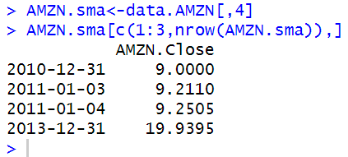

Step 2: Calculate the Rolling 50-Day and 200-DayAverage Price

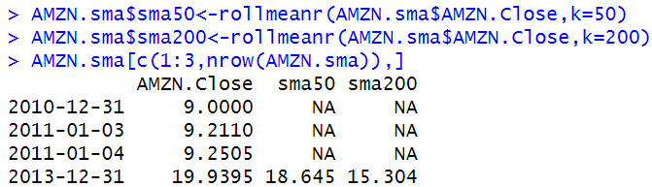

To show that sma50 begins at the 50th date, we output row data from 48th to 52nd date:

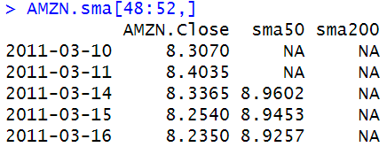

Similarly show again the 198th to 202nd date to show the sma200 beginning at 200th date:

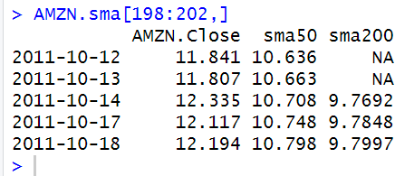

Step 3: Subset to Only Show 2012 and 2013 Data

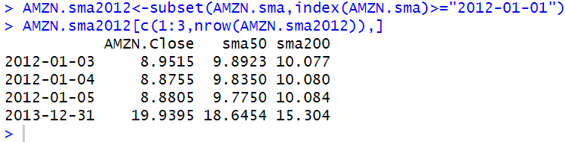

Step 4: Plot the SMA

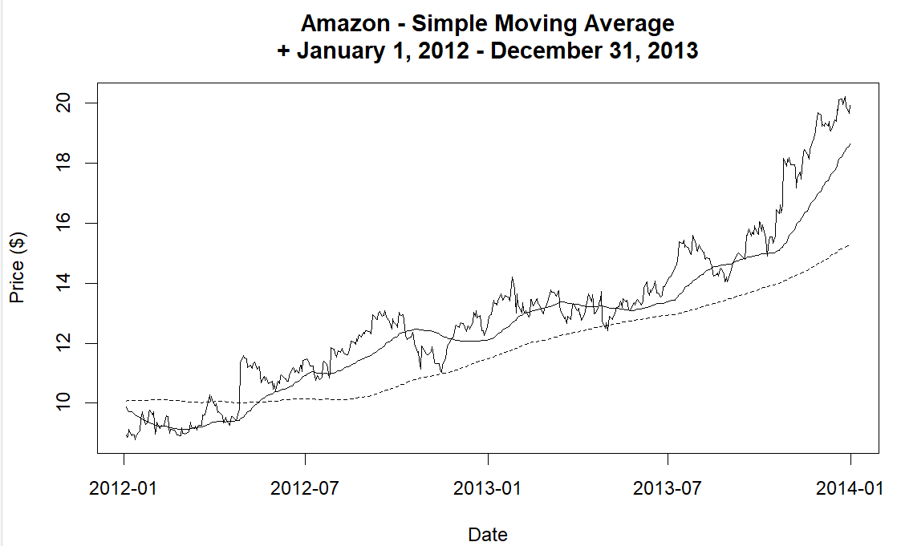

#### 1.6.2 Volatility: Bollinger Bands

The Bollinger Bands have three components. The first component is a 20-day simple moving average (SMA). The second component is an upper band, which is two standard deviations above the 20-day SMA. The third component is a lower band, which is two standard deviations below the 20-day SMA.

Bollinger Bands are considered as volatility indicators because it widens or narrows volatility in the stock market.

Step 1: Obtain Closing Prices for Amazon.com Stock

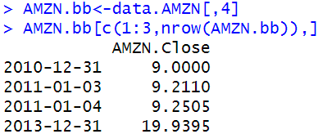

Step 2: Calculate Rolling 20-Day Mean and Standard Deviation.

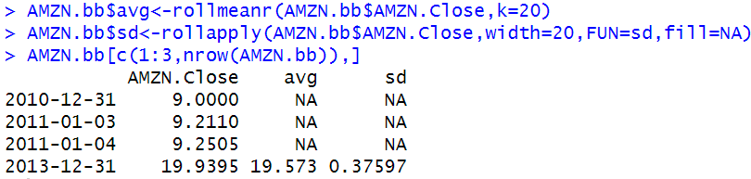

Now we output the 18th to 22nd row data since the calculation is from 20-day interval.

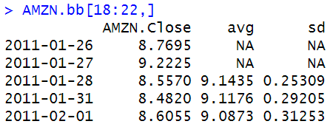

Step 3: Subset to Only Show 2013 Data.

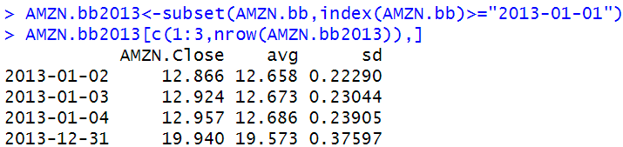

Step 4: Calculate the Bollinger Bands.

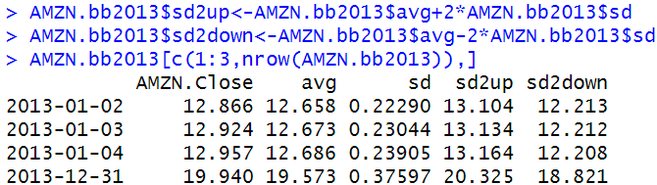

Step 5: Plot the Bollinger Bands.

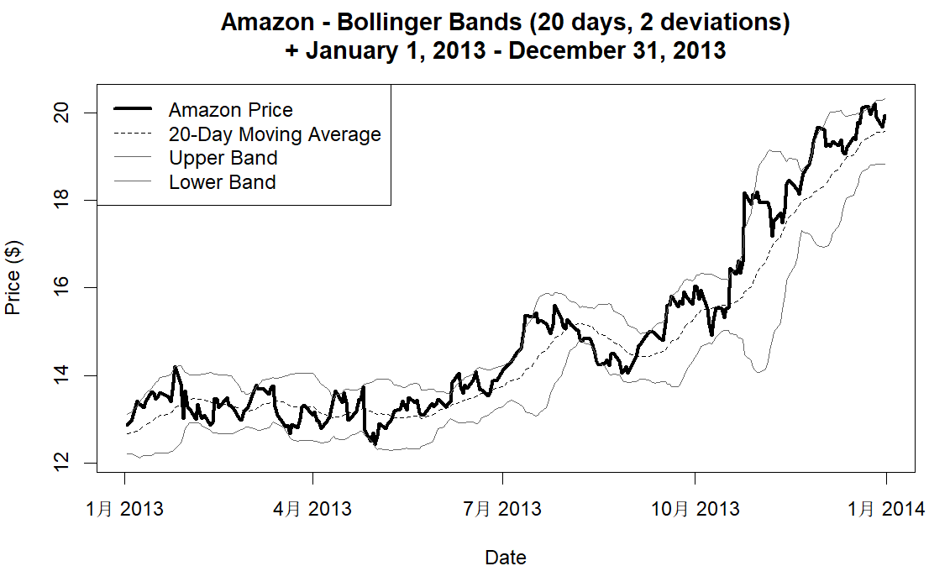

#### 1.6.3 Momentum: Relative Strength Index

A common technical analysis momentum indicator is the Relative Strength Index (RSI). The typical calculation is to use a 14-day period. The RSI is calculated as:

$RSI = 100 – 100/(1 + RS)$.

where RS is equal to the up average divided by the down average with the averages calculated using the Wilder Exponential Moving Average described below.

The RSI is used in conjunction with an overbought line and an oversold line. The overbought line is typically set at a level of 70 and the oversold line is typically set at a level of 30. A buy signal is created when the RSI rises from below the oversold line and crosses the oversold line. Conversely, a sell signal is created when the RSI falls from above the overbought line and crosses the overbought line.

Step 1: Obtain Closing Prices for Amazon.com Stock

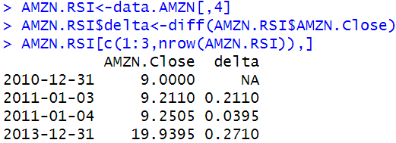

Step 2: Create Dummy Variables to Indicate Whether Price Went Up or Price Went Down

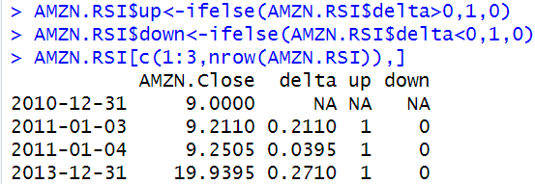

Step 3: Calculate Prices for Up Days and Prices for Down Days

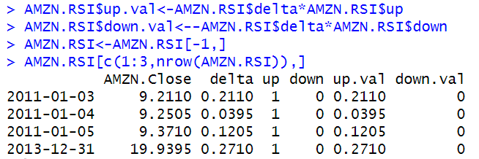

Step 4: Calculate Initial Up and Down 14-Day Averages

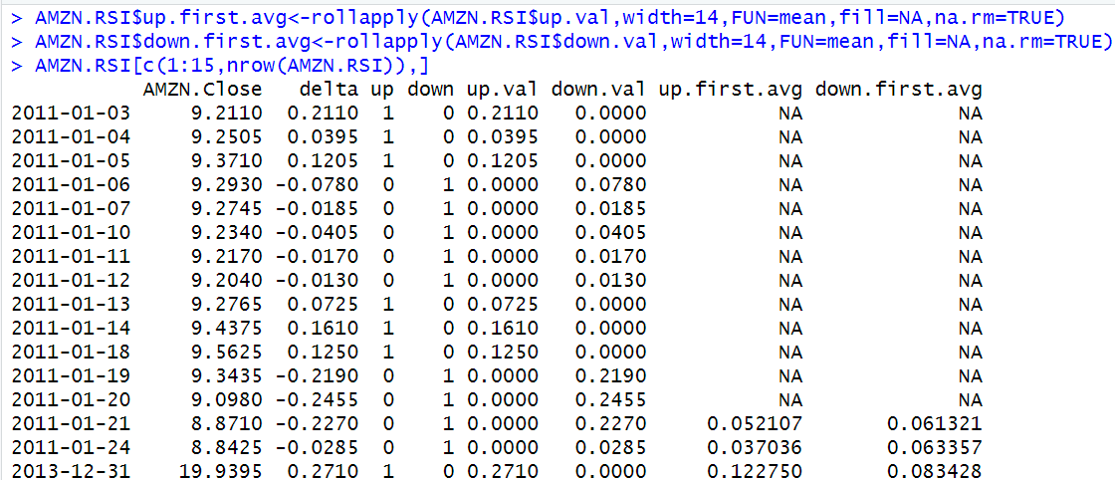

Step 5: Calculate the Wilder Exponential Moving Average to Calculate Final Up and Down 14-DayAverages

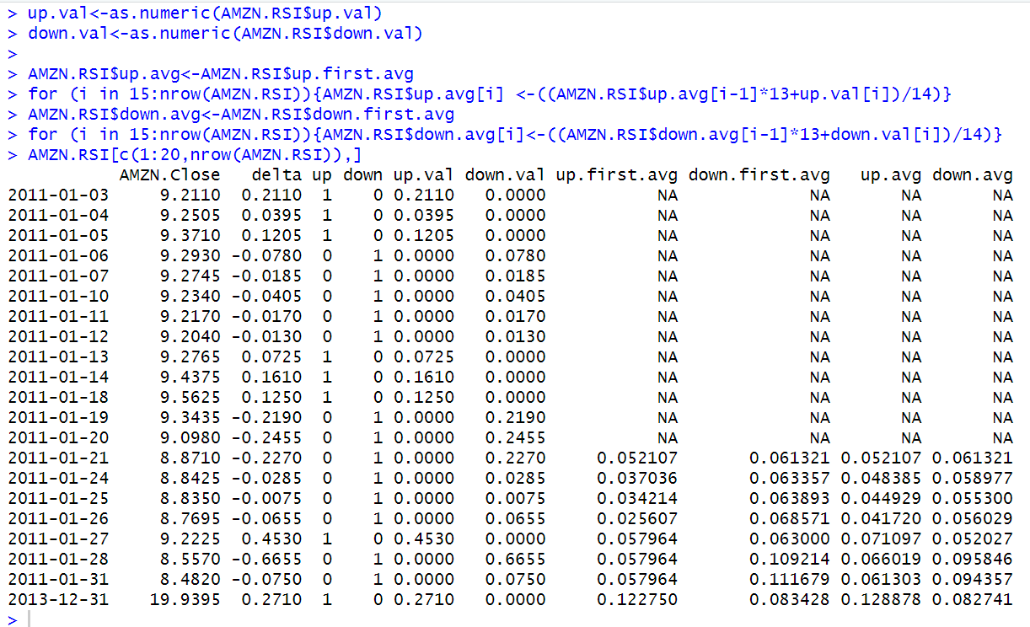

Step 6: Calculate the RSI

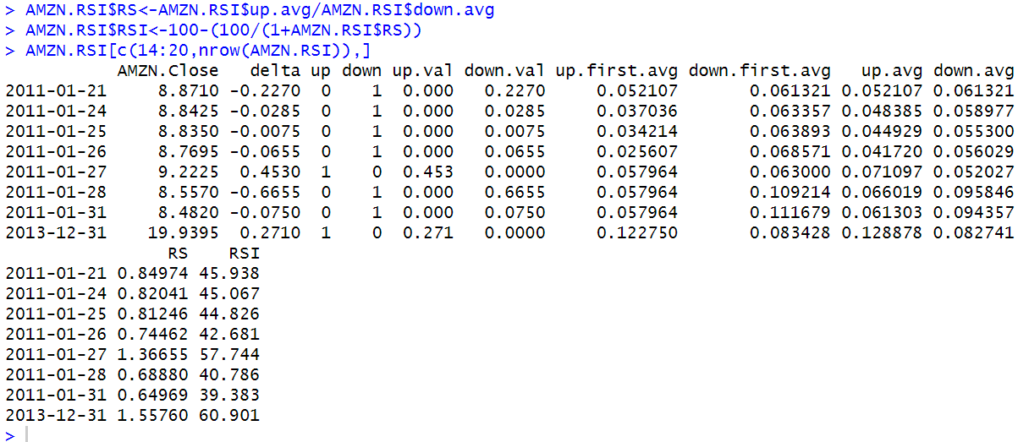

Step 7: Subset to Show Only 2012 and 2013 Data

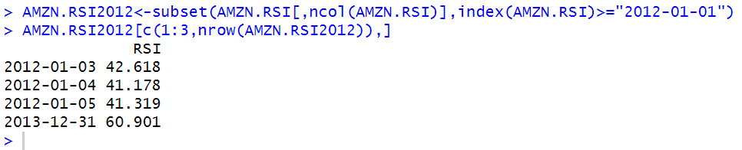

Step 8: Plot the RSI

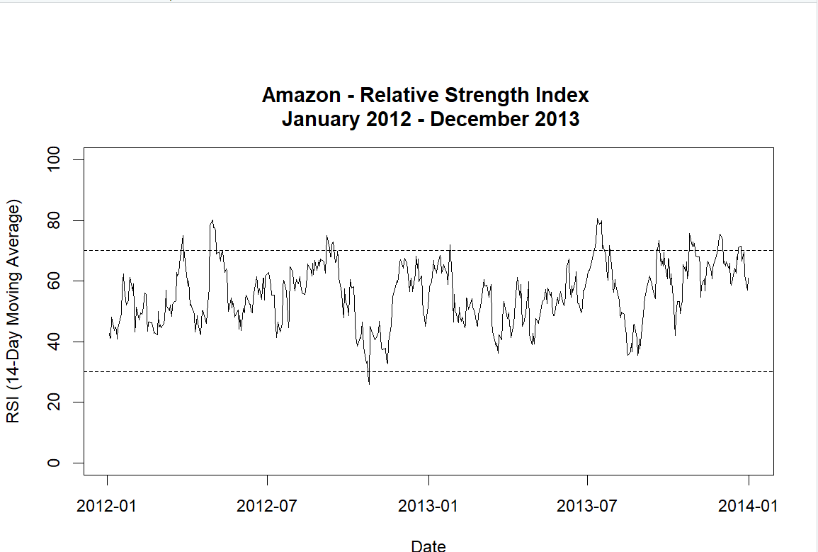

Figure shows that around April, May, and September 2012 and July 2013, a buy indication for Amazon.com may have been made as the RSI was above 70 and crossed below 70 during those periods. In contrast, around November 2012, the RSI was below 30 and crossed above 30 during that period, which could be taken as a sell signal.

### 1.7 Further Reading

The technical analysis charts above can be recreated using chartSeries. For example, the 50-day and 200-day moving average example above can be replicated by:

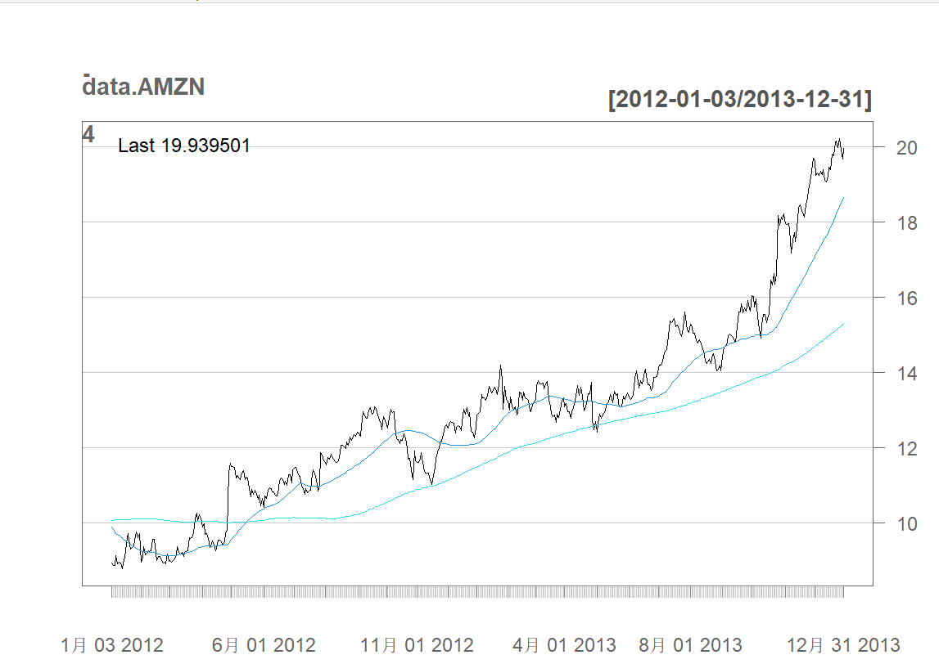

## Chapter 2 Individual Security Returns

It is reasonable to assume that percentage returns are more vital than absolute incomes because absolute incomes don’t show the relevant arising improvement of returns but only shows an absolute value.

For example, 500$ means different compared to 5,000$ or 50,000$, but absolute return only depicts the value of 500$.

Total return is a measure of the return we receive over the entire time we hold the security, this type of return is also known as the holding period return. When necessary to make the distinction, we will call the return without the cash flow yield price return.

We begin this chapter by showing how to calculate price returns and total returns. Then, for statistical and programming considerations, we will show how to calculate logarithmic total returns.

We then show how to cumulate daily returns into multi-day returns using both the arithmetic (i.e., non-logarithmic) returns and logarithmic returns.

We then show that for dividend paying stocks, the total return over a long period of time can be much higher than the price return over the same period.

### 2.1 Price Returns

The daily price return is the percentage change in the price of a security today relative to its price yesterday. That is,

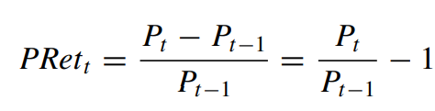

where PRett is the price return on day t, Pt is the price of the security on day t, and Pt−1 is the price of the security the trading day before.

Step 1: Import IBM Data from Yahoo Finance

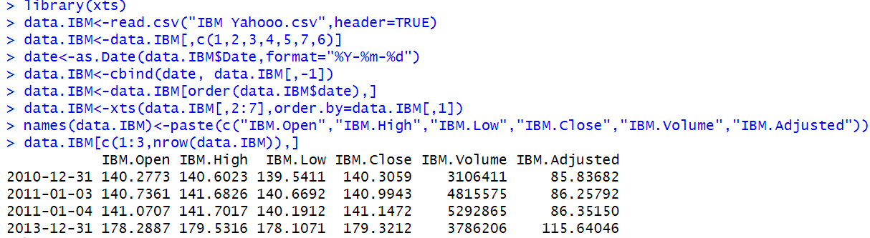

Step 2: Subset the Data to Only Include the Closing Price

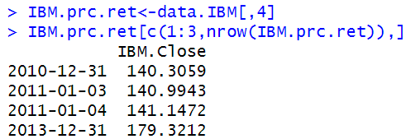

Step 3: Calculate IBM’s Price Return

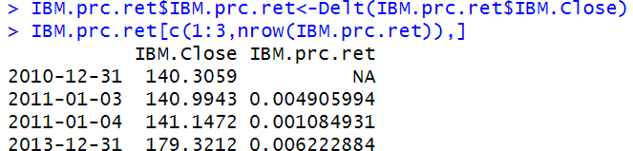

Step 4: Clean up Data Object

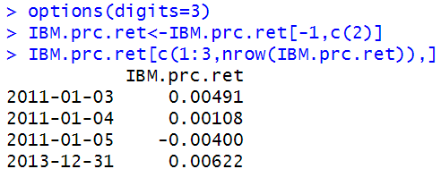

### 2.2 Total Returns

The total return a shareholder can receive from a stock that pays dividends includes both the change in the price of the shares she owns as well as any income generated from the dividends and the reinvestment of those dividends on the ex-date. This is known as the holding period return or total return.

The total return from holding a security is calculated as follows:

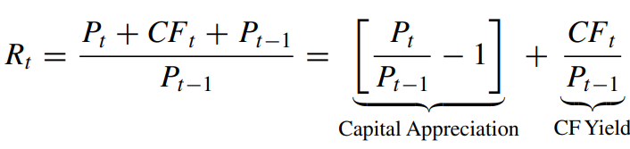

Where CFt is the cash flow (e.g., dividend) payment on day t.

Continuing from our IBM example from the previous section, we now calculate IBM’s total returns from January 2011 to December 2013. As of the writing of this book, the last time IBM declared dividends was on October 29, 2013, which was payable on December 10, 2013. However, the important dividend date for calculating returns is the ex-dividend date or the ex-date, which was on November 6, 2013. The ex-date means that IBM shares will be trading without the dividend beginning on November 6, 2013, such that those who purchase IBM shares on November 6, 2013 and after would not be entitled to the dividend declared on October 29, 2013. The output below shows that the closing price and adjusted closing price for IBM on or after November 6, 2013 are the same, but those two variables have different values prior to November 6, 2013.

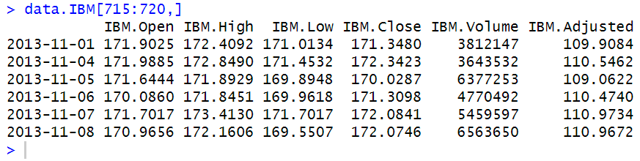

Step 1: Import Adjusted Closing Price Data

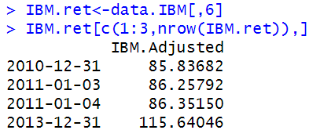

Step 2: Calculate Total Return

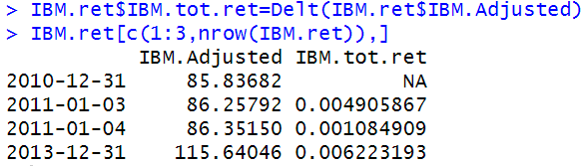

Step 3: Clean up the Data

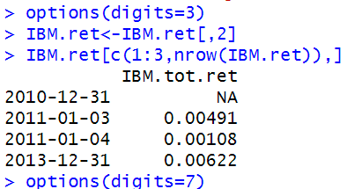

### 2.3 Logarithmic Total Returns

The logarithmic return, $r_{t}$, is calculated as

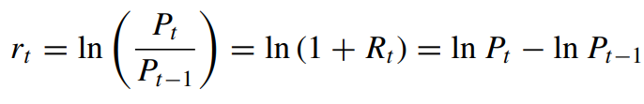

Where ln is the natural logarithm operator and the rest of the variables are defined the same.

Therefore, we can take the difference of the log prices to calculate log returns.

Step 1: Import Adjusted Closing Price Data

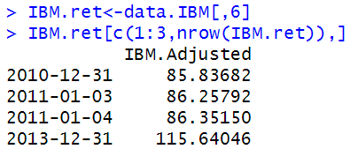

Step 2: Calculate Log Returns

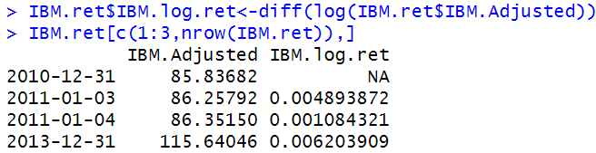

Step 3: Clean up the Data

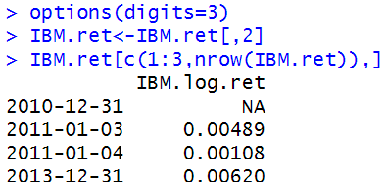

Compare Log Returns with Arithmetic Returns

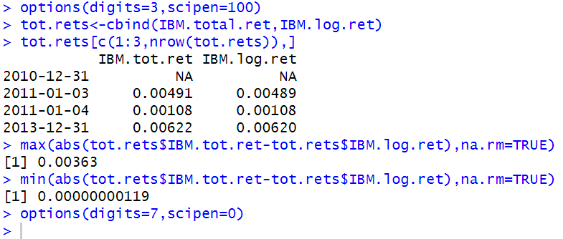

### 2.4 Cumulating Multi-Day Returns

To fully capture the effects of being able to reinvest dividends, we should calculate daily returns and string those returns together for longer periods. Otherwise, if we simply apply Eq. (2.2) using prices at the beginning and end of the investment horizon and add the dividend, we are assuming that the dividends are received at the end of the period and no additional returns on those dividends are earned.

In other words, when we receive the dividend, we would reinvest that amount back into the stock. The returns of that stock going forward determines whether the reinvested dividend earned a positive or negative return.

Suppose we are interested in knowing how much would an investment in Amazon have made through the end of 2013 if we purchased AMZN shares at the closing price on December 31, 2010.

We show how to implement this calculation using arithmetic returns and logarithmic returns, and show that, when consistently implemented, both types of returns yield the same result.

However, some may find the programming for logarithmic returns slightly easier.

#### 2.4.1 Cumulating Arithmetic Returns

To string together multiple days of arithmetic returns, we have to take the product of the daily gross returns.

We can generalize this calculation over a T -day investment horizon as:



Step 1: Import Data and Calculate Arithmetic Returns

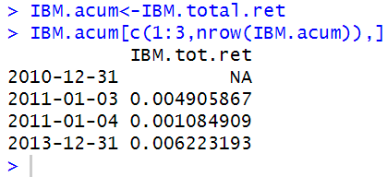

Step 2: Set First Day Total Return Value to Zero

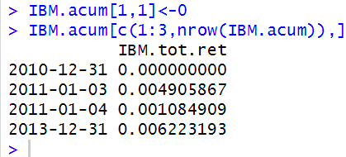

Step 3: Calculate Gross Daily Returns

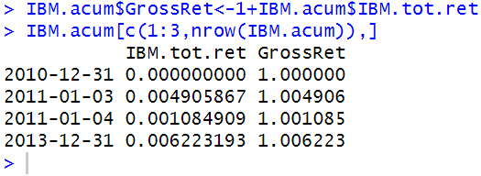

Step 4: Calculate Cumulative Gross Returns

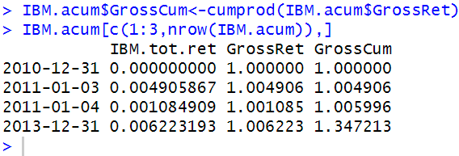

Step 5: Convert Cumulative Gross Returns to Cumulative Net Returns

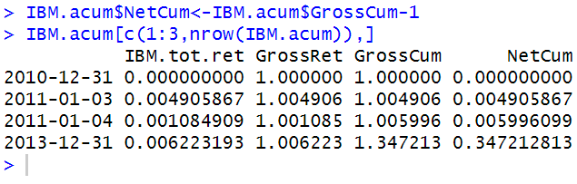

#### 2.4.2 Cumulating Logarithmic Returns

An alternative way to calculate multi-period returns is to take the sum of the daily logarithmic returns. That is,

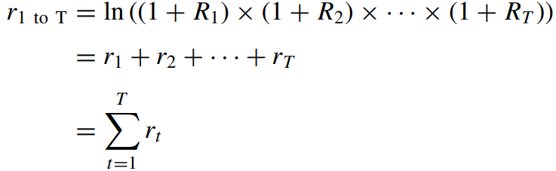

Step 1: Import Data and Calculate Logarithmic Returns

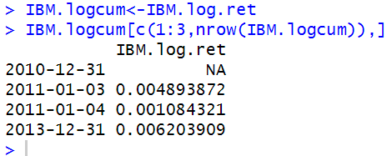

Step 2: Set the First Log Return to Zero

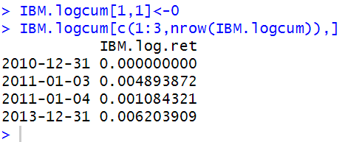

Step 3: Take the Sum of all Logarithmic Returns During the Investment Period

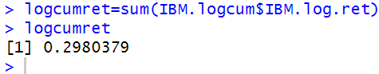

Step 4: Convert Log Return Back to Arithmetic Return

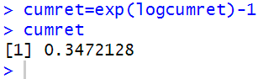

We can see that it takes fewer and simpler steps to calculate multi-period returns using logarithmic returns than it is using arithmetic returns.

#### 2.4.3 Comparing Price Return and Total Return

Step 1: Import Data and Calculate Price and Total Returns

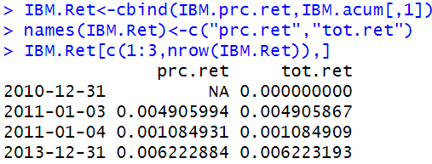

Step 2: Set First Returns to Zero

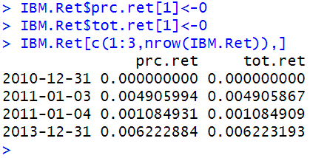

Step 3: Calculate Gross Returns

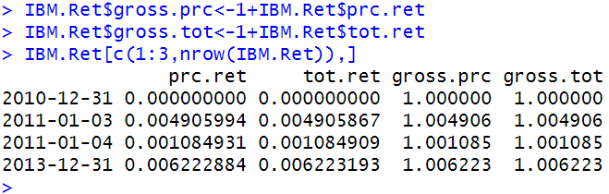

Step 4: Cumulate the Gross Returns

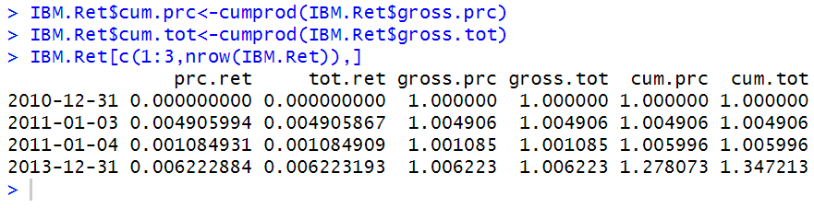

Step 5: Plot the Two Return Series

We then plot the cum.prc and cum.tot variables. We first plot the cum.tot variable, and then plot the cum.prc variable. Using the abline command, we add a horizontal line at $ 1 to make it easy for us to interpret whether the investment is making money or losing money.

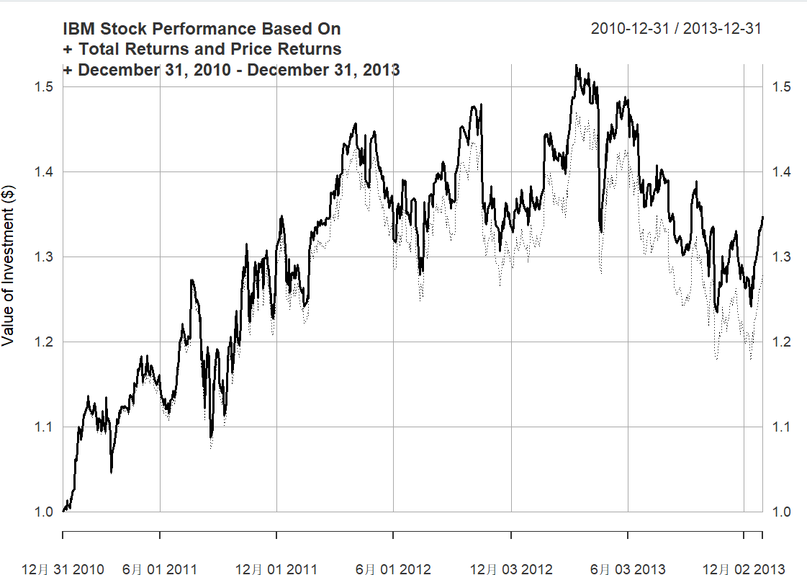

### 2.5 Weekly Returns

In the previous sections, we used daily returns. However, there are applications in which we may have to use returns of lower frequency, such as weekly returns. In this section, we will revert back to using AMZN stock data.

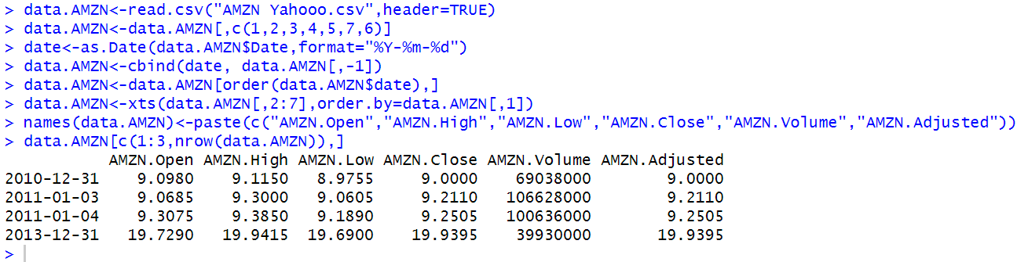

Show the class of “data.AMZN”:

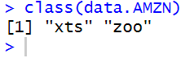

Step 1: Import Data into R

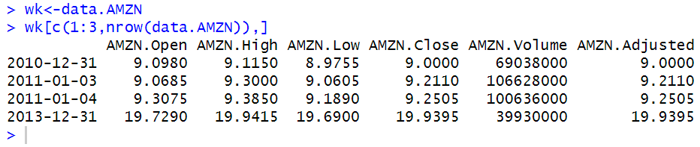

Step 2: Convert to Daily Data to Weekly Data

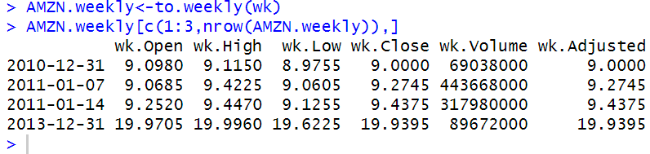

Step 3: Clean up Weekly Data to Keep Only the Adjusted Closing Prices at the End of Each Week

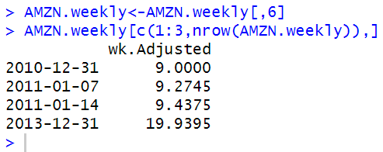

Step 4: Calculate Weekly Returns

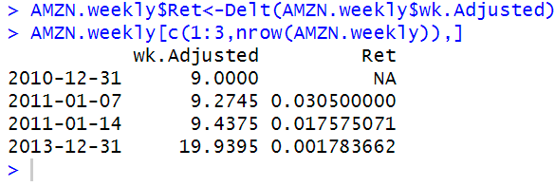

Step 5: Cleanup Weekly Returns Data by Deleting the First Observation

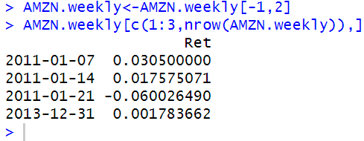

### 2.6 Monthly Returns

Step 1: Import Data into R

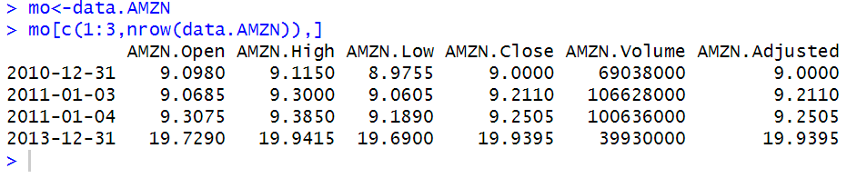

Step 2: Convert Daily Data to Monthly Data.

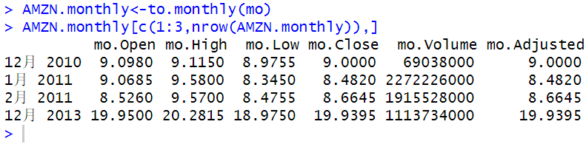

Step 3: Clean up Data to Include Only Adjusted Closing Prices for the End of Each Month

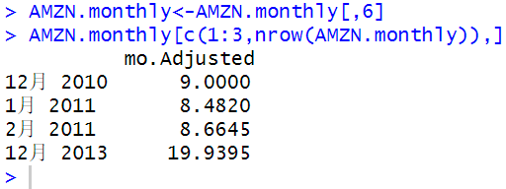

Step 4: Calculate Monthly Returns

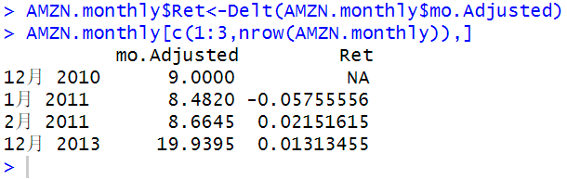

Step 5: Cleanup Monthly Data Object

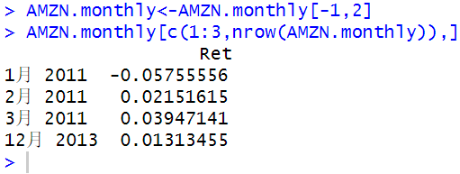

### 2.7 Comparing Performance of Multiple Securities: Total Returns

AMZN and YHOO have not paid dividends, but IBM has. The S&P 500 Index data we use does not include dividends. Therefore, the index value for AMZN, YHOO, and GSPC would be the same regardless of whether we use price returns or total returns. However, for IBM, the index value using total returns will be higher than the index value using price returns.

Step 1: Importing Price Data

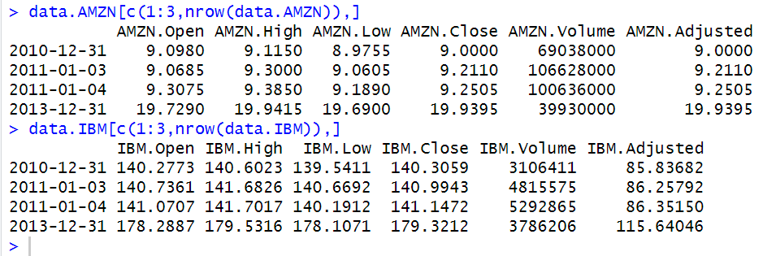

Now import another two securities.

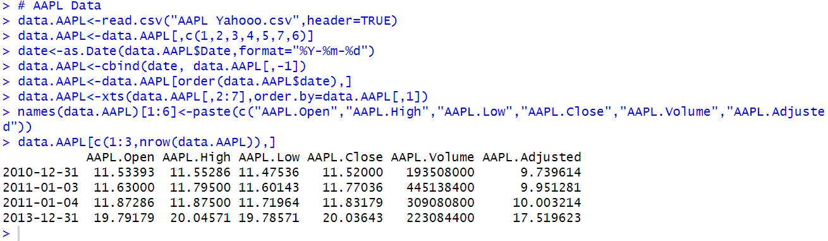

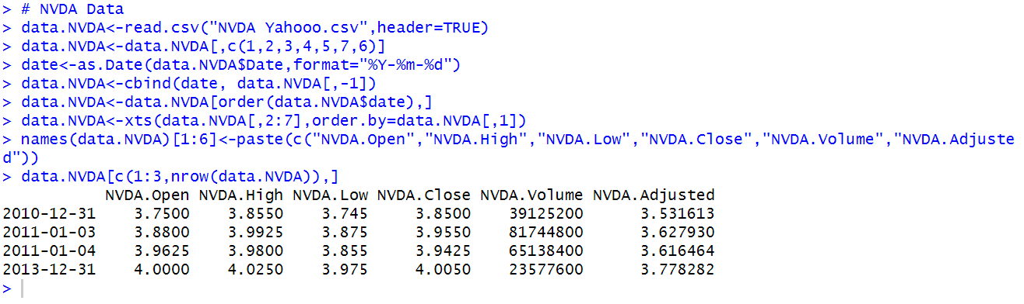

Step 2: Combine Data

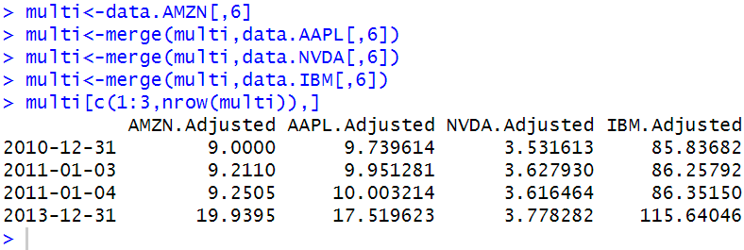

Step 3: Converting Data into a data.frame Object

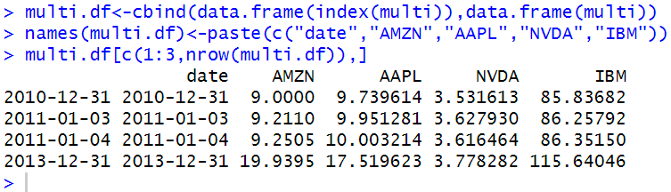

Step 4: Constructing Normalized Values for Each Security

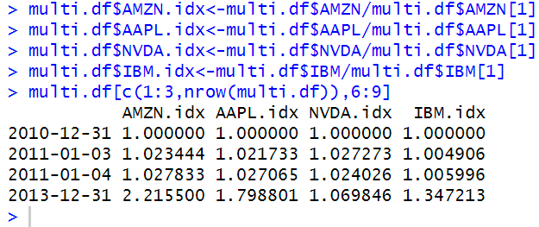

Step 5: Plotting the Index Values of Each Security

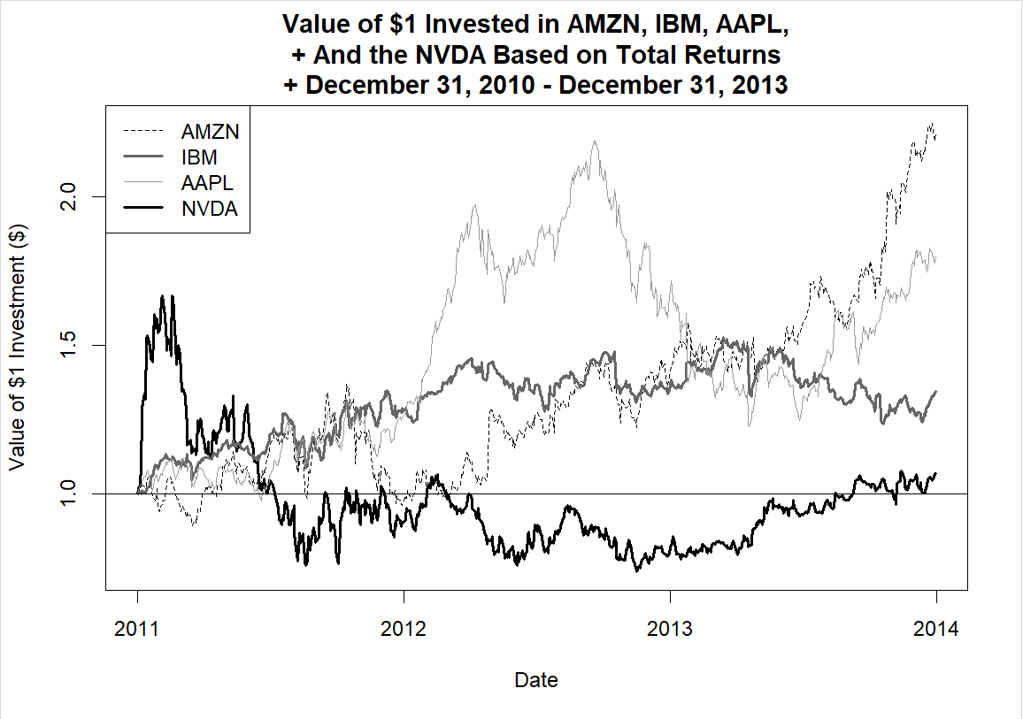

We can see from this graph that AMZN outperformed other three securities with a total return of approximately 120%, whereas the total return of NVDA nearly approaches 0. Generally, Internet Company like Apple and Amazon perform better from 2011-2013.

## Chapter 3 Portfolio Returns

Portfolio returns represent a combination of different securities as the investment of a specific stock market investor calculated as the weighted average, where the weight of each security is referred to the amount of money allocated to each security regarding to the overall investment.

Two approaches are presented here for calculation of Portfolio Returns. The first one is called long way where every detailed step is demonstrated which in later would be used when assessing mean-variance optimization across multiple securities.

The second one is called Benchmark Portfolio Returns, which are returns of a hypothetical portfolio that we can exploit to compare the performance of our portfolio, where we either use an equal-weighted portfolio or a value-weighted portfolio with quarterly rebalancing.

As the literal meaning, an equal-weighted portfolio redistributes the overall value to all the basketed securities within the equal weight on each rebalancing date.

Whereas the total value of all the basketed securities is redistributed based on the capitalization of each security on the market, namely larger firms get bigger share of the pie.

But whatever the weighting method we are using, the weight of each security in the basket is allowed to freely change based on their performance.

### Constructing Portfolio Returns (Long Way)

Namely, the portfolio return is the weighted-average of individual returns for each selected security in the investor’s basket, where the weights are calculated as the percentage occupations of different securities compared to the total volume in the basket.

That is, for a two-asset portfolio, we have

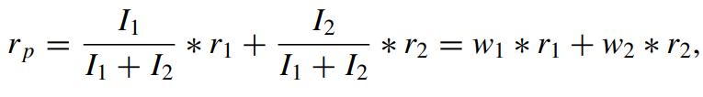

where $r_{p}$ is the portfolio return, $I_{1}$ is the dollar amount invested in security 1, $I_{2}$ is the dollar amount invested in security 2, $r_{1}$ is the return of security 1, $r_{2}$ is the return of security 2.

we can then simplify the percentage invested in security 1 as weight 1 and denote it by $w_{1}$ and we can simplify the percentage invested in security 2 as weight 2 and denote it by $w_{2}$.

We can then extend this 2-asset portfolio return calculation into multiple assets.

That is,

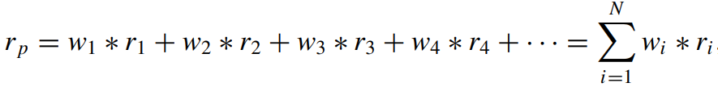

Where the summation is done over the weighted-returns of each of the N assets in the portfolio.

In the case that we have cashes in the portfolio, we could still assign a weight as well as an individual return for the cashes, where the return could be short-term interest rate of money fund.

Note that the summarized percentage should still be 100% even cashes are allowed in the portfolio.

Now our assumption is that $50,000 in AMZN, $10,000 in AAPL, $30,000 in NVDA and $10,000 in IBM.

How much would our portfolio return be as of December 31, 2013 if we made the investment in those securities on December 31, 2010?

Step 1: Find First and Last Adjusted Closing Price for Each Security Over the Investment Period

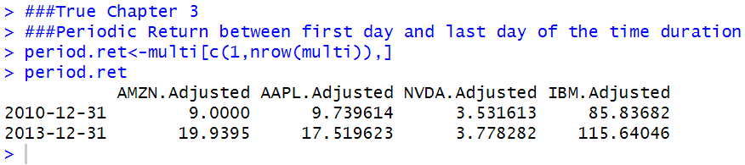

Step 2: Calculate Returns for Each Security Over the Investment Period

To apply the Delt command to all four securities, we can use the lapply command. The lapply command applies a function to each of the variables in the data object. In this case, we are applying Delt to each variable. The output below shows that we get the net total return for each security in a list object.

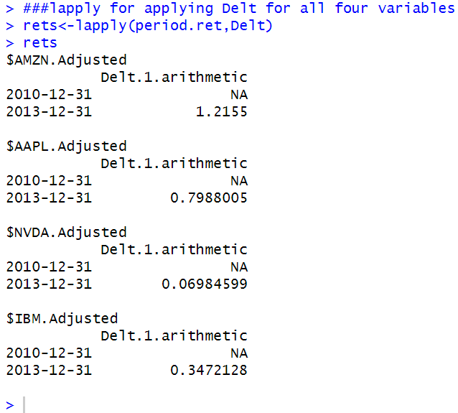

Step 3: Convert to a data.frame and Cleanup Data

Since the returns data is in a list object, we have to convert it to a data.frame to continue with our calculations. We convert rets into a data frame using the data.frame command.

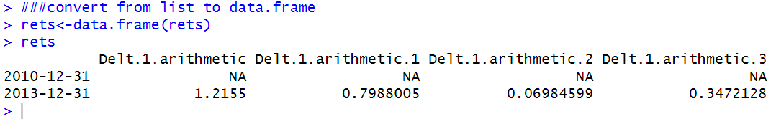

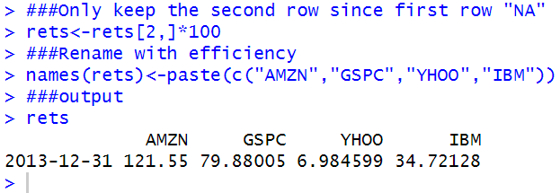

Step 4: Calculate Weight of Each Security in the Portfolio

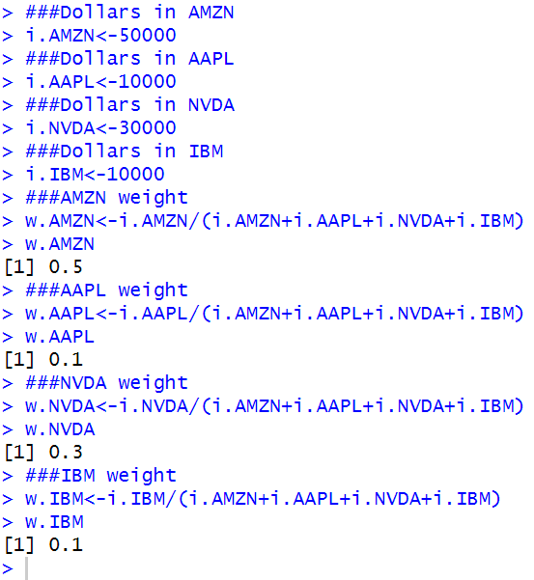

Step 5: Calculate Portfolio Return

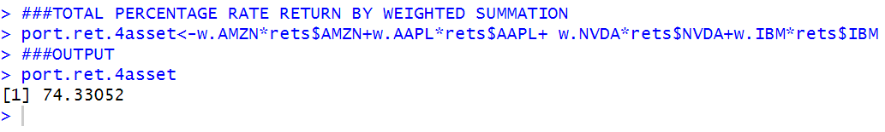

### Constructing Portfolio Returns (Matrix Algebra)

A convenient way to calculate portfolio returns when there are many securities in the portfolio is to use matrix algebra.

To implement this, we have to calculate two vectors, where a vector can be thought of as a series of numbers organized as either a row or a column.

The first is a vector of weights, which in this case is 50 % for AMZN, 10 % for AAPL, 30 % for NVDA, and 10 % for IBM.

The second is a column vector of returns.

We can now calculate the portfolio return by multiplying the row vector of weights by the column vector of returns using the matrix multiplication operator %*%.

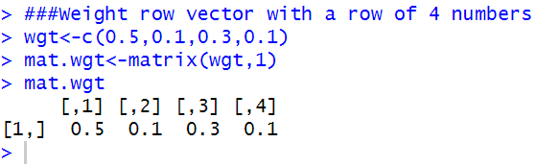

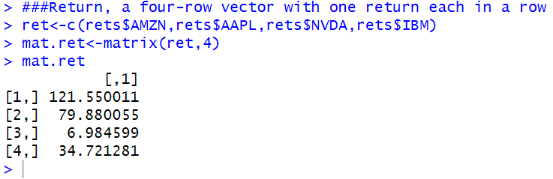

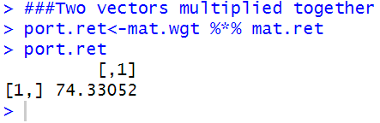

### Constructing Benchmark Portfolio Returns

To determine whether our investment is performing well, we compare the returns of our investment to that of a benchmark.

Typically, some indices of comparable securities are used as the benchmark. Some benchmarks are readily-available (e.g., S&P 500 Index for large capitalization stocks). Alternatively, benchmarks can be constructed.

In this section, we demonstrate how to construct an equal-weighted (EW) index and value-weighted (VW) index.

Step 1: Importing the Price Data

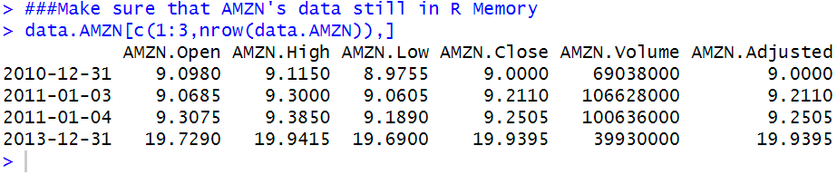

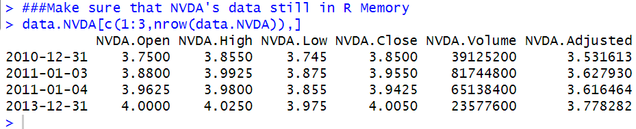

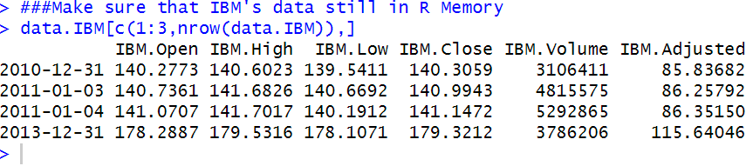

Step 2: Create Object with Only the Relevant Data

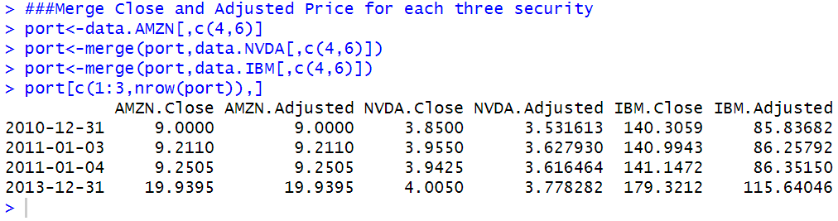

Step 3: Calculate Returns of Each Security

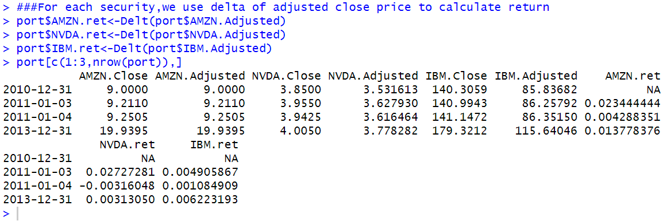

Step 4: Convert to data.frame Object and Subset Data

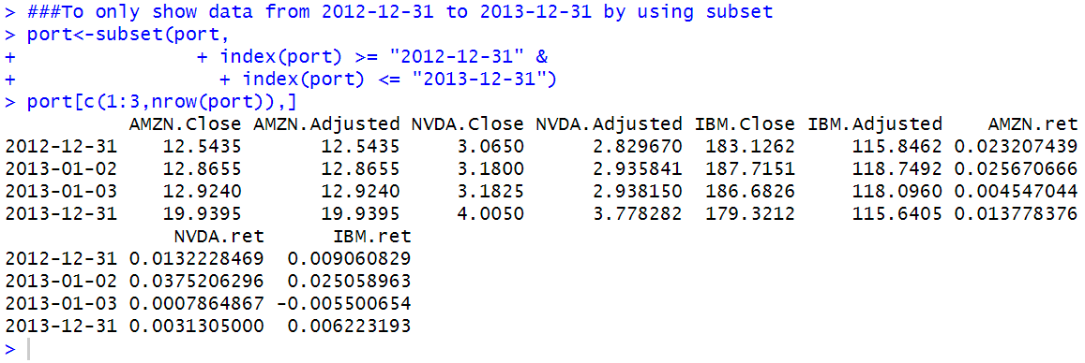

Here I must point out that I think the code and output is not efficient considering what it did regarding to the use of the data.frame object. If the port data is converted into the data.frame object, then “port$date” will also be a data.frame object, which function well when you use the line of the code:

port$date >= “2012-12-31”

But it is inefficient since such output could also be achieved using xts but not converted to data.frame object, only use the following code to substitute above,

index (port) >= “2012-12-31”

I have to say the following codes are too cumbersome.

And you could see the initial code and output generated by myself.

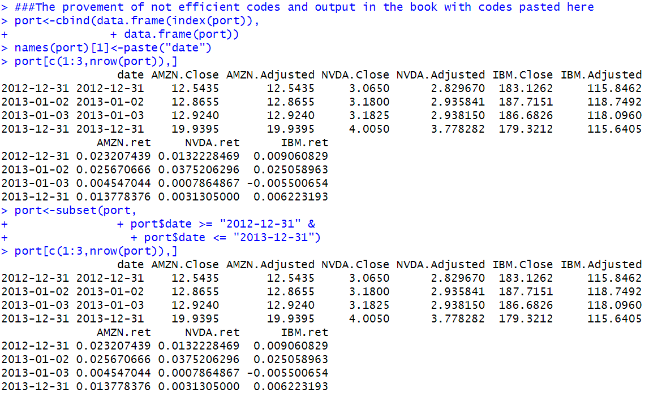

We now turn to discussing the specific steps used to construct an EW portfolio and a VW portfolio.

#### Equal-Weighted Portfolio

An equal-weighted (EW) index gives equal weight to small firms and large firms. As such, an EW index is sometimes considered as an approach to capture the small capitalization stock premium (i.e., the belief that small capitalization stocks yield higher returns over large capitalization stocks).

These indexes are rebalanced quarterly, which means that in between quarters the constituent weights are allowed to fluctuate based on their performance. We follow this quarterly rebalancing approach.

#### Quarterly Rebalancing Explained

The quarterly rebalancing approach means that on each rebalancing date, the weight of each firm is set or reset to 1/N where N is the number of securities in the portfolio. For example, if we have 3 firms in our portfolio and $ 1000 to invest, each firm will be allocated $ 333.33 [= $ 1000/3] or 33.33 % of the portfolio value. Subsequent to this date, each $ 333.33 investment would be allowed to grow at the returns of that security. Then, on each rebalancing date, if we have the same number of firms, we will allocate 33.33 % of the portfolio’s then-existing value to each firm. For example, if the aggregate portfolio value as of March 31, 2013 was $ 1500, then each of the three firms would then be allocated $ 500 [=$ 1500 / 3]. Suppose that Stock 1 had a value of $ 200, Stock 2 had a value of $ 500, and Stock 3 had a value of $ 800 at quarter end. Then, this means we would have to sell $ 300 of Stock 3 and purchase $ 300 of Stock 1. That way, each of the three stocks in the portfolio would have an investment of $ 500 after rebalancing.

We now turn to the mechanics of constructing an EW portfolio.

Step 1: Keep Only Variables We Need to Construct EW Portfolio

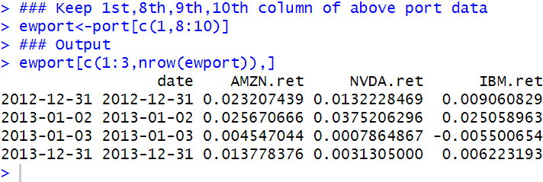

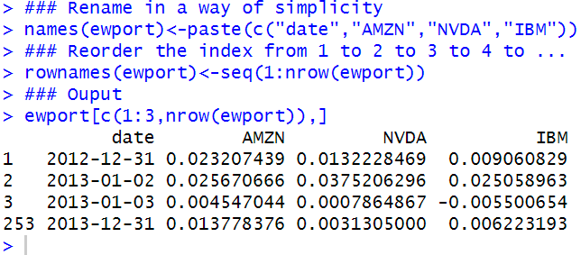

Step 2: Converting Net Returns to Gross Returns

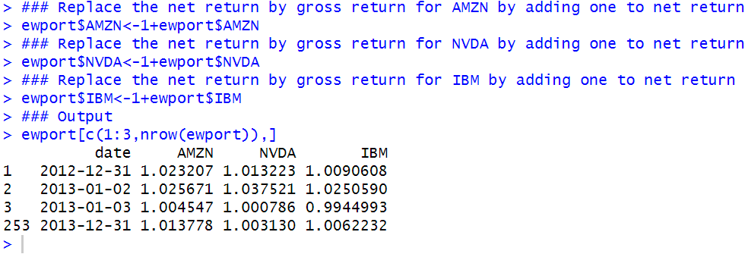

Step 3: Calculate EW Portfolio Values for 1Q 2013

The reason why we would want to include December 31, 2012 is because, when we want to determine how much we made based on the returns in 2013, we are implicitly making the assumption that the investment was made at the closing price on the last trading day of 2012 (i.e., December 31, 2012).

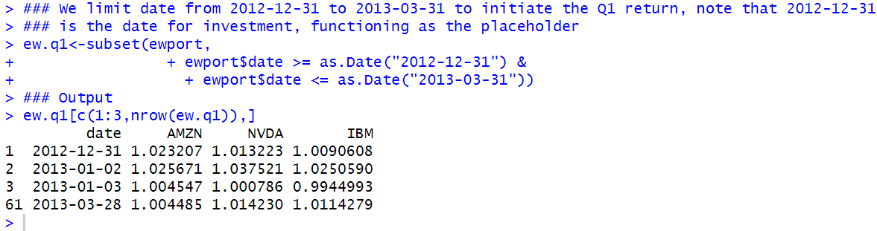

Although we need December 31, 2012, we are not interested in the return on that date. Our main interest for December 31, 2012 is for a placeholder to begin our indexing of each security’s investment performance to $ 1.

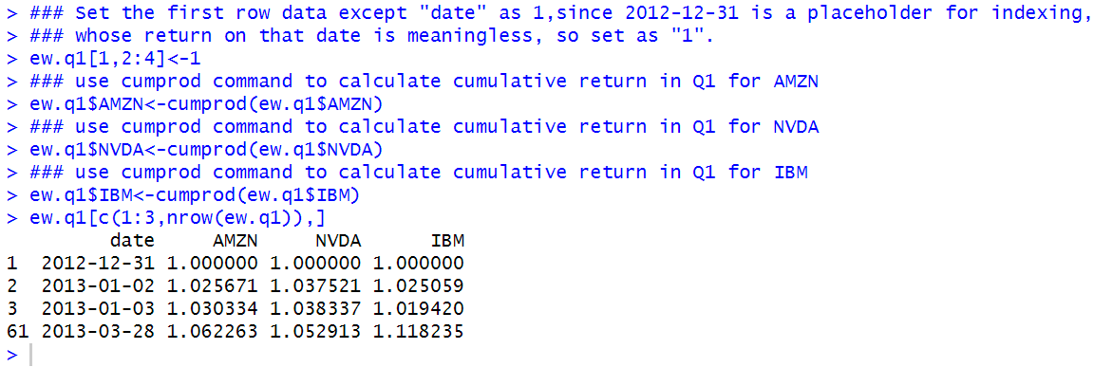

Construct a variable to denote the number of securities in our portfolio.

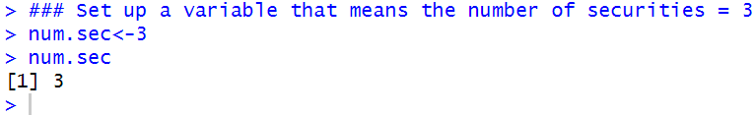

Since in our example each stock has 33 % of the portfolio value, we multiply the cumulative gross returns of each security by 33 % or 1/num.sec to get the index value for each security during the quarter. The variables that hold the index values have a suffix of idx.

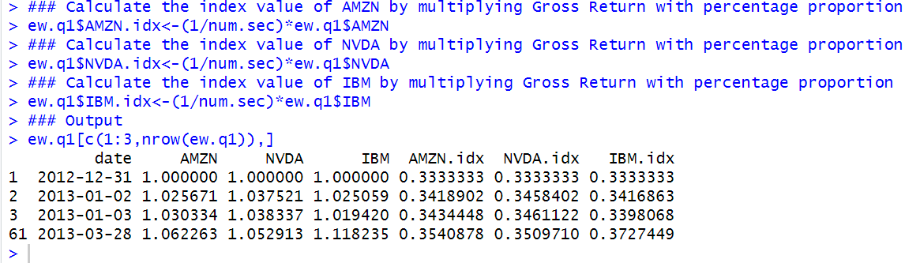

To calculate the value of the EW portfolio on each day, we sum the values of the three index variables.

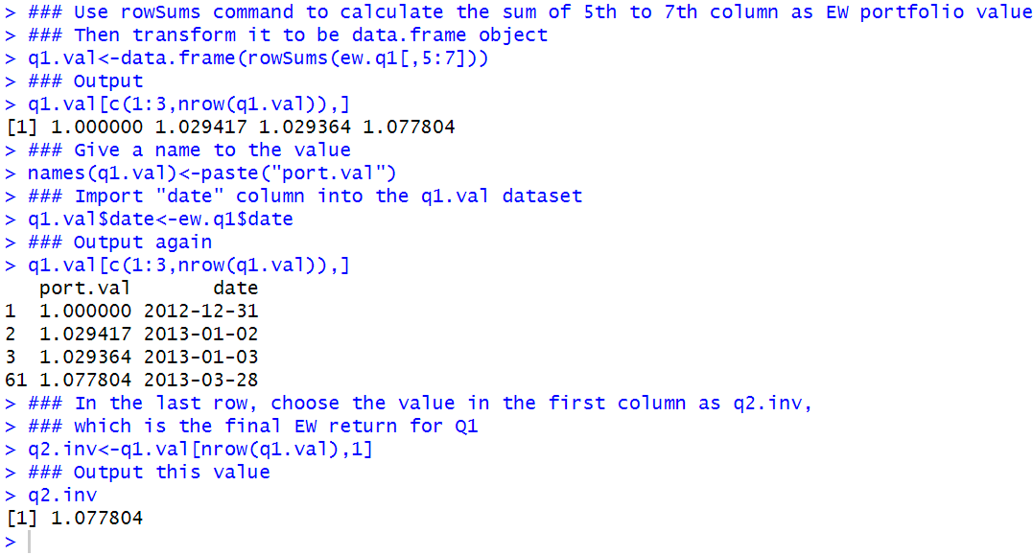

“q2.inv” will be redistributed equally among the three stocks at the beginning of the second quarter. As such, we will use q2.inv value of $ 1.121 in the second quarter calculations as the starting investment value instead of $ 1.

Step 4: Calculate EW Portfolio Values for 2Q 2013 (which is quite similar to above Q1 situation)

Note that the following two screenshots are very similar to the codes above, because we implement the same technical analysis method here.

Well, it should note that I still write comment for each step of codes one by one to let you understand what the R is doing here for computing and calculating.

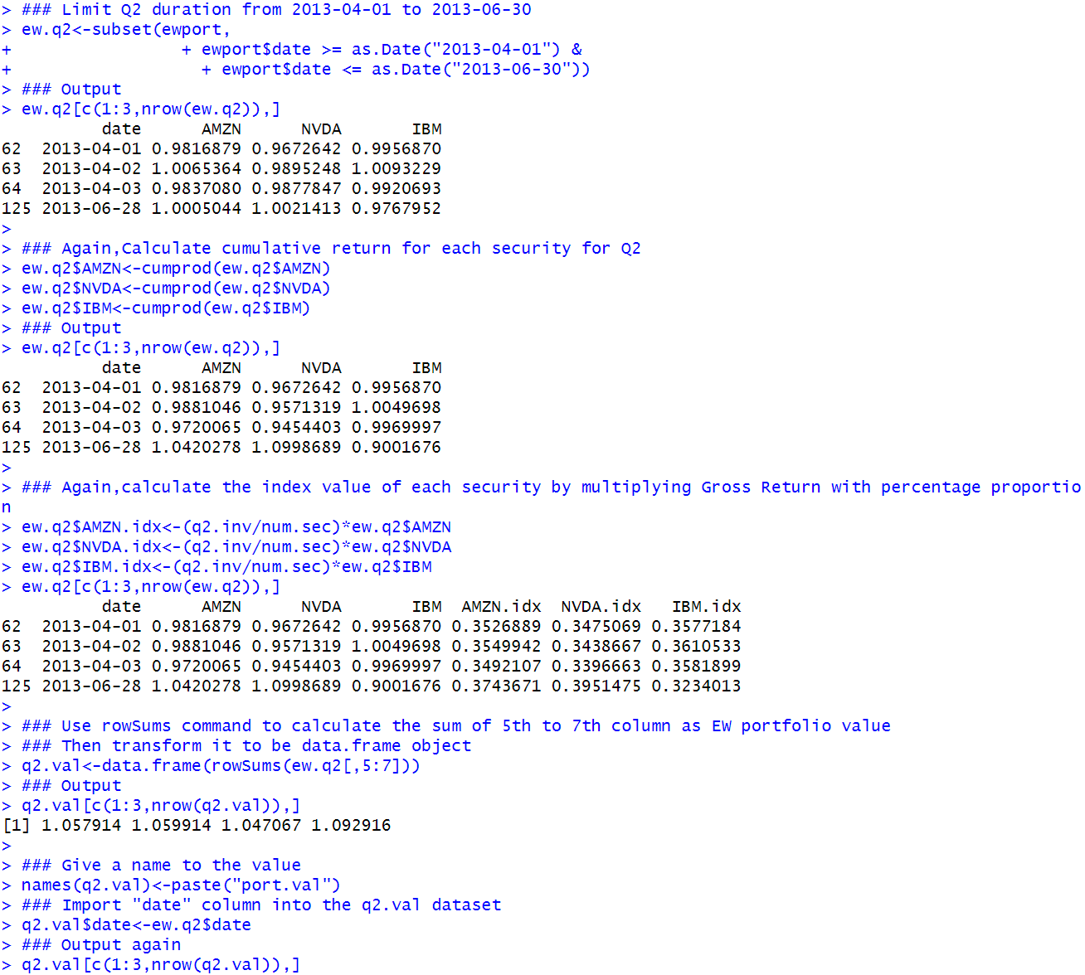

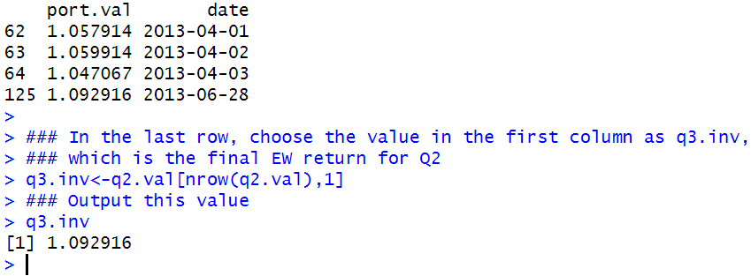

Step 5: Calculate EW Portfolio Values for 3Q 2013

Again, we repeat what we did in step 4.

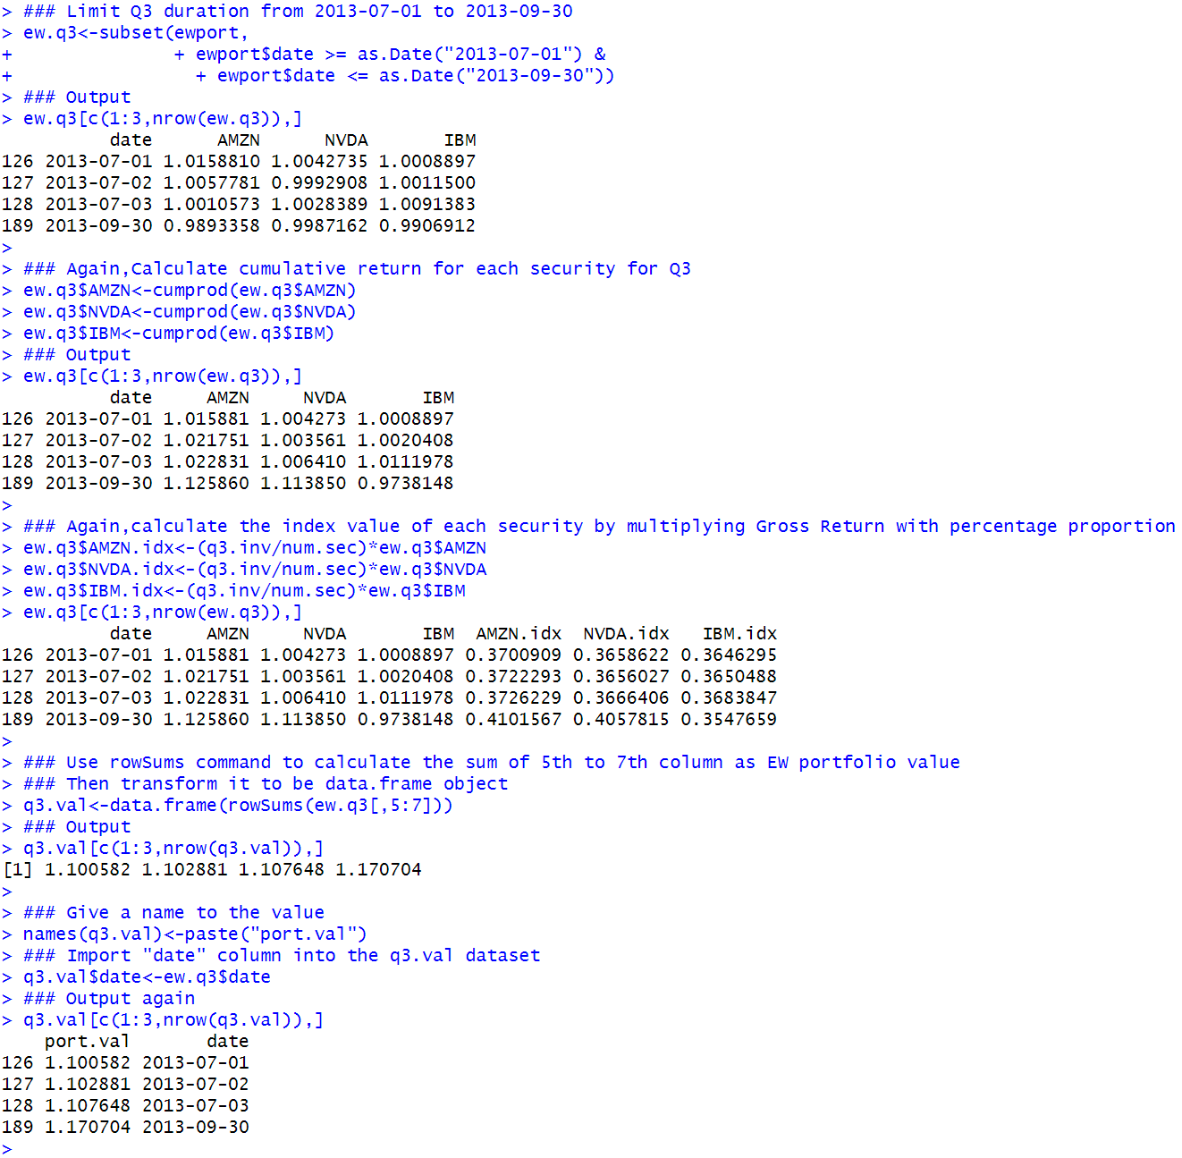

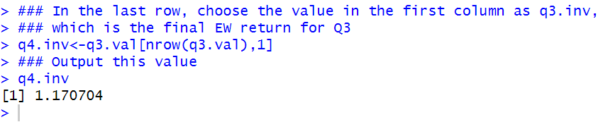

Step 6: Calculate EW Portfolio Values for 4Q 2013

Again, we repeat what we did in step 5.

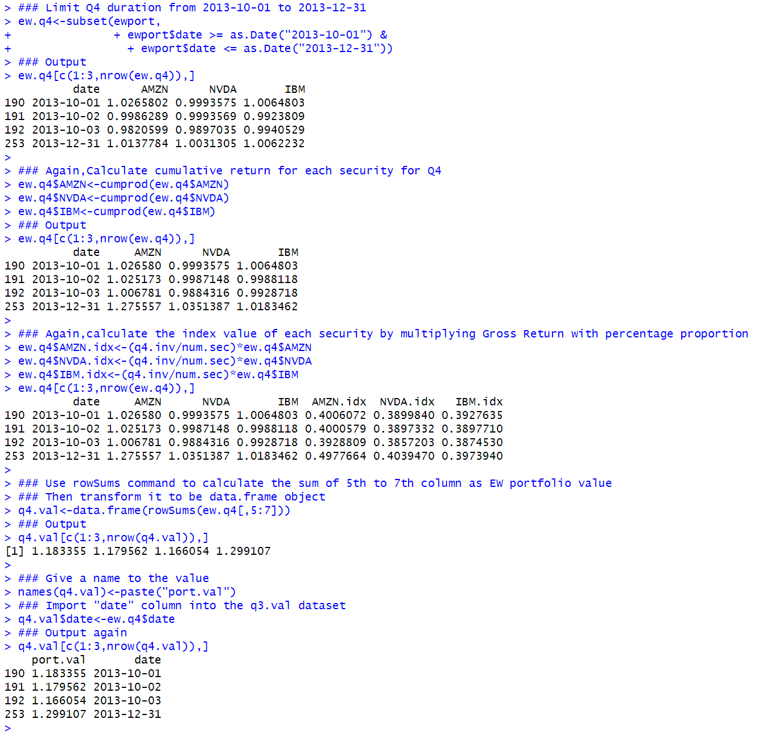

Step 7: Combine Quarterly EW Portfolio Values into One Data Object

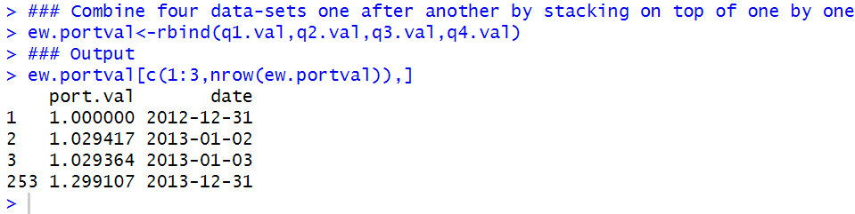

Quarterly rebalancing makes more practical sense as we incur transactions costs only during the rebalancing dates. This makes the use of this EW portfolio more suitable as a benchmark because it is realistically implementable

#### 3.3.2 Value-Weighted Portfolio

Value-weighted returns are also called capitalization-weighted returns.

In a VW portfolio, the returns of larger firms are given more weight.

In the context of say a VW sector index, one can think of capitalization-weighting as an approach to tracking the changes in the size of that sector.

A value-weighted return $r_{vw}$ is constructed as follows:

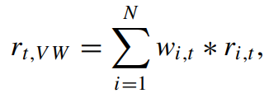

where $w_{i,t}$ is the weight of security i at time t and $r_{i,t}$ is the return of asset i and time t.

For our purposes, the weight of security i is equal to the market capitalization of security i divided by the market capitalization of all securities in the portfolio.

If we use the market capitalization on day t as the weights for day t return, we are assuming perfect foresight as to what the end-of day return would be.

Step 1: Keep Only Variables We Need to Construct VW Portfolio

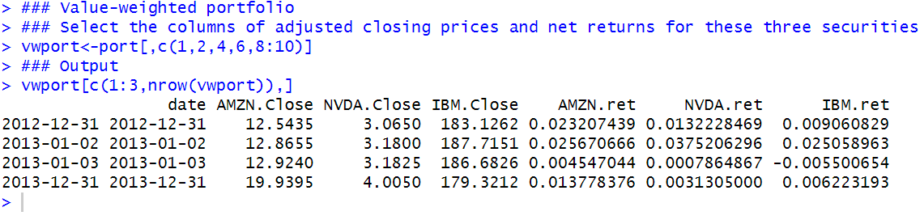

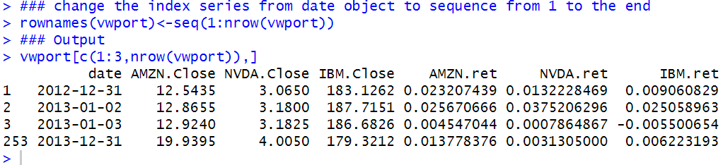

Step 2: Converting Net Returns to Gross Returns

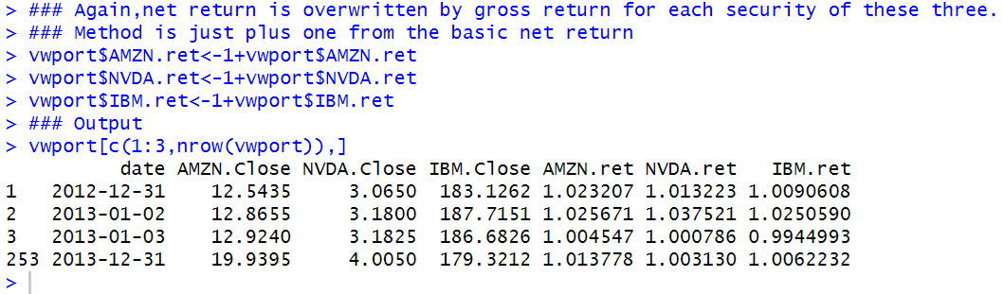

Step 3: Calculate the Market Capitalization of Each Security in the Portfolio

Now, we have to construct the market capitalization weights for each security at the end of each quarter.

A security’s market cap is equal to its price multiplied by its shares outstanding.

As such, we need to get the data for those two components.

Let us first discuss how to find the price that is applicable at the end of each quarter.

**Construct Series of Calendar Days**

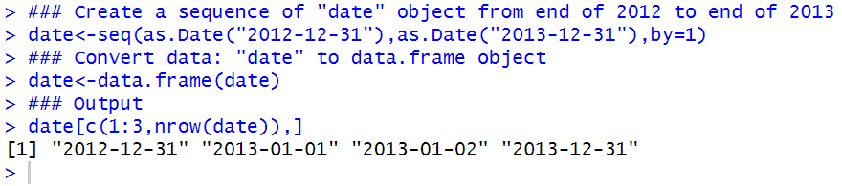

**Create Data Object with Daily Prices, Filling in Last Available Price on Non-trading Days**

We extract the price data first

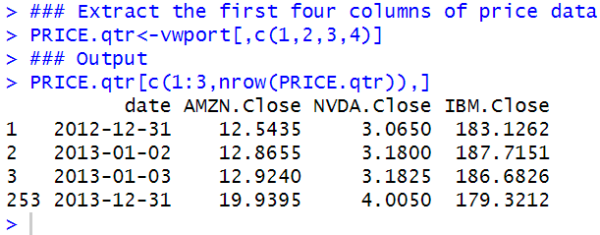

We then merge date and PRICE.qtr using a combination of the na.locf and merge commands.

The merge command combines the two data objects. Using the all.x=TRUE option tells R that when merging we should keep all the data in the “by” variable that is available in x=date data object. The “by” variable in this case is the date.

What the na.locf command does is that it copies over the last available data in y=PRICE.qtr when there is a date in x that is not available in y.

For example, recall that there is no trading on New Year’s Day, January 1, 2013, so the output below shows data on January 1, 2013 which is equal to the closing price on December 31, 2012.

Going forward, any time there is a weekend or trading holiday, the last available value is used.

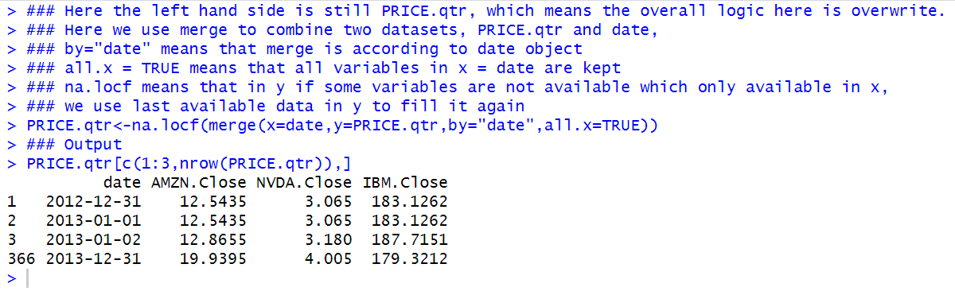

**Keep Only Prices at the End of Each Calendar Quarter**

We do not need data for December 31, 2013 because we are not calculating any returns in the first quarter of 2014.

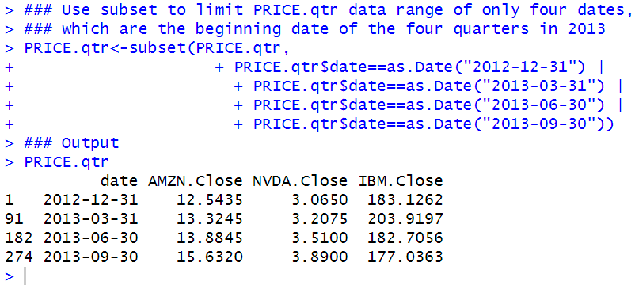

**Obtain Shares Outstanding Data from SEC Filings**

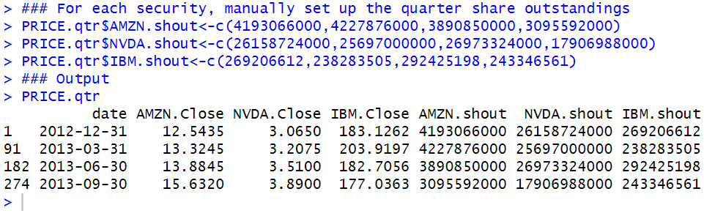

**Calculate Market Capitalization of Each Security**

We first check the structure of the data in PRICE.qtr. We see that the date and closing price variables are read-in as character variables.

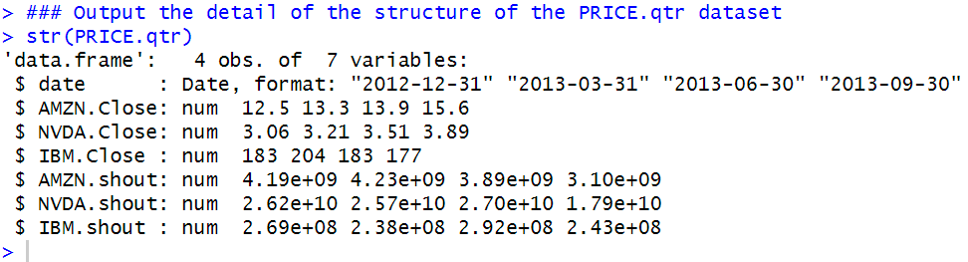

As this is different from the book output, where date and three security closing price is “str” type of data. But here my PRICE.qtr has already been Date format and “num” type. Hence no need to convert according to the book output.

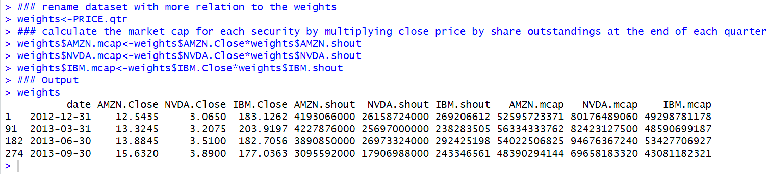

**Calculate Quarter-end Aggregate Market Capitalization**

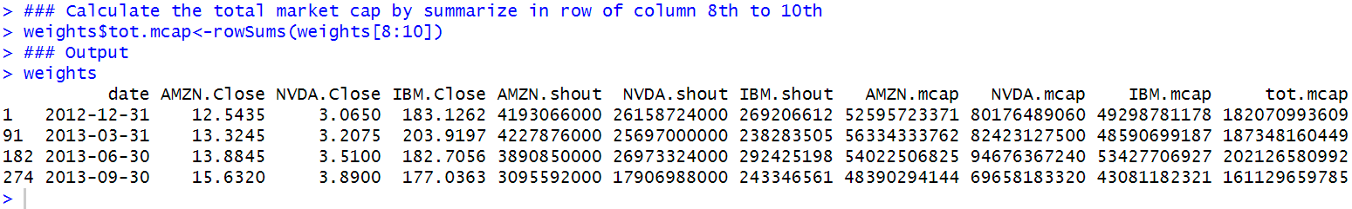

Step 4: Calculate Quarter-end Weights of Each Security in the Portfolio

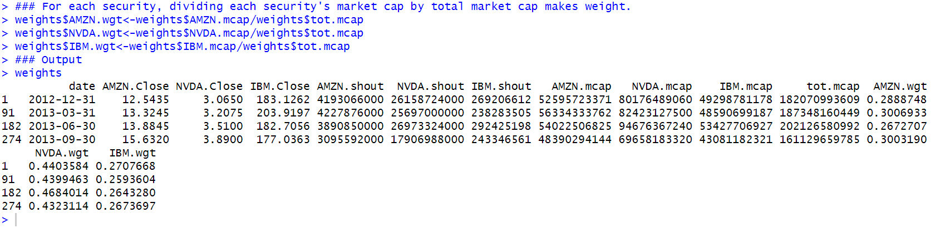

Now we only keep weight data.

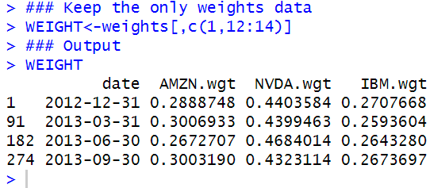

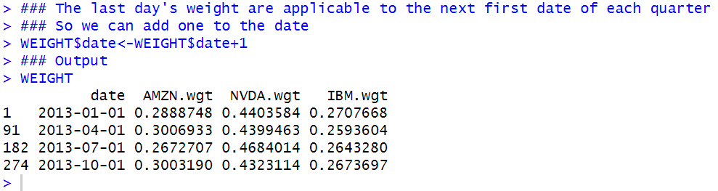

Step 5: Calculating the Quarterly VW Portfolio Values

In the VW portfolio, as shown above, the weights used on the quarterly rebalancing dates are different than that of 33%.

We start with creating a series of dates from December 31, 2012 to December 31, 2013 so that we can find the applicable weights at the beginning of each quarter.

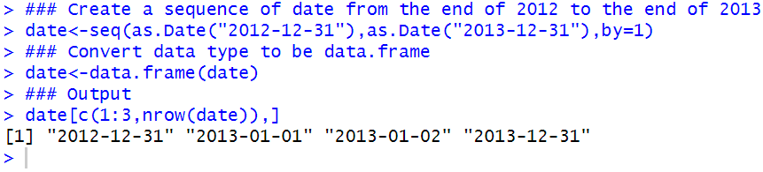

We then merge in the WEIGHT into date using a combination of the na.locf command and merge command. The merge command is implemented with the all.x=TRUE option, which means all dates in date are kept in the new data object, such that there will be missing values for the weights on all days except for the quarter end dates. However, recall that the na.locf command can be used to retain the last available value of weights, such that instead of NAs, we end up using the last available value.

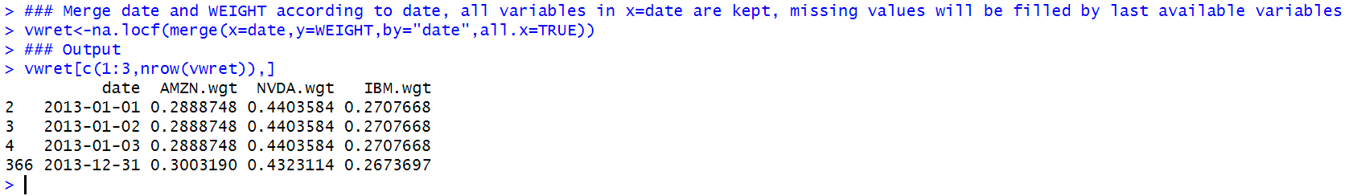

Again, view details of structure of dataset: vwret.

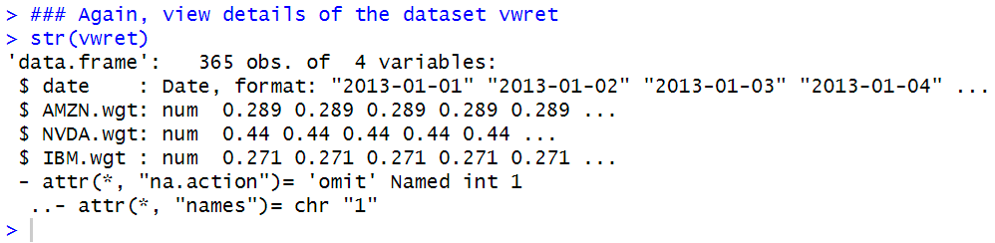

Since already in data type “num”, no need to convert data type like in book.

Now extract the row data of first date of each quarter to find the single line of weight data.

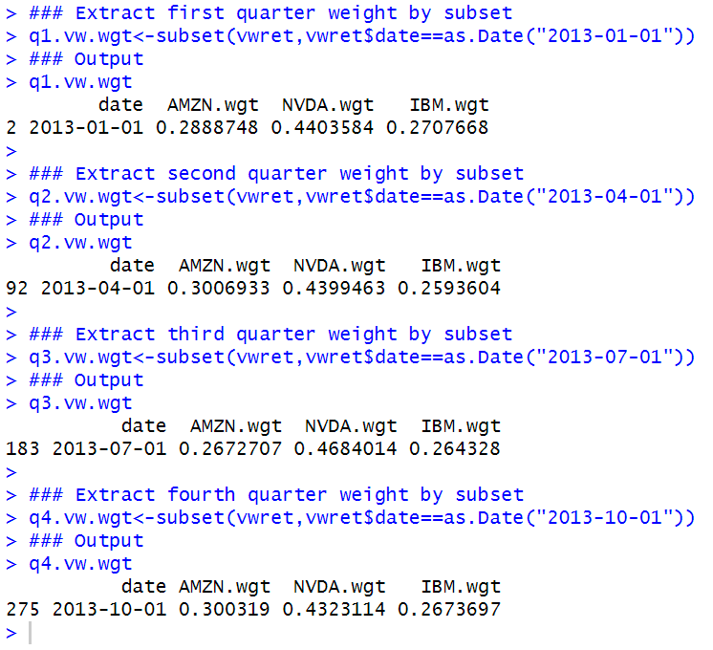

Step 6: Create Pie Charts of the Weights

Note that Q1 and Q2 are use the variable names as labels, while Q3 and Q4 uses re-labeled values and adds the actual percentage weight to the label.

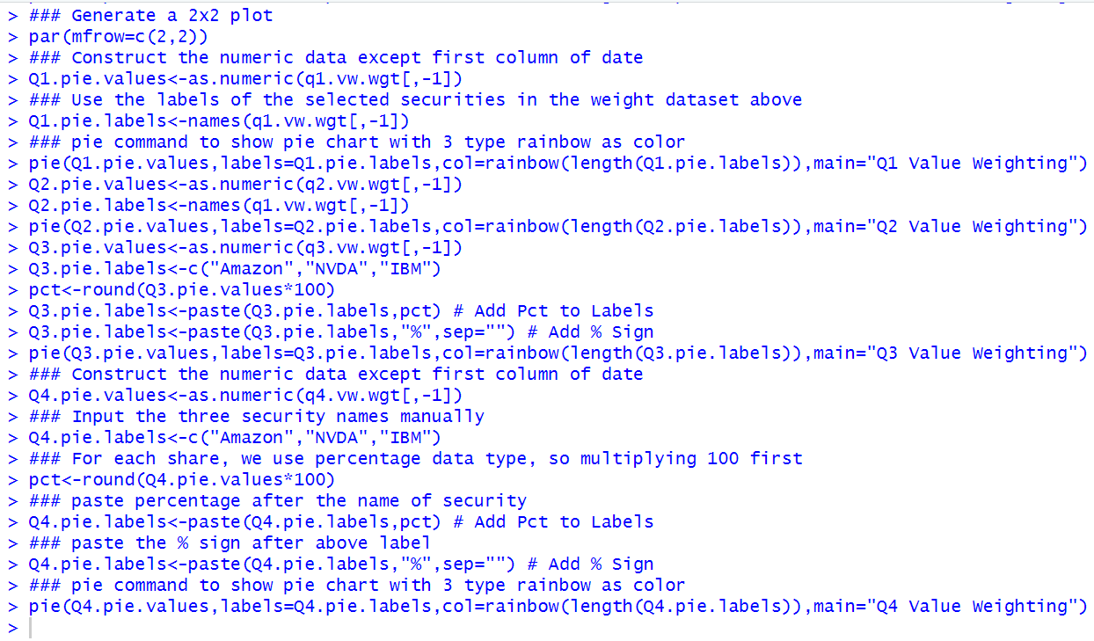

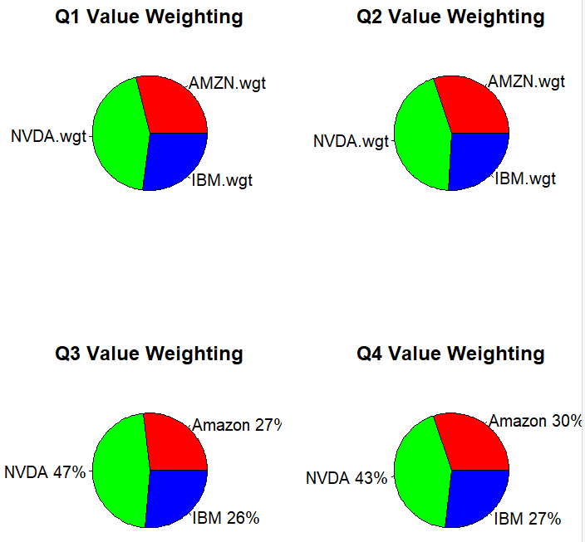

Step 7: Calculating VW Portfolio Values for 1Q 2013

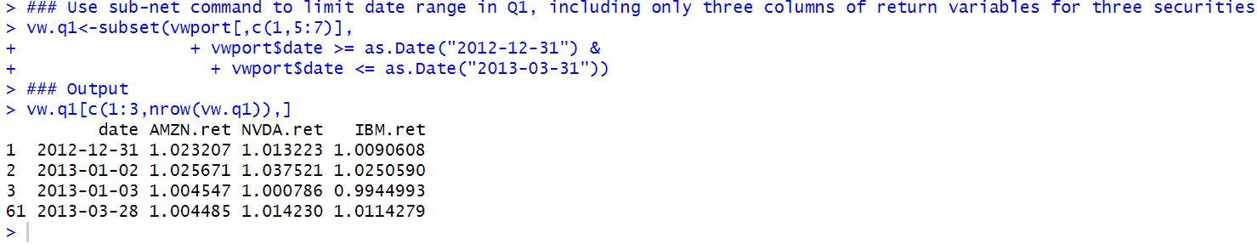

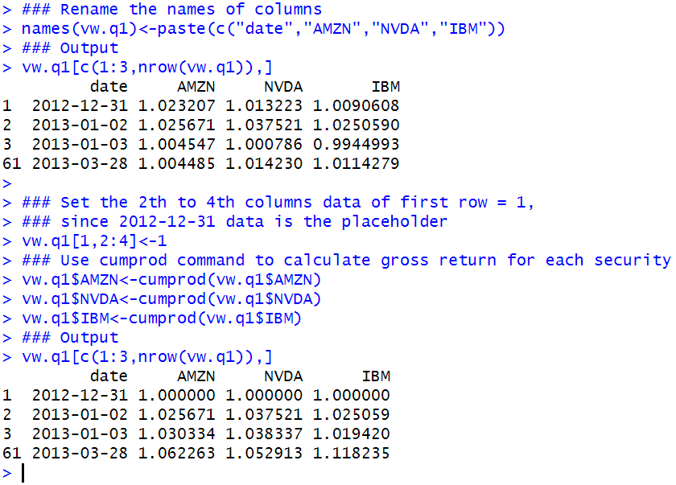

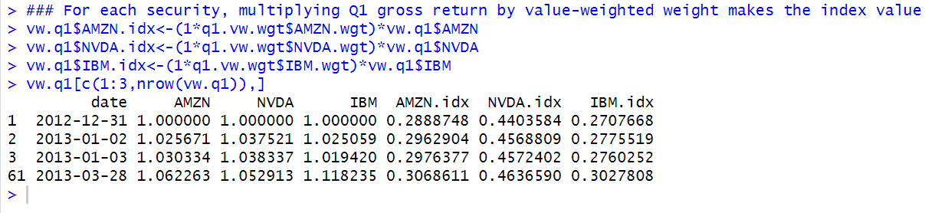

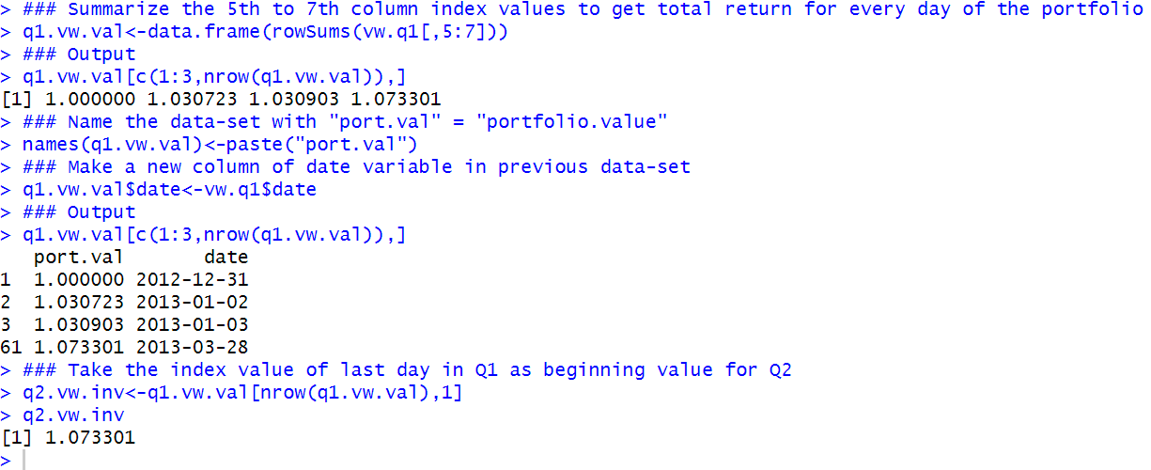

Step 8: Calculating VW Portfolio Values for 2Q 2013

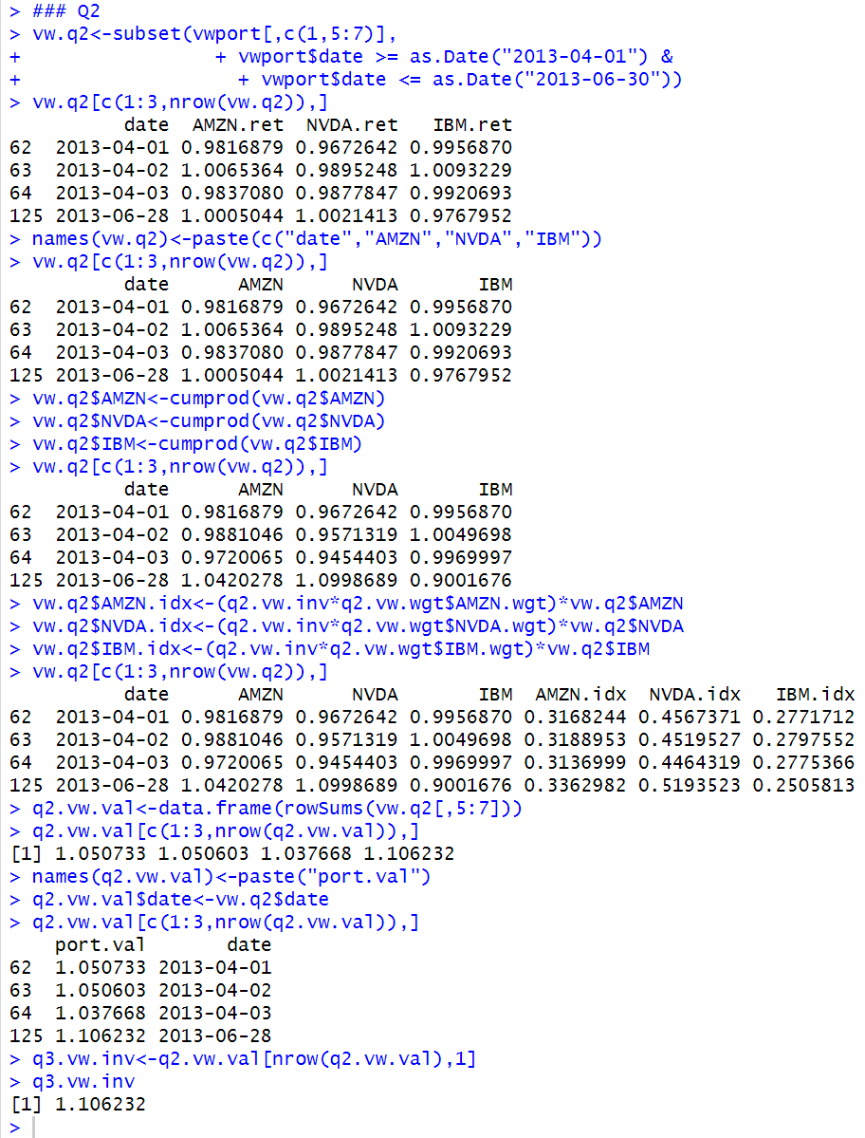

Step 9: Calculating VW Portfolio Values for 3Q 2013

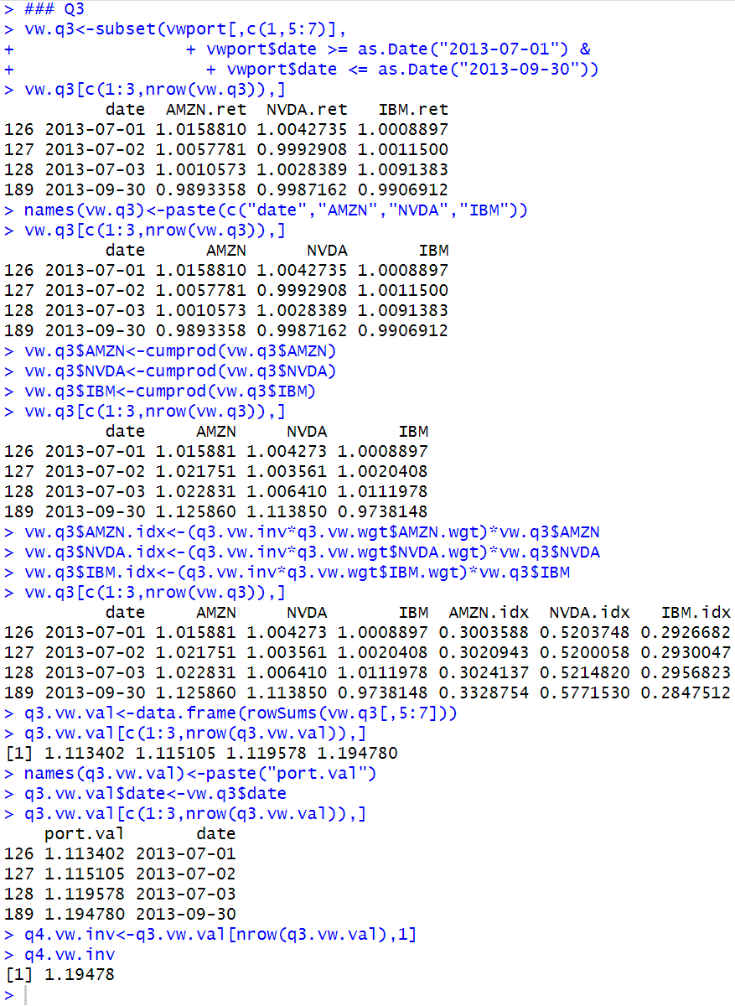

Step 10: Calculating VW Portfolio Values for 4Q 2013

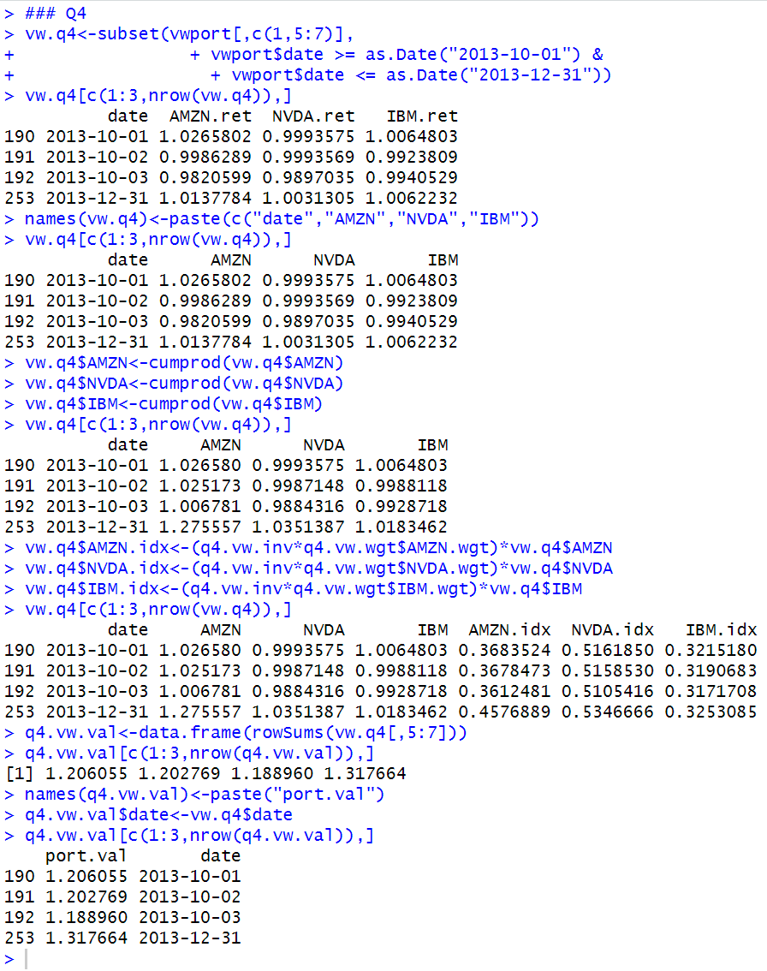

Step 11: Combining Quarterly VW Portfolio Values into One Data Object

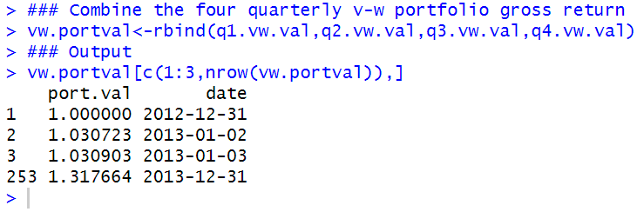

#### Normalized EW and VW Portfolio Price Chart

We now compare the performance of an investment in the EW portfolio and an investment in the VW portfolio over the 1-year period from December 31, 2012 to December 31, 2013.

Step 1: Combine the Data

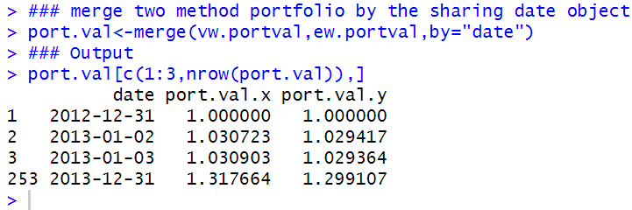

Step 2: Rename the Variables

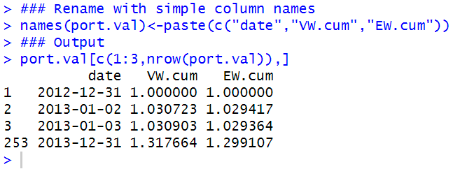

Step 3: Plot the Data

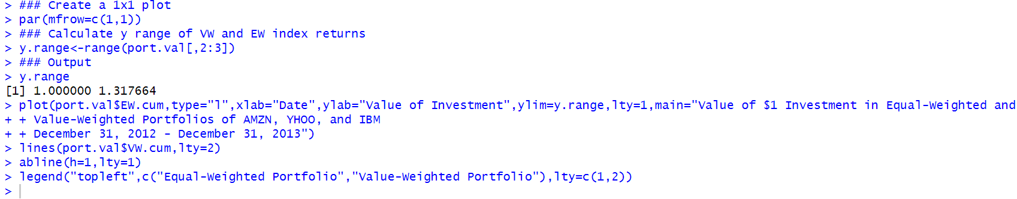

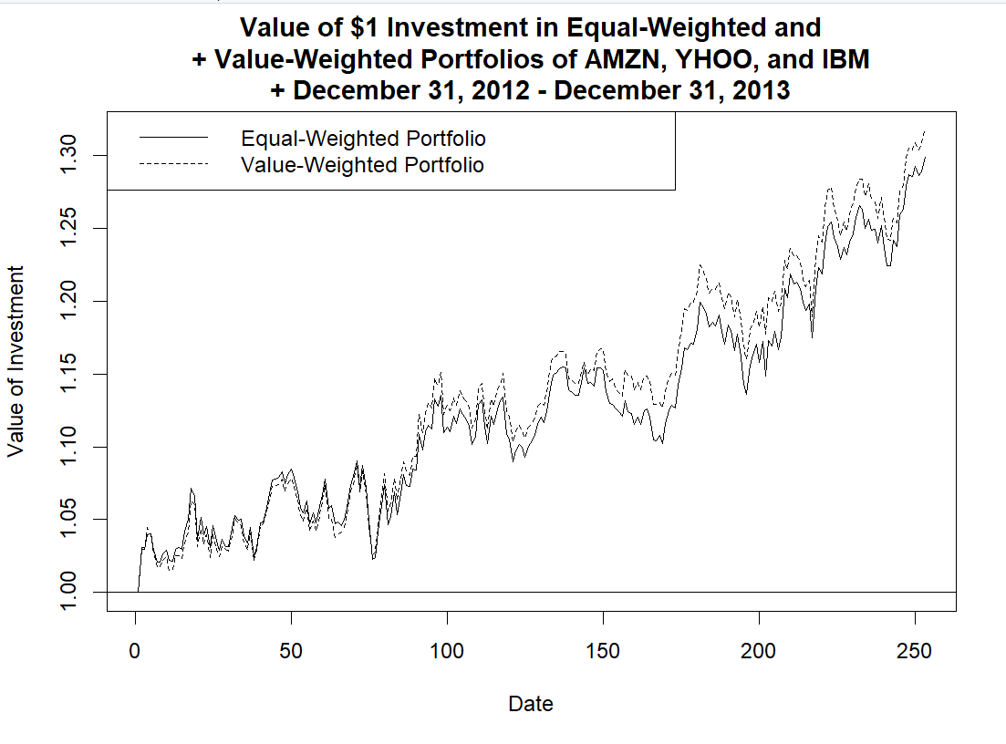

#### 3.3.4 Saving Benchmark Portfolio Returns into a CSV File

In this section, we show how to then save to a CSV file the EW and VW portfolio returns into a CSV file that can be used later.

Because the way the portfolio is constructed, we can calculate the portfolio returns by basing them off the changes in the daily portfolio values.

Step 1: Convert the Data into an xts Object

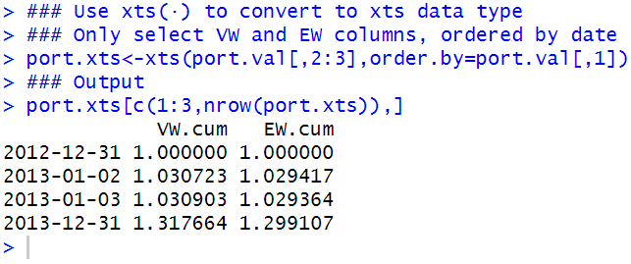

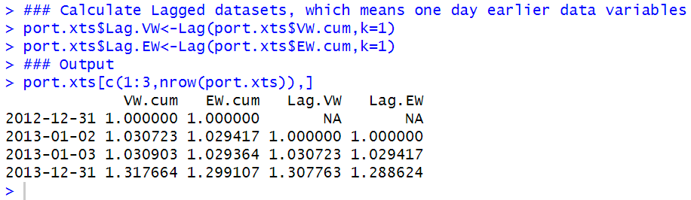

Step 2: Create EW and VW Returns

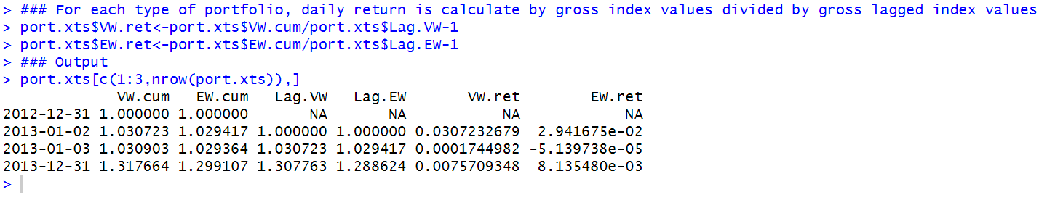

Step 3: Clean up the Data

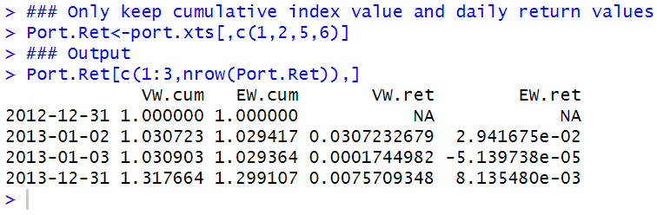

Step 4: Create a Date Variable in the Data Object

If we directly save Port.Ret into a CSV file, we will not have a date variable. So, we first create a DATE object that holds the dates in Port.Ret. Then, we combine DATE with Port.Ret

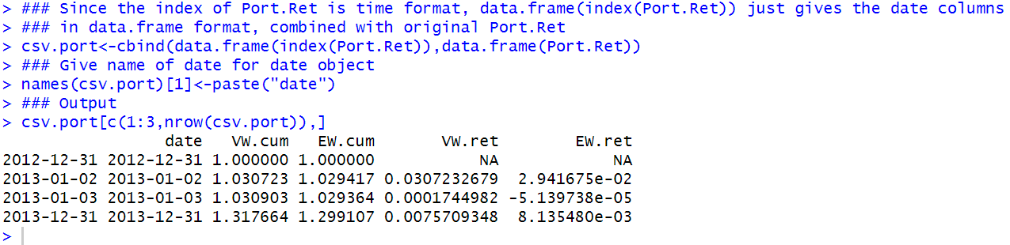

Step 5: Replace Index with Observation Numbers

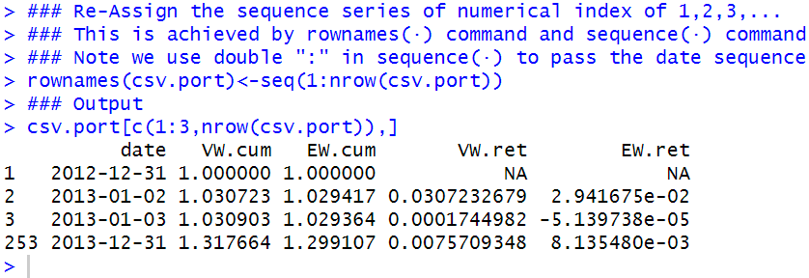

Step 6: Save the Data to a CSV File

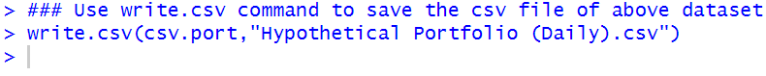

We see that the file is automatically saved in the folder.



### Further Reading

Calculating returns is at the heart of most investment applications. We have only touched upon the basic return concepts in the previous chapter and in this chapter. There are more advanced return concepts that are used in practice, such as Time-Weighted Returns and Money-Weighted Returns.

## Chapter 4 Risk

For most individual investors, it is unlikely to figure out any good chances of profiting from arbitrage opportunities because these opportunities are mostly captured quickly by large corporations to make profit in a sudden of time and eliminated once these corporations finish the process of making profit.

Hence it is very important that the minor investors should fully understand potential risks in the market investment.

As a concept, risk is fairly easy to grasp.

We can summarize some basic principles related to risks from our daily knowledge, here are some examples below:

1. Larger range of changes in price is likely to cause more risks compared to the portfolio of stable securities.
2. More frequent price changes mean that there are more potential risks inside the portfolio of investment.
3. Generally speaking, savings in bank account is less risky than the investment in stock market.

More importantly, we haven’t come up with an exquisite measurement of risks to quantify its influence on the stock market.

Markowitz gave us the most common measure of risk we use today, which is the variance of a security’s price. Variance does not care whether the deviation from the average is a positive deviation or a negative deviation—both are treated as risk.

Apart from variance calculation, some other techniques for measuring risks are measuring loss or downside risk, such as Value-at-Risk and Expected Shortfall. Other measures are modifications of the close-to-close calculation that is typically applied when calculating variance.

**First, we begin with a discussion of the risk-return trade-off. At its core, this means that we should expect higher returns only if we are willing to take on more risk.**

**Next, we discuss individual security risk, as measured typically by the variance (or standard deviation) of returns.**

**Third, we discuss portfolio risk and emphasize that in the context of a portfolio we are less concerned with individual security variance but are more concerned with the covariance of the securities in the portfolio (i.e., in a portfolio context, the way the assets in the portfolio move together is more important).**

**Then, we discuss two measures of portfolio loss: Value-at-Risk (VaR) and Expected Shortfall (ES).**

**Finally, we end with a discussion of several other measures of risk that are used in practice.**

### 4.1 Risk-Return Trade-Off

Here is the screenshot of the explanation of the factors in the .txt file.

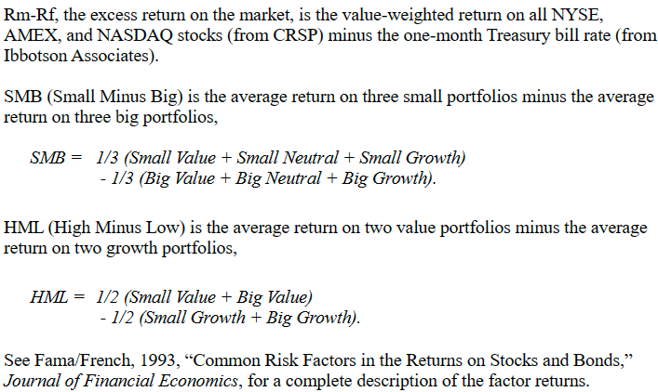

The only way you can get a higher expected return from a security is if you are willing to take on more risk.

To see why, let us first take a look at how stocks and bonds have performed over the last 50 years.

**Step 1: Import Fama-French Data from Professor Kenneth French’s Website**

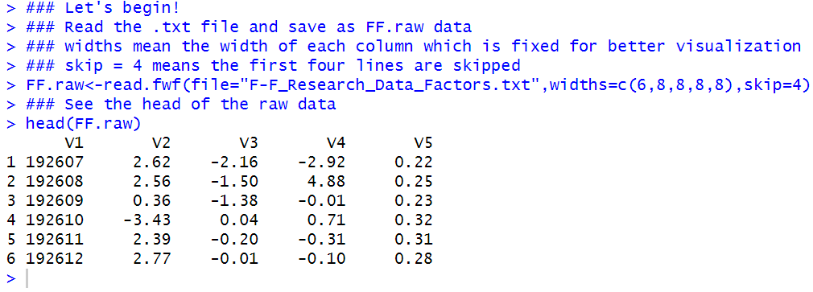

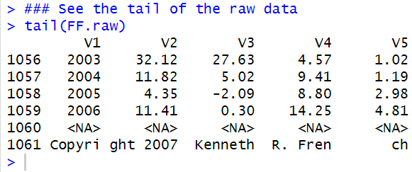

**Step 2: Clean up Data**

The bottom part of the file contains summary annual data, which we do not need.

As such, we delete the data from Row 981 to Row 1066.

We also rename the variable names from V1 to V5 to something more meaningful.

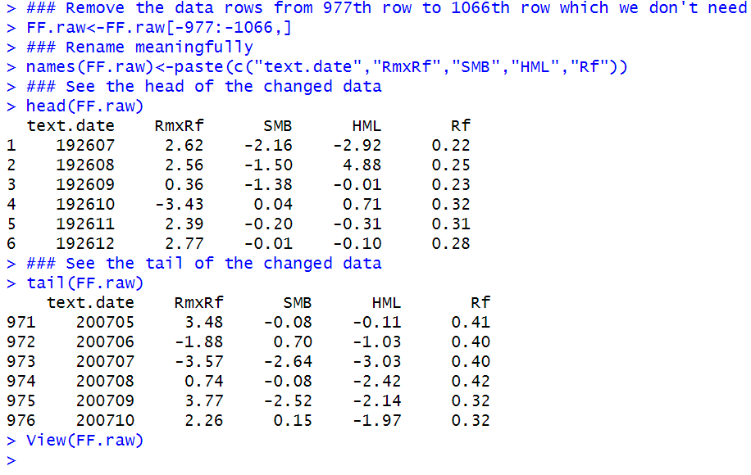

As such, we need to convert the data to numeric variables. For the date variable, it is easier for us to create a sequence of monthly dates rather than converting the text.date variable, so we take that simpler approach.

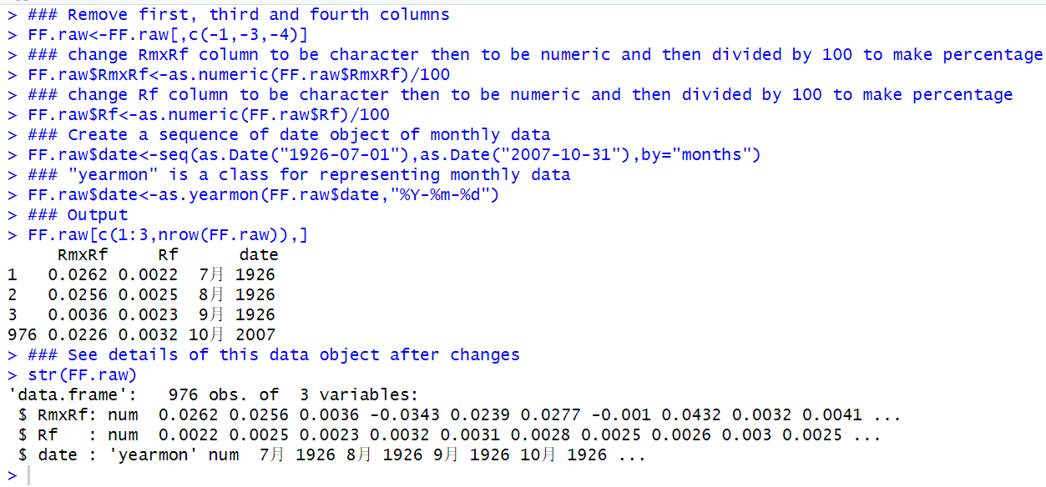

**Step 3: Calculate Raw Market Return Variable**

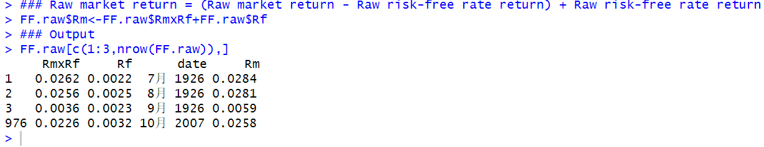

**Step 4: Subset Data from December 1963 to December 2013**

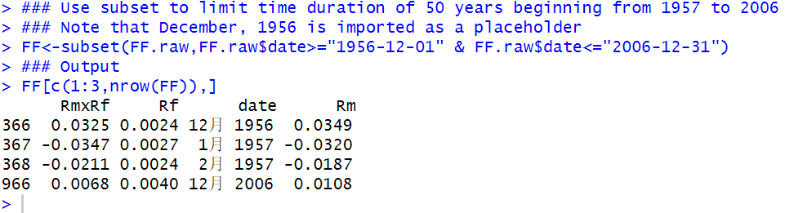

**Step 5: Calculate Gross Returns for the Market and Risk-free Rate**

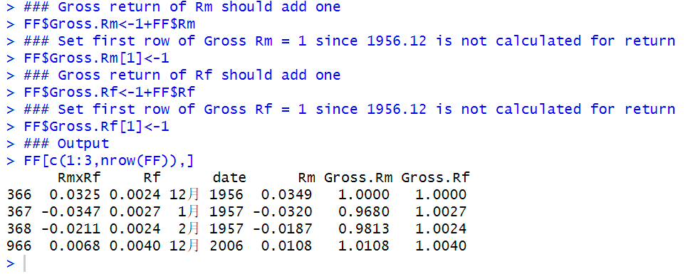

**Step 6: Calculate Cumulative Returns for the Market and Risk-free Rate**

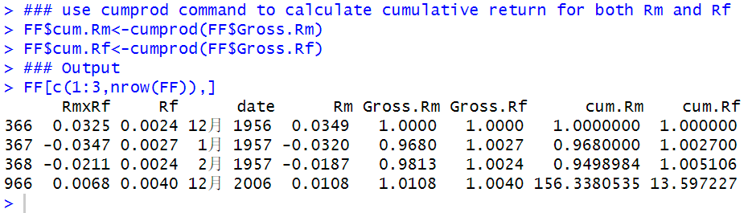

Step 7: Plot the Data

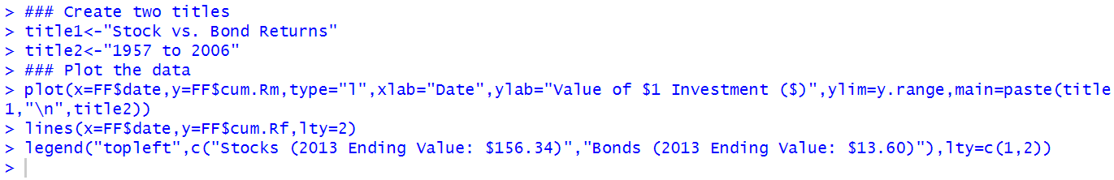

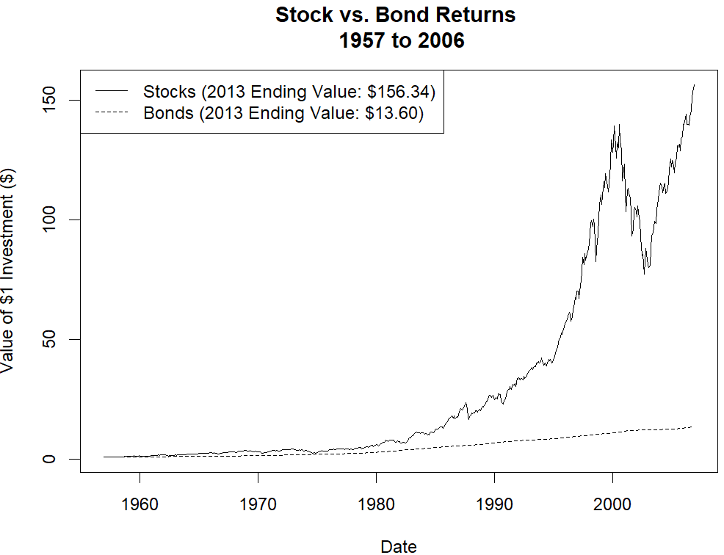

**Step 8: Plot Stock and Bond Returns**

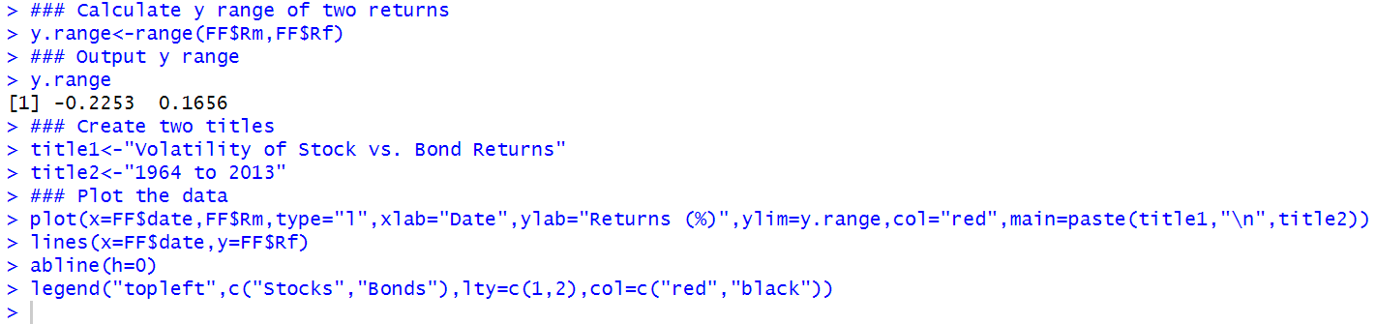

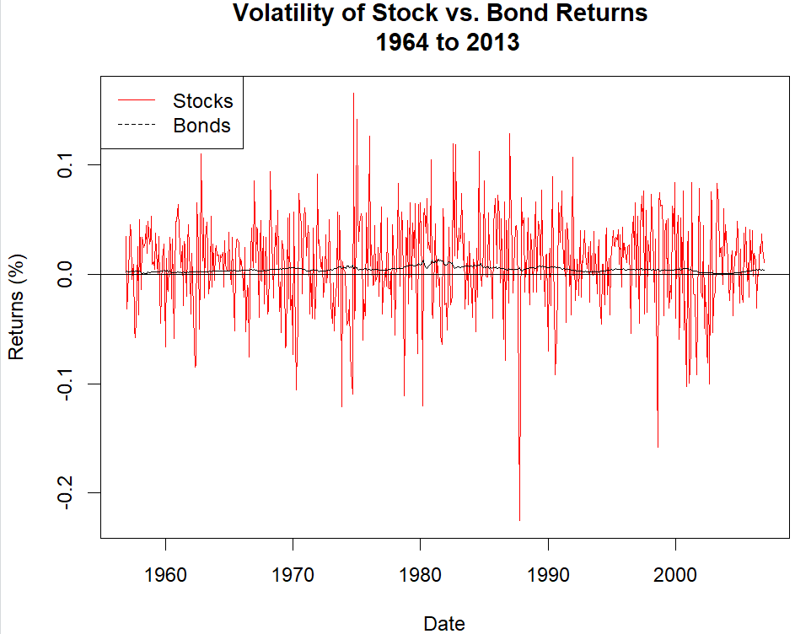

### 4.2 Individual Security Risk

It is common for investors to use variance or, its positive square root, standard deviation as the measure of risk.

The variance of an asset’s return, σ2, is

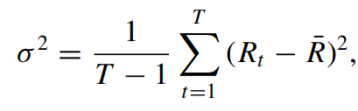

where $R_{t}$ is the return of the asset on day *t* for *t* *=* *1, ..., T* and $\overline{R}$ is the average return of the asset over days *1* to *T*. The standard deviation is equal to the square root of the variance and is denoted by *σ*.

We now calculate the variance and standard deviation of AMZN’s returns.

Note that the variance and standard deviation calculations change depending on the time period we choose.

**Step 1: Import AMZN Data from Yahoo Finance**

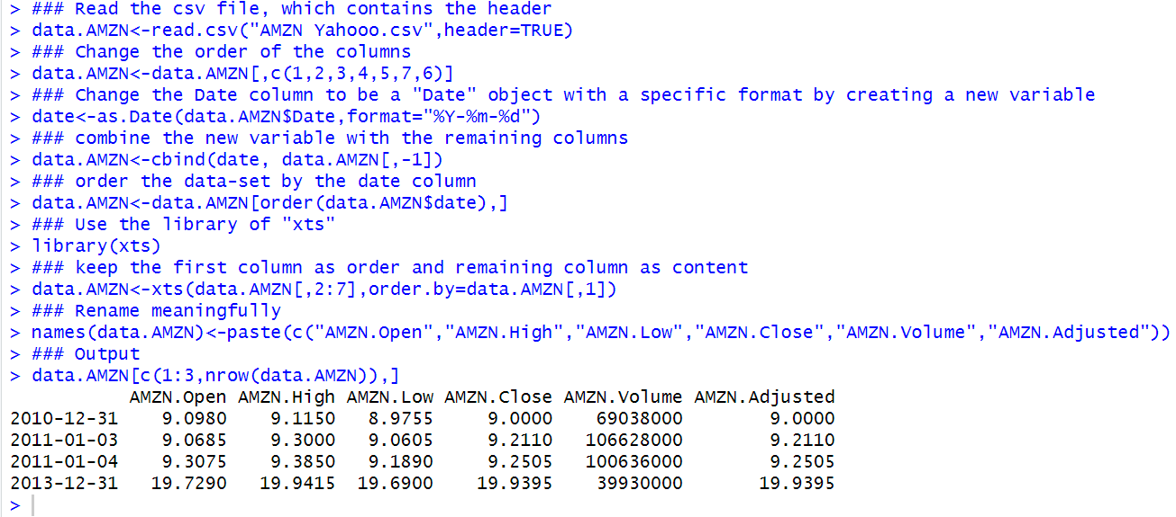

**Step 2: Calculate Returns**

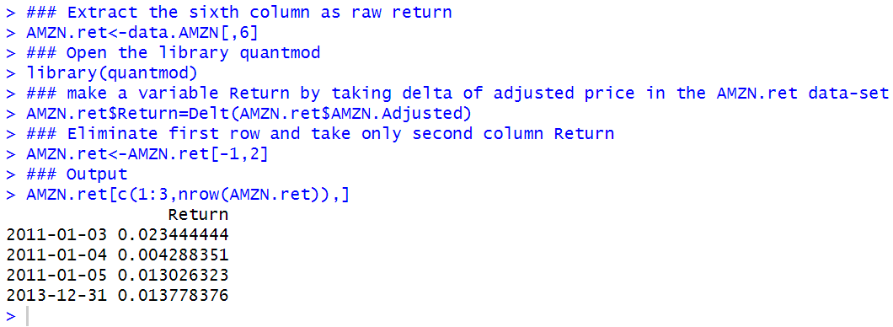

**Step 3: Calculate Full Period (2011–2013) Variance and Standard Deviation**

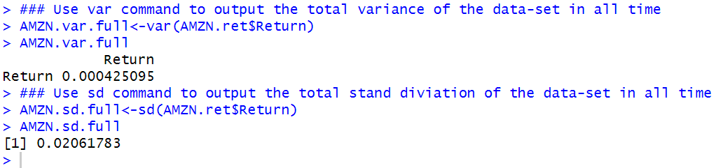

**Step 4: Calculate Variance and Standard Deviation for 2011**

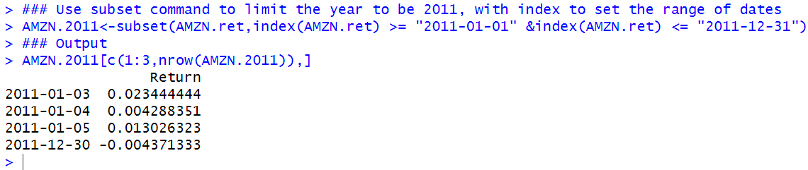

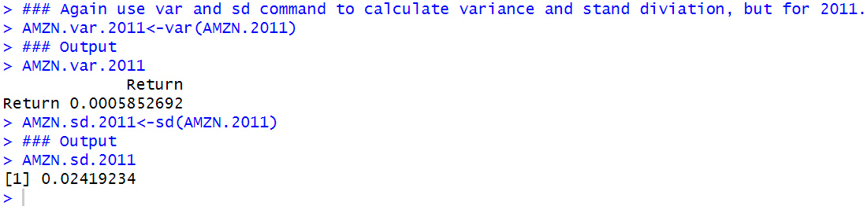

**Step 5: Calculate Variance and Standard Deviation for 2012 and 2013**

**2012**

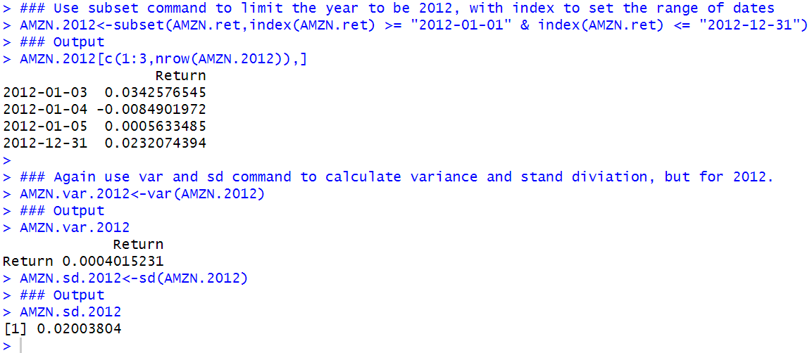

**2013**

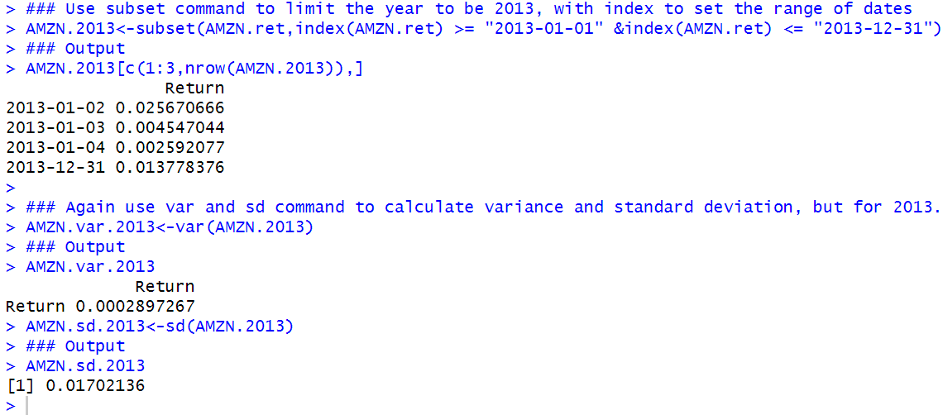

**Step 6: Calculate Average Return for the Full Period and Each of the Subperiods**

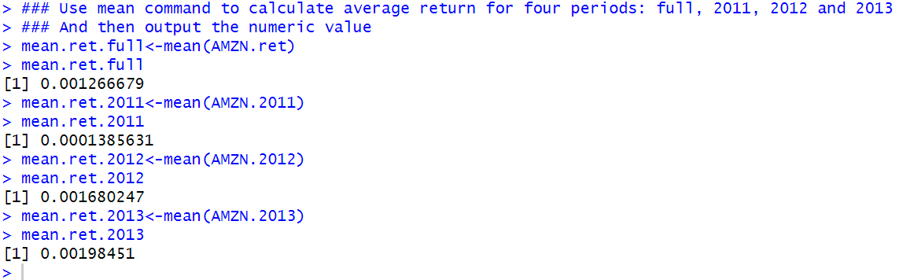

**Step 7: Combine All Data**

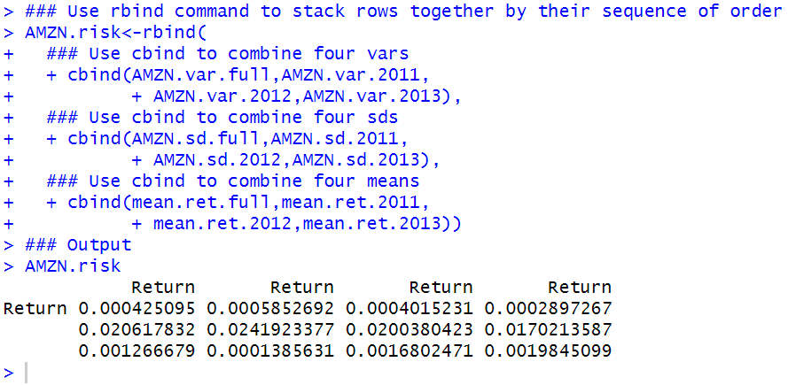

**Step 8: Cleanup Data**

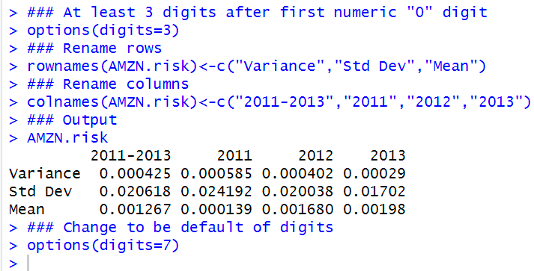

Based on daily returns, we can see that for the 2011–2013 period, AMZN’s average return is 0.13 % but the standard deviation around this mean is 2.07 %. Assuming a normal distribution, 68 % of AMZN returns lie within one standard deviation from the mean and 95 % of the AMZN returns lie within two standard deviations from the mean. Using 2011 to 2013 data, this means that 68 % of AMZN’s daily returns are between −1.9 and 2.2 % and 95 % of AMZN’s daily returns are between −4.0 and 4.3 %.

Standard deviations of returns based on different frequencies are not comparable. We have to convert such volatility measures to an annualized volatility number to make such a comparison.

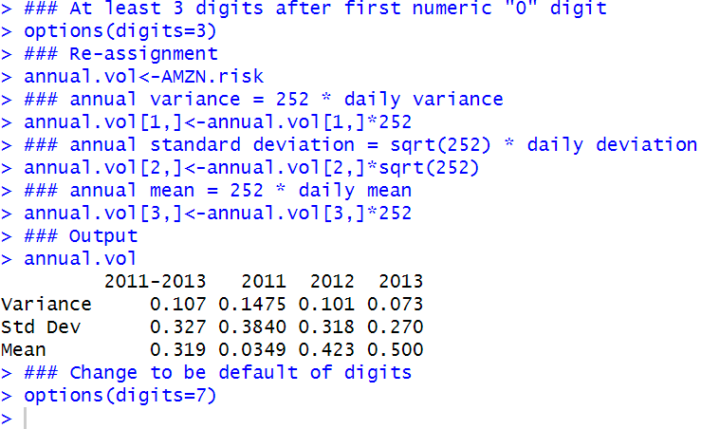

As the output above shows, AMZN’s annualized standard deviation for the full period was 32.7 %. Breaking down the data into three different years, we see that 2011 had the highest standard deviation at 38.4 % while 2013 had the lowest standard deviation at 27.0 %.

### 4.3 Portfolio Risk

In particular, when we add assets that are not perfectly correlated with the securities in our portfolio, the overall risk of the portfolio decreases.

In fact, Reilly and Brown [7] state that using 12–18 well-selected stocks can yield 90 % of the maximum benefits of diversification. Therefore, as a general rule, a portfolio’s risk is not simply the weighted average of the standard deviations of each of the securities in the portfolio but likely something lower.

#### 4.3.1 Two Assets (Manual Approach)

In the case of a two-asset portfolio, portfolio risk is calculated as

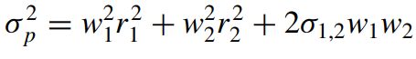

Where $w_{i}$ is the weight of security *i* in the portfolio, $r_{i}$ is the return of security *i*, and $σ_{1,2 }$ is the covariance between the returns of securities 1 and 2.

Let us work through an example of calculating the portfolio risk for a $ 10,000 portfolio that invested $ 2500 in AMZN and $ 7500 in IBM.

**Step 1: Calculate Weights of Securities in the Portfolio**

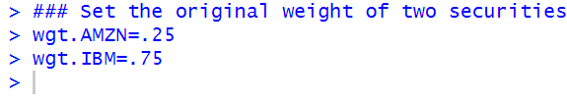

**Step 2: Import AMZN and IBM Data from Yahoo Finance and Calculate Total Returns**

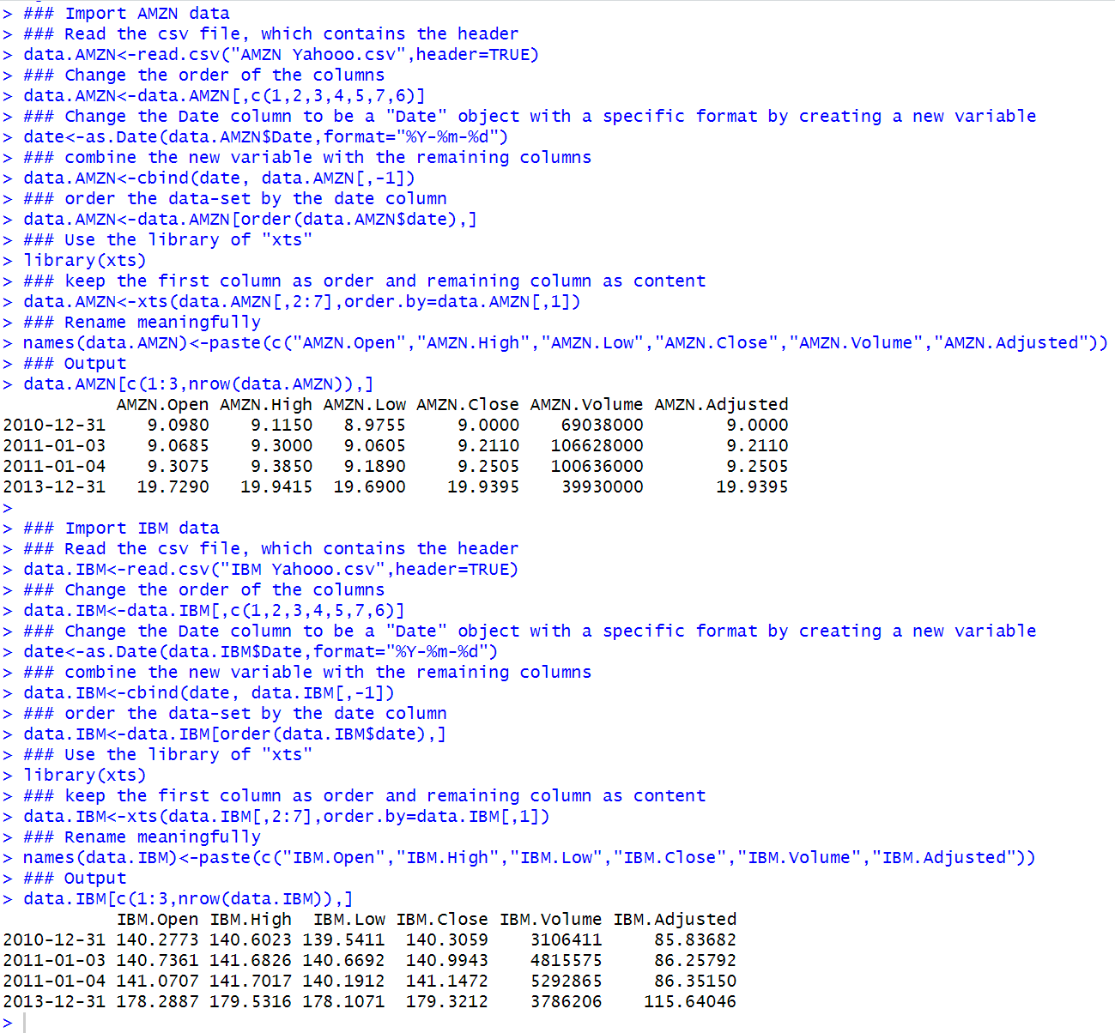

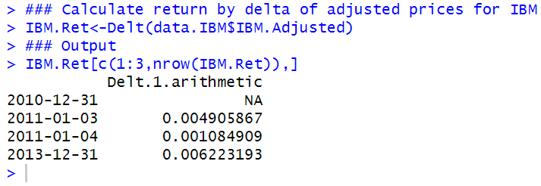

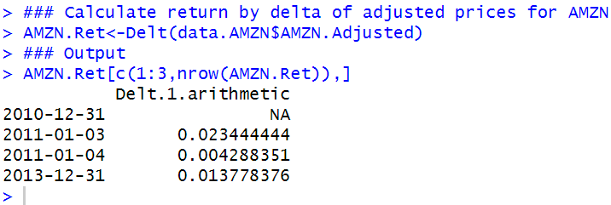

**Step 3: Combine the Two Return Series**

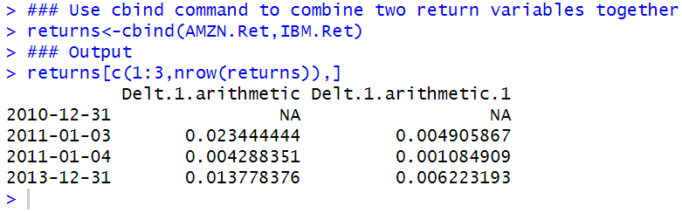

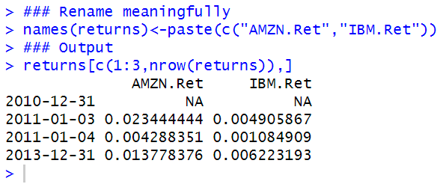

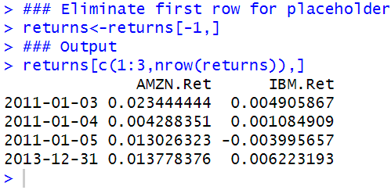

**Step 4: Calculate Standard Deviation and Covariance of the Securities**

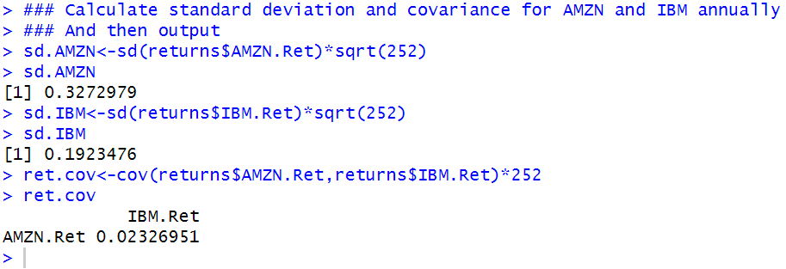

**Step 5: Calculate Portfolio Risk**

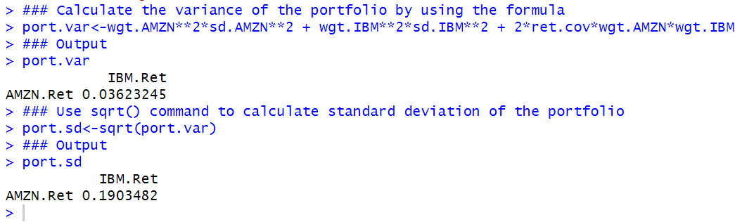

**Benefit of Diversification**

Note that this portfolio standard deviation is lower than the weighted-average standard deviation of AMZN and IBM returns of 22.6 %. Since AMZN and IBM returns only have a 0.37 correlation, portfolio risk is reduced by combining the two securities in a portfolio. In fact, the smaller the correlation, the more gains from diversification we can achieve.

#### 4.3.2 Two Assets (Matrix Algebra)

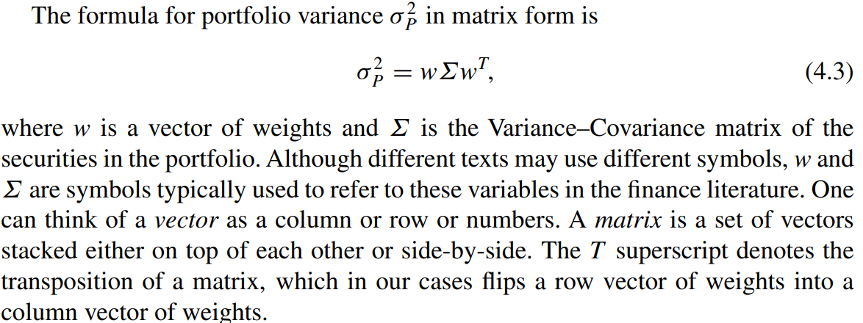

**Step 1: Create Vector of Weights**

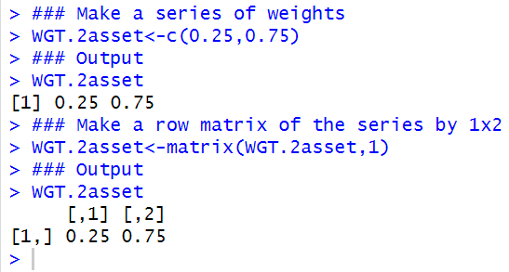

**Step 2: Create Transposed Vector of Weights**

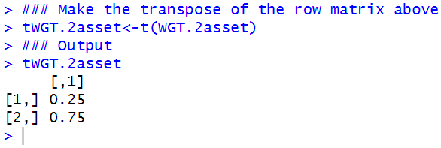

**Step 3: Construct Variance–Covariance Matrix**

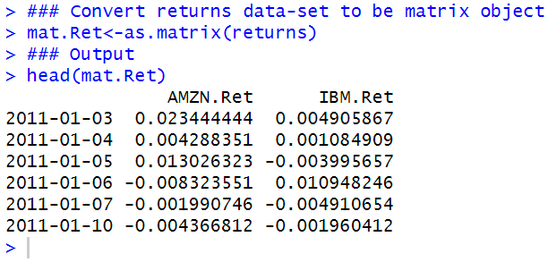

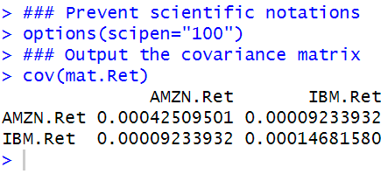

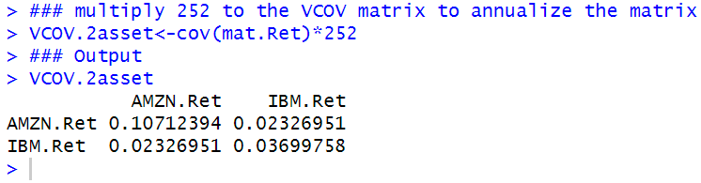

**Step 4: Calculate Portfolio Risk**

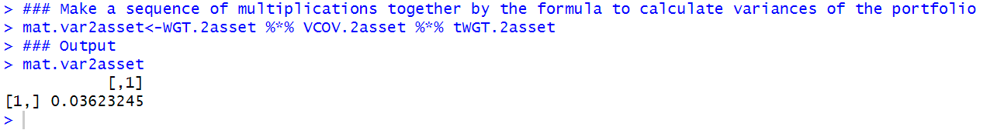

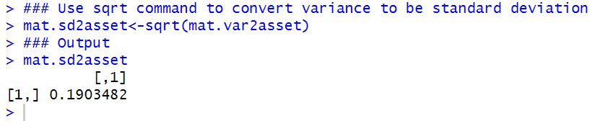

#### 4.3.3 Multiple Assets

**Step 1: Import Data for AMZN, IBM, AAPL, and NVDA**

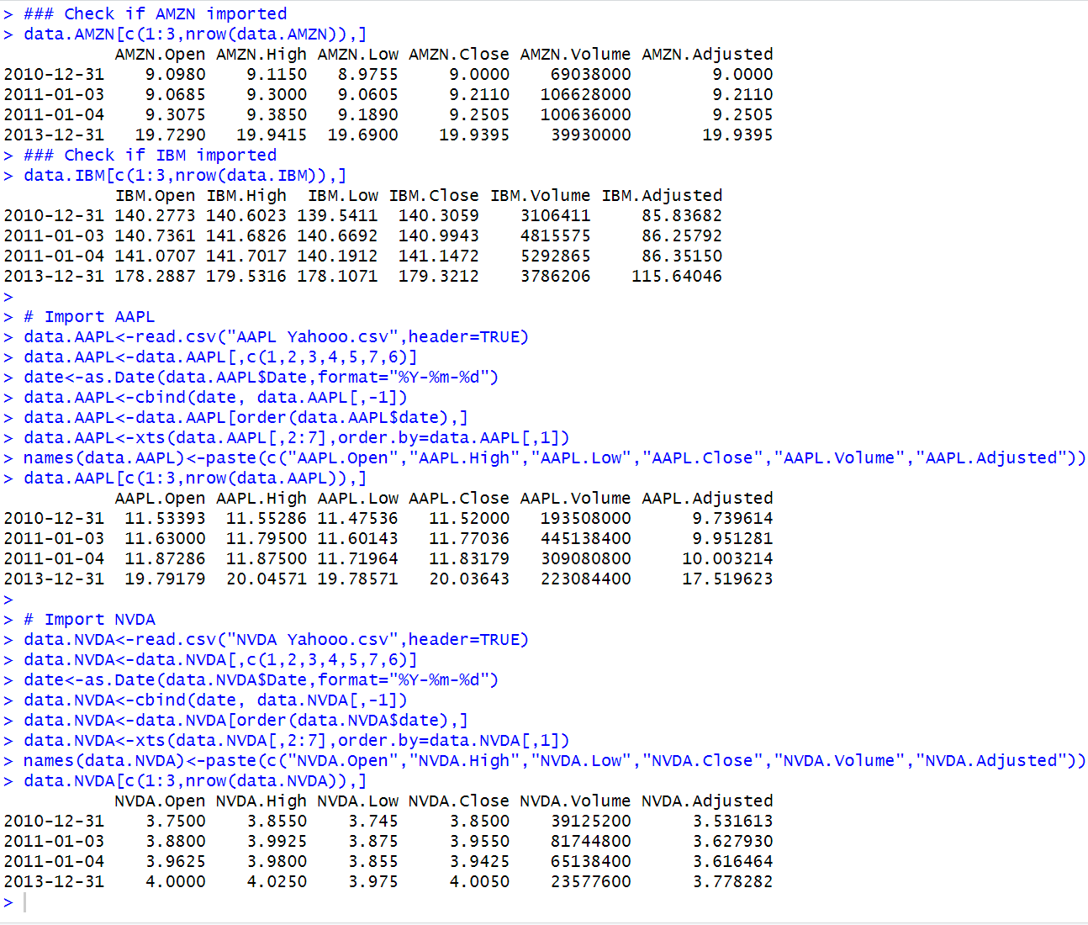

**Step 2: Extract Adjusted Prices of Each Security**

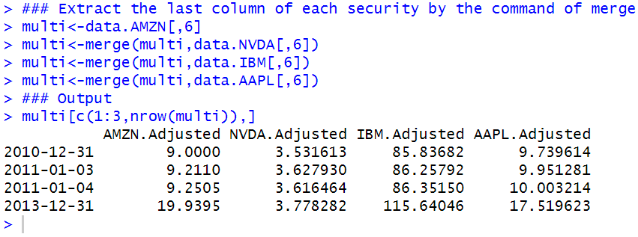

**Step 3: Calculate Returns for Each Security**

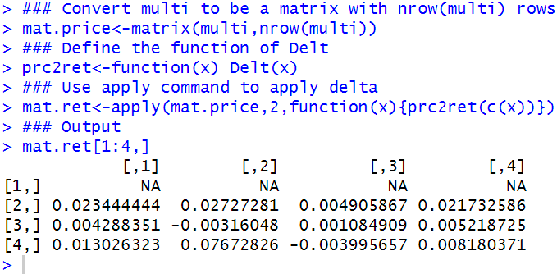

**Step 4: Clean up Returns Data**

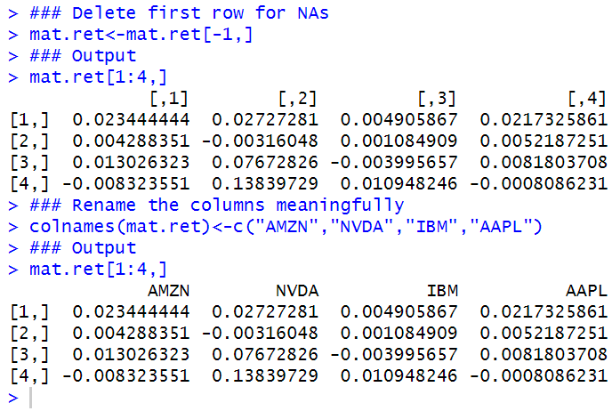

**Step 5: Calculate Annualized Variance–Covariance Matrix**

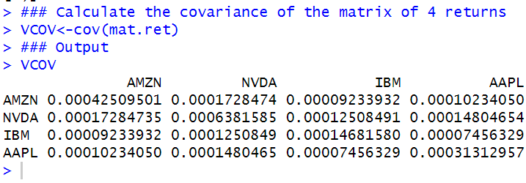

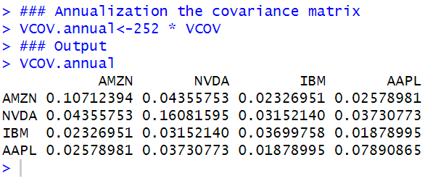

**Step 6: Create a Row vector of Weights**

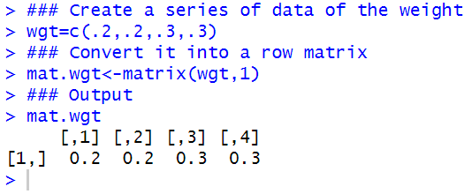

**Step 7: Create a Column Vector of Weights by Transposing the Row Vector of Weights**

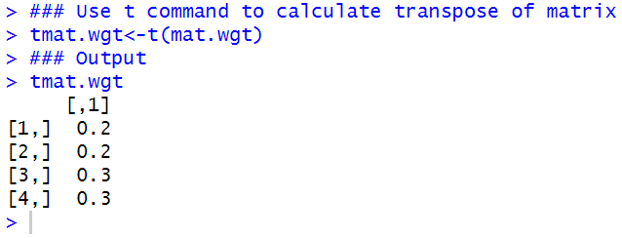

**Step 8: Calculate the Portfolio Variance**

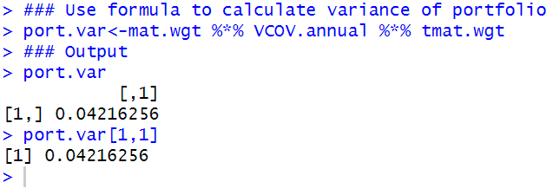

**Step 9: Calculate the Portfolio Standard Deviation**

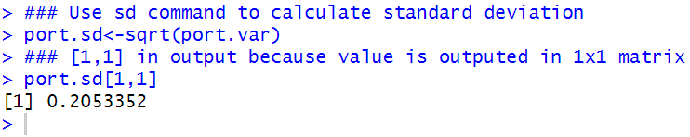

### 4.4 Value-at-Risk

A popular measure of the risk of loss in a portfolio is Value-at-Risk or VaR.

VaR measures the loss in our portfolio over a pre-specified time horizon, assuming some level of probability.、

For example, we will calculate as an example the 1 and 5 % 1- Day VaR on December 31, 2013 of the Value-Weighted portfolio we constructed in Chapter 3, which was based on a portfolio of AMZN, IBM, and NVDA

In this section, we will use the market convention of representing VaR as a positive number and using the significance level (e.g., 1 or 5 %) instead of confidence level (e.g., 99 or 95 %).

We also implement two types of VaR calculations: Gaussian VaR and Historical VaR.

The former assumes that the data follow a normal or Gaussian distribution, while the latter uses the distributional properties of the actual data. As such, Historical VaR requires more data to implement and Gaussian VaR requires less data to implement.

VaR has been criticized for not being able to fully capture how large the loss we should expect if the loss exceeds VaR or what is known as tail risk.

If the tail of the distribution is large, then there is a risk of a very large loss.

ES tells us how much we should expect to lose if our losses exceed VaR.

In this section, we calculate the VaR using both the Gaussian VaR/ES and Historical VaR/ES based on the Value-Weighted Portfolio we constructed in Chap. 3, which consists of AMZN, IBM, and NVDA. We will calculate the 1-Day VaR based on a 1 and 5 % significance level.

#### 4.4.1 Gaussian VaR

One of the simplest approaches to estimate VaR is to assume that the portfolio returns follow a normal distribution. Hence, this approach is called Gaussian VaR.

**Step 1: Import Daily Portfolio Returns for the Last Year**

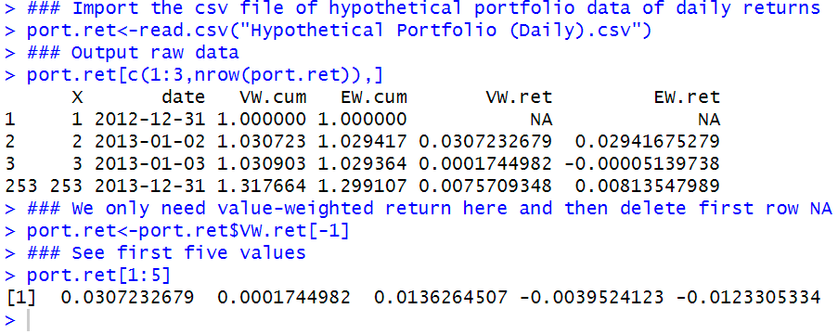

**Step 2: Calculate Mean and Standard Deviation of Historical Daily Portfolio Returns**

In practice, some assume that because we are calculating VaR over a short horizon, the portfolio mean return is zero. In our example, we do not make this assumption but we can see from the output below that our calculated portfolio mean is small.

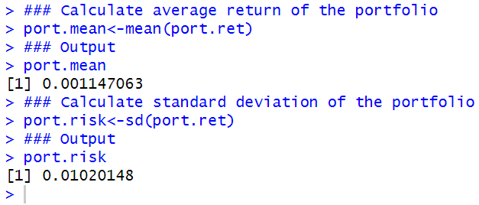

**Step 3: Calculate 1 and 5 % VaR**

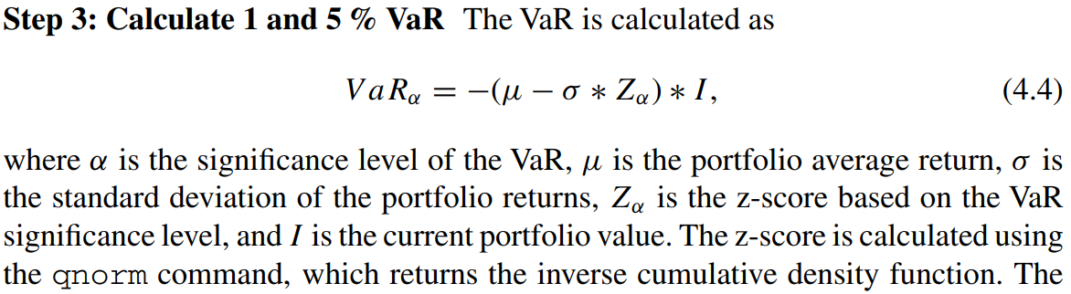

**And we know that $z_{0.01}$ = 2.33**

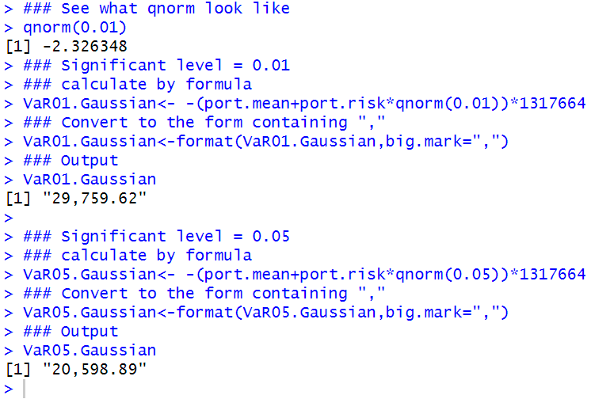

This means that there is a 1 % (5 %) chance that our portfolio loses more than $ 29,760 ($ 20,599) over the next day. Note that to make the VaR result easier to read, we used the format command to format the VaR output to include a comma.

#### 4.4.2 Historical VaR

Historical VaR uses a mix of current weights in the portfolio and a simulation of historical returns of the securities in the portfolio to construct a simulated series of portfolio Profits & Losses (P&L).

Given its use of historical returns data, Historical VaR works better when we have lots of data. Typically, three to five years of data is recommended for this approach.

**Step 1: Import Three Years of Daily Returns Data for Each Security in the Portfolio**

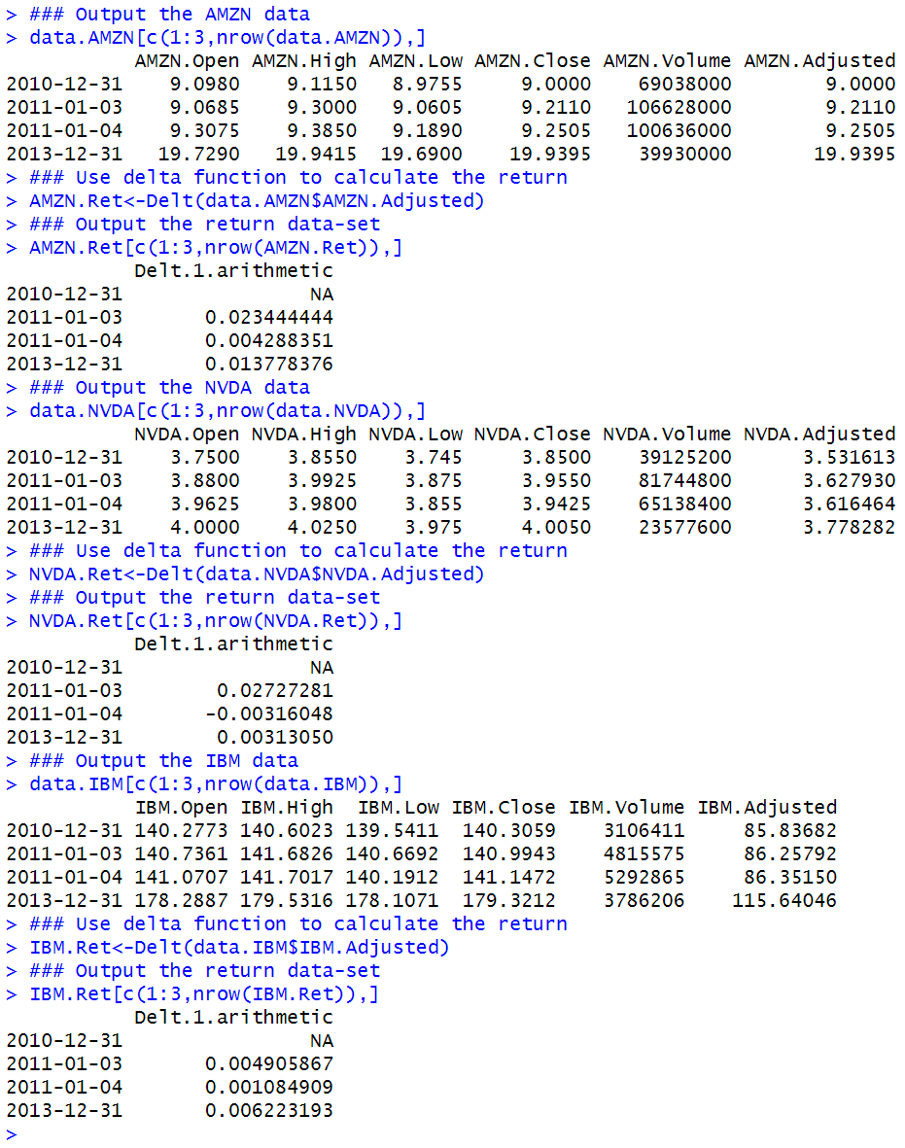

**Step 2: Combine Returns Data into One Data Object**

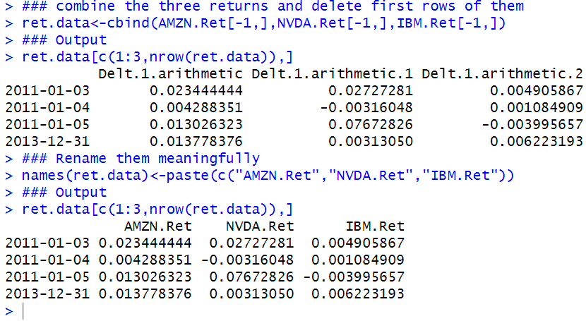

**Step 3: Identify the Value of Each Security in the Portfolio as of December 31, 2013**

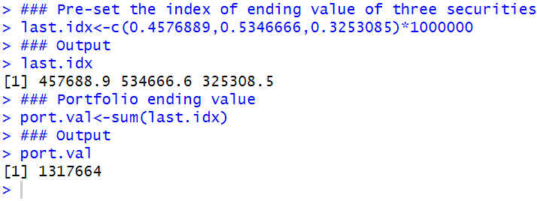

**Step 4: Calculate Simulated Portfolio Returns Applying Current Portfolio Weights to Historical Security Returns**

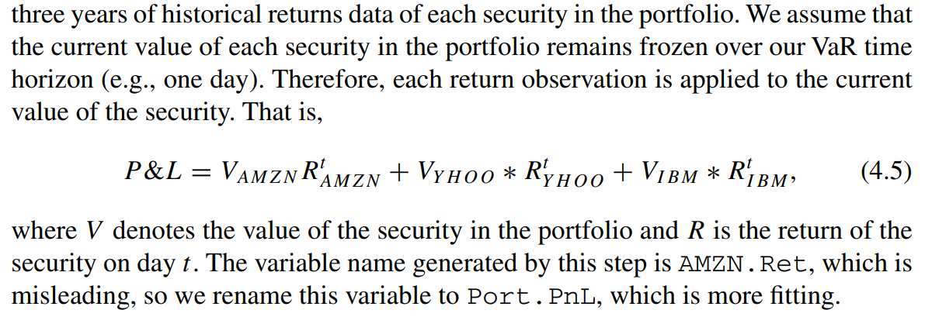

Note that in the formula YHOO is replaced by NVDA since I have mentioned that YHOO has already existed the market and no longer able to show the historical data.

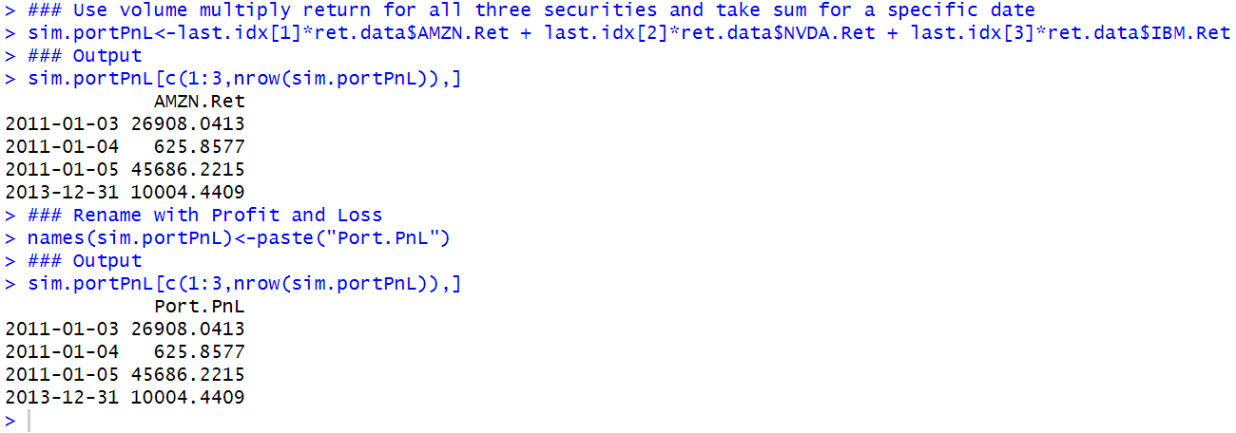

**Step 5: Calculate Appropriate Quantile for the 1 and 5 % VaR**

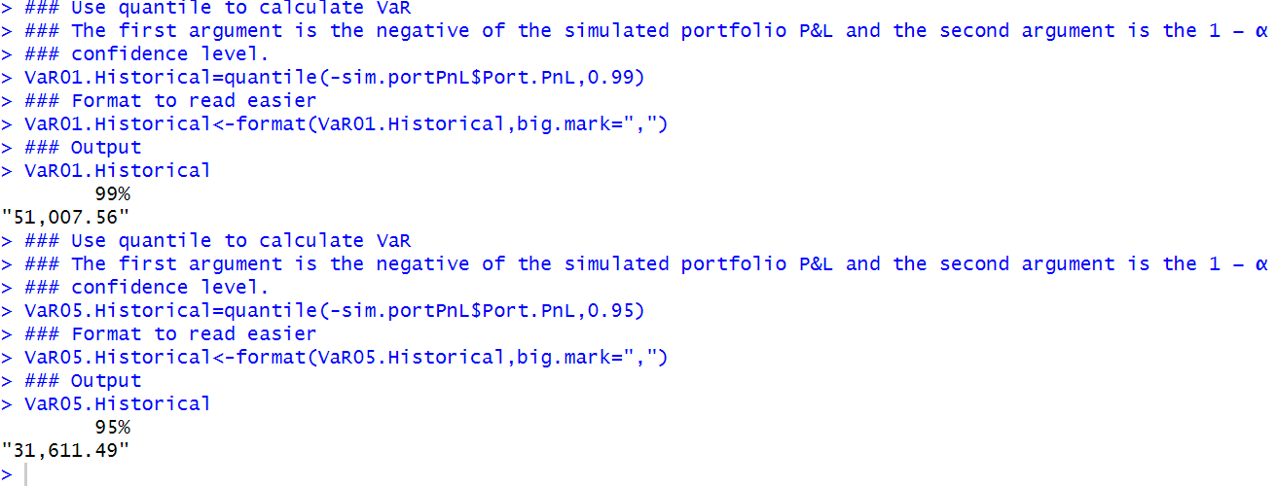

Note that the higher the significance level (i.e., 5 vs. 1 %) or the lower the confidence level (i.e., 95 vs. 99 %), the lower the VaR amount. To see why, suppose we were asked to give our best estimate of a number that we are sure we would not exceed. The higher the estimate of this number we come up with, the higher the likelihood that we will not exceed it. As such, we should expect to have a higher number at the 99 % confidence level than at the 95 % confidence level.

In my own words, when the estimate is as much high as the maximized value we can exceed, then the probability is 100%, which is just the bound of the estimation.

**Step 6: Plot the VaR in Relation to P&L Density**

In this step, we plot the following three contents:

i: the density of the simulated portfolio P&L.

ii: the normal distribution of P&L’s based on the mean and standard deviation of the simulated portfolio P&Ls.

iii: our estimates of the 1 and 5 % 1-Day Historical VaR.

We first plot (i) and (iii), then we add (ii).

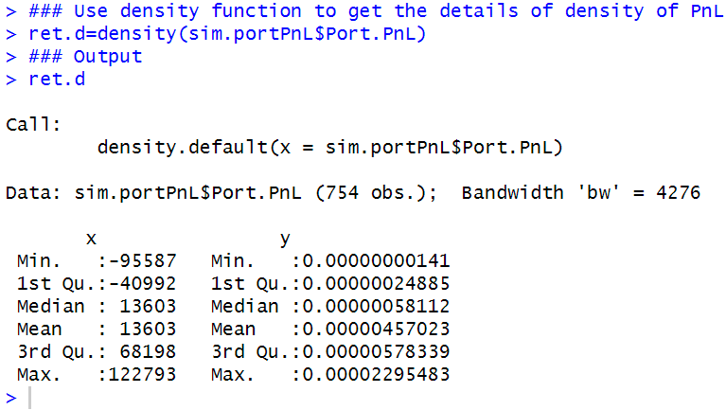

We can now plot (i) and (iii). Note that we add two vertical lines using the abline command. The two lines denote our estimates of VaR, so we can visually see from the density of the simulated portfolio P&L, where the Historical VaR estimates are.

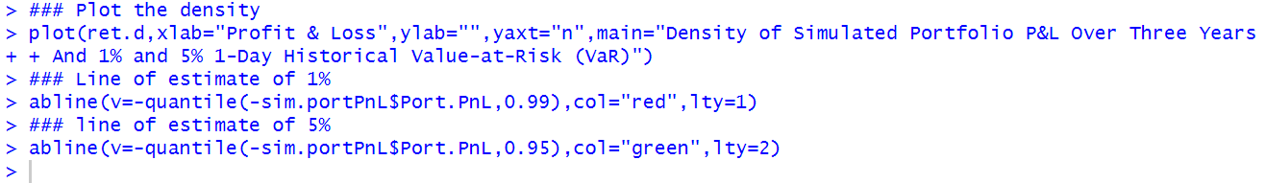

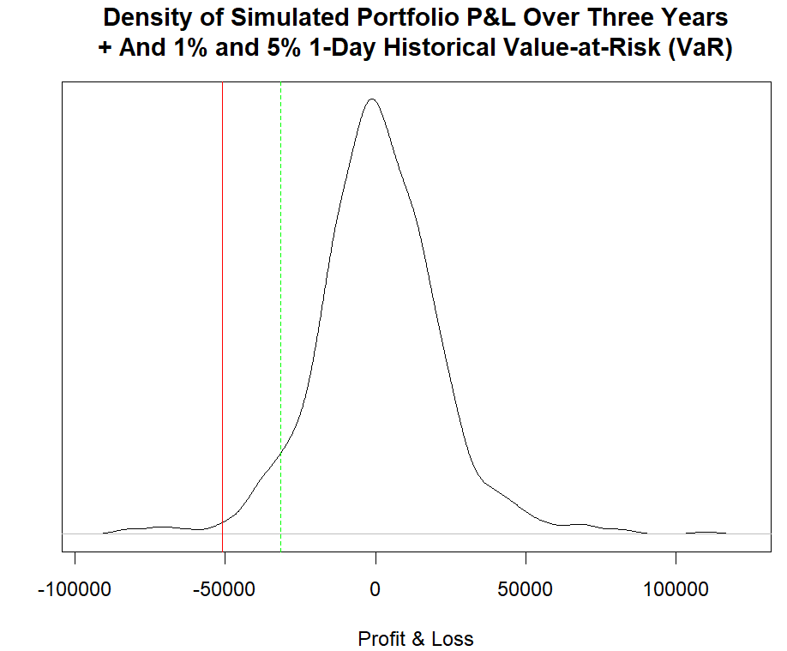

Next, we now turn to number (ii) on the list, which is the plot of the normal distribution based on the mean and standard deviation of the simulated portfolio P&L. First, we create a sequence of 1000 numbers between the smallest and largest simulated P&L. This creates bounds for the normal density plot that follows.

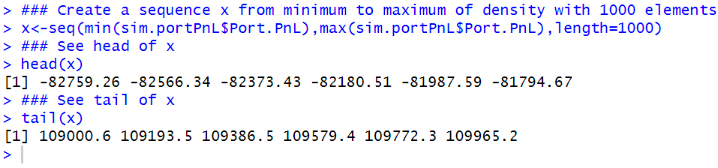

Then, we use the dnorm command to provide the values of the probability density function for the normal distribution.

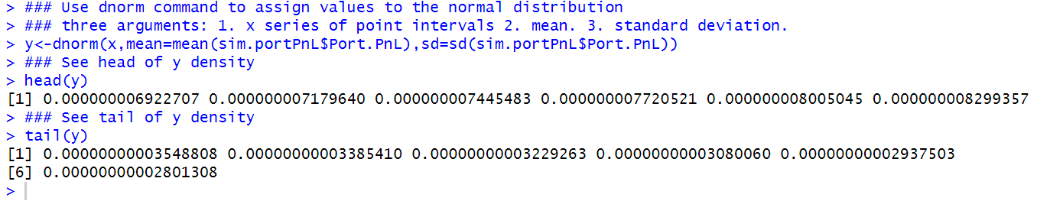

We then use the lines command to add the normal density plot as a dashed bell curve onto the plot.



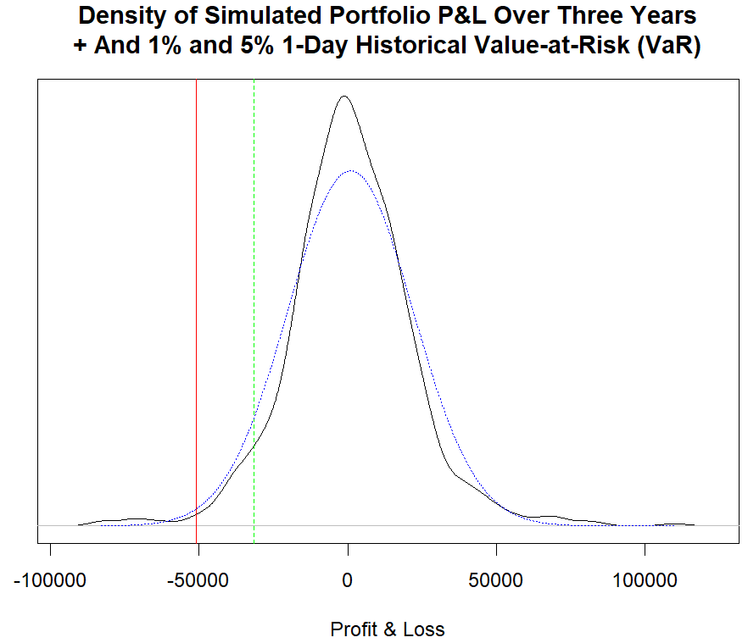

Finally, we add a legend on the top-right portion of the chart, so the legend does not obstruct the other elements of the chart.



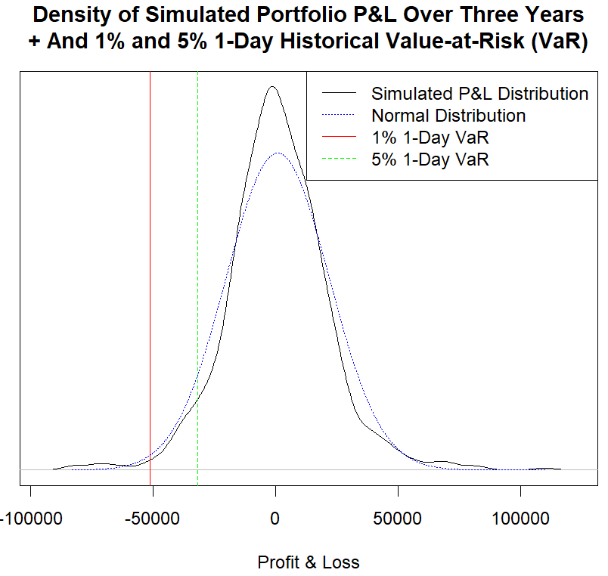

The chart shows that the simulated P&L distribution is more peaked than what a normal distribution with the same mean and standard deviation would show. This means that there are more observations that are around the mean or average P&L of $ 1127 in the simulated P&L.

**Using the Square Root of T rule to Scale 1-Day VaR to a T -Day VaR**

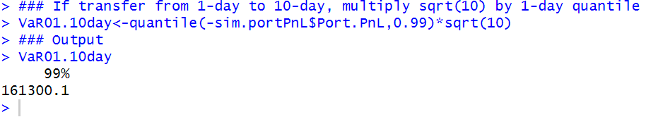

### 4.5 Expected Shortfall

One of the issues with VaR is that it does not capture the shape of the tail of the distribution. That is, VaR does not allow us to answer the question, “if losses exceed VaR, how bad should we expect that loss to be?”

The answer to this is called expected shortfall (ES). ES is known by many other names, such as tail VaR and tail loss.

We show two methods of calculating ES: Gaussian ES and Historical ES.

Similar to the difference between Historical VaR and Gaussian VaR, the difference between Historical ES and Gaussian ES is the assumption of a specific distribution or a lack thereof.

#### 4.5.1 Gaussian ES

Similar to VaR, we can also calculate ES by assuming a normal distribution. This is known as a Gaussian ES. The calculation of Gaussian ES is



Where φ is the dnorm function (i.e., height of the normal probability density function) in R and Φ is the qnorm function (i.e., inverse normal cumulative density function) in R. μ is the mean portfolio return, σ is the standard deviation of the portfolio returns, and α is the significance level.

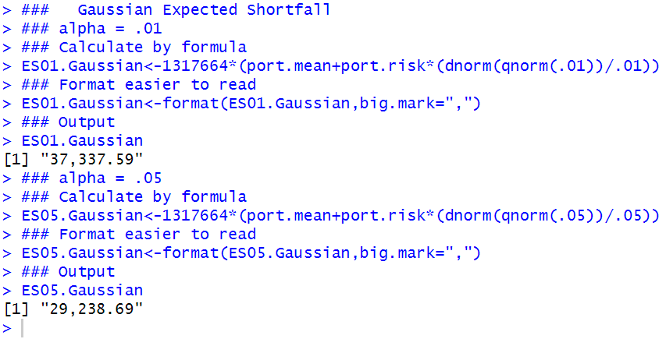

The result means that there is a 1 % (5 %) chance our losses exceed VaR, but when it does, we expect that, on average, we will lose $ 37,338 ($ 29,239).

#### 4.5.2 Historical ES

The Historical ES is calculated by taking the average portfolio loss that falls short of the Historical VaR estimate.

**Step 1: Identify Historical VaR Limit for Portfolio**

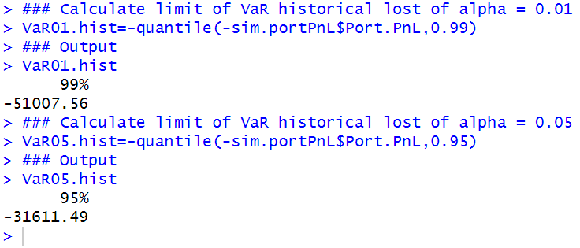

**Step 2: Identify Simulated Portfolio Losses in Excess of VaR**

To calculate ES, we have to find the average of the losses exceeding a loss of $ 51,008 for the 1 % 1-Day Historical ES and $ 31,611 for the 5 % 1-Day Historical ES.

As such, the next step would be for us to use the P&L of our simulated portfolio to identify those losses. To do this, we use dummy variables to indicate what returns fall short of the threshold for 1 and 5 % Historical ES.

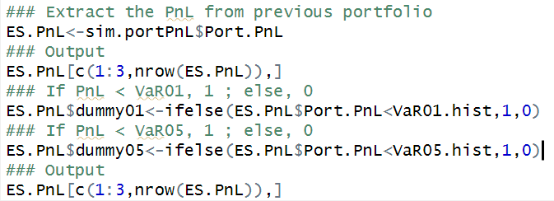

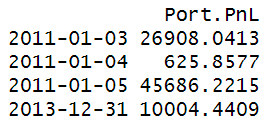

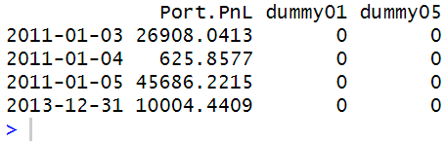

**Step 3: Extract Portfolio Losses in Excess of VaR**

Now that we have dummy variables that identify the days on which the P&L falls short of the Historical VaR estimate, we then extract those observations into a data object for the 1 % Historical ES shortfall01 and 5 % Historical ES shortfall05.

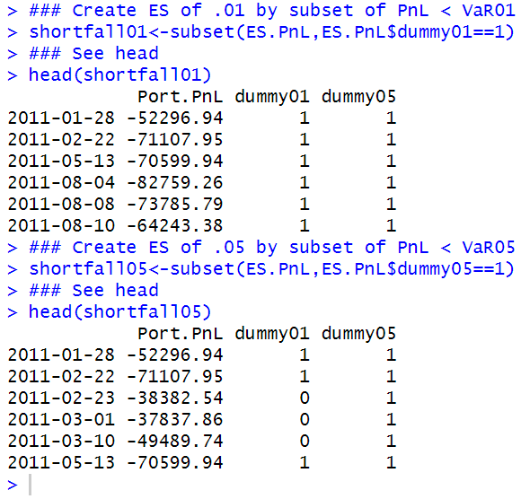

**Step 4: Compute Average of Losses in Excess of VaR**

To get the ES, we take the average of the returns is each of these data objects. We find that the 1 % 1-Day Historical ES is equal to $ 69,718. This result means that we have a 1 % probability that the loss in our portfolio would exceed the VaR, but, when it does, we expect that, on average, we would lose $ 69,718. Similarly, the 5 % 1-Day Historical ES is equal to $ 45,258. This result means that we have a 5 % probability that the loss in our portfolio would exceed the VaR, but, when it does, we expect that, on average, we would lose $ 45,258.

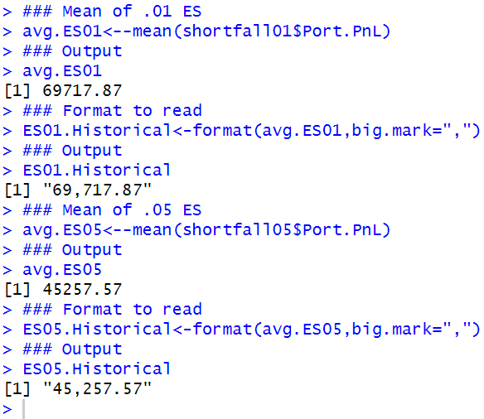

#### 4.5.3 Comparing VaR and ES

We expect that the ES values to be bigger losses than the VaR because, by definition, the ES is the mean or average loss when losses exceed VaR. This can easily be seen when we combine the results into one table.

We use a combination of the rbind and cbind commands to bring together all the resulting calculations of Historical and Gaussian VaR and ES. The intermediate results look quite messy with variable names and row labels that are not too meaningful.



As such, we rename the variable names to make them easy to understand and consistent. We also rename the row names to conform to the convention of using significance levels and, to avoid confusion, include the time horizon in our VaR and ES calculations.

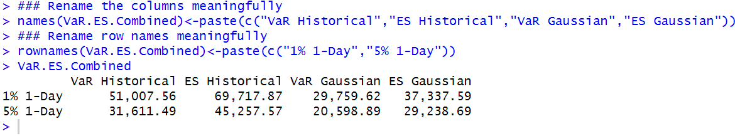

Looking at the output above, we can easily confirm that the ES is larger than the VaR, which is almost always the case.

### 4.6 Alternative Risk Measures

The advantage of using close-to-close volatility is that it only requires you to look at closing prices, but you have to use many observations to get a good estimate of volatility.

Using a large number of observations entails getting a long historical series. The earlier part of such long historical data may be less relevant to measure volatility today. The measures we will discuss are the Parkinson, Garmann-Klass, Rogers-Satchell-Yoon, and YangZhou. Parkinson uses high and low prices, while the remaining alternative volatility measures all use open, high, low, and close data.

Therefore, we may want to consider alternative measures of volatility that are more efficient than close-to-close volatility by utilizing the open, high, and low prices of the day in addition to the closing price.

#### 4.6.1 Parkinson

The Parkinson volatility measure uses the stock’s **high** and **low** price of the day. Specifically,

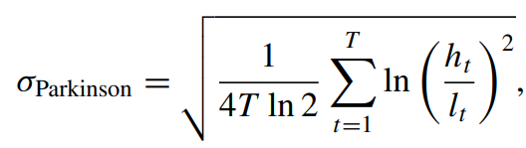



We now demonstrate how to implement this in R. Let’s apply this to the **Amazon.com** data we have been using as our example in this book.

**Step 1: Import Amazon Data from Yahoo Finance**

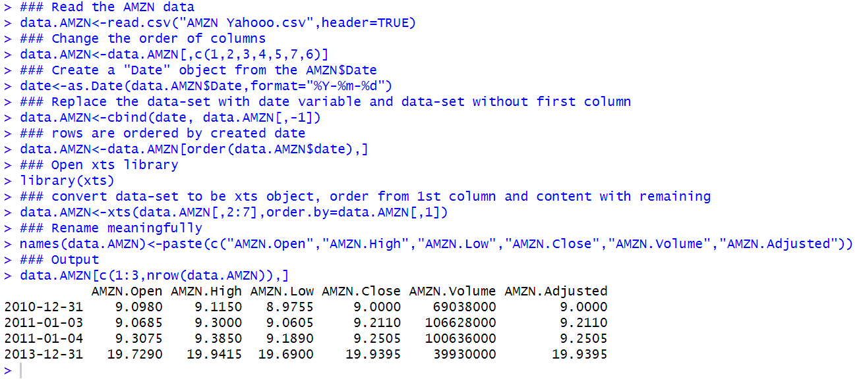

**Step 2: Keep the High and Low Price**

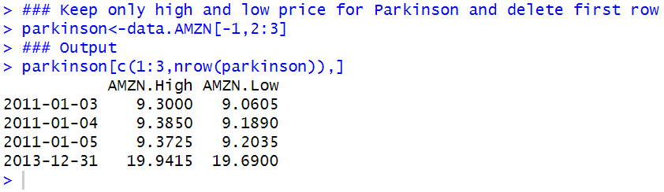

**Step 3: Calculate the Terms in the Parkinson Formula**

We first calculate the term ln ($h_{t}$/ $l_{t}$) and then take the square of that value.

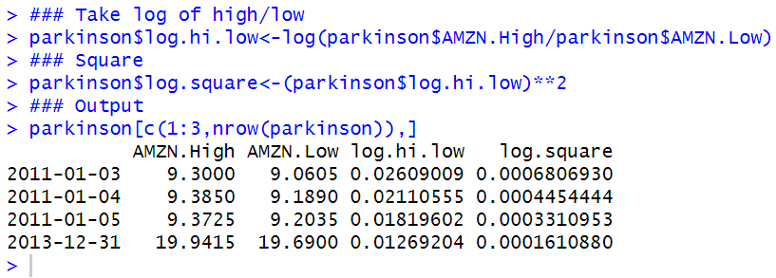

**Step 4: Calculate the Sum of the Values Under the log.square Column**

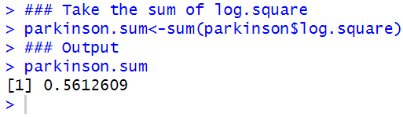

**Step 5: Calculate the Daily Parkinson Volatility Measure**

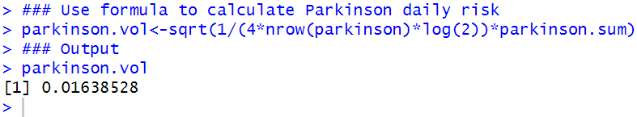

**Step 6: Calculate the Annualized Parkinson Volatility**

Using the square root of time rule, we convert daily volatility into annual volatility by multiplying the daily volatility by the square root of 252. The output below shows that the annualized Parkinson volatility is 26.0 %.

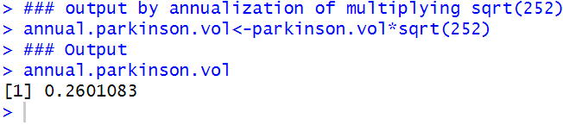

#### 4.6.2 Garman-Klass

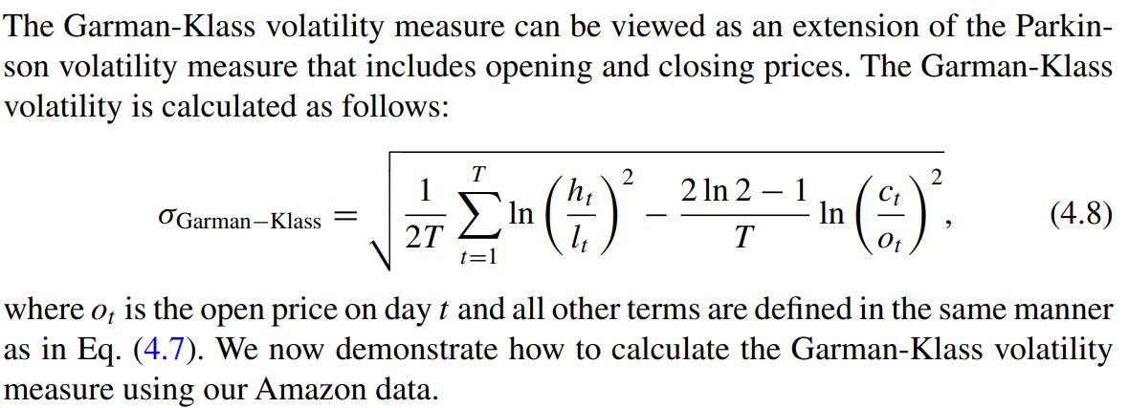

**Step 1: Import Amazon Open, High, Low, and Close Price Data**

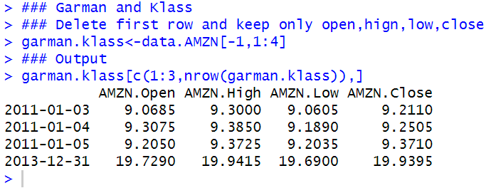

**Step 2: Calculate the First Term**

We calculate the first term inside the square root in Eq. (4.8). Notice also that the summation term is equal to the parkinson.sum we calculated above. Using that same variable can help us save some time coding.

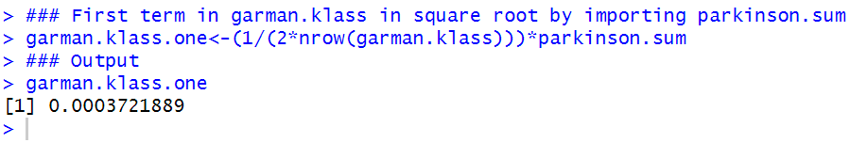

**Step 3: Calculate the Second Term**

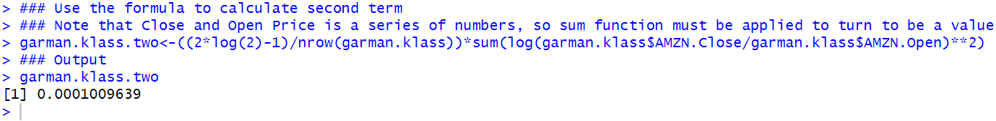

**Step 4: Calculate the Daily Garman-Klass Volatility**

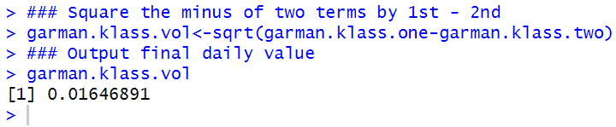

**Step 5: Annualize the Volatility**

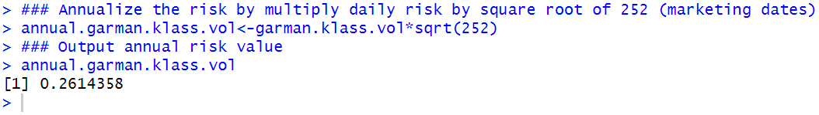

#### 4.6.3 Rogers, Satchell, and Yoon

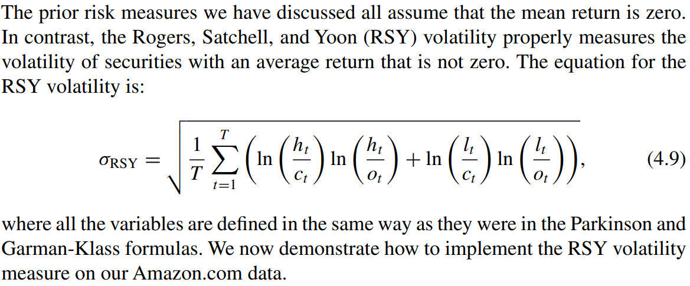

**Step 1: Obtain Open, High, Low, and Close Data**

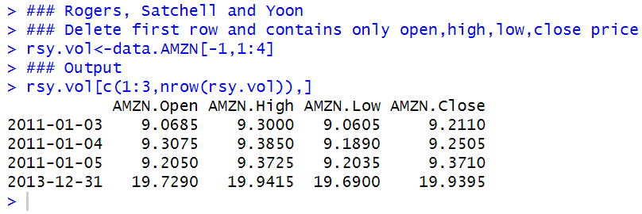

**Step 2: Calculate the Product of First Two Log Terms**

We first calculate each of the log terms (rsy.one and rsy.two) and then take their product (rsy.one.two).

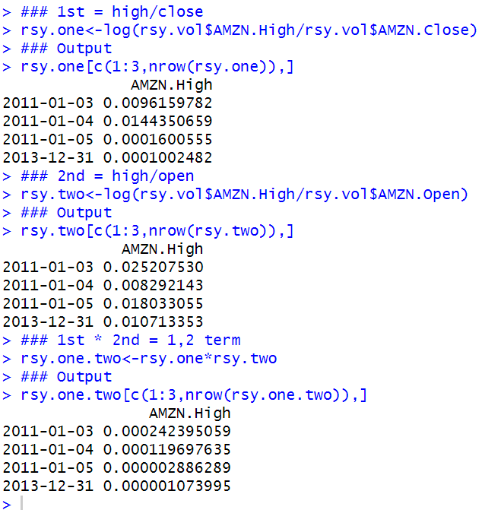

**Step 3: Calculate the Product of Last Two Log Terms**

Similar to Step 2, we first calculate each of the log terms (rsy.three and rsy.four) and then take their product (rsy.three.four).

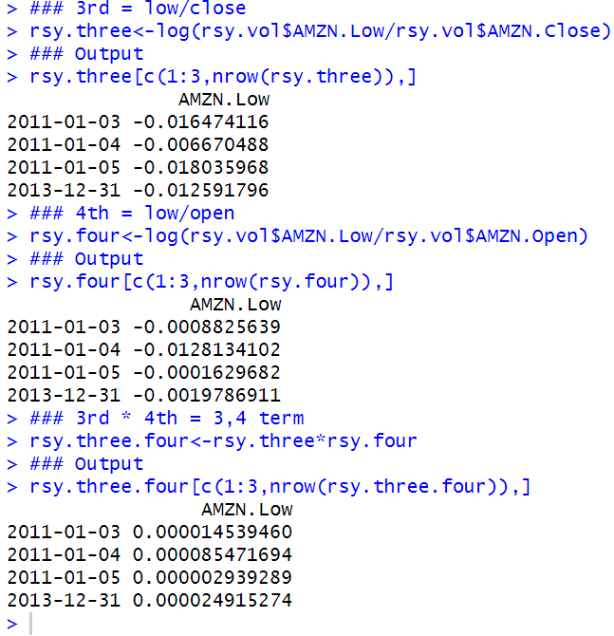

**Step 4: Calculate the RSY Volatility Measure**

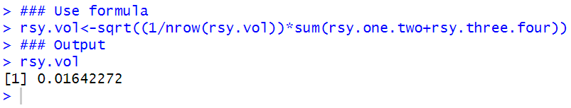

**Step 5: Annualize the RSY Volatility Measure**

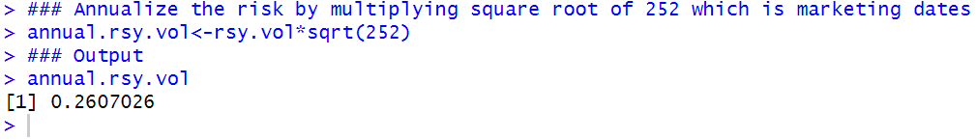

#### 4.6.4 Yang and Zhang

Yang and Zhang developed a volatility measure that handles both opening jumps and drift, which is sum of the overnight (i.e., volatility from the prior day’s close to today’s open) and a weighted average of the RSY Volatility and the day’s open-to-close volatility.

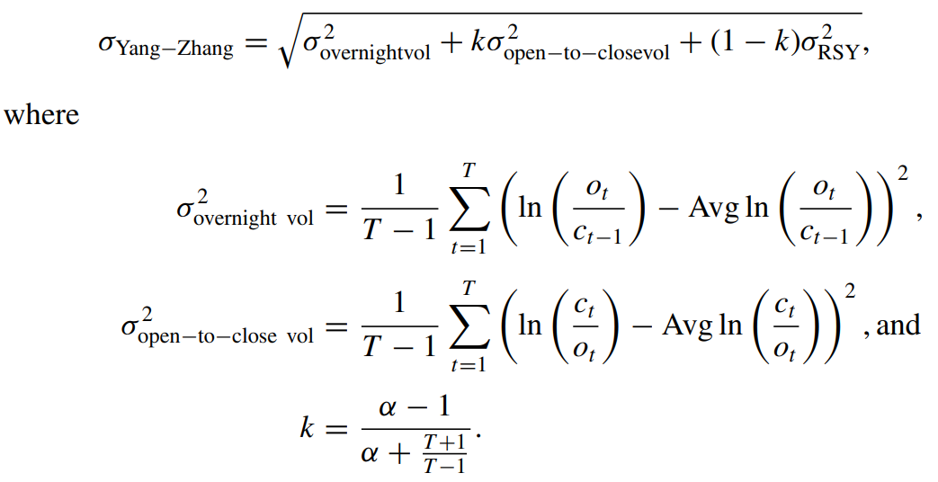

**Step 1: Import Amazon Open, High, Low, and Close Data and Create Variable for Yesterday’s Closing Price**

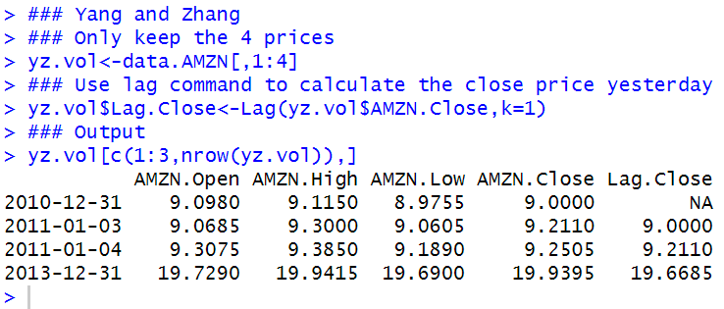

**Step 2: Delete December 31, 2010 Data**

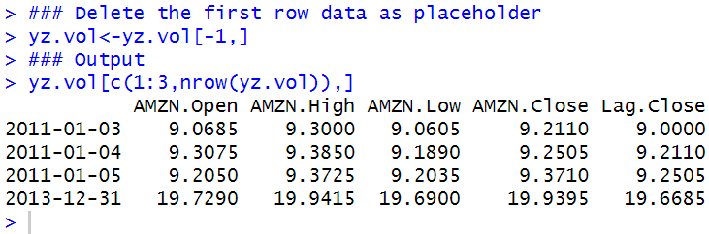

**Step 3: Calculate the First Term in the Yang-Zhang Equation**

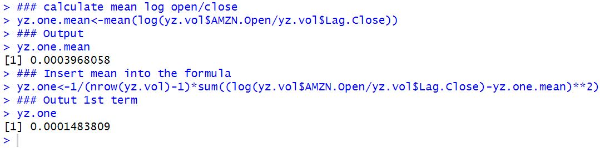

**Step 4: Calculate the Second Term in the Yang-Zhang Equation**

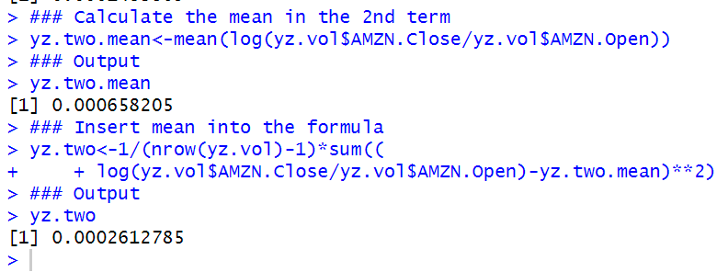

**Step 5: Calculate k**

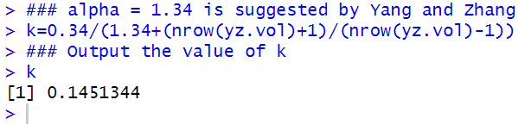

**Step 6: Calculate the Annualized Yang-Zhang Volatility**

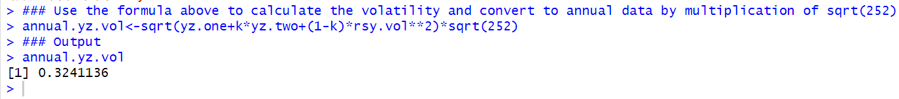

#### 4.6.5 Comparing the Risk Measures

Before we can compare these numbers, we have to first calculate the close-to-close volatility for this same time period.

**Step 1: Calculate Amazon Returns Data**

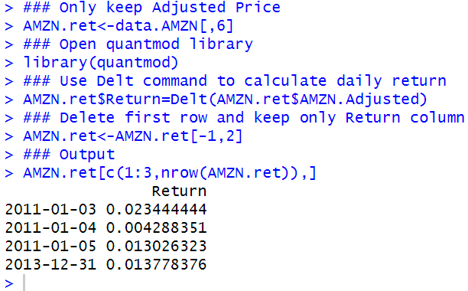

**Step 2: Calculate Log Returns**

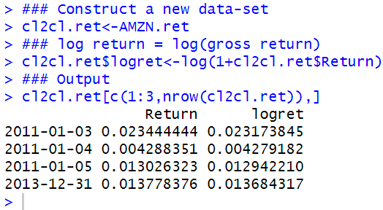

**Step 3: Calculate Standard Deviation of the Returns**

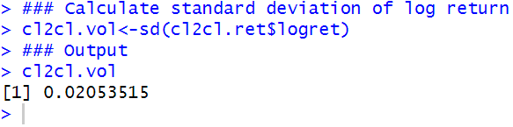

**Step 4: Annualize the Close-to-Close Volatility**

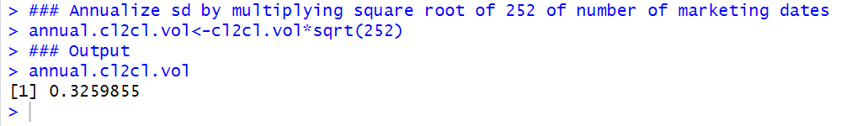

**Step 5: Create Table of the Different Volatility Measures**

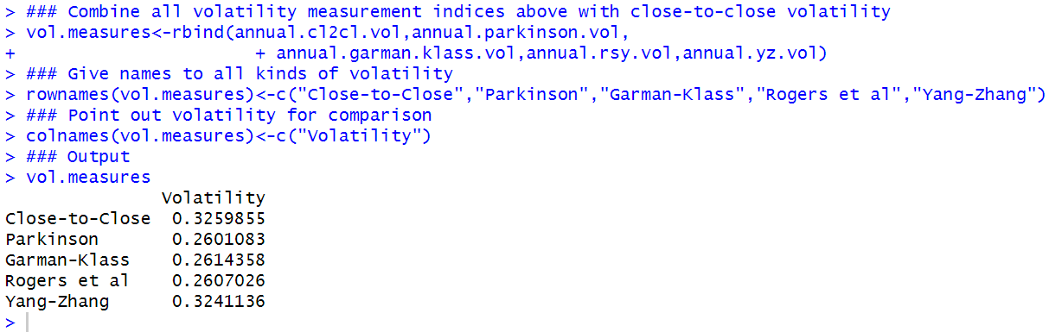

### 4.7 Further Reading

Many investment textbooks (e.g., Bodie et al. [3] and Reilly and Brown [7]) have more detailed discussions of standard deviation/variance as well as portfolio risk. Jorion [5] provides an excellent and readable treatment of value-at-risk. A comprehensive discussion of value-at-risk and expected shortfall, as well as the use of a benchmark VaR, can be found in Alexander [1]. Bennett and Gil [2] and Sinclair [8] have a very good discussion of various risk measures

## Chapter 5 Factor Models

Factor models are used in many financial applications, such as identifying the determinants of a security’s return as well as in cost of capital calculations. Factors help explain the variation in a security’s return.

The simplest factor model is one based on a single factor. The most popular of these models is the Capital Asset Pricing Model (CAPM). In the CAPM, only the sensitivity of the security’s return to the market portfolio’s return matters. The CAPM is based on a series of assumptions, which are detailed in any decent corporate finance or investments textbook. **However, the CAPM does not perform well in empirical testing, but, to its defense, it is unclear whether such poor performance is really a failure of the CAPM or the failure to use the “true” market portfolio of all available assets in these tests (i.e., this is known as Roll’s Critique).**

In many empirical tests, especially for practical applications, a simpler version of the CAPM is often used. This is known as the market model. Like the CAPM, the market model is also a single factor model but, this time, there is no imposition as to what kind of market proxy should be used.

Hence, any broad-based stock market index is often used, such as the S&P 500 Index, MSCI World Index, etc.

An alternative to the CAPM, which is a single factor model, are multi-factor models. These models including additional factors that help explain more of the variation in expected stock returns.

The most common multi-factor model in finance is the Three Factor Model developed by Eugene Fama and Kenneth French (FF Model).

In addition to the market’s return, the FF Model also includes as a factor the difference in returns between small and large capitalization stocks and the difference in returns of high and low book-to-market (i.e., value and growth stocks) stocks.

The FF Model is based on statistical results, but is now becoming the prevalent factor model used in academia.

### 5.1 CAPM

Due to its ease of implementation, the most commonly-applied factor model is the Capital Asset Pricing Model (CAPM) by Sharpe.

At least the starting point of many costs of capital calculations is the CAPM, although adjustments may be made to account for the size premium, country risk premium, and other premiums some analysts believe may not be captured by the CAPM.

The value of a company’s stock can be characterized as the **present value of the stream of dividend payments** shareholders expect to receive from holding the stock.

Since these dividend payments are expected to **arrive at different points in time in the future**, we have to **discount those dividend payments** by an appropriate risk-adjusted **discount rate**.

The CAPM gives us the appropriate risk-adjusted discount rate to use. From a mathematical perspective, the formula for the CAPM is:

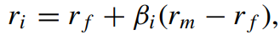



**CAPM Regression**

Empirical tests of the CAPM typically convert the formula into its **excess return** form.

The **excess** pertains to the return over the risk-free rate of both the subject security’s return and the market return. That is, the CAPM in **excess** return form is as follows:

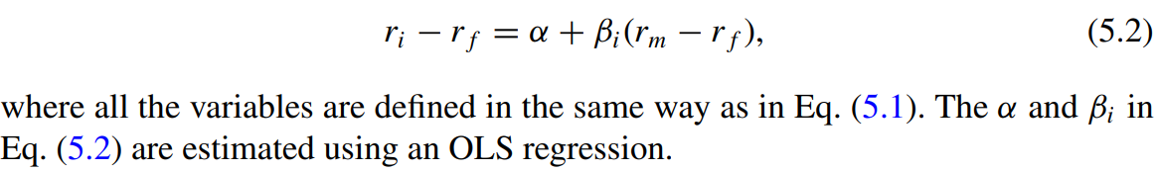

To perform the CAPM regression, we need to choose:

1. the length of the estimation period,
2. the frequency of the returns data,
3. the risk-free rate used in the calculation.

Technically, this gives us a large number of possibilities and could potentially lead to a large number of variations in the results.

In our implementation, for (i) and (ii), we follow the methodology described on the Morningstar and Yahoo Finance websites, which is to use 3 years of monthly returns or 36 monthly return observations for both the subject security’s return and market return.

For (iii), we use the 3-Month Treasury Bill rate following Morningstar’s description.

**Step 1: Import Portfolio Returns and Convert to a data.frame Object**

In this Appendix, we construct a hypothetical portfolio assuming portfolio returns are equal to that of an equal-weighted portfolio of Amazon.com (AMZN), Nvidia (NVDA), and IBM stocks from January 2011 to December 2013 with monthly rebalancing. To implement this, we need to make sure we have data from December 2010 in order to calculate a monthly return for the monthly of January 2011. Note that this is merely a hypothetical portfolio with constructed returns. This is meant as a proxy for our actual portfolio returns used in this book. To construct the portfolio returns, we calculate the monthly returns for AMZN, NVDA, and IBM using the techniques we discussed in Chap. 2.

Here is the code and the output below for simplicity.

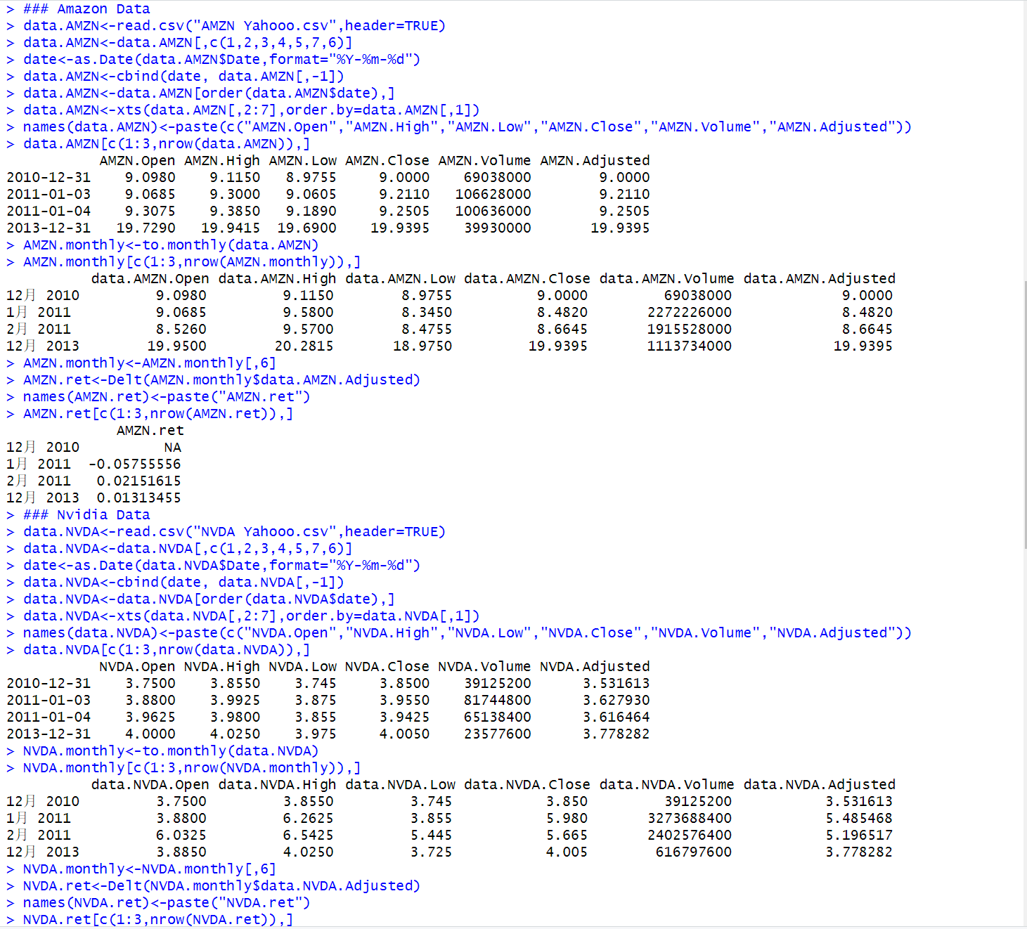

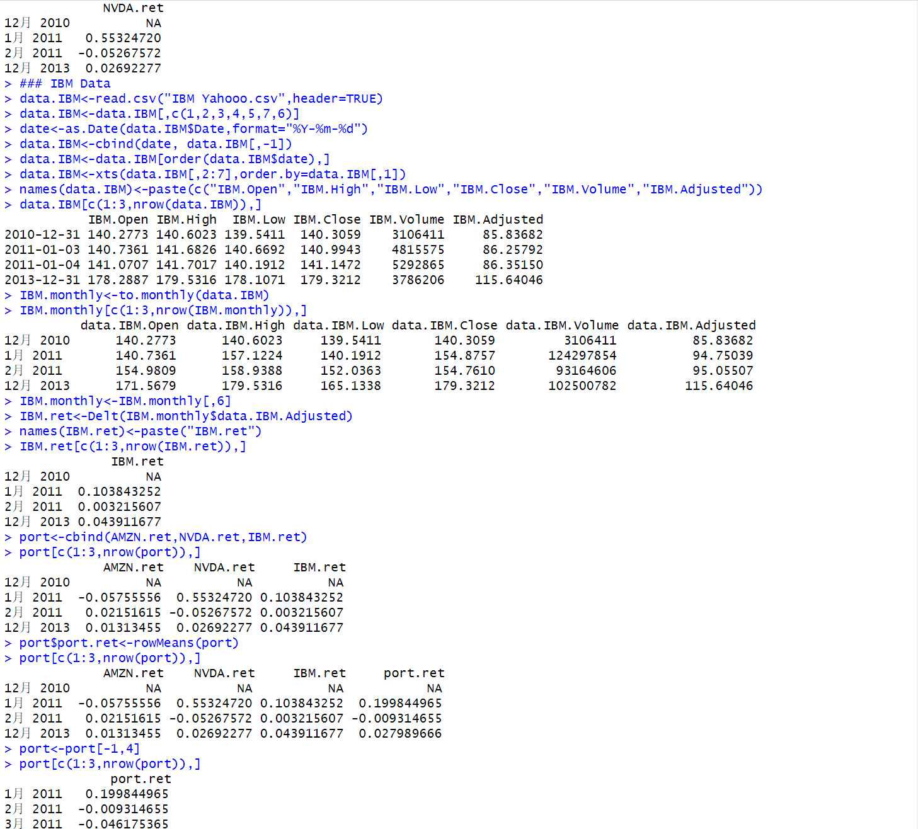

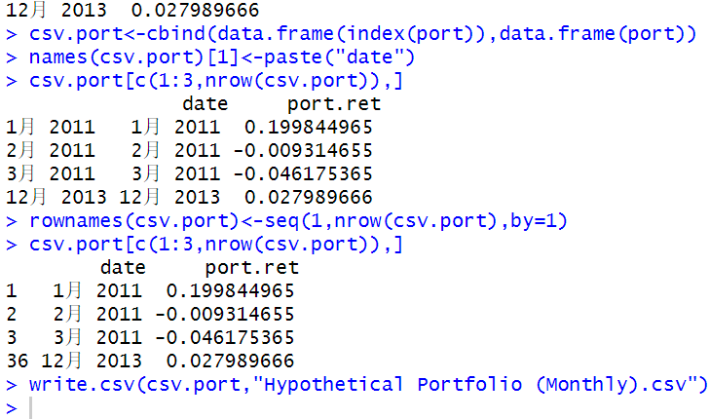

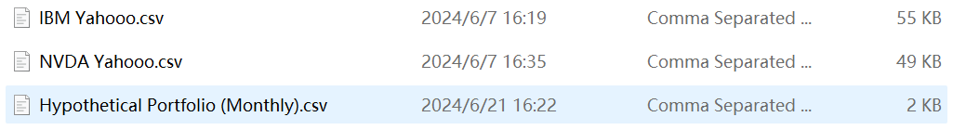

Obviously, the monthly hypothetical portfolio data has been saved in the hierarchy.

Now we go back to implement CAPM Factor Model.

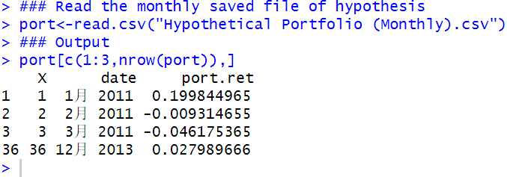

Since we are only using month and year, we use the yearmon class, which we can apply by using the as.yearmon command. Note the %b %Y format. %b tells R the format being read has a three-letter month and the %Y tells R the year is a four-digit year. Details on the different date formats are found in Appendix A.

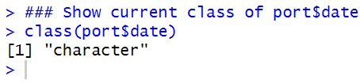

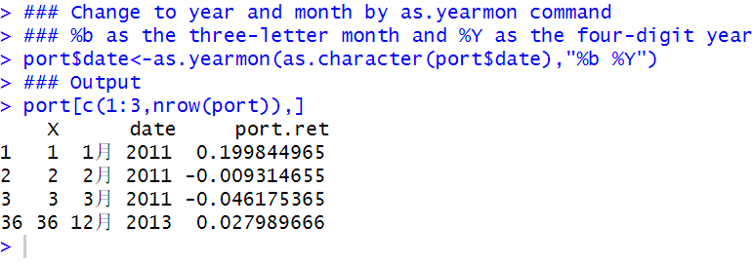

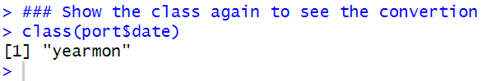

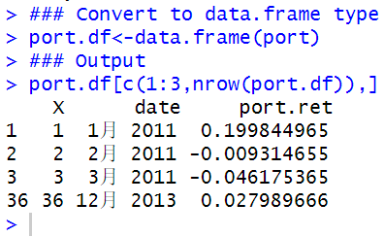

**Step 2: Import S&P 500 Index Data from Yahoo Finance and Calculate Monthly Market Returns**

As I mentioned above, I have replaced S&P 500 Index by Apple (AAPL) to kind of modelling the trends of the market.

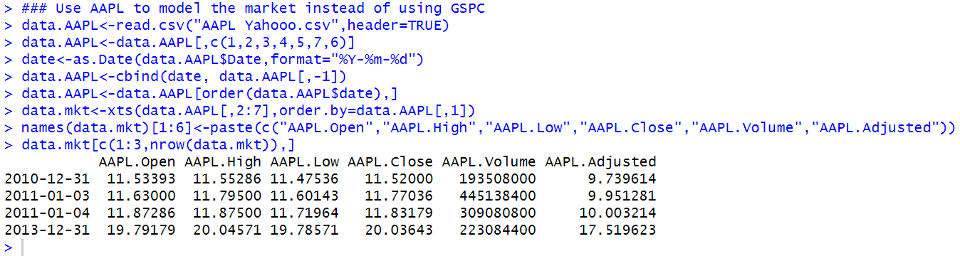

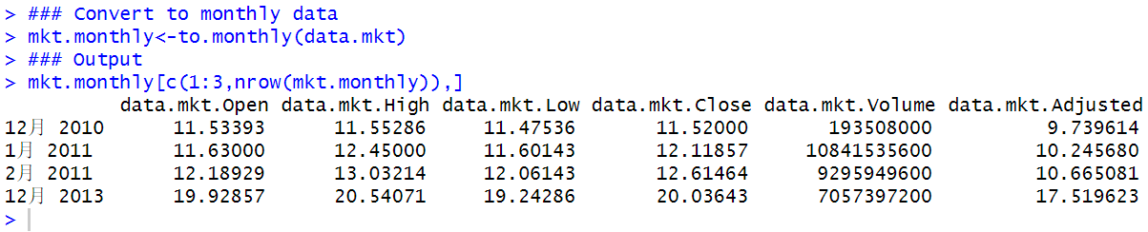

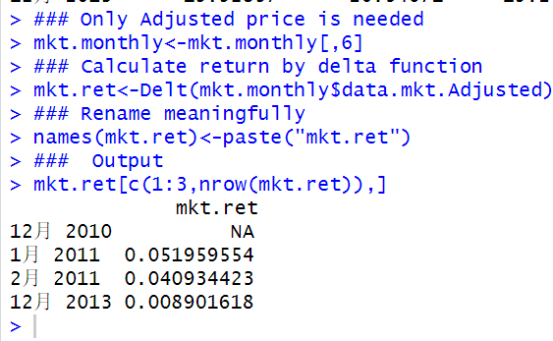

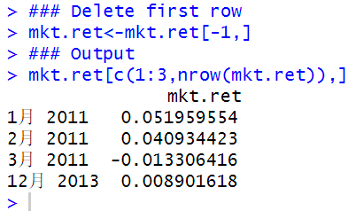

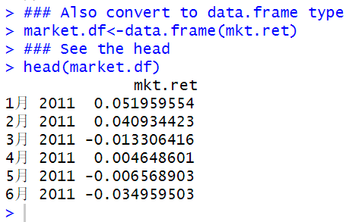

**Step 3: Import Risk-Free Rate Data from FRED and Setup Data to Contain Monthly Risk-Free Returns**

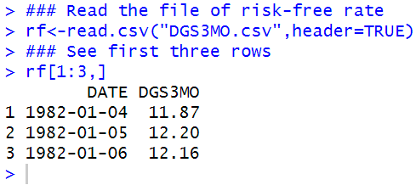

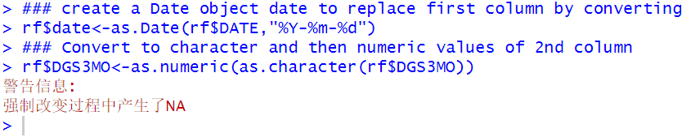

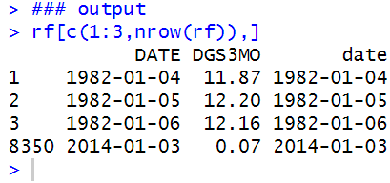

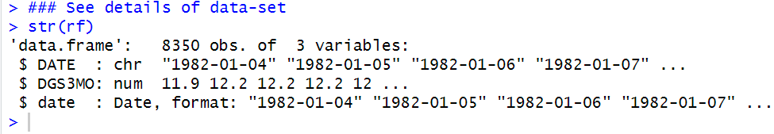

**Step 3a: Convert to xts Object**

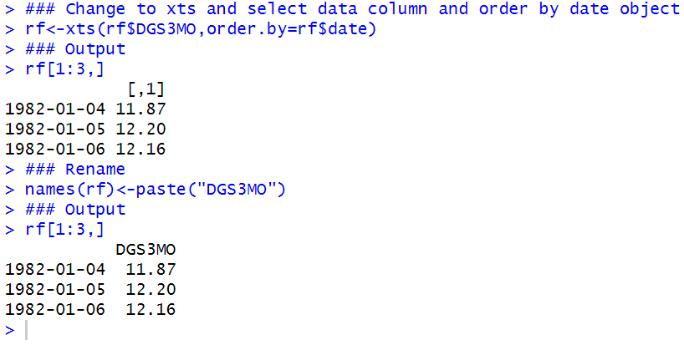

**Step 3b: Apply to.monthly Command to Identify First Yield for Each Month**

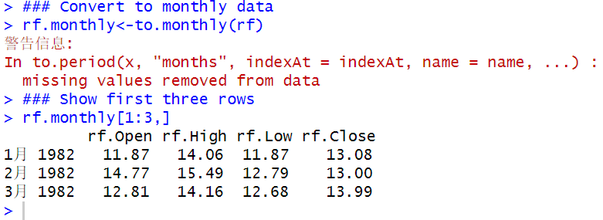

**Step 3c: Convert Opening Annualized Yield for Each Month Into a Monthly Yield**

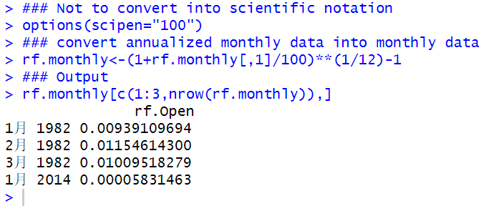

**Step 3d: Subset Data to January 2011 Through December 2013**

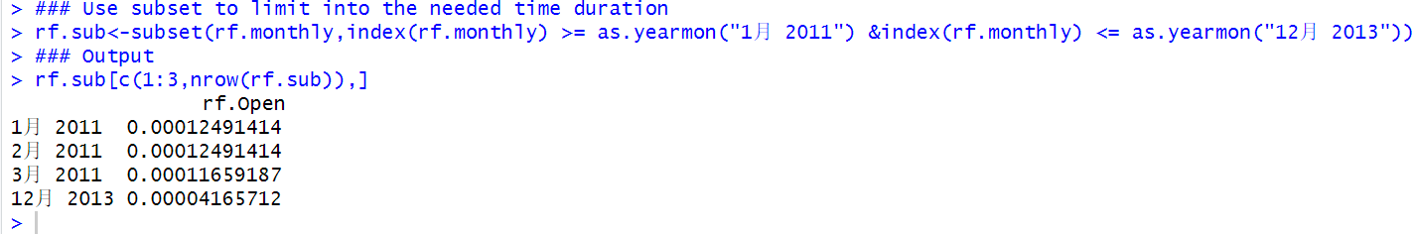

**Step 4: Combine Firm, Market, and Risk-Free Data into One Data Object**

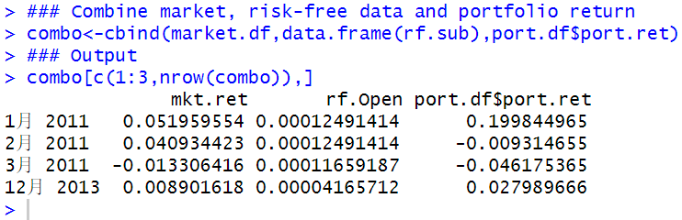

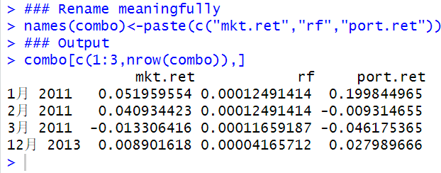

**Step 5: Calculate Excess Firm Return and Excess Market Return**

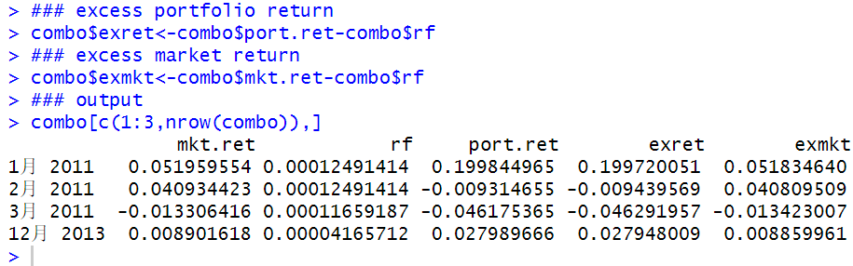

**Step 6: Run Regression of Excess Firm Return on Excess Market Return**

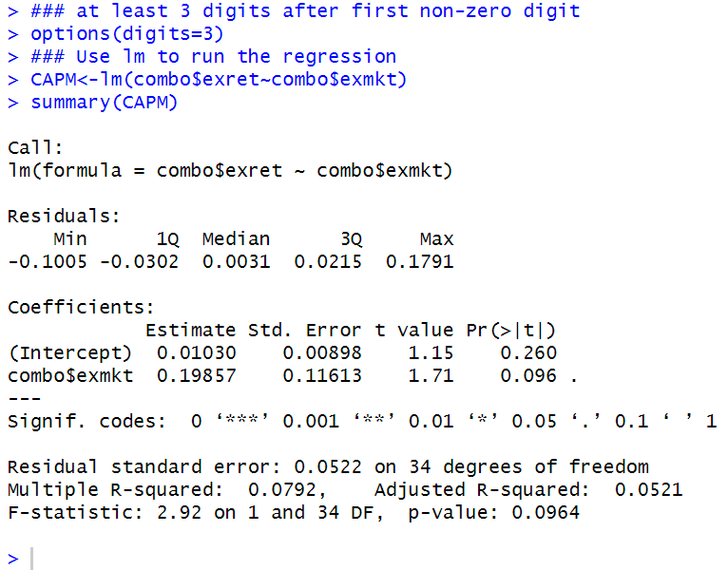

**CAPM Alpha**

When making investments into a fund, investors often consider the contribution of the fund manager to the performance of the fund. As such, we need a way to measure whether a fund manager provided value that goes beyond simply investing in the index (i.e., is there a benefit to active management by the manager instead of simply using a passive investment strategy). An alternative way to look at this problem is we want to know how well did the **fund manager** do compared to her ***benchmark***?

To answer this question, we look at the ***alpha*** of the manager as a measure this outperformance.

The regression controls for the sensitivity of the portfolio’s return to its benchmark.

If this alpha is **positive and statistically significant**, the manager is taken to have provided positive value. Conversely, a **negative and statistically significant** alpha is taken to mean that the manager has provided negative value (i.e., we would have been better off investing in the benchmark).

The alpha of the portfolio is the intercept term from the regression output above. The intercept is equal to 0.01030, which translates to a monthly return of 1.03 %. This alpha is statistically insignificant at the 5 % level, which is a conventional level of significance used in practice. As such, assuming our hypothetical portfolio returns, we can’t make the decision since it is statistically insignificant.

**CAPM Beta**

Another important measure we can derive from the results of the CAPM regression is the portfolio’s ***beta***. The ***beta*** of a portfolio measures how ***sensitive*** the portfolio’s return is to the movement of the overall market. Therefore, the ***beta*** of the portfolio measures what is called ***systematic risk or market risk***. **Systematic risk** is the portion of a security’s risk that **cannot be diversified away** and, as such, it is commonly thought of as the level of risk that investors are ***compensated*** from taking on.

From taking on. From the regression results above, we can read-off what the beta for the portfolio is. This is the parameter estimate of the combo$exmkt variable of 0.199 with a p-value of 0.096. The p-value tells us the minimum significance level for which the beta is statistically significant. A p-value of 0.096 means that only at significant level of 10% it is statistically significant, neither that we still cannot make the decision.

An alternative way to view the beta and the p-value is to call them directly from the regression summary results. Instead of simply stopping at **summary (CAPM)**, we can include **$coefficient[...]** where inside the square brackets we could place **one or a vector of numbers** using the **c(...) operator** to output. Looking at the regression summary output above, we see the coefficients have eight values. The numbering works like this. Number 1 is the Estimate of the intercept, number 2 is the estimate of the excess market return (or the beta), number 3 goes back up as the Std. Err. of the intercept, then number 4 goes down as the Std. Err. of the beta, and so on. So, if we need to know what the **beta and p-value of the beta** are, we choose numbers **2 and 8**.

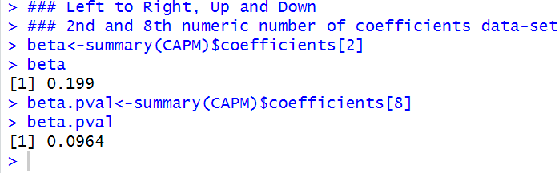

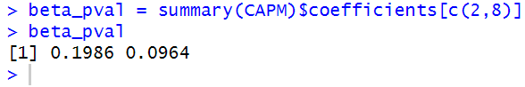

The results of the CAPM regression show that the CAPM beta is 0.199. This beta of 0.199 can then be used in the CAPM to calculate, say, the **cost of equity for the company**. This means that if the market goes up by 1 %, we expect our portfolio to go up by only 0.2 %. However, if the market goes down by 1 %, we expect our portfolio to only go down by 0.2 %. A beta less than one is consistent with **betas of defensive stocks** as these stocks are less affected by adverse market movements.

**Using Calculated Beta to Estimate Cost of Equity Using CAPM**

To calculate the cost of equity using the CAPM, we need to find an **Equity Risk Premium (ERP)** that is compatible.

For our example, we should use an **ERP** that is calculated using a **3-Month Treasury security**. One such source for the historical **ERP** is **Professor Damodaran**’s website.

Professor Damodaran’s calculations show an ERP of 5.38 % based on an arithmetic average of returns from 1928 to 2012 and 7.19 % based on an arithmetic average of returns from 1962 to 2012.

This range of ERPs is consistent with the general range of ERPs of around 5–8 %. Given that the 3-Month Treasury as of December 31, 2013 was approximately 0.07 %, we estimate the cost of equity of our portfolio is 1.15 % [= 0.07 % + 0.2 * 5.38 %] based on the ERP from 1926 to 2012 and 1.51 % [= 0.07 % + 0.2 * 7.19 %] based on the ERP from 1962 to 2012.

The low cost of equity is due to the low beta of 0.199 we estimated for our portfolio.

**Calculate Adjusted Beta**

There have been studies that show betas that are above the market beta of one tend to go down in the long-term, while betas that are below the market beta of one tend to go up in the long-term.

Since valuations take a long-term view,

some believe betas used in calculating the cost of equity need to be adjusted to reflect this reversion to the market beta.

One common adjustment is to apply 2/3 weight to the raw beta, which is the beta we calculated above, and 1/3 weight to the market beta of one.

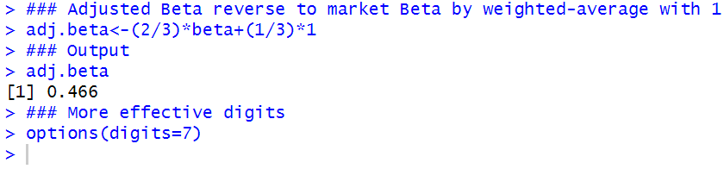

The weighting we used for the adjusted beta calculation is the standard assumption used by Bloomberg when reporting adjusted beta.

### 5.2 Market Model

A more common way to calculate beta in practice is to use the market model, because the market model uses a market proxy without the requirement that this market proxy be the “true” market portfolio.

In addition, the market model does not require the use of a risk-free rate and, therefore, there is no need to calculate the excess returns of the firm and the market. That is,

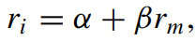

where all variables are defined the same way as in the CAPM regression.

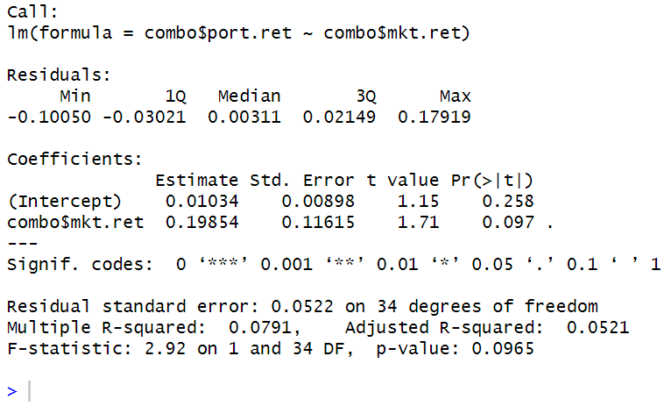

The beta calculated using the market model is 0.19854, which is very close to the beta calculated using the CAPM of 0.19857. The small difference is primarily driven by the low, stable risk-free rate during the estimation period.

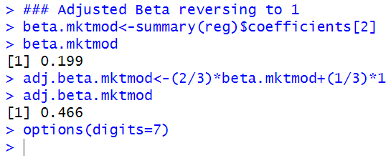

### 5.3 Rolling Window Regressions

In this section, we demonstrate how to run regressions over a rolling window, so we can calculate the alphas and betas for Amazon.com over multiple periods to analyze the variation of the alpha and beta through time.

In our example, we will calculate alphas and betas using regressions on 252 trading day periods from 2012 to 2013. Since our first return starts in 2011, the 252 trading day window, which is approximately one calendar year in length, will use virtually all of the returns in 2011 to generate the first estimate of alpha and beta on December 31, 2011.

**Step 1: ImportAmazon.com and Apple.com Data**

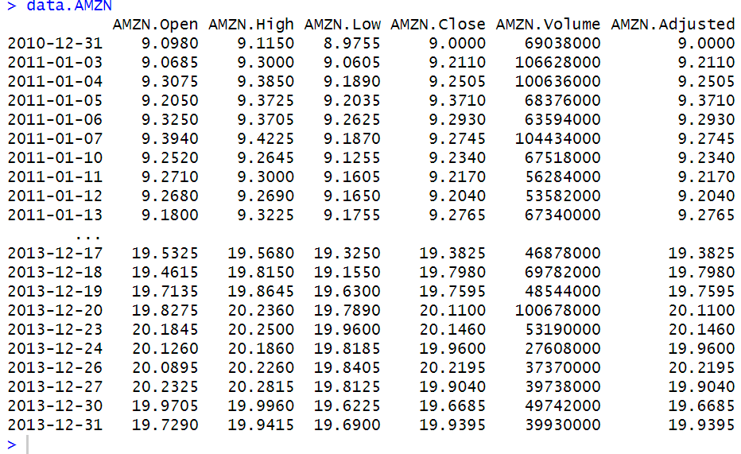

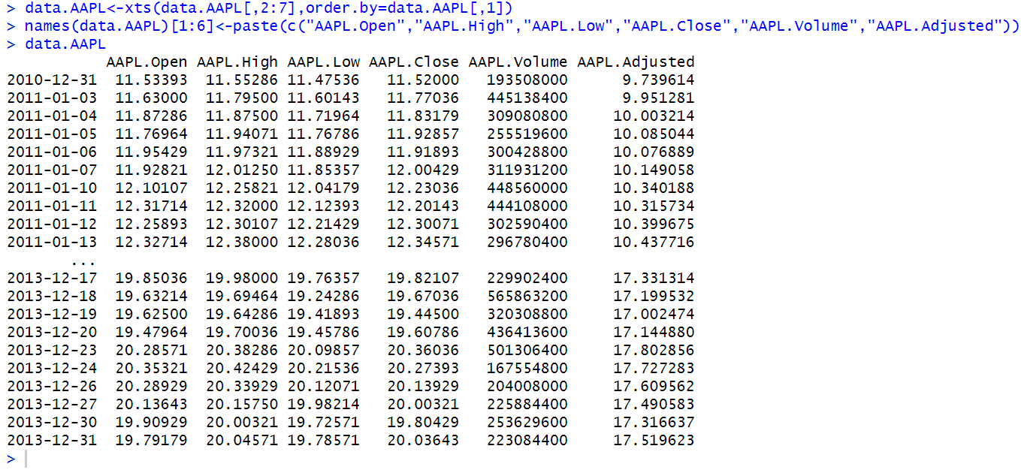

Both have been imported by R memory.

**Step 2: Calculate the Amazon.com and Apple.com Returns**

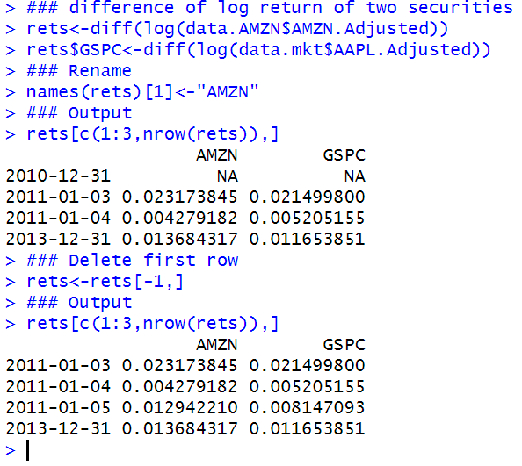

**Step 3: Create the Rolling Window Regression Function**

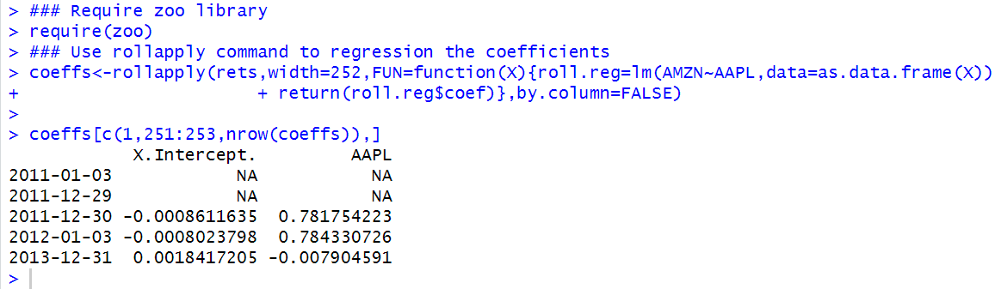

Note that the term return(roll.reg$coeff) is used to output the parameter estimates (i.e., the intercept term and the coefficient for the market return) of the regression.

**Step 4: Remove NAs From the Data**

As the output above shows, the first 251 observations of coeffs are NAs. This is because we need 252 observations to generate the first regression, which would be on December 30, 2011. As such, we would want to delete all those NAs.

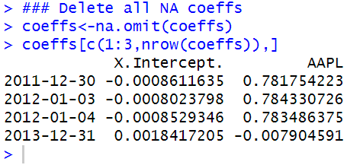

**Step 5: Clean-Up Data**

For presentation purposes, the coeffs data has a single observation in 2011, contains labels that may not make sense to other people, and we may feel that there are too many decimals that are being reported.

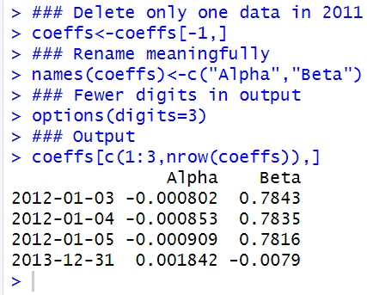

**Step 6: Plot the Data**

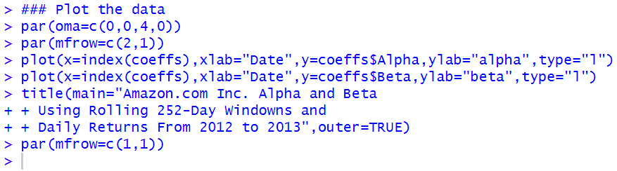

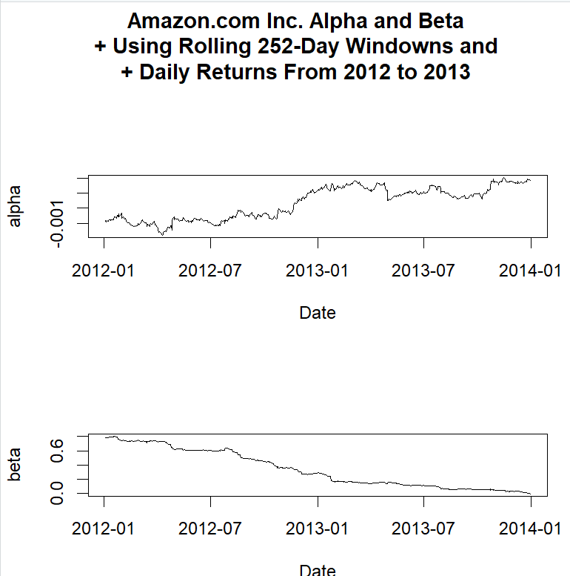

From the graph it is known that risk-free assets are increasing in values over the time, and compared to Apple.com, Amazon.com becomes more and more of a defensive stock since beta decreases steady to 0, where AMZN is not affected by AAPL finally.

### 5.4 Fama-French Three Factor Model

The popularity of the CAPM is due to its simplicity and it is grounded in finance theory. However, the CAPM has not performed well in empirical testing. This suggests other factors may need to be added to help explain the remaining variation in asset returns unexplained by the market.

One such model that has gained popularity, especially in the academic community, is the Fama-French Three Factor (FF) Model (see Fama and French).

For example, Cochrane points out that the FF Model has taken the place of the CAPM for routine risk adjustment in empirical work.

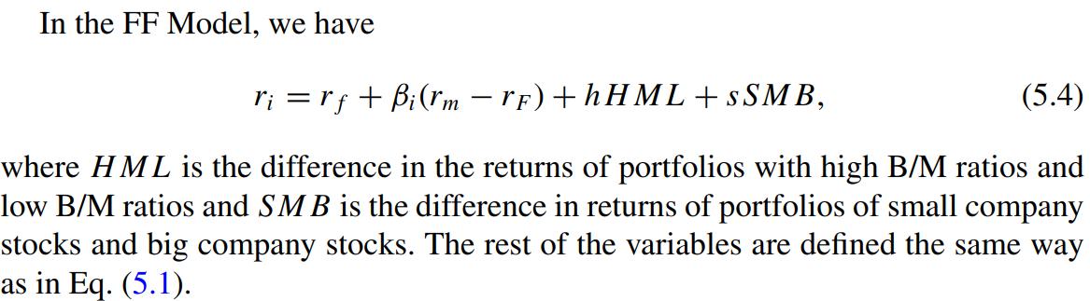

The data needed to implement the FF Model can be downloaded from Professor Kenneth French’s Data Library (U.S. Research Returns Data). Note that the files on Professor French’s data library are regularly updated, so downloading data at a later date results in retrieving more data albeit the start of the data should remain the same as what we report below.

**Step 1: Import Portfolio Returns Data**

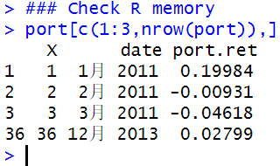

**Step 2: Import Fama-French Data Retrieved From Ken French’s Website**

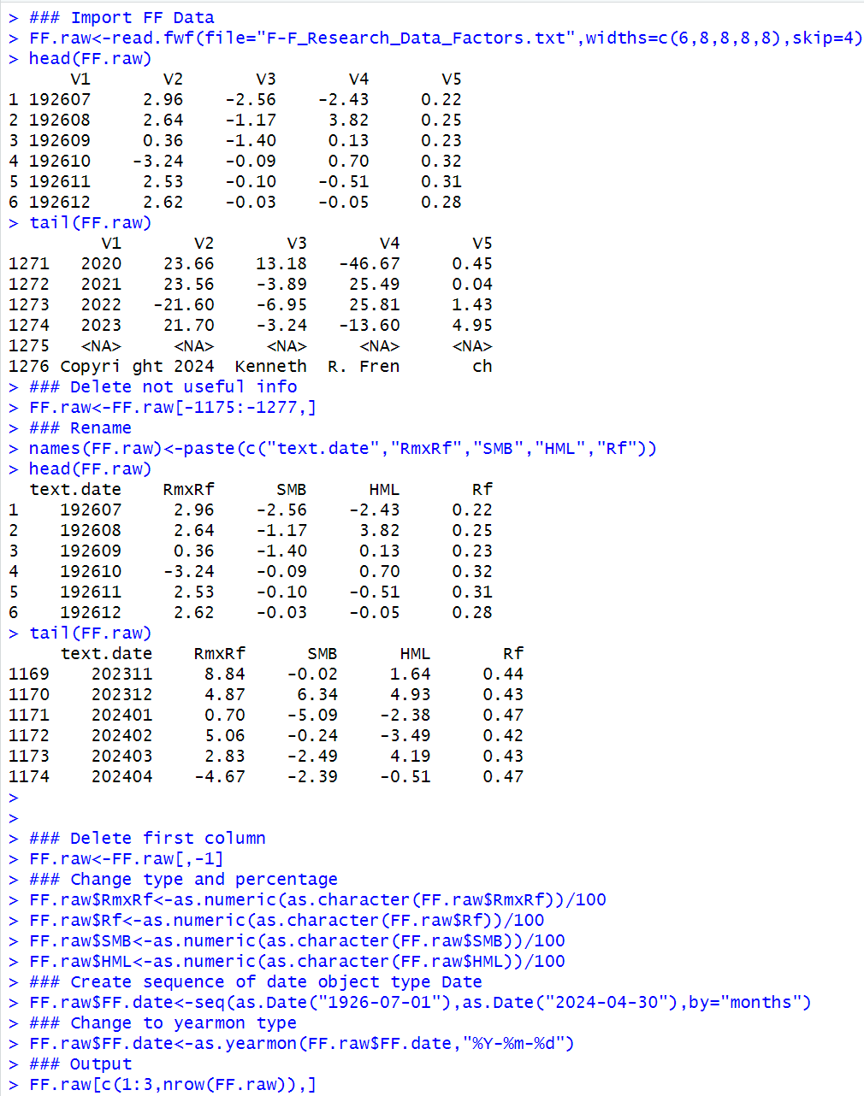

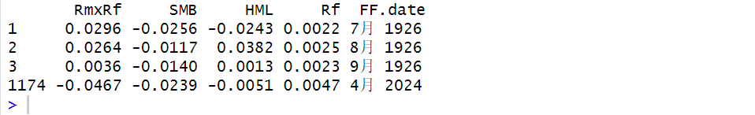

**Step 3: Subset Fama-French Data to Relevant Time Period**

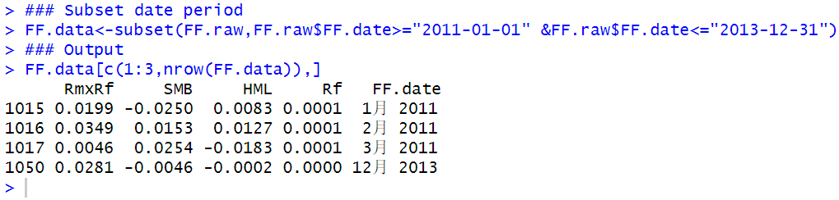

**Step 4: Combine Portfolio Returns Data and Fama-French Data**

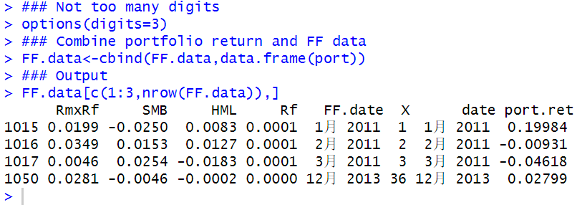

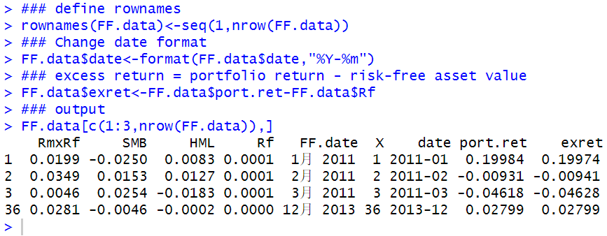

**Step 5: Run Regression Using Fama-French Factors**

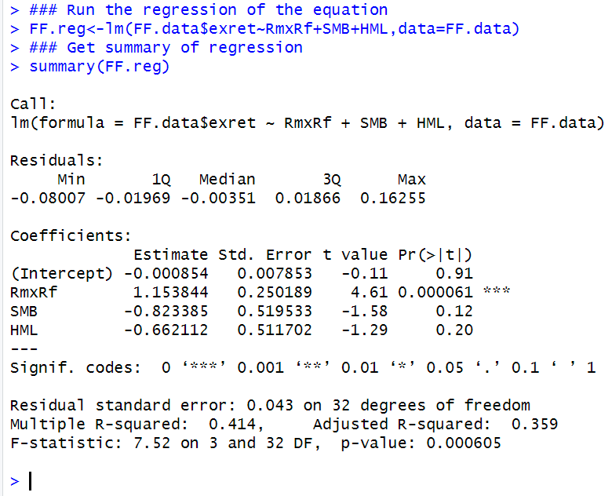

Now, we can run a regression based on Eq to find the parameter estimates. The FF model shows that only the excess market return (RmxRf) is the only coefficient that is statistically significant. However, the model has an F-statistic that is highly significant.

**Compare Fama-French Results with CAPM Results**

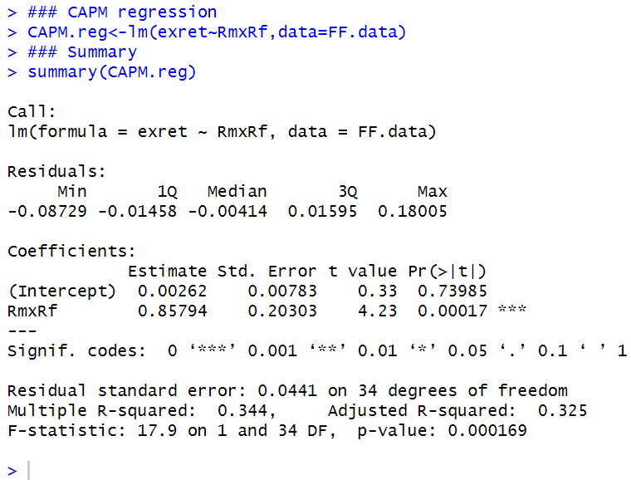

We can create a small summary table comparing the FF and CAPM beta, p-value of the beta, and adjusted R-squared. We can do this by combining the rbind and cbind commands.

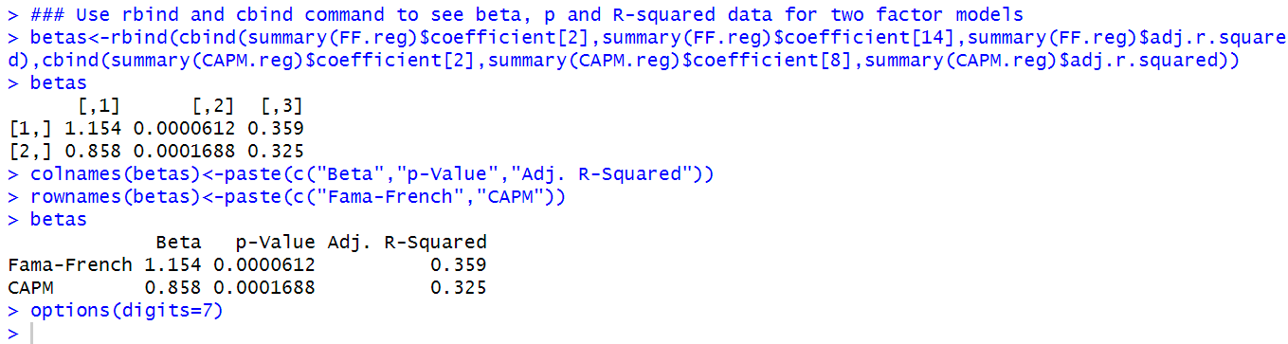

Fama-French’s Beta here is more than 1, which is not a relatively good defensive factor model, however, the calculation cannot just be ERF multiplying beta here since it is a more complicated model. But its R squared is bigger.

### 5.5 Event Studies

An event study tests the impact of new information on a firm’s stock price. As such, event studies presume that markets are semi-strong form efficient.

The foundation of the event study is based on the Capital Asset Pricing Model (CAPM). An event study estimates the impact of a specific event on a company or a group of companies by looking at the firm’s stock price performance.

The event study uses the historical relationship between the firm’s stock return and one or more independent variables.

The independent variables are often chosen to be a proxy for the market and/or the firm’s industry.

Based on this historical relationship, an event study predicts a return for the company on the event date. An abnormal return is then calculated as the difference between the firm’s actual return on the event date and the predicted return on the event date.

As the name suggests, an event study requires an “event” to be identified. This “event” could be something that affects a particular firm (e.g., corporate earnings announcements) or something that affects an entire industry (e.g., passing of new legislation). Moreover, some events are not reported in isolation (i.e., events are announced together with other information that could also affect the firm’s stock price).

Therefore, the hypothesis we test in an event study depends on the specifics of the event and a more involved analysis may be necessary to determine the effect of the particular “event” we intend to study. Put differently, we cannot simply apply a cookie-cutter approach to performing event studies, as the underlying economics may not match a purely mechanical application of event studies. This is truer for single-firm event studies, because we cannot benefit from averaging our results across multiple firms.

To conduct an event study, we need to identify two time periods. The first time period is the day or days around which the effects of an event has occurred. We call this the event window. The length of the event window depends on the type of event being studied. In the US, strong empirical evidence exists to show that stock prices react very quickly, usually within minutes, of material news announcements. Therefore, a one-day event window is likely sufficient when the timing of the event can be clearly identified. In some instances, news may be leaked days or weeks prior to the official announcement. This can be the case for some mergers. In this case, the event window can be extended to longer periods to fully capture the effect of the event.

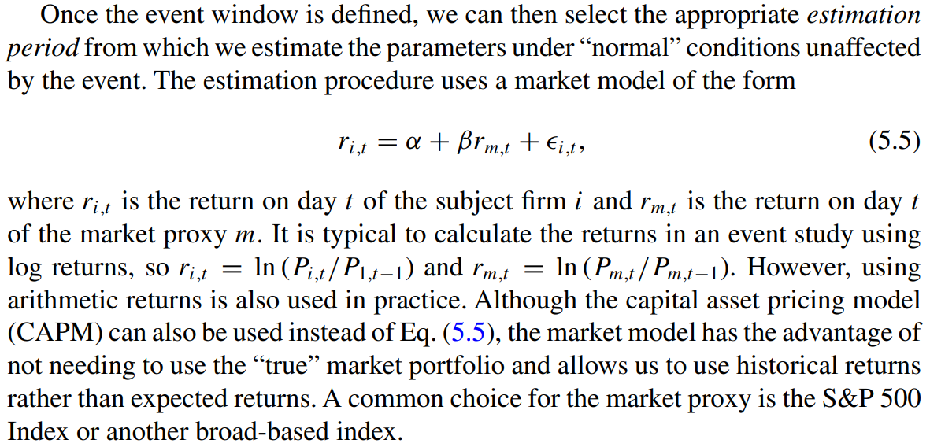

Note that what constitutes “normal” depends on the event being studied. For example, if we are studying earnings announcements, then placing the estimation period prior to the event window may be appropriate. However, if we are studying an event immediately after a large merger that changes the underlying economics of the firm, then placing the estimation period after the event window may be better. Further, one must also be cognizant of whether the volatility of the abnormal return is significantly different due to non-event factors. For example, we likely will find many significant days if we analyze an event during the 2008/2009 financial crisis when we choose an estimation period before or after the crisis.

Typically, when daily data is used, a 6-month or 1-year period is sufficient. Note that the choice of the length of the estimation period is a trade-off between including more data with the risk of including less relevant data to predict the performance of the stock during the event window.

Since we are using statistical methods to estimate the abnormal return, not all non-zero abnormal returns should be interpreted as a reaction to the disclosed information. The reason is that we have to account for the normal volatility of the firm’s stock return. For example, a highly volatile stock may move up or down 5–10 % in any given day, which means that a 10 abnormal return for that stock cannot be discerned from the normal volatility of the stock. Hence, we have to test whether the abnormal return is sufficiently large that it can be considered statistically significant.

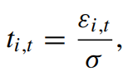

An approach to determining statistical significance of the abnormal return is to find the corresponding p-value of the t-statistic, which is based on the number of degrees of freedom. The p-value will tell us the smallest possible significance level for which the t-statistic is considered statistically significant. In other words, for a sufficiently large number of observations, a t-statistic of 1.65 will have a 2-tail p-value of 0.10. This means that the abnormal return is statistically significant at the 10 % level. Other conventional levels of significance are equal to 1 and 5 %.

#### 5.5.1 Example: Netflix July 2013 Earnings Announcement

After markets closed on July 22, 2013, Netflix announced earnings that more than quadrupled from a year ago but its new subscriber numbers for the second quarter of 630,000 failed to meet investors’ expectations of 800,000 new subscribers.5 Netflix stock dropped 4.5 % on July 23, 2013, the first full trading day on which investors could have reacted to Netflix’s information. News reports attributed the drop to the miss in new subscriber numbers. A 4.5 % drop seems huge, but we must put this in the context of NFLX stock volatility, which may be high as its stock tripled from its price 1 year before the announcement. Therefore, we can use an event study to determine whether the price reaction on July 23, 2013 can be distinguished from normal volatility in Netflix stock.

**Step 1: Identify the Event and the Event Window**

The event is the July 22, 2013 Netflix earnings announcement that was made after markets closed.

As such, the first full trading day investors could react to this news would be on July 23, 2013. We therefore use a one-day Event Window of July 23, 2013.

**Step 2: Identify the Estimation Period**

A one calendar year period ending the day before the Event Window as our Estimation Period.

Our Estimation Period uses returns from July 23, 2012 to July 22, 2013.

**Step 3: Import Netflix Data From Yahoo Finance From July 20, 2012 to July 23, 2013**

Since July 21 and 22, 2012 are non-trading days, we need the price from July 20, 2012.

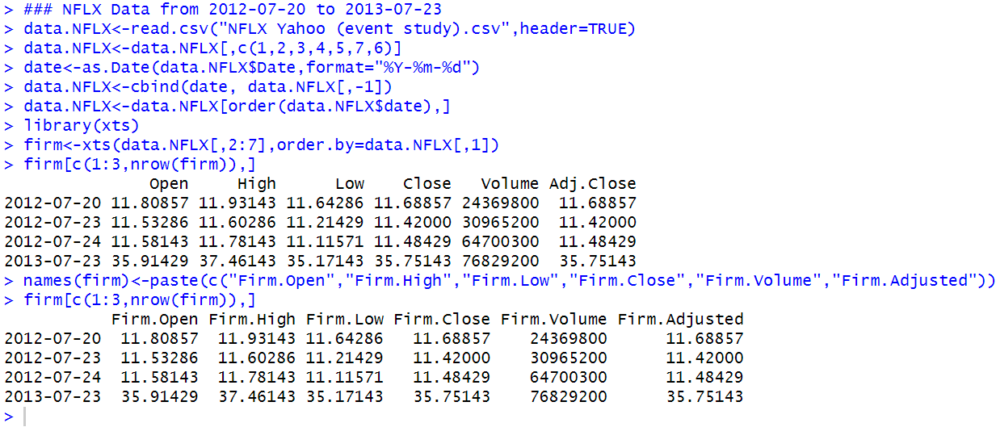

**Step 4: Import SPDR S&P 500 Index ETF Data From Yahoo Finance From July 22, 2012 to July 23, 2013**

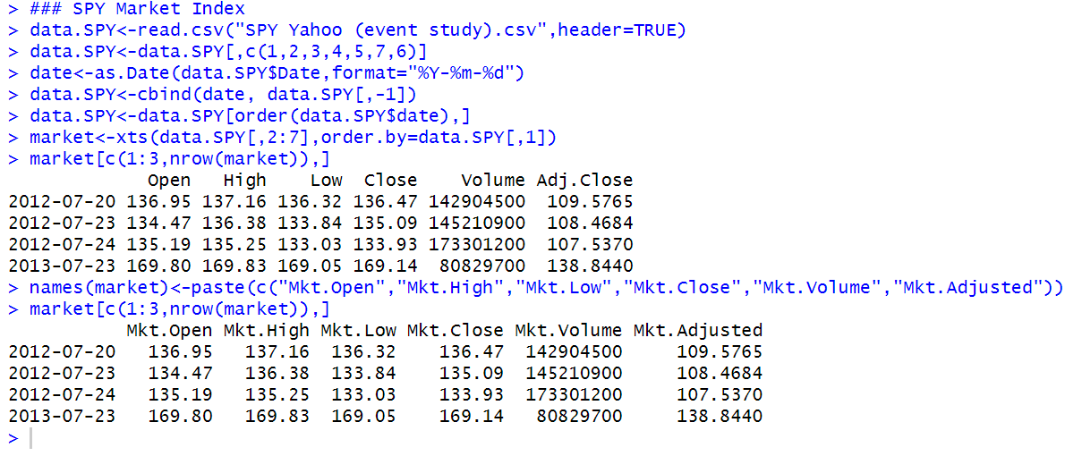

**Step 5: Combine the Two Data Objects**

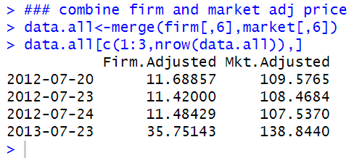

**Step 6: Calculate NFLX and SPY Returns**

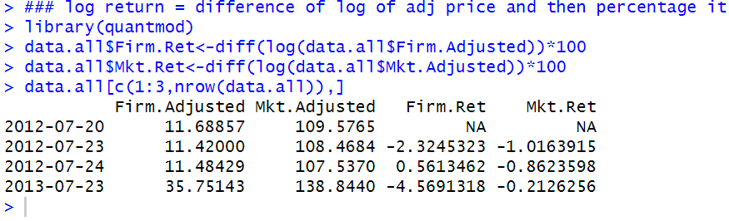

**Step 7: Perform Market Model Regression During the Estimation Period**

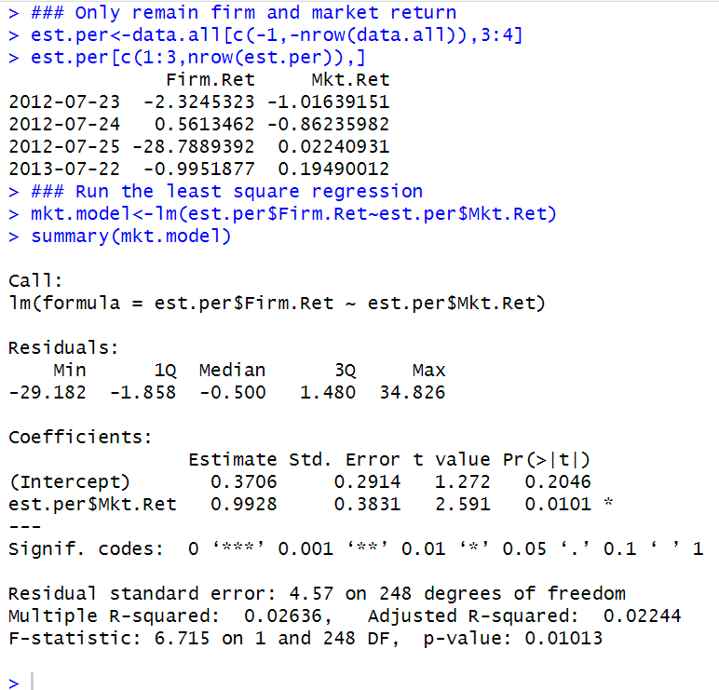

**Step 8: Calculate Abnormal Return, t-Statistic, and p-Value for Dates in Event Window**

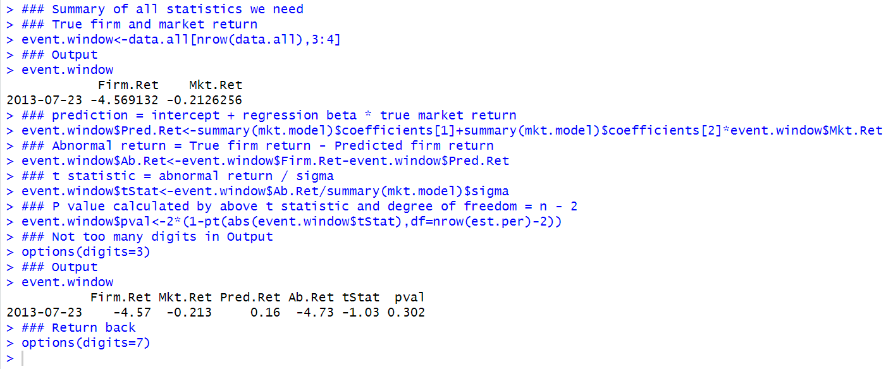

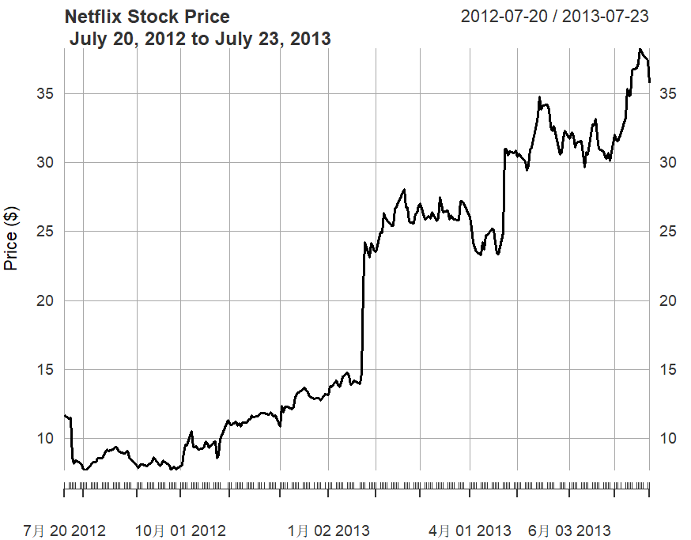

Netflix’s stock price tripled during the one calendar year period prior to the July 23, 2013 announcement, which caused the significant volatility in the stock relative to the market.

Although an estimation period of one calendar year for daily returns data is typical, we may want to estimate the market model over a shorter period given that the period closer to the event window but after the jump may be more relevant in measuring the price impact of the event. We now continue from our previous calculations and create a second set of calculations.

**Step 9: Identify the Date of the Jump in January 2013**

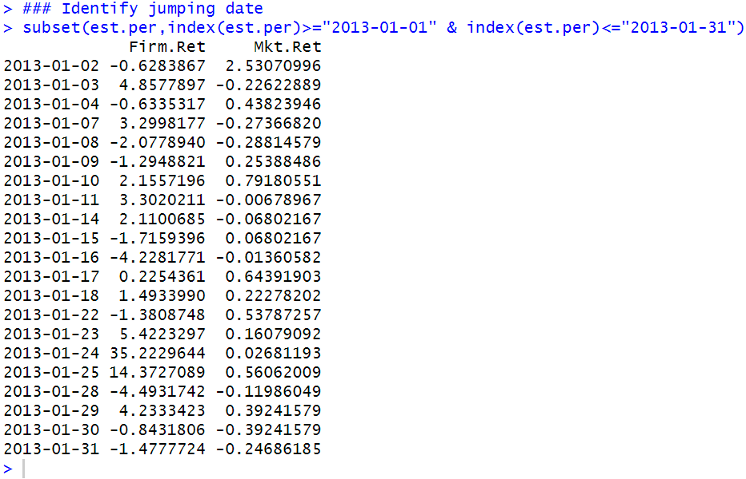

The output above shows that Netflix’s stock price increased by 42 and 15 % on January 24, 2013 and January 25, 2013, respectively. For purpose of this analysis, we will exclude all returns on or before January 25, 2013. Therefore, we start our alternative estimation period on January 28, 2013.

**Step 10: Construct Series for Estimation Period Beginning January 28, 2013**

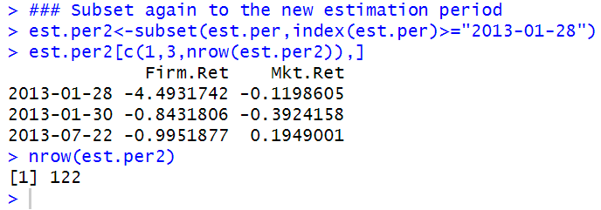

As the output shows, there are 122 observations in our alternative estimation period. Although there are no strict rules as to what the minimum number of observations that should be used, 120 observations for daily data is reasonably sufficient.

**Step 11: Calculate the Market Model Parameters of this Alternative Estimation Period**

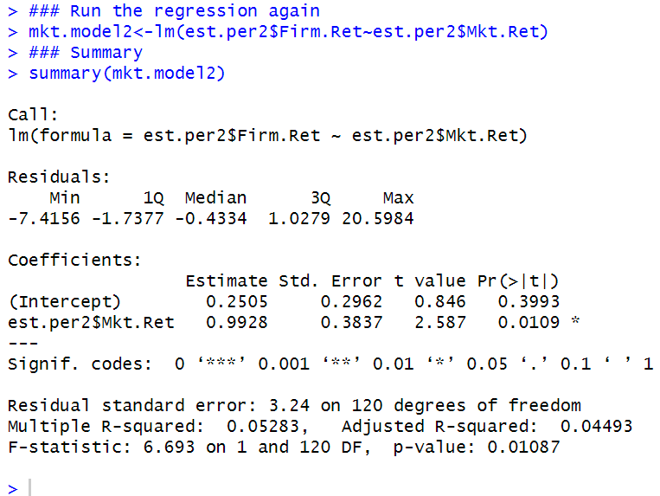

**Step 12: Calculate Abnormal Return and Statistical Significance of the Event Date**

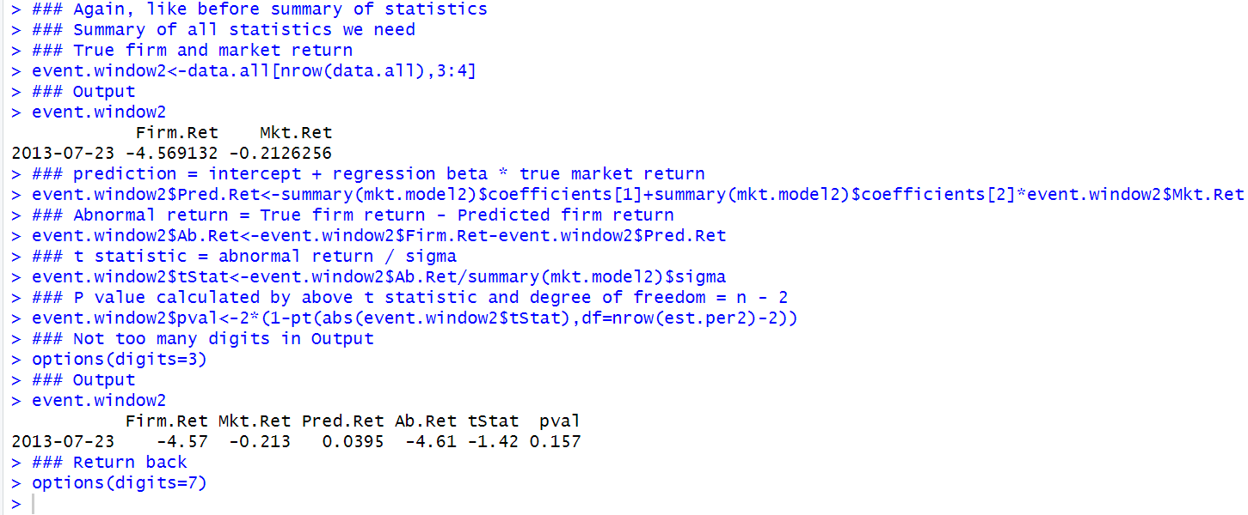

In many academic studies, the final event study result is often an average across a large sample. This averaging has the benefit of reducing the individual firm-specific effects on the abnormal returns and it may be less important to have very precise inputs and assumptions. However, when dealing with individual firm event studies, we have to be more careful in the inputs and assumptions that we make.

### 5.6 Further Reading

The original paper on the CAPM is Sharpe [12]. In the above example, we calculated the beta using 36 months of returns data. Another common method is to use 2 weeks of weekly returns data

The first trade-off is that higher frequency (i.e., daily returns data) is more susceptible to asynchronous trading issues than lower frequency (i.e., monthly data).

The second trade-off is that shorter estimation periods may be more relevant to the current beta but may be more affected by extreme events than longer estimation periods, but longer estimation periods may include older and less relevant data.

The original paper on the FF Model is Fama and French [6]. Much more data compiled for the FF Model can be found in Ken French’s website. An excellent treatment of factor models can be found in Damodaran [5] and Koller et al. [9].

The seminal paper on event studies is Fama et al. [7]. A good background on event studies can be found in Kothari and Warner [10]. The authors report over 575 published articles in five top finance journals made use of event studies from 1974 to 2000. A good discussion of the approach we use is in MacKinlay [11]. An alternative approach is to implement the event study in one-pass, by using a dummy variable to represent the abnormal return on event dates. This is discussed in Binder [2] and Karafiath [8]. Another variation of the event study is to augment the market model to include an industry proxy, such that the abnormal return can be interpreted as a return after accounting for market and industry factors. This model is commonly used in the context of securities litigation and is discussed in Crew et al. [4].

## Chapter 6 Risk-Adjusted Portfolio Performance Measures

We should only expect higher returns if we take on more risk. Therefore, the performance of an investment should be taken in the context of the level of risk taken.

A more appropriate comparison would be to somehow normalize the returns from the different investments by their respectively risk levels. The complicating issue is that there is no single definition of returns as well as no single definition of risk.

In this chapter, we implement several risk-adjusted performance measures that differ in their definition of returns and/or risks.

In particular, we will look at the Sharpe Ratio, Roy’s Safety-First Ratio, Treynor Ratio, Sortino Ratio, and Information Ratio. However, because of the differences in the definition of return and risk, these metrics may rank investments differently.

### 6.1 Portfolio and Benchmark Data

We first need to have portfolios whose performance we wish to analyze. However, for our simplified analysis, we will compare the performance of two portfolios: an Actual Portfolio, which is a proxy for our investment portfolio, and an Alternative Portfolio, which is a proxy for an investment alternative.

In addition, we need to set a benchmark portfolio for use with some metrics. The portfolios could either be our actual portfolios or existing securities we view as potential investment candidates. For some metrics, we need a benchmark portfolio.

**Step 1: Import Actual Portfolio Data**

However, for illustrative purposes, we will import monthly returns data from a hypothetical portfolio constructed using equal-weighted returns of AMZN, IBM, and NVDA with monthly rebalancing from January 2011 to December 2013.

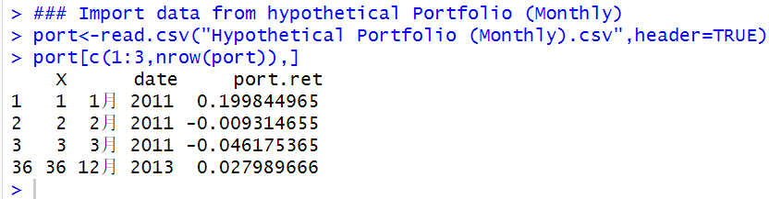

**Step 2: Import Alternative Portfolio Data**

We then construct monthly returns for the SPY from January 2011 to December 2013 using techniques we discuss in earlier chapters.

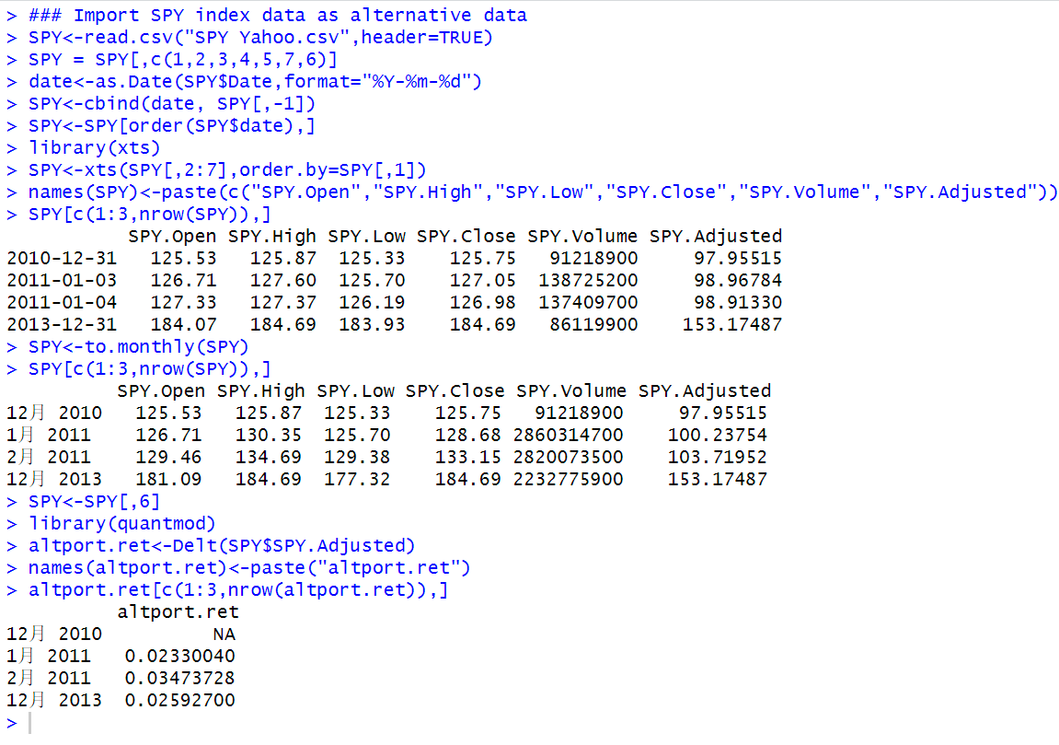

**Step 3: Import Benchmark Portfolio Data**

We use the S&P 500 Index as our benchmark portfolio. The S&P 500 Index data is obtained from Yahoo Finance and is saved in a file labeled GSPC Yahoo.csv.

Again, keep in mind that GSPC index has been replaced by AAPL apple.com.

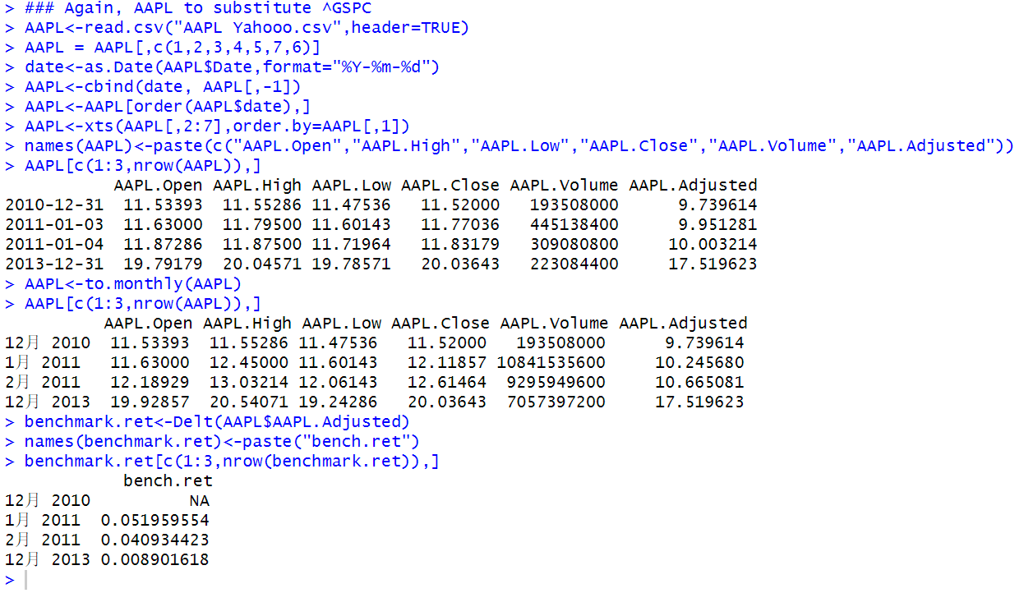

**Step 4: Combine Portfolios and Benchmark Data**

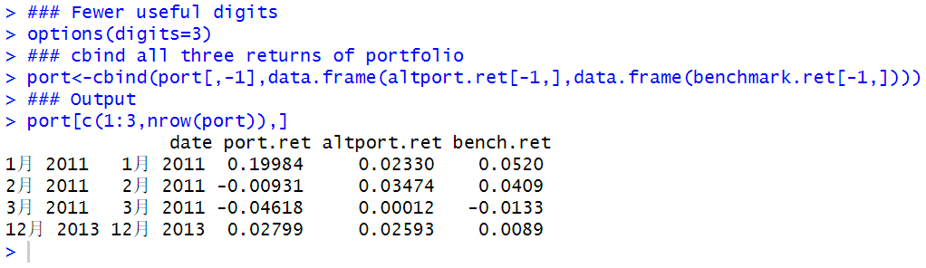

**Step 5: Rename Index Values to Observation Number**

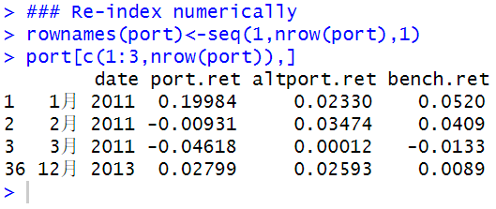

**We will use the data object port in our subsequent analysis.**

### 6.2 Sharpe Ratio

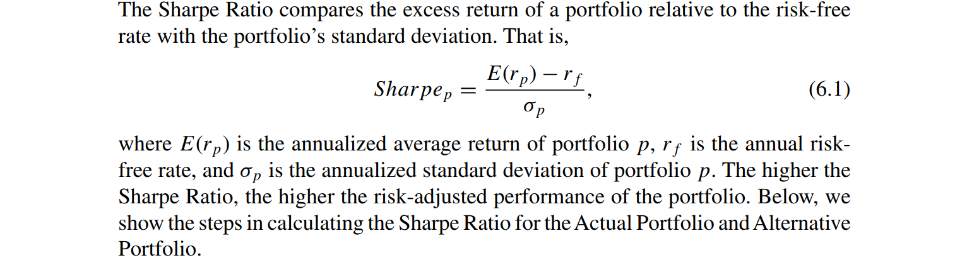

**Step 1: Identify the Frequency of the Returns and the Length of the Estimation Period**

According to the Morningstar Investment Glossary, we can calculate the Sharpe Ratio using the past 36 months of returns. We follow this definition for our example.

**Step 2: Identify the Risk-Free Rate**

Recall we used the 3-Month Treasury in our CAPM calculation in Chap. 5. For consistency, we will also use the 3-Month Constant Maturity Treasury to calculate the Sharpe Ratio. On December 31, 2013, the 3-Month T-Bill had a yield of 0.07 %.

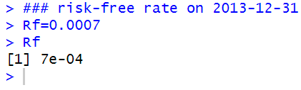

**Step 3: Annualize Monthly Portfolio Returns and Standard Deviation**

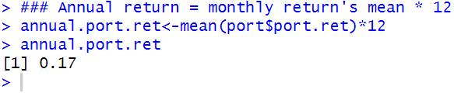

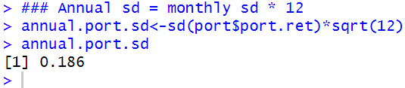

**Step 4: Calculate Sharpe Ratio**

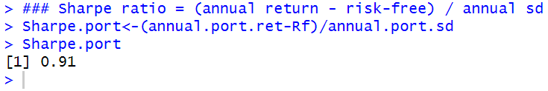

**Step 5: Repeat Steps 1–4 for the Alternative Portfolio**

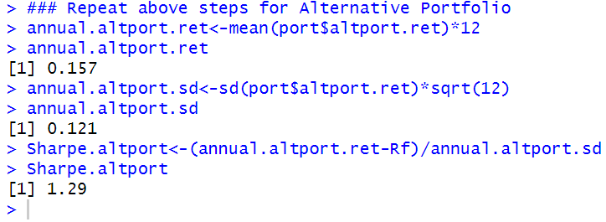

The Actual Portfolio has a Sharpe Ratio of 0.91, which is higher than the Sharpe Ratio of the Alternative Portfolio of 1.29. As such, based on the Sharpe Ratio, the Actual Portfolio yields a lower risk-adjusted return.

### 6.3 Roy’s Safety-First Ratio

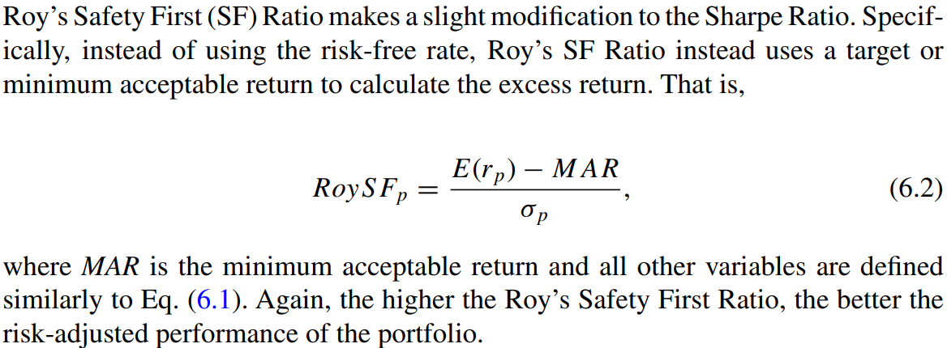

**Step 1: Determine the MAR**

Based on the December 2013 Livingston Survey, the 2012–2013 inflation rate is 1.5 %. We use this as our proxy for MAR and calculate Roy’s SF Ratio for our portfolio and alternative portfolio.

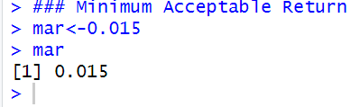

**Step 2: Calculate the Annual Portfolio Return and Standard Deviation**

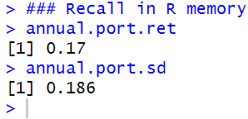

**Step 3: Calculate the Roy’s Safety-First Ratio for the Actual Portfolio**

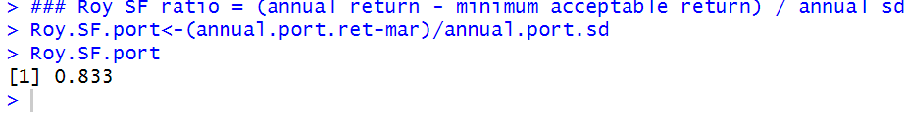

**Step 4: Repeat Steps 1–3 for the Alternative Portfolio**

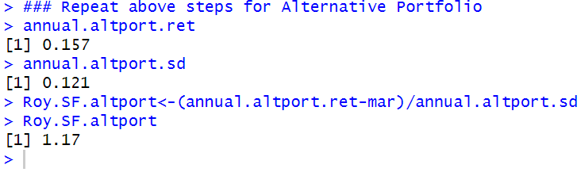

The Actual Portfolio has a Roy’s SF Ratio of 0.833, which is higher than the Roy’s SF Ratio of the Alternative Portfolio of 1.17. As such, based on the Roy’s SF Ratio, the Actual Portfolio yields a lower risk-adjusted return.

### 6.4 Treynor Ratio

The Treynor Ratio modifies the denominator in the Sharpe Ratio to use beta instead of standard deviation in the denominator. That is,

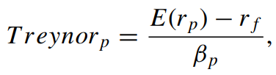

where βp is the beta of the portfolio and the rest of the terms are defined similarly to above equation. The higher the Treynor Ratio, the better the risk-adjusted performance of the portfolio.

**Step 1: Identify the Frequency of Returns and Length of the Estimation Period**

Using beta instead of standard deviation implies that the Treynor Ratio only considers systematic risk while the Sharpe Ratio considers total risk (i.e., systematic and firm-specific risk). Therefore, the ratios could differ if the ratio of systematic risk to total risk is different in the two funds we are comparing.

**Step 2: Import Actual Portfolio Returns**

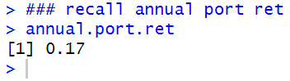

**Step 3: Obtain the Relevant Risk-Free Rate**

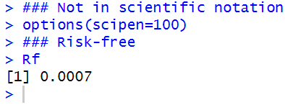

**Step 4: Estimate the Beta of the Actual Portfolio**

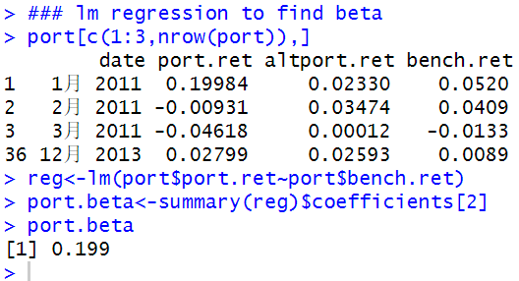

**Step 5: Calculate the Treynor Ratio for the Actual Portfolio**

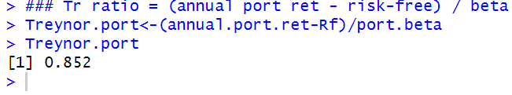

**Step 6: Repeat Steps 1–5 for the Alternative Portfolio**

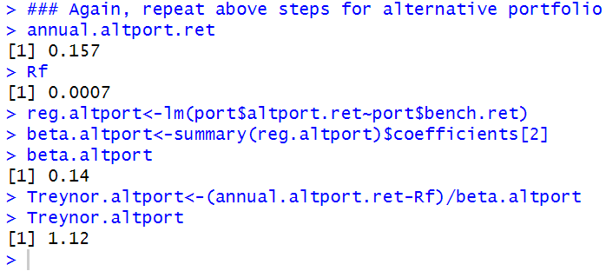

The Actual Portfolio has a Treynor Ratio of 0.852, which is higher than the Treynor Ratio of the Alternative Portfolio of 1.12. As such, based on the Treynor Ratio, the Actual Portfolio yields a lower risk-adjusted return.

### 6.5 Sortino Ratio

Given our implementation of Roy’s SF Ratio using a minimum acceptable return (MAR), the Sortino Ratio has the same numerator Roy’s SF Ratio in above Equation. However, the denominator measures only the deviation of values lower than the MAR, which is referred to as Downside Deviation (DD). That is,

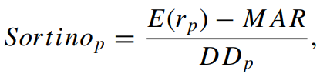

where E(rp) is the average return of portfolio p, MAR is the minimum acceptable return, and DDp is the downside deviation. The higher the Sortino Ratio, the better the risk-adjusted performance of the portfolio.

**Step 1: Determine the Period MAR**

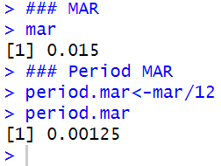

**Step 2: Identify Monthly Returns in Actual Portfolio That are Less Than the MAR**

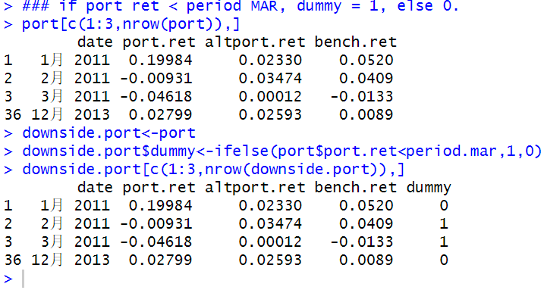

**Step 3: Extract Monthly Returns That are Less Than the MAR**

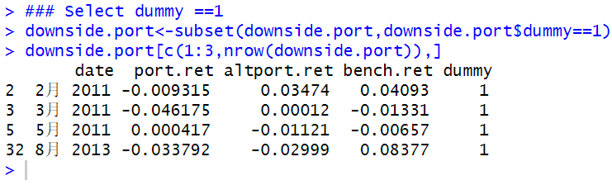

**Step 4: Calculate Downside Deviation**

downside.port only contains returns that are less than the period MAR. The standard deviation of these returns is called the downside deviation. We then annualize the downside deviation to make it compatible with the other inputs to the Sortino Ratio.

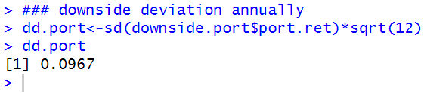

**Step 5: Calculate Sortino Ratio**

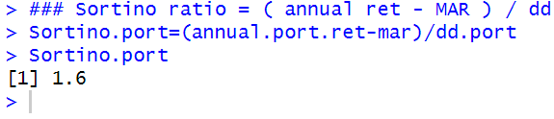

**Step 6: Repeat Steps 1–5 for the Alternative Portfolio**

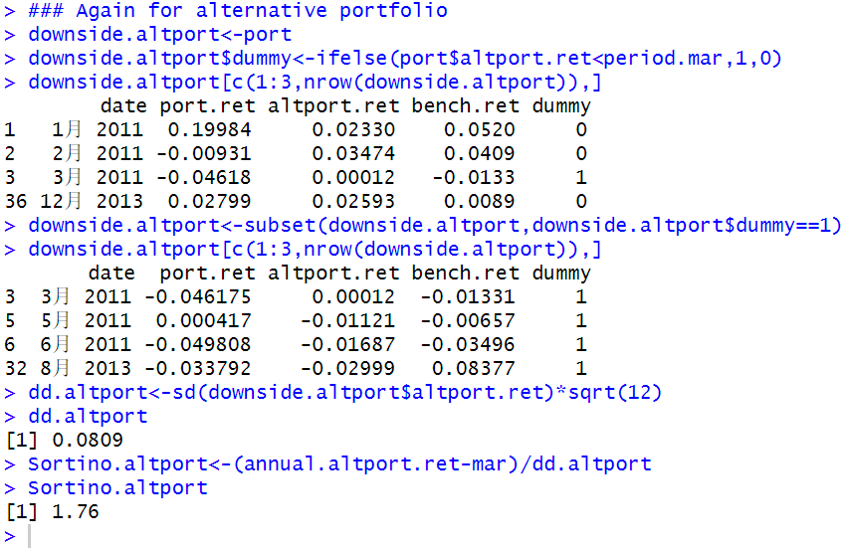

The Actual Portfolio has a Sortino Ratio of 1.6, which is higher than the Sortino Ratio of the Alternative Portfolio of 1.76. As such, based on the Sortino Ratio, the Actual Portfolio yields a lower risk-adjusted return.

### 6.6 Information Ratio

The IR is the ratio of the portfolio alpha over the tracking error. The alpha of the portfolio is the annualized active return, which is the difference between the portfolio’s return and the benchmark return (e.g., return of the S&P 500 Index). The tracking error is the annualized standard deviation of the active return.

**Step 1: Calculate the Active Return of the Actual Portfolio**

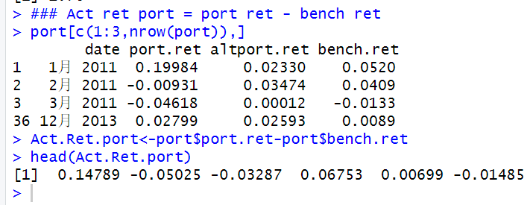

**Step 2: Calculate Portfolio Alpha**

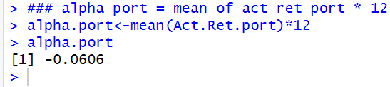

**Step 3: Calculate Tracking Error**

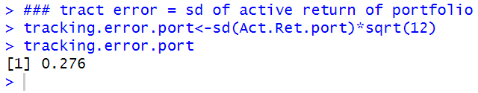

**Step 4: Calculate the Information Ratio**

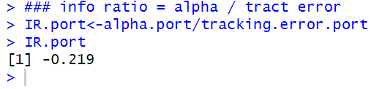

**Step 5: Repeat Steps 1–4 for the Alternative Portfolio**

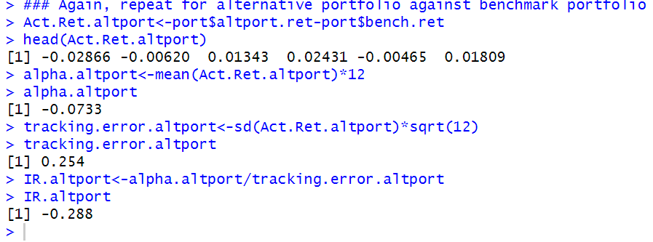

### 6.7 Combining Results

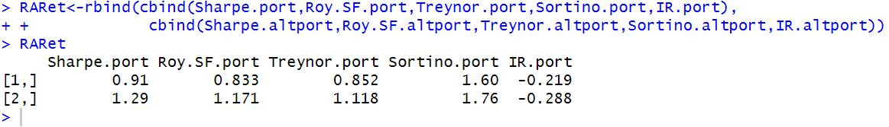

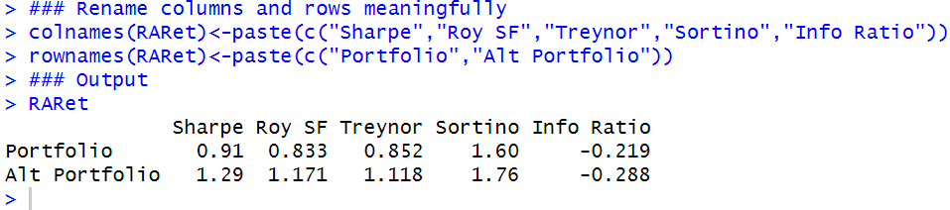

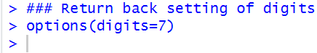

Recall that the rule for all these ratios is that the higher the ratio the better.

As we can see from the output above, our Actual Portfolio has a lower Sharpe Ratio, Roy SF Ratio, Treynor Ratio, and Sortino Ratio than the Alternative Portfolio. Looking specifically at the Sharpe and Treynor Ratios, we can see that our portfolio provides worse risk-adjusted returns regardless of whether we measure risk as total risk (i.e., standard deviation) or only systematic risk (i.e., beta).

Looking at the Sharpe Ratio and Roy SF Ratio, even considering a minimum acceptable return slightly higher than the risk-free rate does not change our results. Comparing the Roy SF Ratio and Sortino Ratio, we can see the difference in the two ratios is that the Roy SF Ratio uses standard deviation in the denominator while the Sortino Ratio uses the downside deviation (i.e., standard deviation of returns that fail to meet the MAR).

The results are consistent with the Actual Portfolio having many more returns that exceed the MAR that caused a lot more of the deviation, as we have quite a small downside deviation.

The results above for the IR suggests a different story. The IR implies that the manager of the Actual Portfolio performed worse relative to the risk assumed compared to the manager of the Alternative Portfolio. The active choice by the manager of our Actual Portfolio to select securities resulted in a higher alpha but also a correspondingly higher tracking error. The Alternative Portfolio had a lower alpha but also tracked our benchmark much closer.

### 6.8 Further Reading

Maginn et al. [2] contains a detailed discussion of the portfolio performance measures we discussed in this chapter. Applications of risk-adjusted performance measures for hedge funds can be found in Tran [6] and Gregoriou [1].

#### References

1. Gregoriou, G., Hubner, G., Papageorgiou, N., & Rouah, F. (2005). Hedge funds: Insights in performance measurement, risk analysis, and portfolio allocation. New Jersey: Wiley.
2. Maginn, J., Tuttle, D., Pinto, J., & McLeavey, D. (2007). Managing investment portfolios: A dynamic process (3rd ed). New Jersey: Wiley.
3. Markowitz, H. (1952). Portfolio selection. The Journal of Finance, 7, 77–91.
4. Sharpe, W. (1975). Adjusting for risk in portfolio performance. Journal of Portfolio Management, 1, 29–34.
5. Sharpe, W. (1994). The Sharpe ratio. Journal of Portfolio Management, 21, 49–58.

6. Tran, V. (2006). Evaluating hedge fund performance. New Jersey: Wiley.

## Chapter 7 Markowitz Mean-Variance Optimization

In Markowitz [3], Harry Markowitz put forth a theory of how to use mean and variance to determine portfolios that offer the highest return for a given level of risk.

In this chapter, we show how to construct the Mean-Variance (MV) Efficient Frontier, which is the set of all portfolio generated by various combinations of the securities in the portfolio that yield the highest return for a given level of risk.

We begin by manually constructing the MV Efficient Frontier using two assets, so we can gain the intuition of what we are trying to accomplish. Then, we convert this manual approach for two assets to an approach that uses *quadratic programming*.

Since many investors (e.g., pension funds) do not or cannot short sell securities for various reasons, we implement the two-asset case not allowing short selling.

Then we extend the quadratic programming approach to show how we find the MV efficient portfolios when we have multiple securities. In the multiple asset scenario, we first continue with the no short sale case and then demonstrate the effect on the MV Efficient Frontier of allowing short selling.

We will see that allowing short-selling extends outward the MV Efficient Frontier such that we are able to achieve higher returns for a given level of risk.

### 7.1 Two Assets the “Long Way”

We first demonstrate the intuition of how to construct the MV Efficient Frontier using the case of a 2-asset portfolio and manually laying out each step of the calculation.

This approach is termed the “Long Way” because we lay out each step without the benefit of any mathematical optimization techniques.

In determining how much money to invest in each of the two securities, we may want to know what combination of these two securities yields the smallest portfolio risk (i.e., the minimum variance portfolio) and we may want to know what combination of these two securities yields the highest Sharpe Ratio (i.e., the tangency portfolio).

We identify the set of portfolios that meet that criteria and these portfolios are called mean-variance ***efficient portfolios***.

**Step 1: Import SPY and LAG Data from Yahoo Finance**

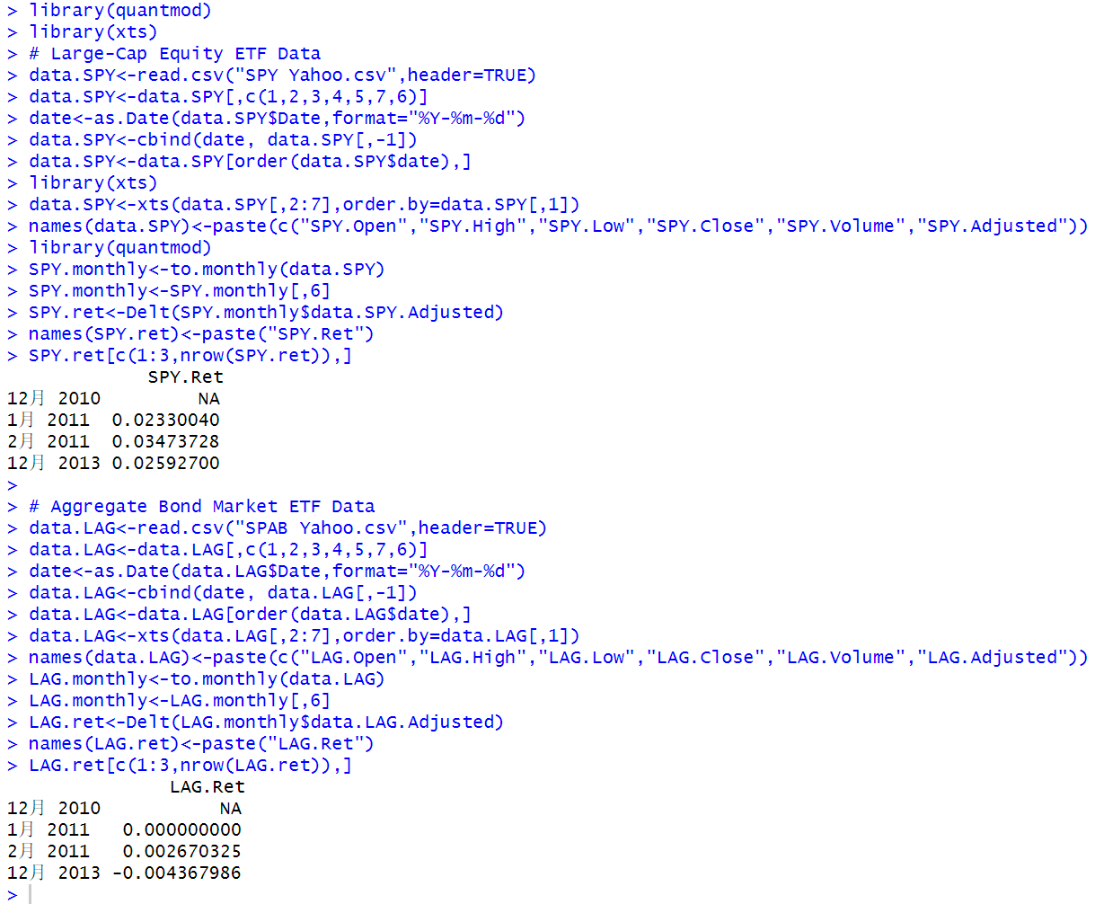

**Step 2: Combine Monthly Return Data for SPY and LAG**

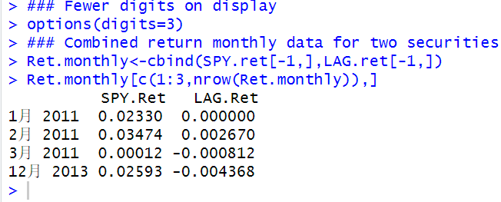

**Step 3: Calculate the Mean and Standard Deviation of SPY and LAG Returns**

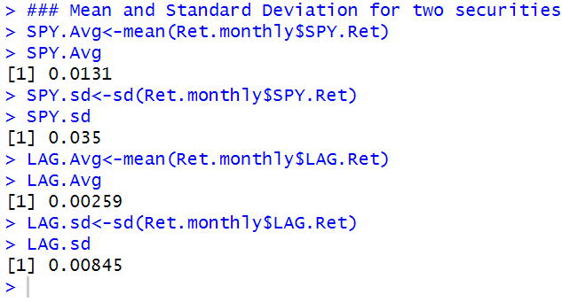

**Step 4: Find the Covariance of SPY and LAG Returns**

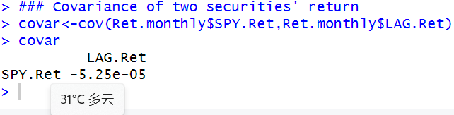

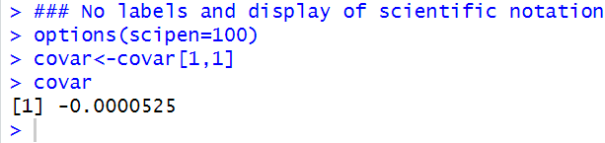

**Step 5: Create a Series of Weights for SPY Stock**

To find out all the risk/return combination of SPY and LAG stock, we need to create a series that all possible weight combinations.

Since individual investors and some institutional investors do not or are not allowed to short sell stock, we can restrict our weights from 100 % SPY/0 % LAG to 0 % SPY/100 % LAG.

Since the weights must sum to one, we can create a series of weights for SPY between 0 and 100 % by 1 % increments.

Note that the number of increments is a trade-off between speed and accuracy. For our purpose, using 1 % increments would be sufficiently accurate and would not affect the speed of running the program substantially.

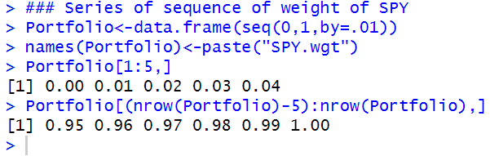

**Step 6: Create a Series of Weights for LAG Stock**

**No short sell, so weight of LAG = 1 – weight of SPY**

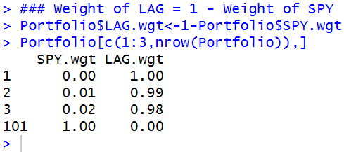

**Step 7: Calculate Portfolio Return for Each Weight Combination**

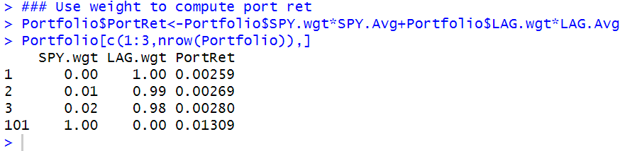

**Step 8: Calculate Portfolio Risk for Each Weight Combination**

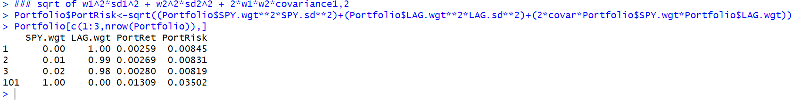

**Step 9: Identify the Minimum-Variance Portfolio**

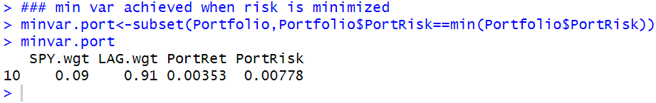

**Step 10: Identify the Tangency Portfolio**

The *tangency portfolio* is the portfolio that yields the highest Sharpe Ratio.

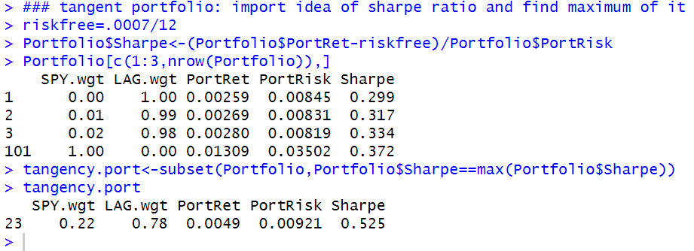

**Step 11: Identify Efficient Portfolios**

Efficient portfolios are only those portfolios that yield the highest return for a given level of risk. We extract these efficient portfolios by using the subset command and only keep those portfolios with returns greater than the return of the minimum variance portfolio.

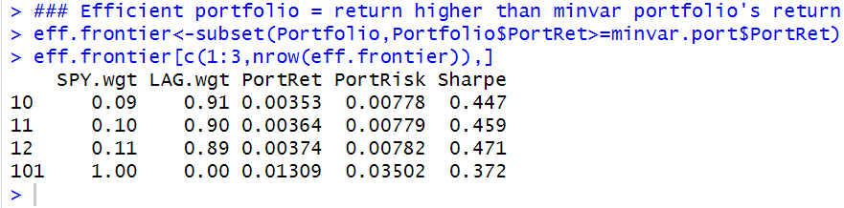

**Step 12: Plot the MV Efficient Frontier**



From the below graph, **triangle point** is the minimum variance point and the **circle point** is the tangent portfolio judged by Sharpe Ratio.

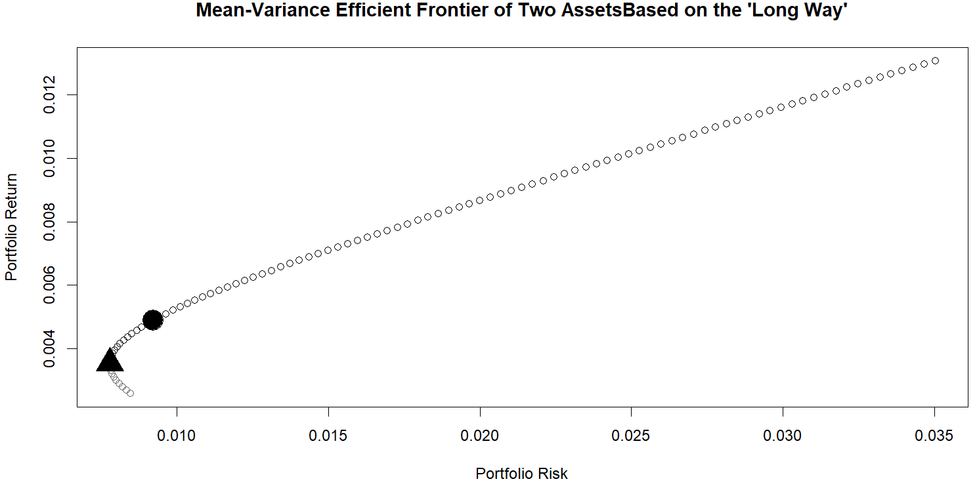

### 7.2 Two-Assets Using Quadratic Programming

The “Long Way” is useful to gain an intuition of what is going on when we apply quadratic programming. The technique is called quadratic programming because we are performing an optimization on a quadratic function. A quadratic function is a function that has a variable (in this case weight) that is squared. In the two-asset case, we are minimizing Eq. (4.2). The weights in that formula are squared. For our purpose, quadratic programming finds the combination of securities that yield the minimum risk for a specific level of return.

**Step 1: Import Returns Data and Convert it Into a Matrix**

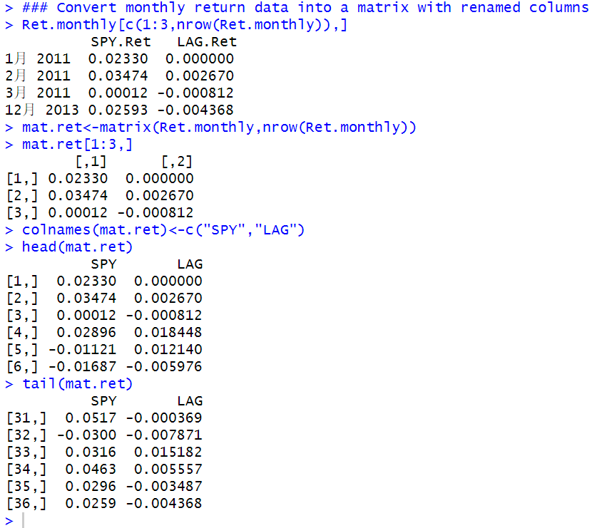

**Step 2: Calculate Variance-Covariance (VCOV) Matrix of Returns**

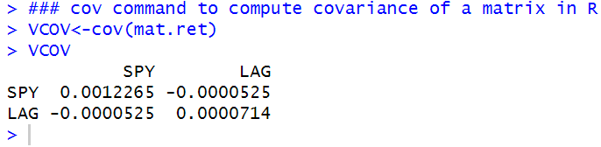

**Step 3: Construct the Target Portfolio Return Vector**

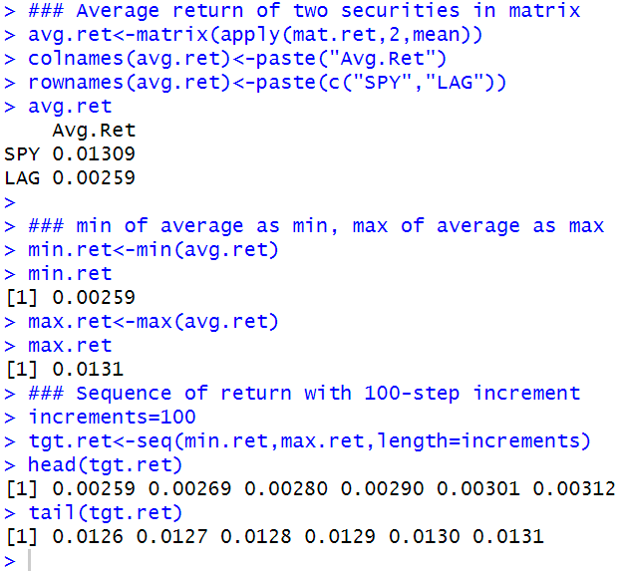

**Step 4: Construct Dummy Portfolio Standard Deviation Vector**

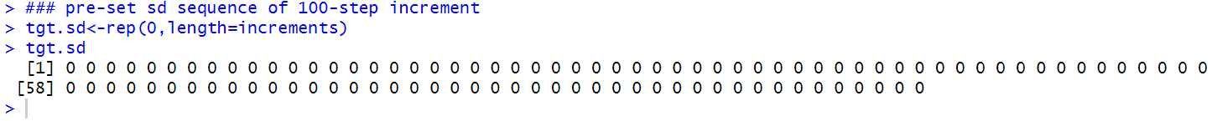

**Step 5: Construct Dummy Portfolio Weights Vector**

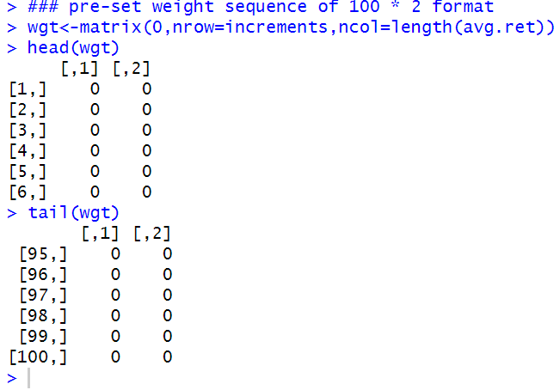

**Step 6: Run the quadprog Optimizer**

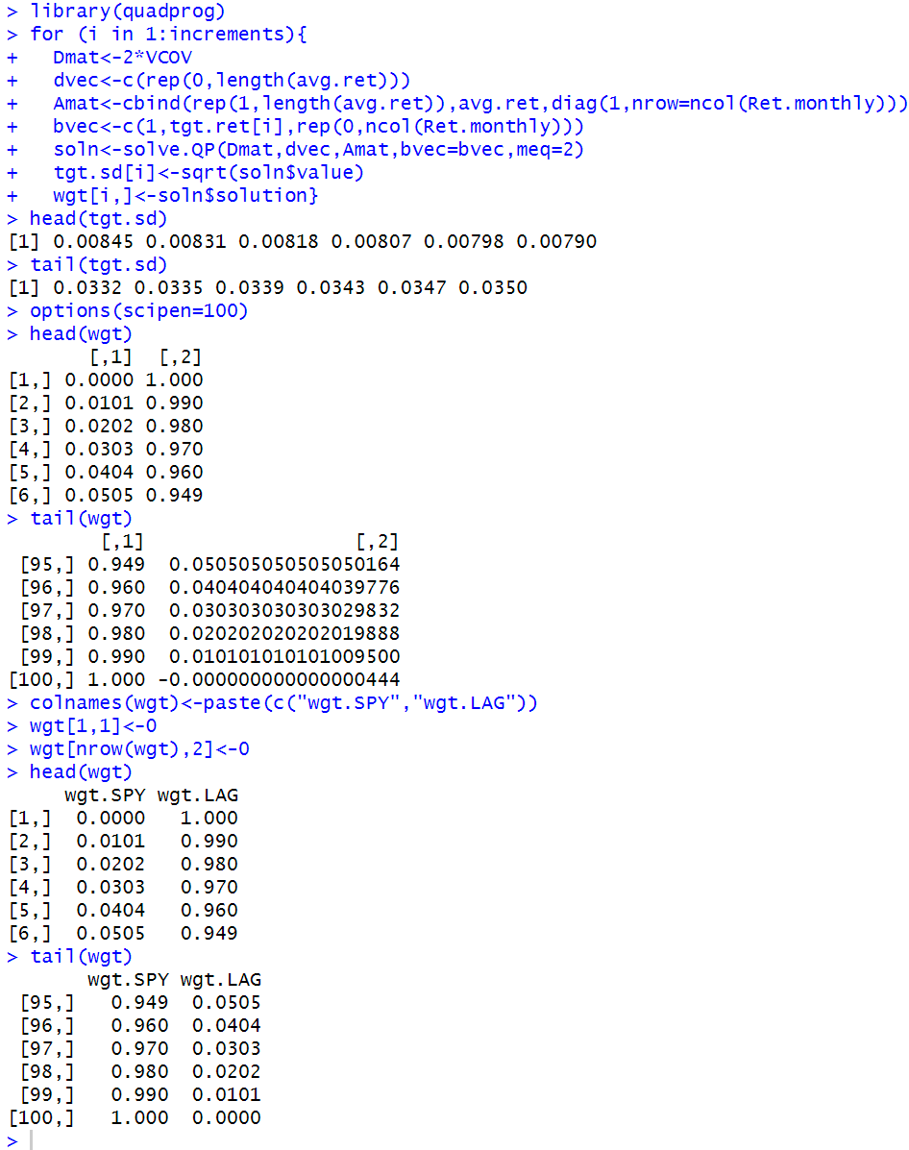

**Step 7: Combine Portfolio Returns, Portfolio Standard Deviations, and Portfolio Weights**

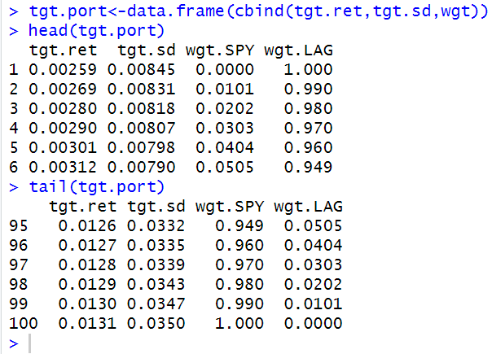

**Step 8: Identify the Minimum Variance Portfolio**

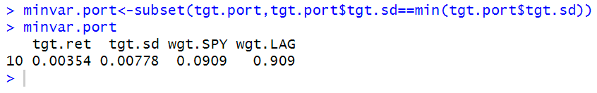

**Step 9: Identify the Tangency Portfolio**

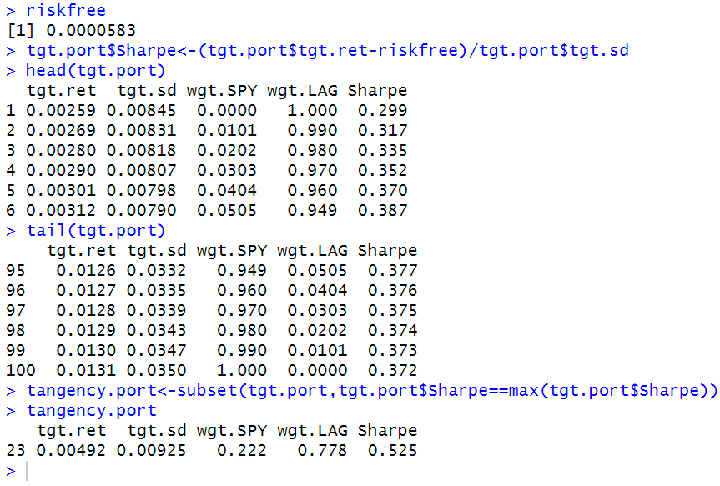

**Step 10: Identify Efficient Portfolios**

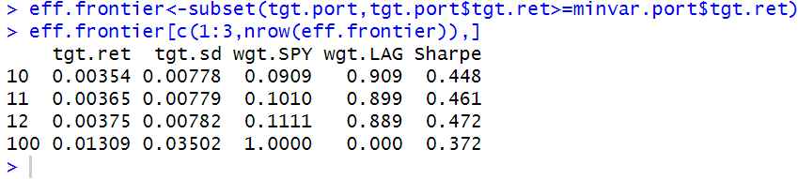

**Step 11: Plot the MV Efficient Frontier**

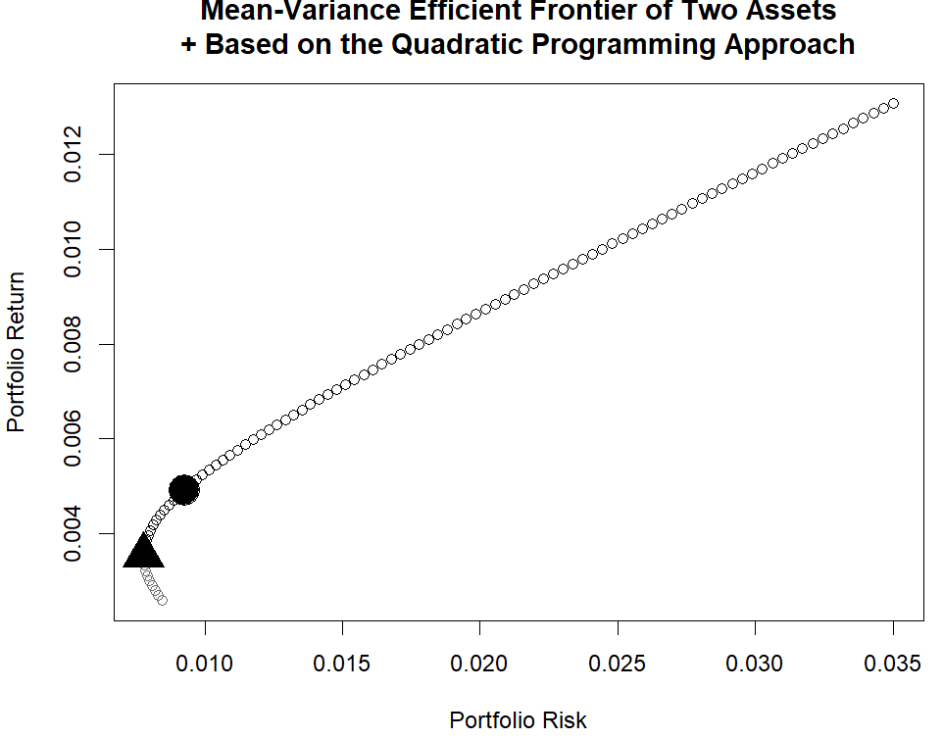

### 7.3 Multiple Assets Using Quadratic Programming

**Step 1: Import SPY, LAG, SLY, and CWI Data From Yahoo Finance and Calculate Monthly Returns for Each Security**

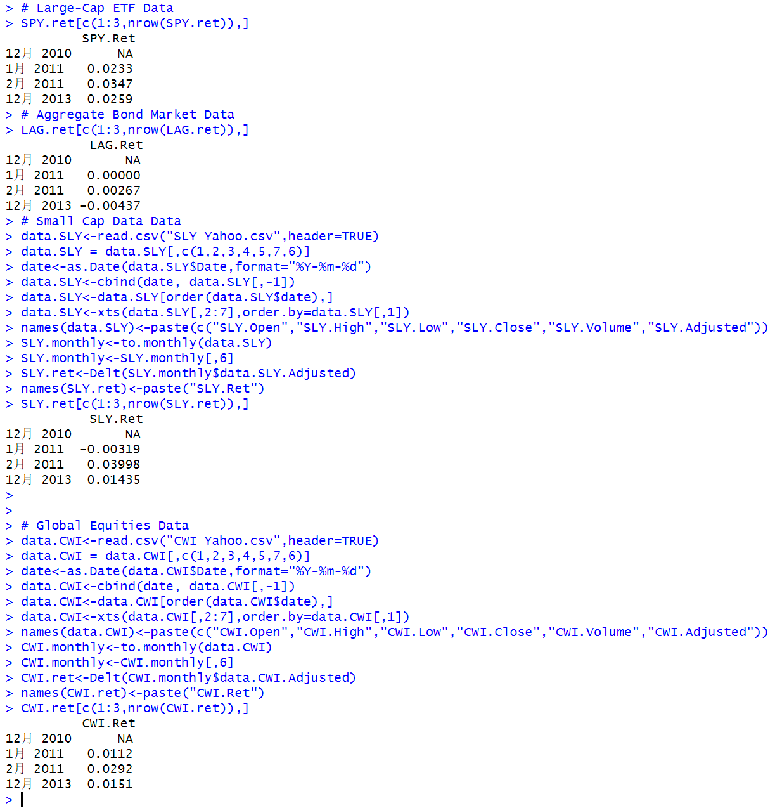

**Step 2: Combine Monthly Returns Data for the Four Securities and Convert Combined Data Into a Returns Matrix**

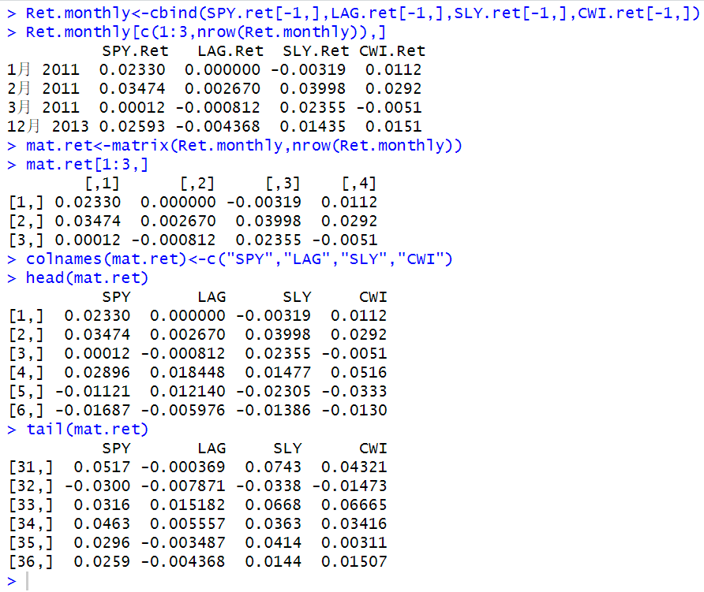

**Step 3: Calculate Variance-Covariance (VCOV) Matrix of Returns**

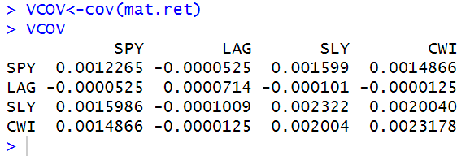

**Step 4: Construct the Target Portfolio Return Vector**

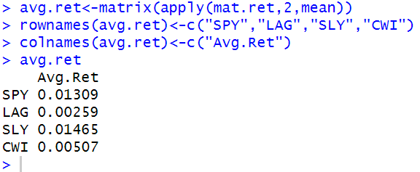

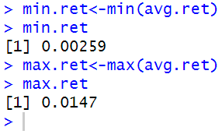

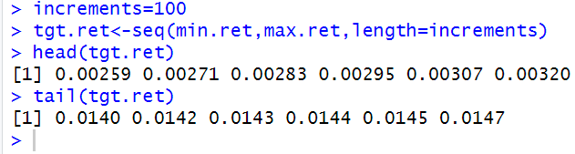

**Step 5: Construct Dummy Portfolio Standard Deviation Vector**



**Step 6: Construct Dummy Portfolio Weights Vector**

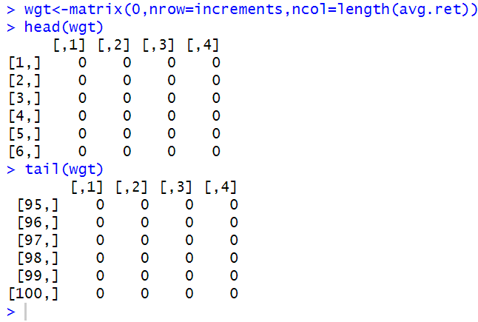

**Step 7: Run the quadprog Optimizer**

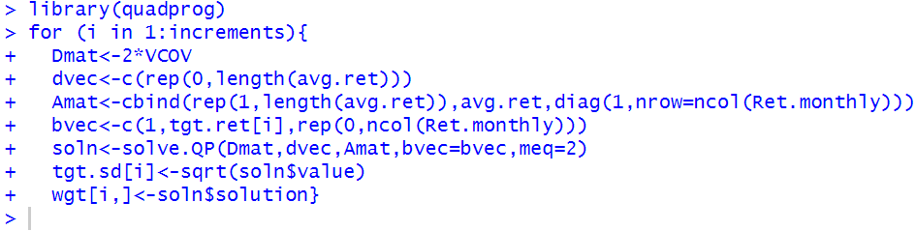

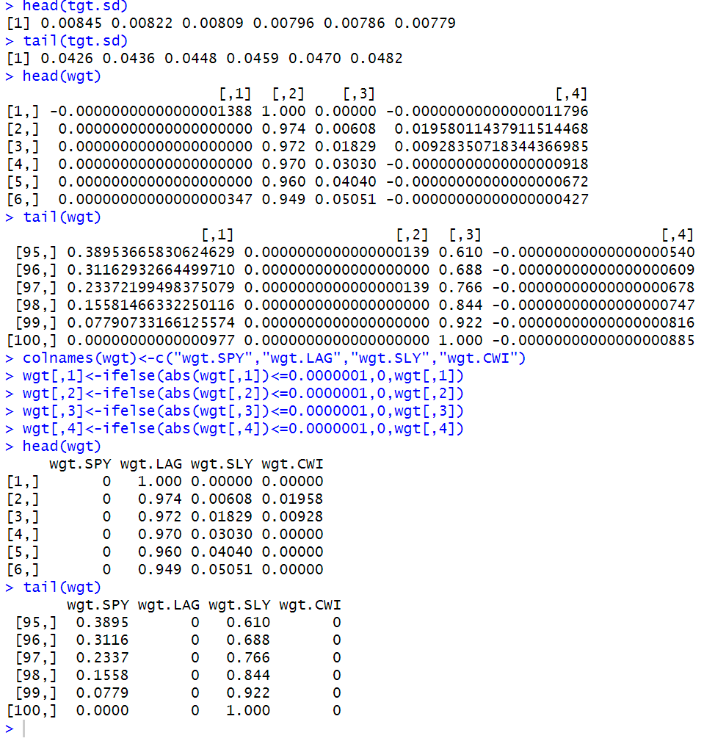



**Step 8: Combine Portfolio Returns, Portfolio Standard Deviations, and Portfolio Weights**

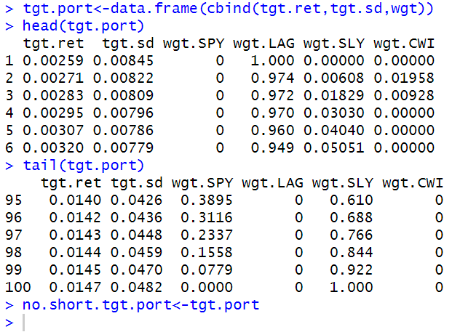

**Step 9: Identify the Minimum Variance Portfolio**

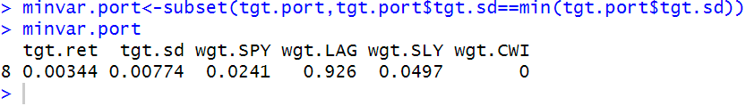

**Step 10: Identify the Tangency Portfolio**

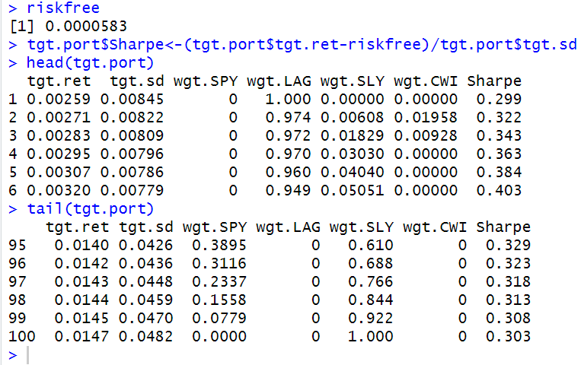

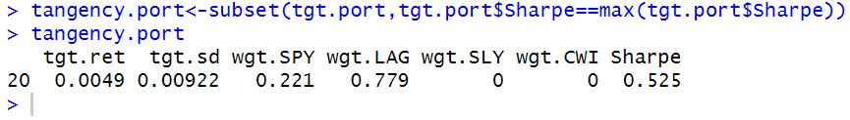

**Step 11: Identify Efficient Portfolios**

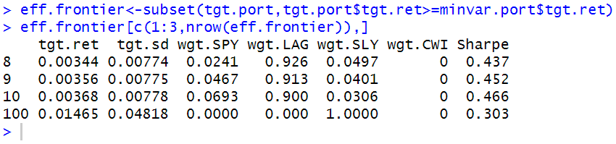

**Step 12: Plot the MV Efficient Frontier**

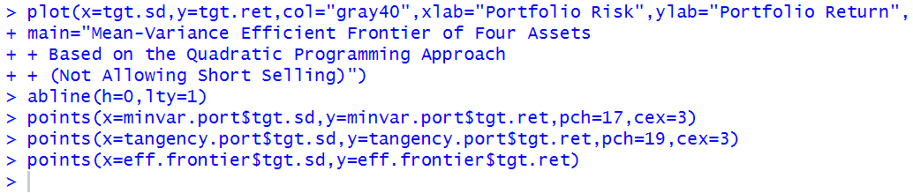

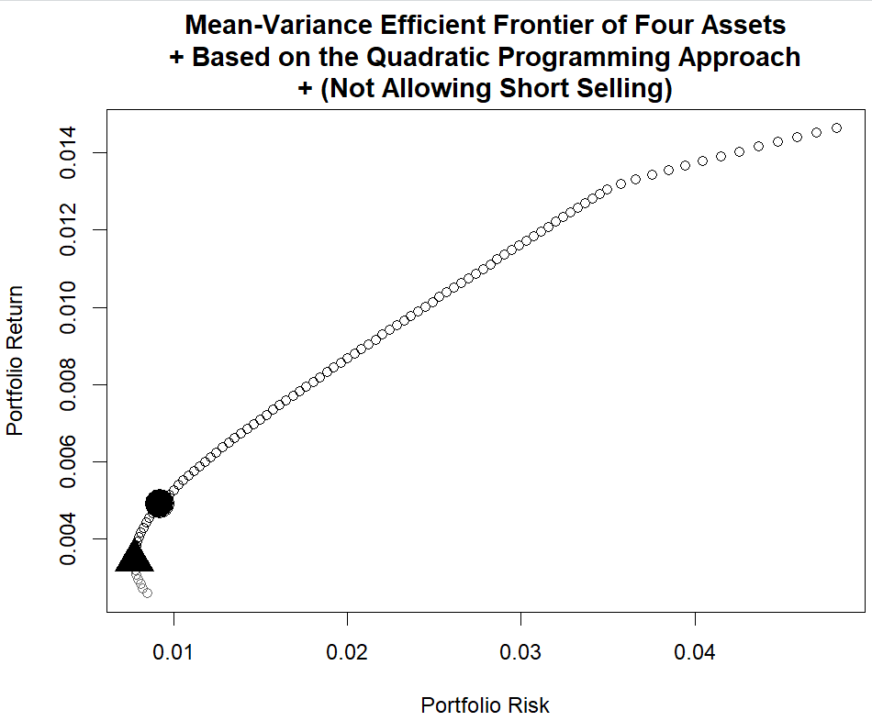

### 7.4 Effect of Allowing Short Selling

Note that by not allowing short selling we are adding a constraint that restricts the optimizer from putting negative weights on securities that could enhance return if we were allowed to take on short positions.

First, we cannot be worse off when we do not impose a short selling restriction.

Second, short selling should enhance returns in situations where taking a short position in a security can benefit us.

Now, let us turn to the portions of the code that need to be modified when short selling is allowed. No modification is necessary for Steps 1–3. We will begin the modifications with Step 4 of the last section.

**Step 4ss: Construct the Target Portfolio Return Vector (Modifying to Allow for Short Selling)**

However, when short selling is allowed, we can in theory sell the other securities and invest the proceeds from the sale of those securities in the security with the largest return.

For the upper bound, we will construct it to be twice the maximum return of the four securities in our portfolio. This number is arbitrary but gives us a good enough range of portfolio returns for our purpose.

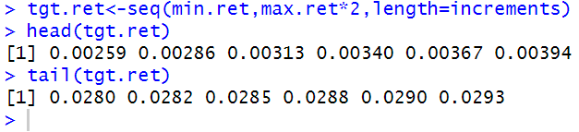

**Step 5ss: Construct Dummy Portfolio Standard Deviation Vector**

There is no change here.

**Step 6ss: Construct Dummy Portfolio Weights Vector**

There is no change here.

**Step 7ss: Run the quadprog Optimizer (Modifying to Allow for Short Selling)**

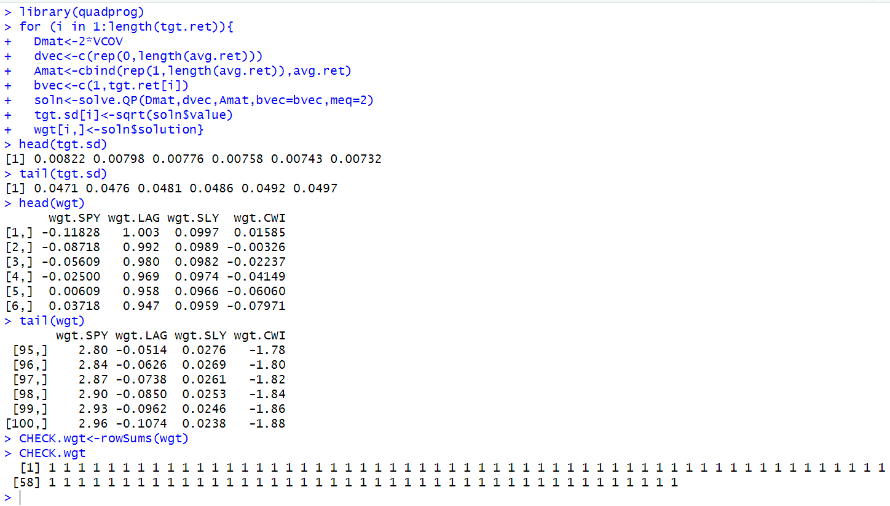

**Step 8ss: Combine Portfolio Returns, Portfolio Standard Deviations, and Portfolio Weights**

There is no change in the code here.

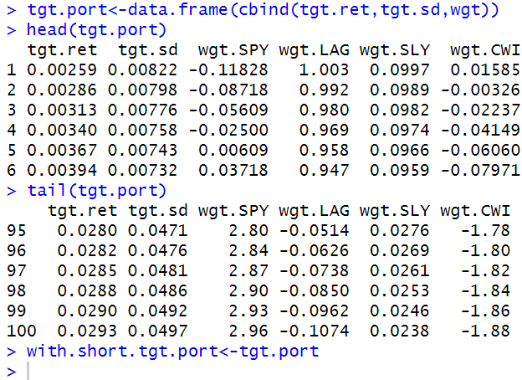

**Step 9ss: Identify the Minimum Variance Portfolio**

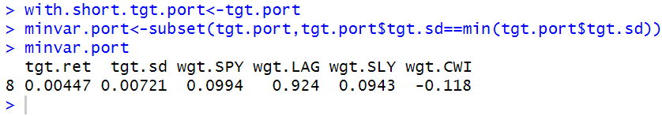

**Step 10ss: Identify the Tangency Portfolio**

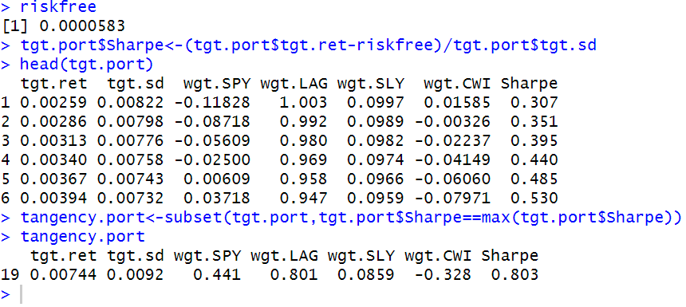

**Step 11ss: Identify Efficient Portfolios**

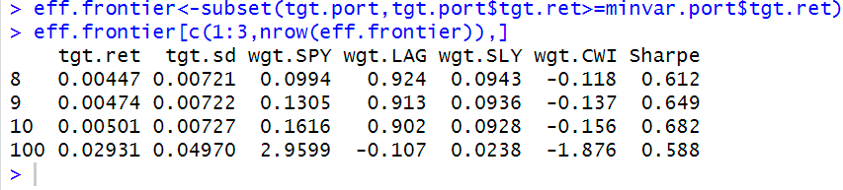

**Step 12ss: Plot the MV Efficient Frontier**

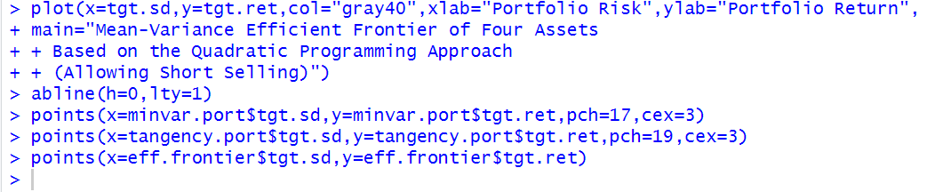

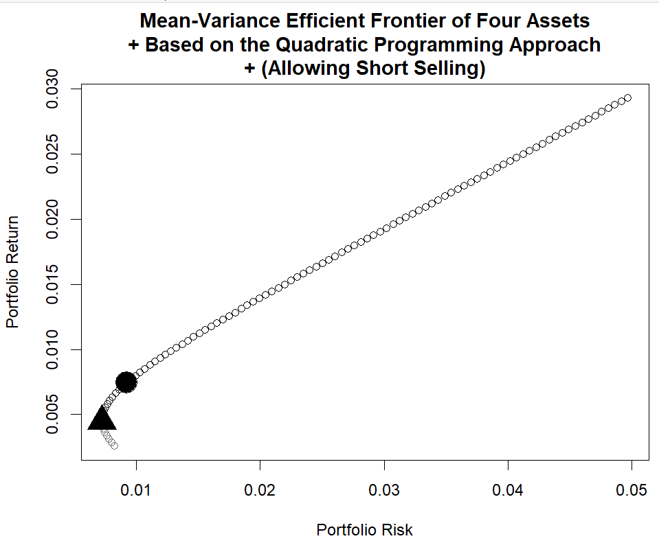

**Comparing the Efficient Frontier With and Without Short Sales**

The black line represents the MV Efficient Frontier when short selling is not allowed. The gray line represents the MV Efficient Frontier when short selling is allowed.

That is, the gray line (efficient frontier when short sale restrictions are lifted) attains higher levels of portfolio returns for the same level of risk as the black line (efficient frontier when short sales are not allowed) once we start moving to higher levels of portfolio risk.

For lower levels of portfolio risk, relaxing the short sale restrictions does not enhance returns.

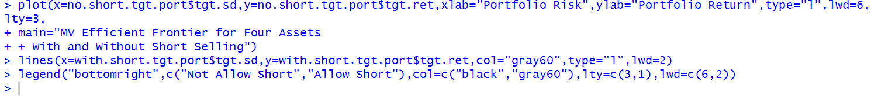

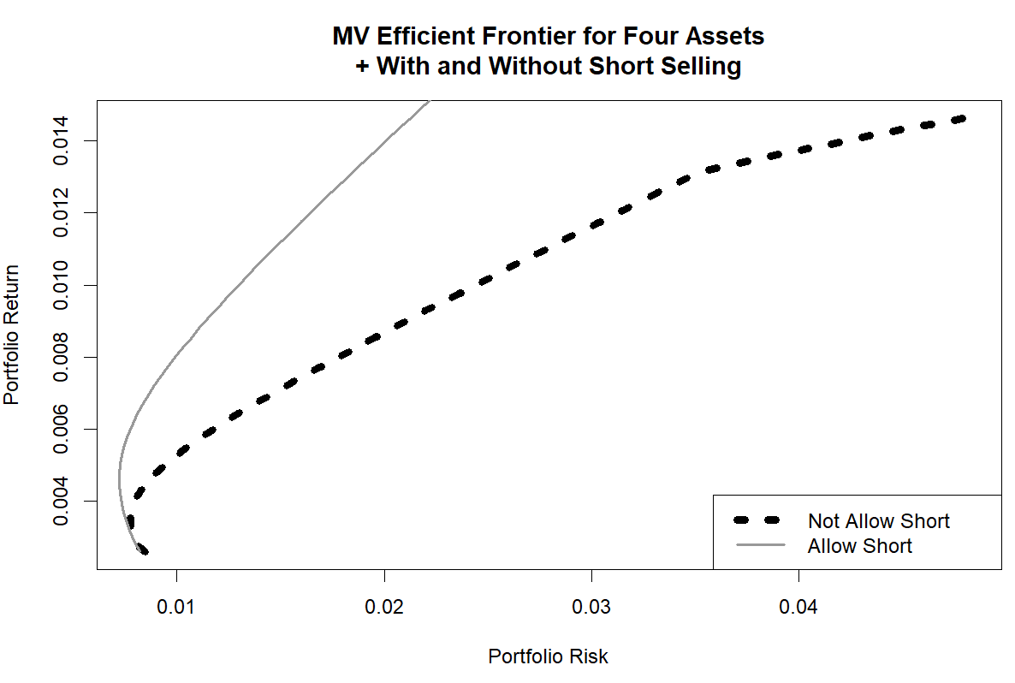

### 7.5 Further Reading

More details on the Sharpe Ratio are found in Sharpe [4] and [5]. Markowitz [3] is the original paper on portfolio selection. A more comprehensive and modern treatment of asset allocation and portfolio management can be found in Maginn et al. [2]. Additional techniques used to calculate the efficient frontier are found in Elton et al. [1].

#### References

1. Elton, E., Gruber, M., Brown, S., & Goetzmann, W. (2010). Modern portfolio theory and investment analysis (8th ed.). New Jersey: Wiley.

2. Maginn, J., Tuttle, D., Pinto, J., & McLeavey, D. (2007). Managing investment portfolios: A dynamic process (3rd ed.). New Jersey: Wiley.

3. Markowitz, H. (1952). Portfolio selection. The Journal of Finance, 7, 77–91.

4. Sharpe, W. (1975). Adjusting for risk in portfolio performance. Journal of Portfolio Management, 1, 29–34.

5. Sharpe, W. (1994). The Sharpe ratio. Journal of Portfolio Management, 21, 49–58.

## Chapter 8 Fixed Income

In this chapter, our analysis focuses on fixed income securities as examples. Many of the techniques used in this chapter are also equally applicable to both equity and fixed income securities.

We begin our analysis of fixed income securities by showing how to obtain and analyze economic data, which makes analyzing economic data important to understanding how our investments may perform during our holing period.

We then demonstrate an analysis of Treasury yields. Since other fixed income instruments rely on the rates of Treasury securities, understanding the shape of the yield curve and the slope of the yield curve is essential to making sound fixed income investment decisions.

Then, we demonstrate how to identify mean reverting patterns in Treasury securities.

Next, we analyze the time series of spreads between corporates of different investment grade ratings. We show how such an analysis can reveal the widening or tightening of credit spreads.

The second part of this chapter demonstrates discounted cash flow bond valuation. We also demonstrate how to calculate duration and convexity of bonds, which are tools used to manage interest rate risk.

### 8.1 Economic Analysis

As such, for illustrative purposes, we only analyze three economic indicators: Real GDP, unemployment, and inflation. The sources and techniques used in this section can be applied to identify and analyze other economic data.

#### 8.1.1 Real GDP

When the economy does well, securities prices tend to increase. Conversely, when the economy does poorly, securities prices tend to decrease.

As such, it is important to know where we are in the economic cycle to determine the best investments that fit our strategy.

In particular, we obtain the data from the October 2013 World Economic Outlook.

As of early 2014, the US Real GDP growth data contains actual historical results from 1980 through 2012 and projected results from 2013 through 2018. From a presentation perspective, a key element for this analysis is to distinguish between historical results and projected results. For that purpose, we will construct a chart that uses different colored bars for the historical data and for the projected data.

**Step 1: Import Historical and Projected Real GDP Growth Data from the IMF Website**

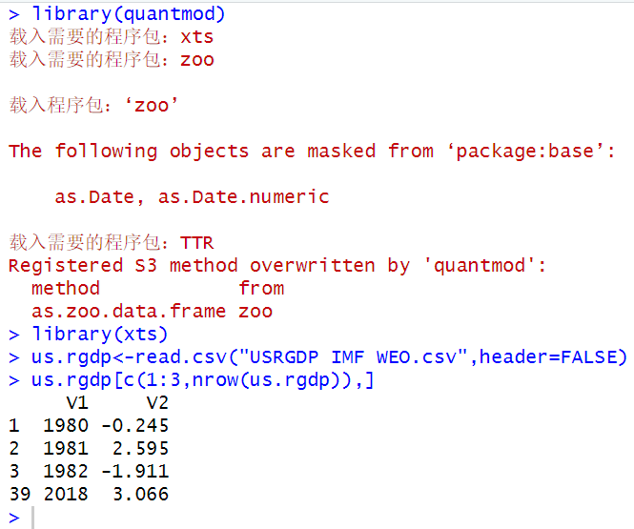

**Step 2: Rename Variables and Fix Index of Data Object**

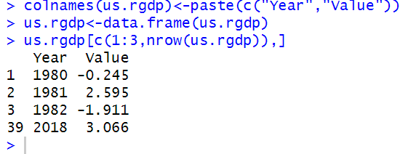

**Step 3: Create Separate Variable for Historical Real GDP Growth Data**

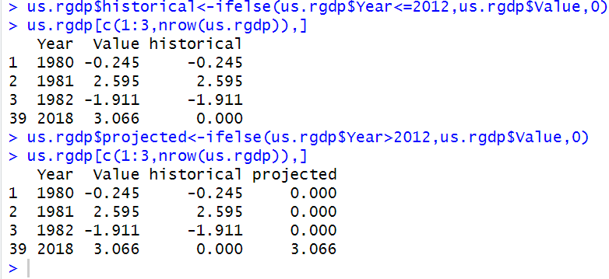

**Step 4: Setup Data for Transposition and Transpose the Data**

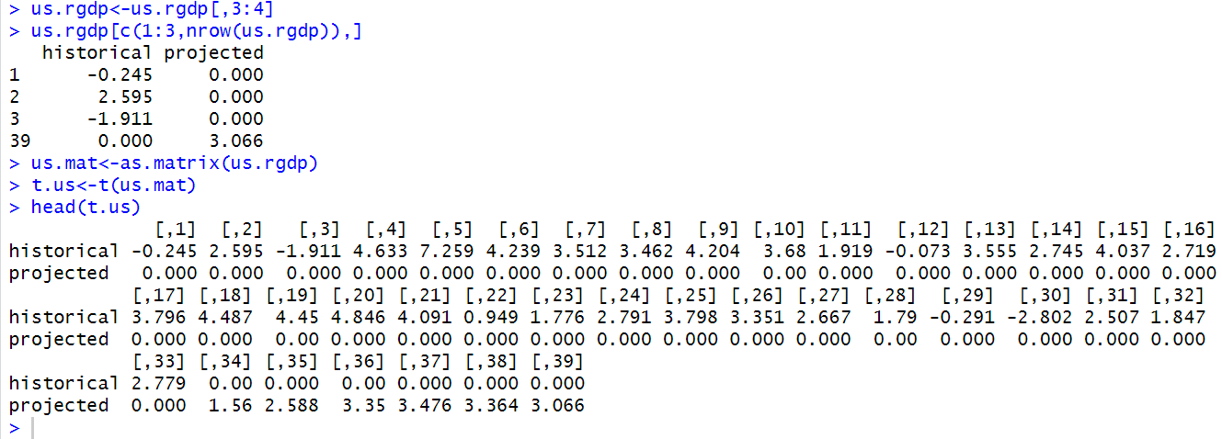

**Step 6: Setup Sequence of Even Years to Customize x-axis**

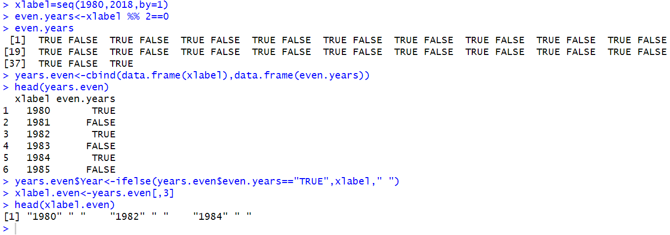

**Step 7: Plot a Bar Chart of Annual Real GDP Growth Rate**

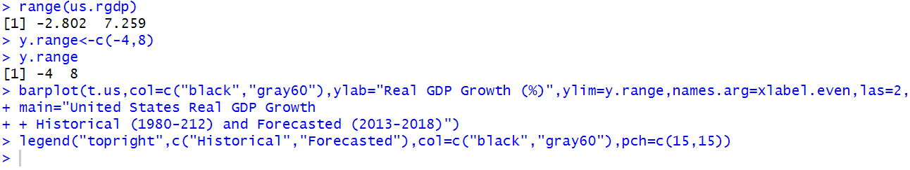

The las=2 argument flips the text of the x-axis 90◦.

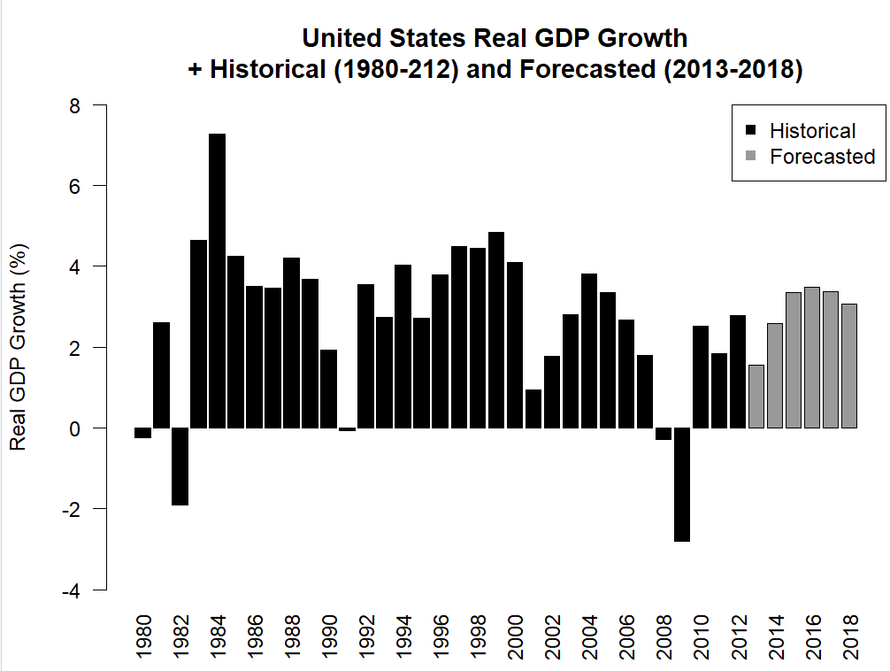

The names.arg argument tells R to use the xlabel.even sequence for the x-axis.

This presentation of the data makes it easy to distinguish which data are historical data and which data are projections.

#### 8.1.2 Unemployment Rate

For our example, we analyze the unemployment rate over the last 50 years and identify its peaks and long-term average. To emphasize the peaks and long-term average, we need to annotate the chart we create. Below we show how to implement this analysis.

**Step 1: Import Unemployment Rate Data from FRED**

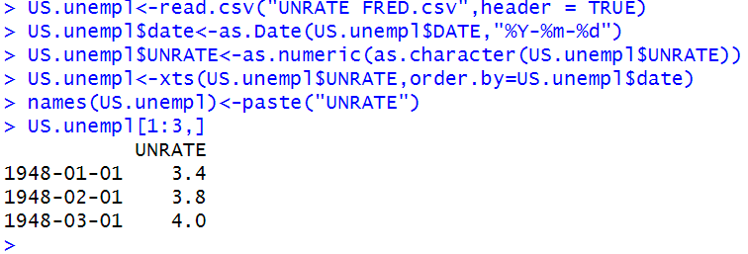

**Step 2: Subset Data from 1964 to 2013**

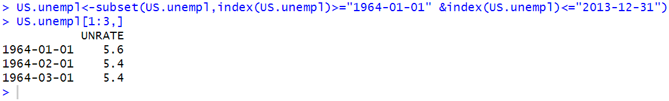

**Step 3: Calculate Long-Term Average Unemployment Rate**

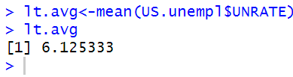

**Step 4: Plot the Unemployment Rate Data**

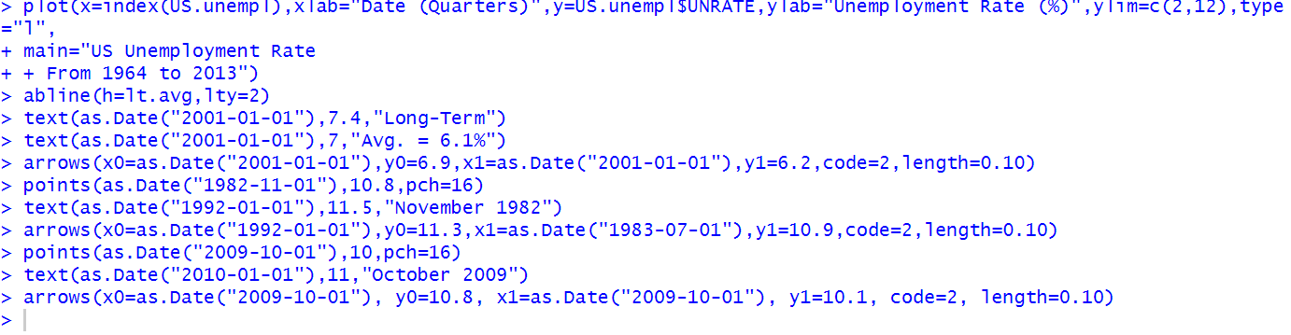

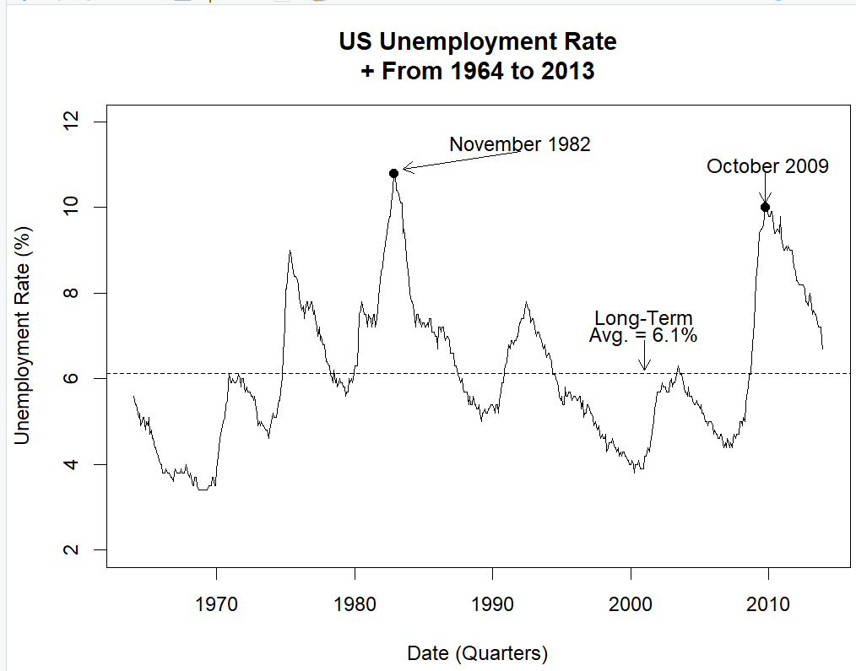

#### 8.1.3 Inflation Rate

A higher inflation rate would lead to a higher required expected rate of return, as a dollar tomorrow is worth less than a dollar is worth today.

**Step 1: Import CPI Data from FRED**

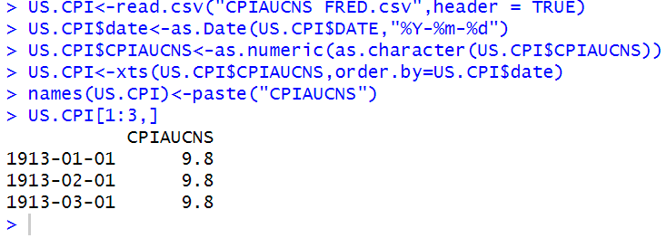

**Step 2: Calculate a 12-Month Lag Variable**

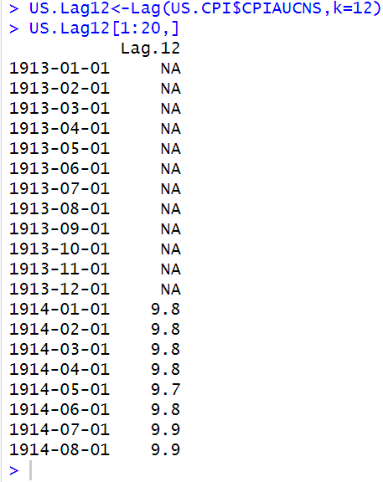

**Step 3: Combine CPI and Lag CPI Data**

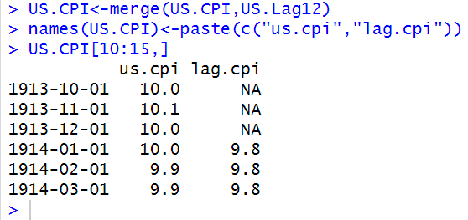

**Step 4: Calculate Inflation Rate**

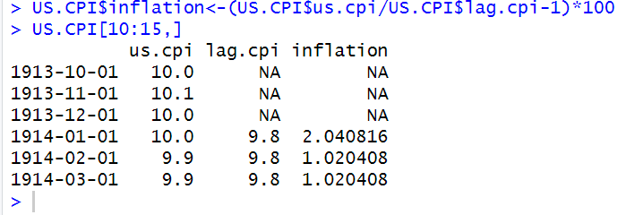

**Step 5: Subset Inflation Data Over the Last 50 Years**

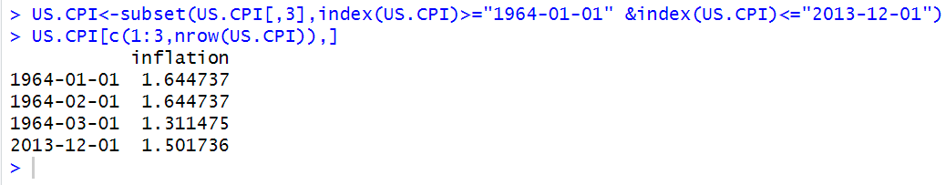

**Step 6: Plot the Inflation Rate Data**

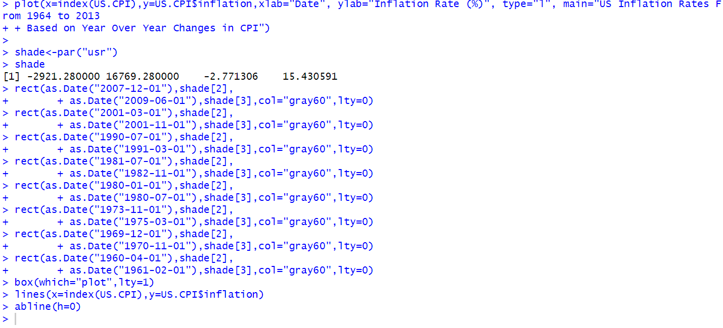

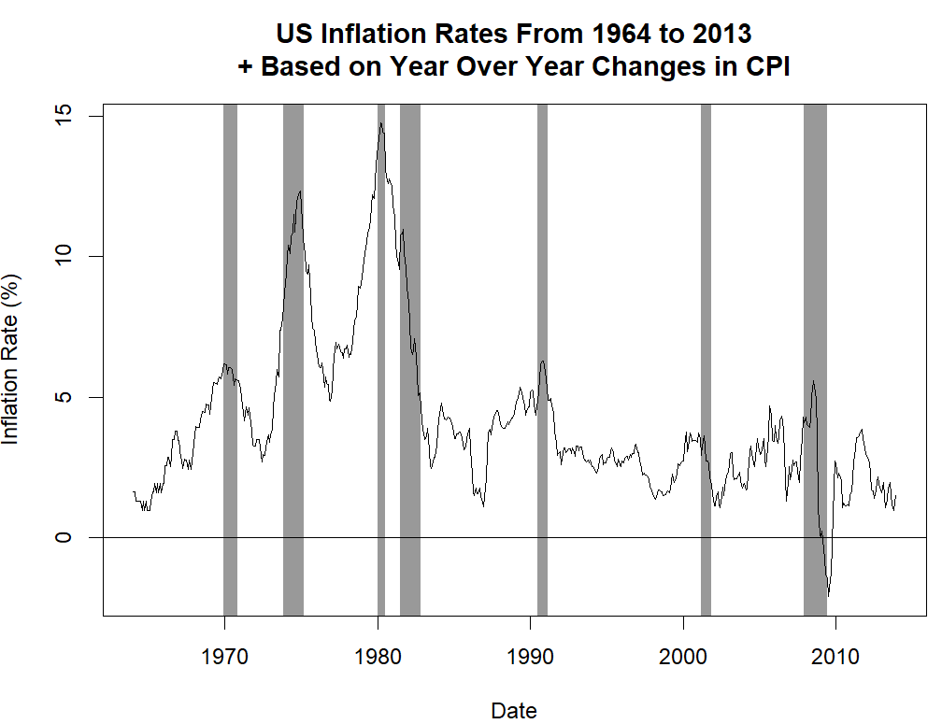

### 8.2 US Treasuries

#### 8.2.1 Shape of the US Treasury Yield Curve

As such, knowledge of Treasury yields is required to determine whether the yields of other fixed income securities are large enough for the incremental risk we are taking on. In addition, trading strategies can be constructed around the differential between short rates and long-term rates.

If T-bill rates for 3-months is substantially lower than 6-month rates, an investor who expects to hold a T-Bill for 3 months may instead purchase a 6-month T-Bill and sell it in 3 months to take advantage of the higher yields on the longer dated instrument.

This strategy is known as *riding the yield curve*.

In this section, we demonstrate how to find examples of these different shapes of the yield curve and plot these examples.

**Step 1: Obtaining US Treasury Yields for Key Maturities**

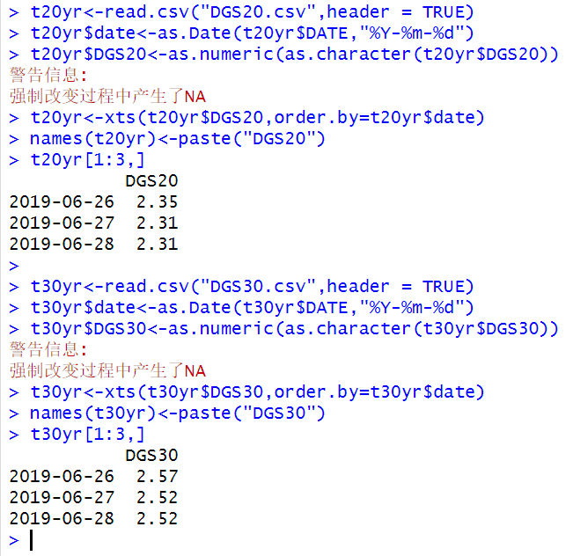

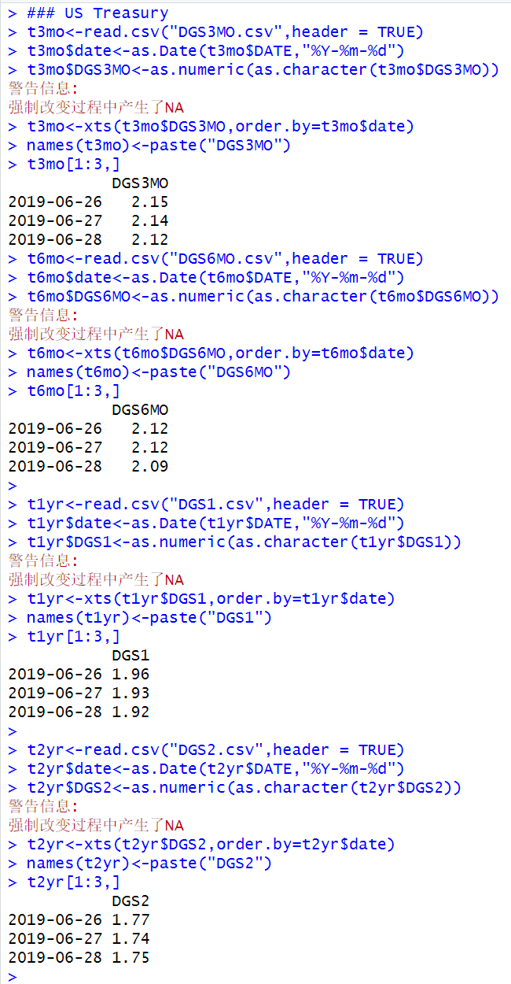

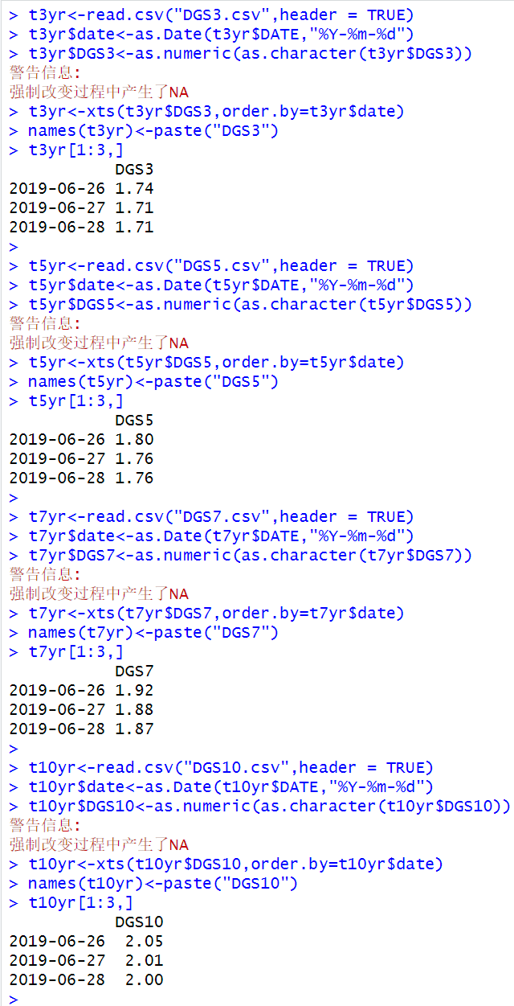

**Step 2: Combine Yield Data into One Data Object**

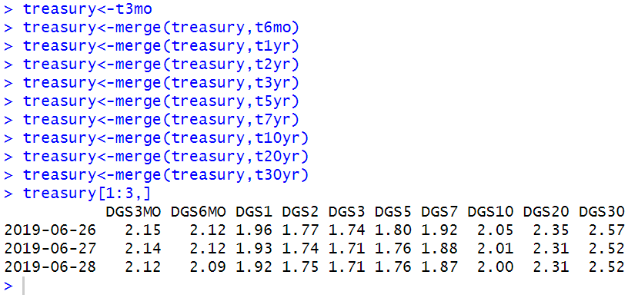

**Step 3: Subset Data to Only Include Yields from 2020 to 2024-06-26**

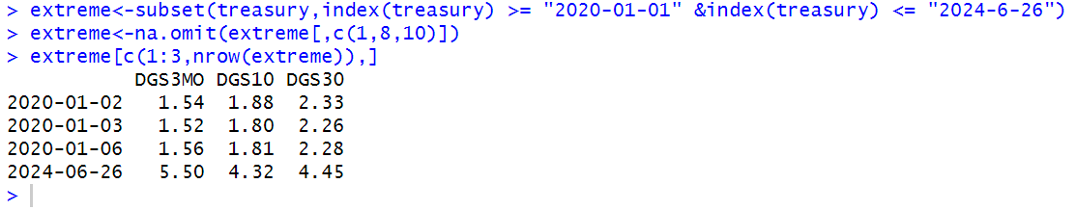

**Step 4: Identify Examples of Different Shapes of the Yield Curve**

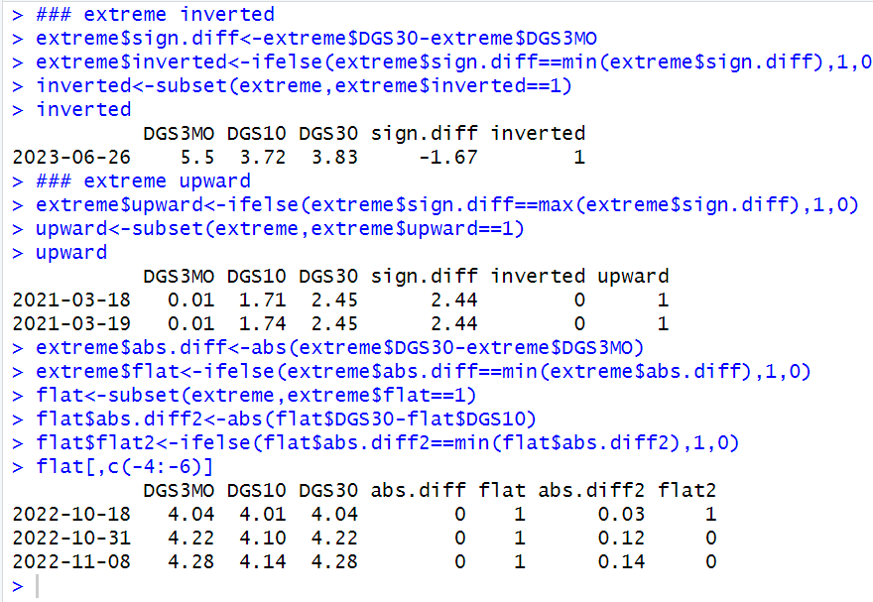

**Step 5: Extract the Yield Curve on Dates Selected and on January 8th, 2020**

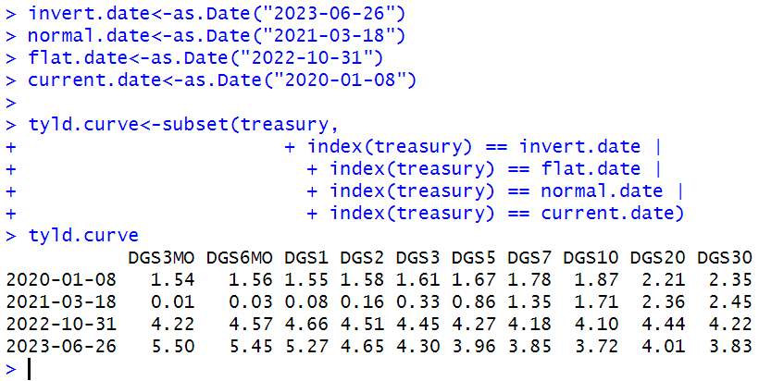

**Step 6: Prepare Data for Plotting**

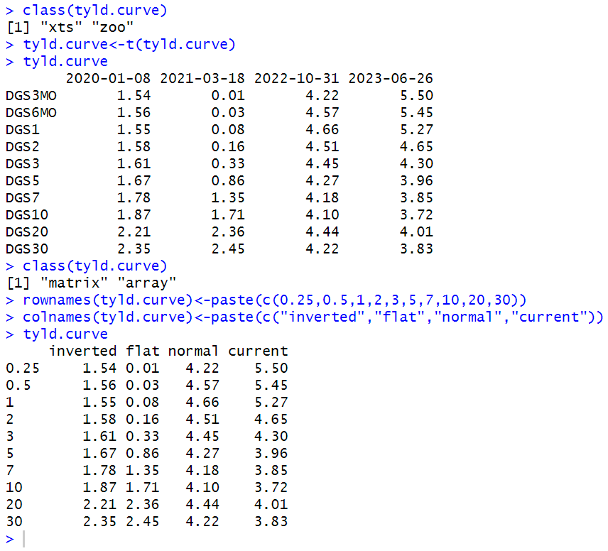

**Step 7: Plot the Yield Curve on the Four Dates Selected**

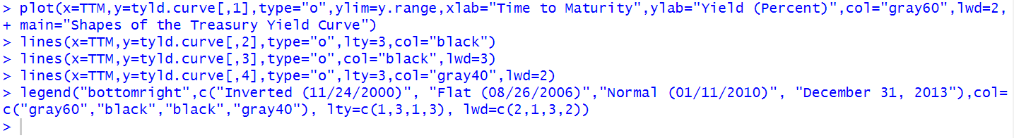

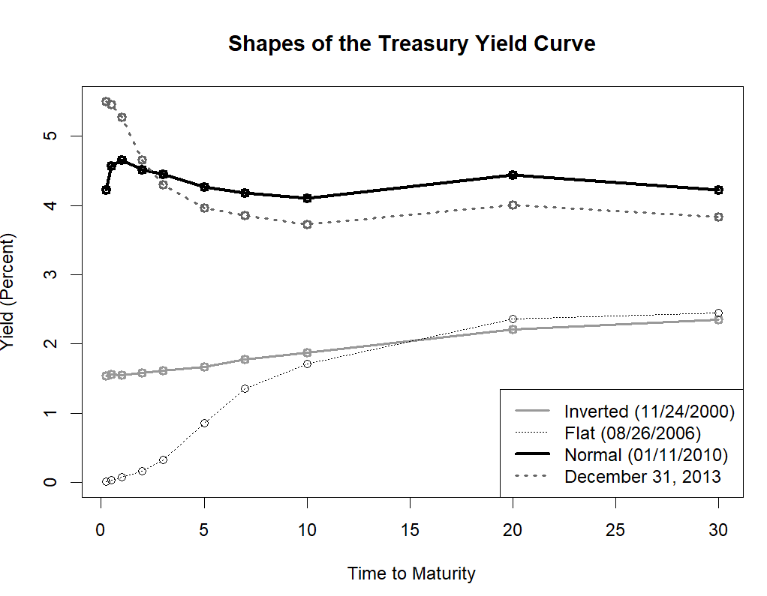

#### 8.2.2 Slope of the US Treasury Yield Curve

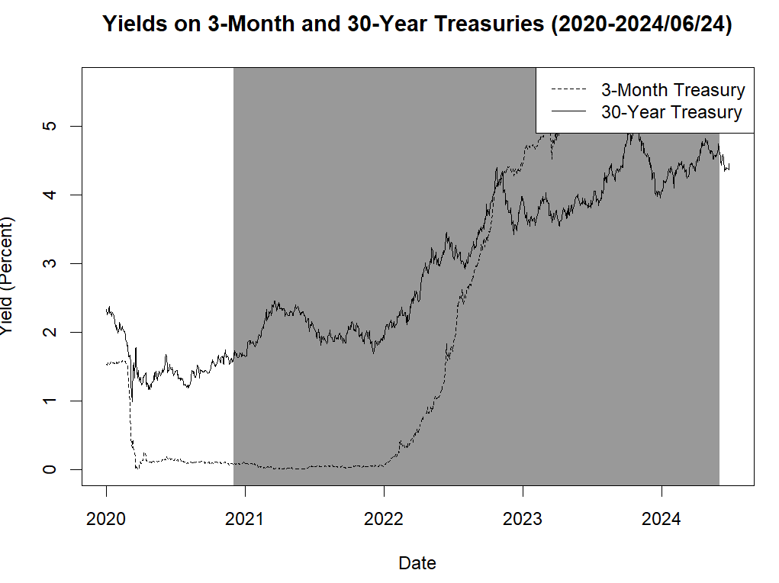

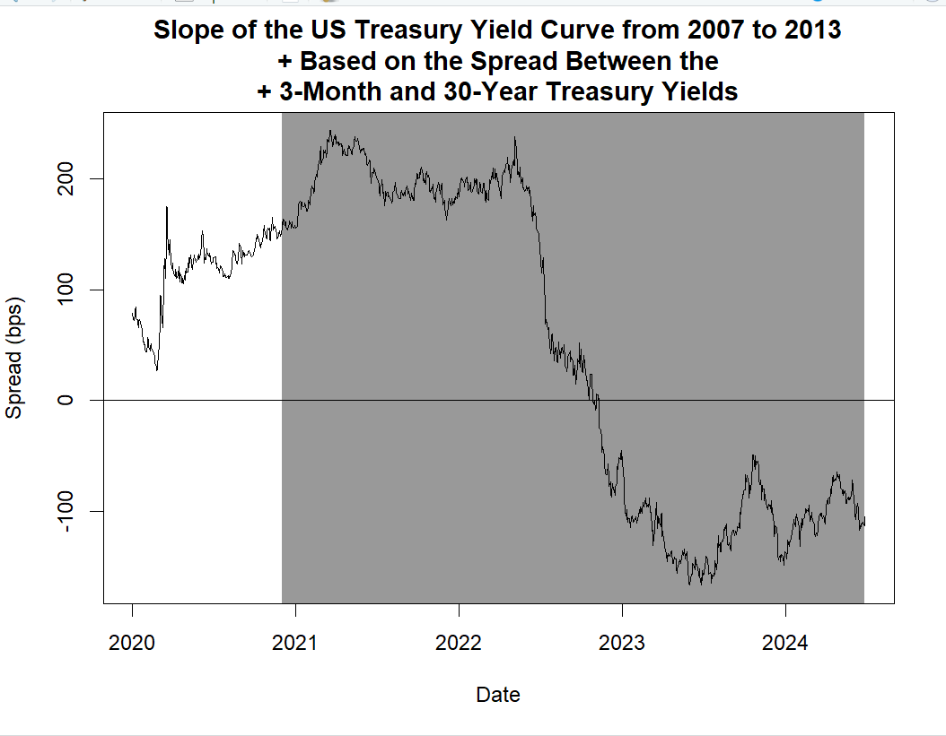

### 8.3 Further Reading

An excellent overview of the bond markets can be found in Thau [5]. More details on bond calculations can be found in Fabozzi [3] and Tuckman and Serrat [6]. Two excellent books on bond strategies are Crescenzi [1] and Huggins and Schaller [4].

There are additional resources on the web from which we can obtain up-to-date fixed income information. US bond prices can be obtained from Yahoo Finance Bonds Center (http://bonds.yahoo.com). A wealth of information about bonds can be found on various regulatory websites. For example, the website of the Financial Industry Regulatory Authority (FINRA) (http://www.finra.org) contains, among other things, information on US corporate and agency data. Another regulator, the Municipal Securities Rulemaking Board (MSRB) provides information and market data through its Electronic Municipal Market Access (EMMA) website (http://emma.msrb.org/). Sterling (UK) corporate bond and bond index prices, as well as other information on Sterling bond markets can be obtained from Fixed Income Investor (http://www.fixed incomeinvestor.co.uk).

#### References

1. Crescenzi, A. (2010). The strategic bond investor: Strategies and tools to unlock the power of the bond market (2nd ed.). New York McGraw-Hill.

2. Estrella, A., & Trubin, M. (2006). The yield curve as a leading indicator: Some practical issues. Current Issues in Economics and Finance, 12, 1–7.

3. Fabozzi, F. (2009). Bond markets, analysis and strategies (7th ed.). New Jersey: Prentice-Hall.

4. Huggins, D., & Schaller, C. (2013). Fixed income relative value analysis: A practitioner’s guide to the theory, tools, and trades. United Kingdom: Bloomberg Press.

5. Thau, A. (2011). The bond book (3rd ed.). New York McGraw-Hill.

6. Tuckman, B., & Serrat, A. (2012). Fixed income securities: Tools for today’s markets (3rd ed.). New Jersey: Wiley.

## Reference

Ang, C. S. (2015). *Analyzing financial data and implementing financial models using R.* : Springer Cham Heidelberg New York Dordrecht London.

## Attachment of zips of R codes

[Summer Research.zip](https://1drv.ms/u/s!Aiula8jGwX7YjGpw3skF71aO80GN?e=gUpwME)